U N I V E R S I T Y O F C O P E N H A G E N

F A C U L T Y O F S O C I A L S C I E N C E S

Thesis

Dynamic Trading with a GARCH volatility model

Casper Nordblom Eneqvist (xfj248) & Niels Eriksen (dvp957)

Advisor: Stefan Voigt

20th of December 2021

Keystrokes: , normal pages:

Abstract

This thesis considers dynamic multi-period minimum variance portfolio (MVP) optimization with an investor using DCC MGARCH models to forecast the conditional covariance matrix. We test three variance models and model the transaction costs as quadratic. We consider two strategies for…….. One, the investor seeks a minimum variance portfolio that ignores the transaction costs associated with rebalancing this portfolio (simple strategy). Two, the investor seeks a minimum variance portfolio but adjusts for the expected transaction costs (sophisticated strategy). We derive dynamic optimal solutions for both strategies with a closed-form solution for the simple strategy. The sophisticated strategy requires numerically solving for coefficients and additional restrictions. As new information arrives, the simple strategy immediately rebalances to the new MVP portfolio whereas the sophisticated strategy partially trades towards an aim portfolio depending on the level of transaction costs. Measured in gross returns, both strategies achieve lower annualized standard deviation with higher Sharpe ratios than an Equal-weight strategy but still a lower Sharpe ratio than a Buy-and-hold strategy. In terms of net returns, the simple strategy performs very poorly as expensive transaction costs increase the standard deviation drastically. After tuning the ex-ante transaction costs, the sophisticated strategy performs well as the investor trades less while still achieving lower annualized standard deviation than our benchmark strategies.

# Division of Labor

Casper Nordblom Eneqvist (xfj248):

Section

Niels Eriksen (dvp957):

Section

Mutual Work:

Section

# Contents

List of Figures 2

List of Tables 3

1. Introduction 4
2. Modern portfolio theory 6
   1. Characterization of the investor and the market . . . . . . . . . . . . . . . . . 7
   2. Mean-variance approach . . . . . . . . . . . . . . . . . . . . . . . . . . . . . . 7 2.2.1 Solving the problem for multiple assets . . . . . . . . . . . . . . . . . . 9
3. GARCH processes
   1. Stylized facts about returns
   2. Univariate GARCH models . . . . . . . . . . . . . . . . . . . . . . . . . . . . . 14
   3. Multivariate GARCH models . . . . . . . . . . . . . . . . . . . . . . . . . . . 17
      1. One-period forecast of the conditional covariance, Ω*t*+1 . . . . . . . . . 20
      2. Shrinkage of the covariance matrix . . . . . . . . . . . . . . . . . . . . 20
      3. Multivariate GARCH models in Portfolio theory . . . . . . . . . . . . . 21
4. Dynamic Trading Strategies 21
   1. Dynamic programming techniques . . . . . . . . . . . . . . . . . . . . . . . . . 22
   2. Optimal dynamic strategies for multiple risky assets . . . . . . . . . . . . . . . 23
      1. Derivation of the simple strategy (ignoring transaction costs) . . . . . . 23
      2. Derivation of the sophisticated strategy (adjusting for transaction costs) 25
5. Description of data 28
6. Empirical results 32
   1. Can the conditional covariance estimate from a GARCH model reduce risk? . 33
   2. Calibration and model fit . . . . . . . . . . . . . . . . . . . . . . . . . . . . . . 34
   3. Simple strategy (ignoring transaction costs) . . . . . . . . . . . . . . . . . . . 36
      1. Understanding the dynamics of the simple strategy . . . . . . . . . . . 36
      2. Backtesting the simple strategy . . . . . . . . . . . . . . . . . . . . . . 40
   4. Sophisticated strategy (adjusting for transaction costs) . . . . . . . . . . . . . 46
      1. Understanding the dynamics of the sophisticated strategy . . . . . . . . 47
      2. Backtesting the sophisticated strategy . . . . . . . . . . . . . . . . . . 52
7. Discussion 60
8. Conclusion 62

References 64

1. Appendix 67
   1. Student’s t-distribution . . . . . . . . . . . . . . . . . . . . . . . . . . . . . . . 67
   2. Non-Central Student’s t-distribution . . . . . . . . . . . . . . . . . . . . . . . 67
   3. Optimal strategies with GARCH volatility models . . . . . . . . . . . . . . . . 68
      1. Optimal strategy in a static setting with multiple risky assets . . . . . 68
      2. Optimal dynamic strategy for multiple risky assets when adjusting for

transaction costs (the sophisticated strategy) . . . . . . . . . . . . . . . 68

* 1. Empirical . . . . . . . . . . . . . . . . . . . . . . . . . . . . . . . . . . . . . . 75
     1. MGARCH model estimates . . . . . . . . . . . . . . . . . . . . . . . . 75
     2. Excess figures . . . . . . . . . . . . . . . . . . . . . . . . . . . . . . . . 77
     3. Algorithms . . . . . . . . . . . . . . . . . . . . . . . . . . . . . . . . . 82
  2. Excess tables . . . . . . . . . . . . . . . . . . . . . . . . . . . . . . . . . . . . 84
  3. Python Code . . . . . . . . . . . . . . . . . . . . . . . . . . . . . . . . . . . . 85

List of Figures

* + - 1. Estimated efficient frontier with minimum variance portfolio and efficient portfolio 8
      2. Response of the conditional variance *σt*2 to a shock . . . . . . . . . . . . . . . . 15
      3. The trading cycle of the investor . . . . . . . . . . . . . . . . . . . . . . . . . . 28
      4. Indexed prices of our asset sample . . . . . . . . . . . . . . . . . . . . . . . . . 29
      5. Asset return densities and time series plots . . . . . . . . . . . . . . . . . . . . 31
      6. Comparison of sample covariance estimate vs. GARCH conditional estimate . 33
      7. The impulse response function of *vt*MVP for the simple ARCH(1) strategy . . . 37
      8. The impulse response function of *vt*MVP for the simple GARCH(1,1) strategy . 38
      9. The impulse response function of *vt*MVP for the simple GJR-GARCH(1,1) strategy 39
      10. Portfolio weights from the unconditional and conditional covariance matrix . . 40
      11. Portfolio weights of the simple strategy, all assets . . . . . . . . . . . . . . . . 41
      12. Cumulative returns of the simple strategy, all assets . . . . . . . . . . . . . . . 41
      13. Portfolio weights of the simple strategy, stocks . . . . . . . . . . . . . . . . . . 44
      14. Cumulative performance of the simple strategy, stocks only . . . . . . . . . . . 45
      15. Similarity between the normalized aim portfolio (red) and the simple strategy

(green) . . . . . . . . . . . . . . . . . . . . . . . . . . . . . . . . . . . . . . . . 47

* + - 1. Impulse response function of *vt*MVP for the sophisticated ARCH(1) . . . . . . . 49
      2. Impulse response function of *vt*MVP for the sophisticated GARCH(1,1) . . . . . 50
      3. Impulse response function of *vt*MVP for the sophisticated GJR-GARCH(1,1) . . 51
      4. Annualized performance for different values of *γ*˜*D* for GARCH(1,1) (log på y-

akse i (a) og (c)) . . . . . . . . . . . . . . . . . . . . . . . . . . . . . . . . . . 52

* + - 1. Portfolio weights of the sophisticated strategy, all assets . . . . . . . . . . . . . 53

|  |  |
| --- | --- |
| 21 Cumulative performance of the sophisticated strategy . . . . . . . . . . . . . . | 55 |
| 22 Cumulative performance of the sophisticated strategy, commodities . . . . . . | 58 |
| 23 Impulse response function of *vt*MVP for GJR-GARCH(1,1) with a shock of 2 . . | 77 |
| 24 Annualized performance measures across different values of *γ*˜*D* . . . . . . . . | 77 |
| 25 Simple GJR-GARCH(1,1) portfolio weights . . . . . . . . . . . . . . . . . . . . | 78 |
| 26 Weights of different sophisticated GARCH type strategies for *γ*˜*D* = 1*.*52e−6 . . | 78 |
| 27 Sophisticated GJR-GARCH(1,1) portfolio weights . . . . . . . . . . . . . . . . | 79 |
| 28 ARCH(1) MVP weights for different *γ*˜*D* . . . . . . . . . . . . . . . . . . . . . . | 79 |
| 29 GARCH(1,1) MVP weights for different *γ*˜*D* . . . . . . . . . . . . . . . . . . . . | 80 |
| 30 GJR-GARCH(1,1) MVP weights for different *γ*˜*D* . . . . . . . . . . . . . . . . .  List of Tables | 81 |
| 1 Correlation matrix of selected asset returns . . . . . . . . . . . . . . . . . . . | 29 |
| 2 Descriptive statistics, tests, and distribution fit . . . . . . . . . . . . . . . . . . | 30 |
| 1. Annualized performance in gross return . . . . . . . . . . . . . . . . . . . . . . 2. Estimates of a DCC MGARCH(1,1) with univariate GARCH(1,1) - *tν* errort- | 34 |
| erms . . . . . . . . . . . . . . . . . . . . . . . . . . . . . . . . . . . . . . . . . | 36 |
| 5 Annualized performance of the simple strategy, all assets . . . . . . . . . . . . | 42 |
| 6 Annualized performance of the simple strategy, stocks . . . . . . . . . . . . . . | 46 |
| 7 Annualized performance of the sophisticated strategy, all assets . . . . . . . . | 56 |
| 8 Annualized performance of the sophisticated strategy, commodities . . . . . . | 59 |
| 9 Estimates of a DCC MGARCH(1,1) with univariate ARCH(1) - *tν* error terms 10 Estimates of a DCC MGARCH(1,1) with univariate GJR-GARCH(1,1) - *tν* | 75 |
| error terms . . . . . . . . . . . . . . . . . . . . . . . . . . . . . . . . . . . . . | 76 |
| 11 Annualized performance, sophisticated strategy, stocks . . . . . . . . . . . . . | 84 |
| 12 Annualized performance, sophisticated strategy, bonds . . . . . . . . . . . . .  List of Algorithms | 85 |
| 1 Optimal weights using DCC MGARCH model without transaction costs . . . . | 82 |
| 2 Optimal weights using a DCC MGARCH model with transaction costs . . . . | 83 |
| 3 Calculation of transaction costs . . . . . . . . . . . . . . . . . . . . . . . . . . | 84 |

# 1 Introduction

The optimal allocation of funds, whether for retail investors, banks, or institutional clients, is a vast research topic. Given the compounding nature of returns, the difference in achievable wealth over a long horizon with an optimal portfolio compared to a sub-optimal portfolio is immense. Thus, it is theoretically possible to substantially improve the future living standards of savers or profits for firms by investing optimally.. The insurance and pension sectors are examples of industries for which better investment strategies could ultimately lead to substantial welfare gains for millions of people as these sectors generally mediate the investments of household savings.

The so-called “Modern Portfolio Theory” advanced this pursuit of optimizing portfolios, which the Nobel prize-winning Harry Markowitz introduced in his seminal paper [Markowitz, 1952].

“Modern Portfolio Theory” which the Nobel prize-winning Harry Markowitz introduced in his seminal paper [Markowitz, 1952] is one of the first great advances in the pursuit of portfolio optimization strategies.

In the paper, Markowitz introduces the now widely applied mean-variance approach. Markowitz considers risk-averse investors who maximize expected returns and minimize the risk of their portfolios. While the theoretical work of [Markowitz, 1952] is the foundation of countless finance papers, the empirical implementation of his model is limited. Specifically, it is limited in accuracy by estimation uncertainty in the statistical moments of the asset returns, a point we will expand upon later. Furthermore, Markowitz’s result is difficult to apply over a long time horizon.

[Merton, 1969] addressed this problem with theoretical continuous time models of varying time horizons for portfolio selections - famously computing the Merton fraction. This constant optimally determines what fraction of savings an investor should allocate to the single risky asset in the Merton model over an investor’s lifetime, which, surprisingly, is independent of the timing of the investment and the complete value of the portfolio. This result comes out of Merton’s simple setup where returns follow a Wiener process with a constant mean and variance. This reduces the multi-period problem of a dynamic portfolio to an appealing static solution for the one optimal portfolio composition.

While Markowitz’s and Merton’s approaches are theoreticallypleasing, a (naive) empirical application of either model runs into three major problems. First, the future mean returns and variance are very time-varying, the predictability of which is the subject of much research, which implies a second problem. Namely, that investors should change the allocation of wealth across time given new predictions of the future mean and variance. This gives rise to a third problem; investors incur transaction costs to make portfolio changes, which means a target portfolio can take many days or weeks to achieve, rendering the static result unattainable.

[Gârleanu and Pedersen, 2013] address all three issues, except the constant covariance matrix, by solving the multi-period problem for an investor who hasmean-variance preferences andfaces quadratic transaction costs. They derive an analytical solution for returns given by a factor type model and a constant covariance matrix. The authors find that the optimal portfolio is a combination of the previous period’s portfolio and an aim portfolio, depending on the level of transaction costs. It is analogous to how a missile homes onto its target by aiming for where it will be rather than where it currently is. the authors find their dynamic approach is empirical superior, emphasizing the importance of adjusting for transaction costs when deriving an optimal trading strategy for institutional investors.

[Gârleanu and Pedersen, 2013]’s focus on factor models for the mean of returns leaves an opportunity to focus on the conditional volatility and correlations of returns rather than the conditional mean as a vast literature like [Welch and Goyal, 2008] and [Jobson and Korkie, 1980] finds that forecasting the mean of returns is very noisy. [Jagannathan and Ma, 2003] writes:

*"Tangency portfolios, whether constrained or not, do not perform as well as the global minimum variance portfolios in terms of the out-of-sample Sharpe ratio. This means that the estimates of the mean returns are so noisy that simply imposing the portfolio weight constraint is not enough..."*

Therefore, we consider a multi-period investment strategy similar to [Gârleanu and Pedersen, 2013] but focused on optimal minimum variance portfolios. This corresponds to investors with mean-variance preferences with extreme risk aversion. We model returns with a constant mean process and use a DCC MGARCH model for the conditional covariance matrix of the returns as proposed by [Engle, 2002]. Engle decomposes the covariance matrix Ω*t* into variance and correlation and models these separately with *N* univariate GARCH type models for the conditional variances and a single scalar BEKK model for the conditional correlation. This allows for a two-stage estimation of…..that significantly reduces the number of parameters to be estimated andallows for a larger number of assets to be included in the model.

The idea of using MGARCH models to model the conditional covariance matrix in minimum variance portfolios is not new as [Engle and Sheppard, 2001] consider a DCC MGARCH model as the data generating process of the conditional covariance matrix and the time-varying minimum variance weights resulting from using the conditional covariance matrix.

We wish to expand on this usage of the DCC MGARCH process to model the covariance matrix to find the optimal dynamic portfolio trading strategy for an investor with a long horizonl. A time-varying covariance matrix has previously been used in dynamic investing strategies like [Collin-Dufresne et al., 2015], who consider efficient portfolios with returns given by factors models. In their model, the residual covariance matrix, Σ, is constant but the covariance matrix of the returns, Σ*t*→*t*+1, is time-varying by scaling of the time-varying factor exposures, *βi,t*. The authors implement the time-varying covariance matrix into the result of [Gârleanu and Pedersen, 2013] and evaluate each period’s Riccati equations. Although this adds extra computational demands, it significantly improves the outcome in terms of average terminal wealth and average utility across different levels of transaction costs.

Returning to the topic of transaction costsa vast literature is dedicated to estimating transaction costs like [Robert et al., 2012], who find that trading 1.59% of the daily volume of an asset costs an average of 10 basis points on NYSE and NASDAQ. Another question is the specific form of transactions costs. These range from simple yet unrealistic forms like constant transaction costs, which are rarely used in the literature, to proportional transaction costs used extensively in the literature. An example is [Constantinides, 1986], which considers a two-asset case and shows that proportional transaction costs drastically decrease trading volume. [Mei et al., 2016] considers a problem similar to [Gârleanu and Pedersen, 2013] but with proportional and quadratic transaction costs. The main difference between the two is that quadratic transaction costs punish large movements more harshly than proportional transaction costs, which are generally more consistent with large institutional investors.

To summarize, the research question of this thesis is *"What is the optimal minimum variance dynamic strategy when investors face quadratic transaction costs with returns modelled by a constant mean process and a DCC MGARCH model for the conditional covariance?"*.

This implies modelling a tiny subset of the efficient frontier with an infinitely risk-averse investor. Our reasoning behind this decision is the high noisiness of mean return estimates, [Jobson and Korkie, 1980] and [Jagannathan and Ma, 2003], and the inaccuracies of forecasts using factor models, [Welch and Goyal, 2008]. In contrast, it is somewhat possible to forecast conditional variances and correlations to find minimum variance portfolios.

The structure of this paper is as follows; Section 2 is an introduction to Modern Portfolio Theory along with the efficient and minimum variance portfolios (MVP) and arguments for focusing on the latter. Section 3 presents stylized facts of financial time series and how the GARCH type model captures these facts. Furthermore, we present both univariate and multivariate GARCH models, along with methods for forecasting the covariance matrix and how to use this forecast to find the optimal MVP portfolio. In section 4, we go through the dynamic programming techniques of [Bellman, 1966] and solve the multi-period optimization problem with and without accounting for transaction costs. Following a brief description of our sample data in section 5, we proceed with presenting the model’s dynamics and historical backtesting of the model in section 6. This section also explores the differences between a static Markowitz portfolio using the covariance matrix from an empirical estimate and the covariance matrix from an MGARCH model. Finally, we round off with a discussion and conclusion in sections 7 and 8, respectively.

# 2 Modern portfolio theory

Modern portfolio theory was introduced in the seminal paper [Markowitz, 1952]. We give an overview of his approach, starting by characterizing the asset universe and the investor we model in section 2.1. Then we introduce Markowitz’s mean-variance approach and review the optimal allocation of *N* assets in section 2.2. Furthermore, we discuss the investor’s empirical challenges when using the mean-variance method in practice in section 2.2.1.

## 2.1 Characterization of the investor and the market

The market in this thesis is characterized by *N* risky assets with prices given as *Pi,t*. The risky assets may be stocks, ETFs, or other financial assets. Additionally, the model presented assumes that investors pay no taxes, transaction costs cover brokerage fees, bid-ask spread costs, and price impact costs and that the investor is risk-averse to a certain degree

Finally, the model assumes that the investor only cares about the return and variance of their portfolio. This type of preference is called *mean-variance* utility or *quadratic preferences*, which the following utility function can express:

 (1)

E*t*−1[·] = E[·|F*t*−1] denotes the conditional expectation with respect to the filtration, F*t*−1, and similar for V*t*−1[·] denoting the conditional variance. *γ* is the investor’s level of risk aversion and *rt* = (*r*1*,t,r*2*,t,...,rN,t*)0 is the return of the financial assets given as *ri,t* = *Pi,t/Pi,t*−1 −1. *vt* is an *N* × 1 vector of weights *vt* = (*v*1*,t,v*2*,t,...vN,t*)0 defining a portfolio of assets. The weights are normalized wrt. the total amount invested and are determined in the previous period. The portfolio resulting from the quadratic preference utility function has mean return and variance given by;

 and 

This utility function captures the trade-off between maximizing the expected returns of the portfolio,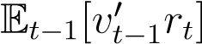, and minimizing the variance of the portfolio, 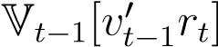. For *γ* = 0, the investor is risk-neutral which means the only objective of the investor is to maximize the expected returns regardless of the risk it may pose, which shows as 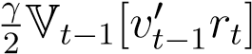 disappears from the utility function.

Real-world investors also care about intermediate consumption rather than just intermediate returns and volatility. Many authors have worked on this problem, like [Merton, 1969] who derived rules for intermediate consumption and wealth allocation. While this problem is undoubtedly fascinating, the model presented only considersan investor who cares about intermediate returns and variance, thus limiting the scope of our thesis to portfolio allocation.

## 2.2 Mean-variance approach

The mean-variance approach is built upon [Markowitz, 1952]’s seminal paper that lays the foundation for the field of Modern Portfolio theory. Markowitz considers an investor with the objective of obtaining maximum future returns at the lowest possible risk. This corresponds to an investor with preferences as in equation (1). To apply this theory in practice, one must estimate mean asset returns and (co)variances. The simplest method is to use past returns to estimate mean returns and the sample averages for the (co)variances of returns.

After estimating mean asset returns and the covariance matrix of returns, the investor forms portfolios from *N* assets, and any set of mean and variance obtained by combining these *N* assets is so-called *feasible*. All feasible combinations are called *the feasible set*. The number of assets determines the size of the feasible set, which increases as the number of assets grows. In figure 1, we see the feasible set between the black and red striped lines. Notice that the feasible set is much larger than any mean-variance combination obtainable from individual stocks. The investor can thus invest in any portfolio within the feasible set. Figure 1: Estimated efficient frontier with minimum variance portfolio and efficient portfolio

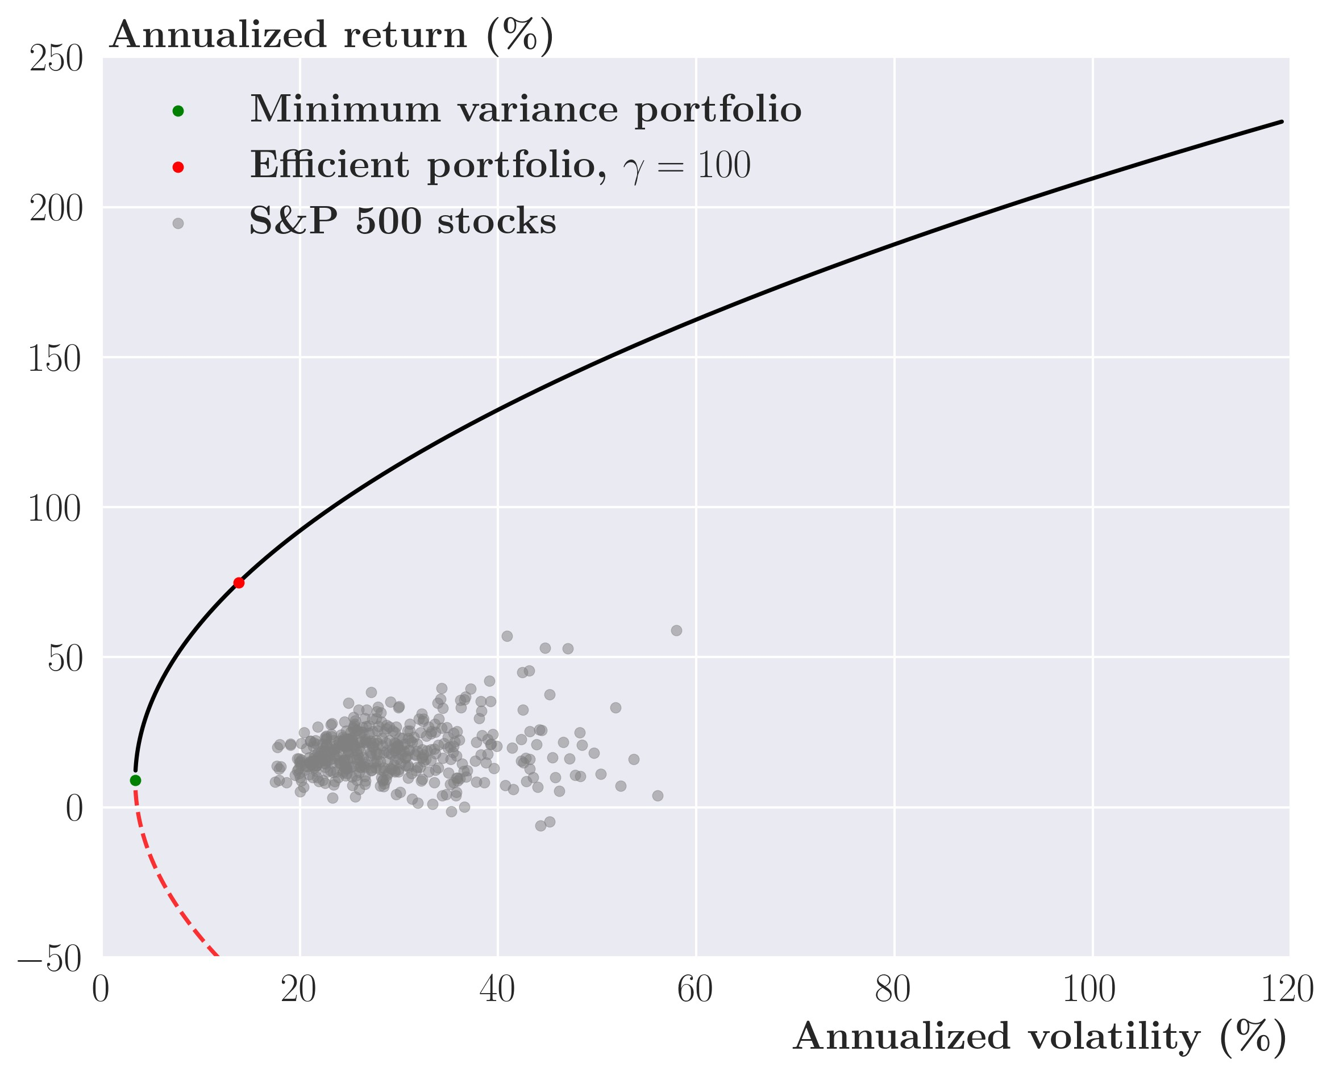

*Source: Yahoo Finance. Data from January* 1*st 2013 to September* 1*st 2021*

However, a rational investor will only invest in a portfolio along *the efficient frontier*, which is the set of portfolios that either

* Has the highest expected return for a given variance
* Has the lowest variance for a given expected return

There are many efficient portfolios on the efficient frontier, which in figure 1 is all portfolios on the black line. The investor picks a portfolio from the efficient frontier that maximizes the investorsutility with respect to their level of risk aversion, *γ*. The more risk-averse the investor is, the more to the left in the figure the investor prefers to be. An infinitely risk-averse investor, who only cares about minimizing risk, will prefer the *minimum variance portfolio* (the green dot) under our assumption of no outside option. In contrast, a moderately risk-averse investor will prefer the *efficient portfolio* (the red dot), a trade-off between expected return and risk.

Markowitz’s mean-variance approach requires either Gaussian returns, N*N*(*µ,*Σ), or quadratic preferences given by equation (1). We use the second assumption that the investor has quadratic preferences for the following model (I don’t know but you need to specify whenu use the quadratic and when u use gaussian)even though we use Gaussian returns for the following derivations for simplicity. Let us consider a standard mean-variance approach for *N* risky assets to see how this works in practice.

### 2.2.1 Solving the problem for multiple assets

Consider a market defined by *N* risky assets, the returns of which are given by a multivariate

Gaussian distribution N*N*(*µ,*Σ). *µ* is an *N* × 1 vector of mean returns, and Σ is the *N* × *N* covariance matrix of the *N* assets. *vt* is an *N* × 1 vector of weights. An investor with mean-variance preferences as given by equation (1) seeking to maximize expected utility in period *t* + 1 solves the following *static* optimization problem:



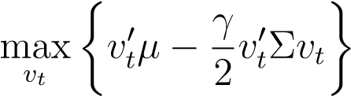 s.t. 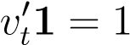

The constraint *vt*01 = 1 means that the investor must invest all available funds into the risky assets of the market. The natural interpretation is that the investor has no outside option besides the *N* assets. Given the individual weights of the weight matrix, *vi*, are not restricted to be positive, *vi* ≥ 0, investors can short sell assets.

To solve the problem, we set up the Lagrangian with constraint *vt*01 = 1 with a Lagrangian multiplier *λ*

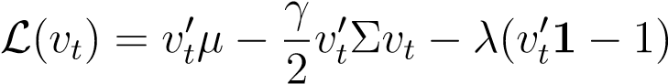

Taking first-order conditions with respect to the weight, *vt*

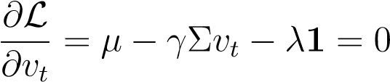

Solving for *vt* yields

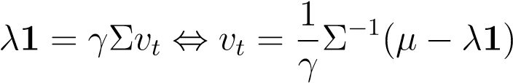

The constraint requires that *vt*01 = 1 ⇔ 10*vt* = 1, which can be used to solve for the Lagrangian multiplier *λ*



Now, we insert the expression for *λ* into the weights, *vt*

!

Resulting in

(2)

*v*

EFF

*t*

=

*v*

MVP

*t*

+

1

*γ*

Σ

−

1

*µ*

−

1

0

Σ

−

1

*µ*

1

0

Σ

−

1

1

Σ

−

1

1

!

|

{

z

}

(

*i*

)

Thus, the efficient portfolio, *vt*EFF, consists of the minimum variance portfolio *vt*MVP and a self-financing portfolio *(i)*[1].

An investor seeking to maximize his utility invests all available funds into the minimum variance portfolio, *vt*MVP, and creates a self-financing portfolio, *(i)*, that increases the expected return of the investor’s portfolio but also increases the risk of the portfolio. In terms of figure 1, *vt*EFF corresponds to some portfolio on the efficient frontier, with the red dot as an example with *γ* = 100. As *γ* → ∞ then (*i*) → 0 and the investor only invests in the minimum variance portfolio, the green dot.

Intuitively, it makes sense to care about the expected return of the portfolio, *µ*. However, the investor does not know the true mean of returns, *µ*. However, It can be estimated byits empirical counterpart, *µ*ˆ. However, neither the true mean, *µ*, nor the empirical mean, *µ*ˆ, can predict the return of an asset tomorrow with any noticeable accuracy. Actually, [Jobson and Korkie, 1980] show that the sample mean from a wide range of stocks are unstable and biased or as [Jagannathan and Ma, 2003] puts it:

*“The estimation error in the sample mean is so large that nothing much is lost in ignoring the mean altogether when no further information about the population mean is available”*

If the sample mean is used, the instabilities in *µ*ˆ add instabilities to the chosen weights, *vt*. Therefore, some authors prefer to use a factor-like model that often includes factors like momentum, market-to-book ratio, etc., that attempt to predict future returns. While many authors have used factor models, famously [Fama and French, 1993], and [Carhart, 1997] with their three and four factors models, citing statistically significant parameters for the factors, [Welch and Goyal, 2008] showed that many parameters estimates for the factors are mostly unstable and even prone to spurious results.

Another argument against factor models is the efficient market hypothesis, stating that no publicly available information today can predict returns tomorrow. Other market participants also have that information and have traded the benefits of the information away. Thus, the explanatory power of the factors models should already be reflected in the prices of today, thus giving the factor models no predictive power, theoretically.



In summary, no method exists to estimate future returns reliably, and even if they are successful, the literature tells us we can only expect to gain marginally helpful information from them. Even if we tried to estimate mean returns, the estimation uncertainty from these methods introduces two significant problems for the optimal portfolio weight, *vt*EFF.

Firstly, estimation uncertainty adds instability to the optimal weights. This leads to unnecessary rebalancing for real-world investors, which adds transaction costs without benefits since any deviation from the current portfolio is costly.

Secondly, estimation uncertainty of the sample mean or the factor model may cause extreme portfolio weights. To explain why, consider two assets, *i* and *j*, where the sample mean of asset *i* is much higher than *j*. In this case, the investor will go long asset *i* and go short asset *j*, all else equal. This is problematic because [Jobson and Korkie, 1980] and [Jagannathan and Ma, 2003] have shown, that the sample average is unstable and biased. Because of this, the sample mean may be spurious, leading to erroneous portfolio allocations, which in the real market will hurt investors’ returns badly. For these reasons, we narrow the scope of the thesis and focus solely on minimizing the risk of the investors' portfolio.

Specifically, rather than maximizing expected utility, we now minimize the variance of the portfolio.

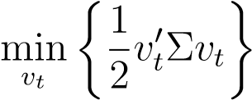 s.t. 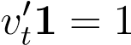

To solve the problem, we set up the Lagrangian with an identical weight constraint like before 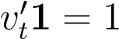, with a Lagrangian multiplier *λ*

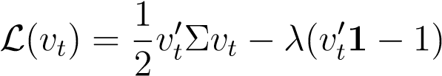

Taking first order conditions with respect to the weights, *vt*

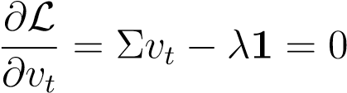

Solving for *vt* yields

*λ*1 = Σ*vt* ⇔ *vt* = Σ−11*λ*

The constraint requires that *vt*01 = 10*vt* = 1, which can be used to solve for the Lagrangian

multiplier, *λ*

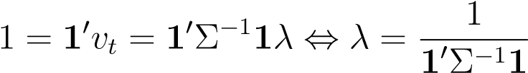

Now, we insert the expression into the weights, *vt*

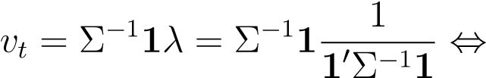

*vt* = 1Σ0Σ−−1111 = *vt*MVP (3)

The Minimum Variance Portfolio (MVP) is the portfolio that has the lowest variance of all possible portfolios. To visualize this consider figure 1, where the Minimum Variance Portfolio (the green dot) has the lowest annualized volatility of all portfolios along the efficient frontier. Comparing the MVP portfolio to the efficient portfolio in figure 1, we see that the efficient portfolio (red dot) has a much higher expected return than the MVP portfolio (green dot) but recall that the sample mean is prone to estimation uncertainty.

We consider minimum variance portfolios not because we are completely disinterested in the returns of the portfolio but because of the estimation uncertainty associated with the mean of returns. Combined with [Jagannathan and Ma, 2003] that states the minimum variance portfolios has the highest out-of-sample Sharpe ratio. We have good reasons to believe that this simpler approach might be superior to an efficient portfolio in terms of risk-adjusted returns.

A major drawback to the theoretical derivations above is that the assumed Gaussian returns do not mimic the empirical process of financial time series, which we elaborate on in the next section.

# 3 GARCH processes

Modelling Gaussian returns is mathematically convenient but the subsequent sections useStudent’s t-distributed returns in a GARCH type volatility model. In section 3.3.3, we show that changing the volatility process does not fundamentally change the results of the mean-variance approach. The following section explains why we are interested in deviating from conventional volatility modelling by exploring stylized facts about financial time-series and how the GARCH type models capture these features.

## 3.1 Stylized facts about returns

Numerous empirical studies of financial time-series like [Cont, 2001], [Fama, 1965] and [Mandelbrot, 1967] have revealed some stylized facts about returns. When modelling asset returns, it is important that the model of choice mimics these stylized facts. However, there is a fine line between a complete and rigorous model that might have high estimation uncertainty and a simple but sufficient model with low estimation uncertainty. Consider the following three stylized facts:

1. *The distribution of asset returns is non-Gaussian*

The empirical distribution of returns has higher kurtosis and fatter tails than a Gaussian distribution. Thus, financial returns are more likely to be centered around the mean and also more likely to experience extreme events of either sign than returns drawn from a Gaussian distribution.

Distributions with a better fit to the empirical distribution of returns include the Generalized Error Distribution (GED) or the Student’s t-distribution, both offering higher kurtosis and fatter tails than the Gaussian distribution. We use the Student’s t-distribution.[2]

1. *There is almost no correlation between returns for different days*

Consider the sample autocorrelation function between period *t* and *t*+*τ* for *τ >* 0 with a sample length of *T*

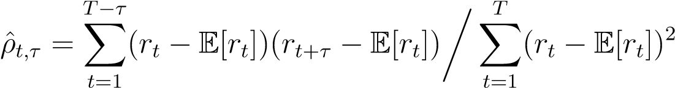 (4)

which measures the autocorrelation, i.e., the average correlation between the values of a time series at different points in time. For almost all financial time-series, the empirical autocorrelation, *ρ*ˆ*t,τ*, is insignificant and thus close to zero.[3] Thus, an autoregressive (AR) model for returns would likely be a poor fit for financial time series and past returns give little to no information about future returns. Therefore, a constant mean model for the mean process might actually be the best choice even though it is very simple.

1. *There is a positive dependency between squared (or absolute) returns of nearby days*

Previously, we considered autocorrelation of returns where we found no correlation. Thus, one might be tempted to think that returns are *identical and independently distributed* (IID). However, this is not correct as many transformations of returns feature strong dependency across time. The most common of which is squared returns, the autocorrelation of which is rarely insignificant.[4] This also implies *volatility clustering* of returns, which means that periods of high or low volatility tend to be clustered together across time or as [Mandelbrot, 1967] puts it:

*“...large changes tend to be followed by large changes, of either sign, and small changes tend to be followed by small changes.”*

This latter part implies that returns are not homoskedastic, i.e., they do not have a constant variance across time.

To summarize, it would be inaccurate to model returns using an IID or a Gaussian distribution. Thus, the succeeding part of the paper presents a model in which returns are not Gaussian and where returns are not modeled as independent of each other across time. The following section investigates the types of models that fit these criteria. There are several possible approaches to achieve such a model, but one of the most widely used is the Autoregressive Conditional Heteroskedasticity (ARCH) model with a non-Gaussian distribution, which is the first model we introduce.

## 3.2 Univariate GARCH models

[Engle, 1982] developed the precursor to the GARCH model to model and forecast variances more accurately than Modern Portfolio theory can account for., This would be of greatuse to an investor seeking to minimize the variance of theirportfolio. The resulting Autoregressive Conditional Heteroskedasticity model, or ARCH for short, models the conditional variance as dependent on past shocks to the modeled time series. Consider a simple model for the mean of a time series with a constant mean

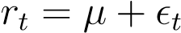 (5)

We introduce different GARCH models that have different variance specifications but they all share the constant mean specified in equation (5). Consider the simplest possible model given by an *ARCH(1)* where the conditional variance only depends on the last period’s shock,

.

 (6)  (7)

with initial values taken as given and *t* = 0*,*1*,...T*. Notice that the variance of this process is heteroskedastic. The parameter restrictions are needed to ensure strictly positive variance for all *t*. *D*(0*,*1) is some distribution with mean zero and unit variance. This often takes the form of a Gaussian distribution for ease of computation, but other choices with better fits to financial time series like a Generalized Error Distribution (GED) or a Student’s t-distribution can be used. We utilize the latter, the probability density function of which can be found in the Appendix A.1. We elaborate on this choice in section 5.

*ω* is a constant ensuring strictly positive variance. The parameter *α* is the effect of past shocks on the conditional variance and can also be interpreted as short-run persistence of the conditional variance.

The ARCH model has an empirical weakness in that the conditional variances from the model converge back to the minimum conditional variance after a large shock much quicker than empirical estimates indicate it should - even for large lag lengths.

[Bollerslev, 1986] solved this problem with the Generalized Autoregressive Conditional Heteroskedasticity (GARCH) model which adds persistence between the individual measures of the conditional variance across time. It does so by adding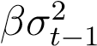 to the equation for the conditional variance in equation (7), which results in the *GARCH(1,1)*.

 (8)

This reduces the speed with which the conditional variance decreases after a big shock as the parameter *β* represents how persistent the conditional variance is and can be interpreted as the long-run persistence of volatility.

We illustrate the difference in convergence speed between the ARCH(1) and GARCH(1, 1) in figure 2, where we plot the conditional variance over 40 periods. In period *t* = 25, we Figure 2: Response of the conditional variance *σt*2 to a shock

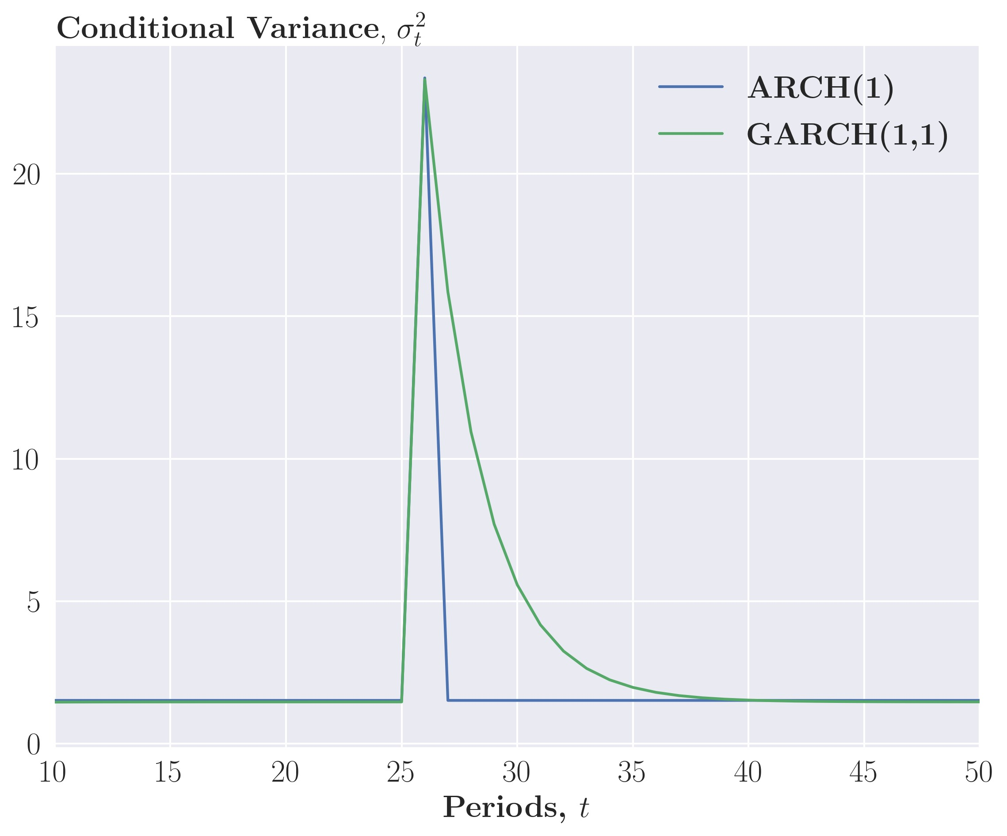

*Note*: In order to fairly compare the two models, parameters are chosen to give an identical unconditional variance for similar convergence.

give the asset returns a large shock of 8% which causes an increase in the conditional variance. For the ARCH(1) in eq. (7), we see a spike in the conditional variance in period *t* = 26 and an immediate return to the minimum conditional variance at *t* = 27 as the ARCH model has no persistence between measures of conditional variance. For the GARCH(1,1) in eq. (8), we see an identical spike in period *t* = 26, but in contrast to the ARCH(1), it exponentially convergences back to the minimum conditional variance as the GARCH(1,1) has persistence between measures of conditional variance such that the shock remains in the model for longer.

We see that adding a lagged conditional variance term to the ARCH model,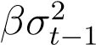, causes the conditional variance to converge more slowly back to the *minimum conditional variance* which is given as

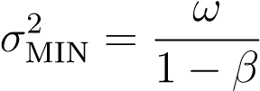 (9)

and the *unconditional variance*, which, given weak stationarity, is given as

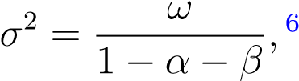 (10)

This slower convergence is more in line with how the empirical variance behaves.

6[Taylor, 2011],*Asset price dynamics, volatility, and prediction*, p. 202

While the standard GARCH model does an admirable job of explaining the conditional variance of financial time series, econometricians have continuously worked to improve upon the work done by Engle and Bollerslev, like allowing for asymmetric effects of shocks which [Glosten et al., 1993] did with the *GJR-GARCH(1,1)* model where the conditional variance is given by

 (11)

such that the effect on the conditional variance is *α* + *κ* if the shock is negative which is well documented to be true and named the "leveraged effect". For GARCH models in general, these are denoted GARCH(*p*,*q*) where *p* is the number of lagged residuals and *q* is the number of lagged conditional variances terms.

These models can be estimated via maximum likelihood estimation (MLE). Define the parameters of the model as a vector, *θ* = (*µ,ω,α,β,κ,ν*), to be estimated by the Maximum Likelihood estimator (MLE), and the information set, F*t*−1 = (*rt,rt*−1*,...,rT* ). Note that *ν* is the shape parameter for the Student’s t-distribution.[5] The likelihood function is the joint probability of the observed data given the parameters of the model. It is more convenient to consider the log-likelihood function which can be written as

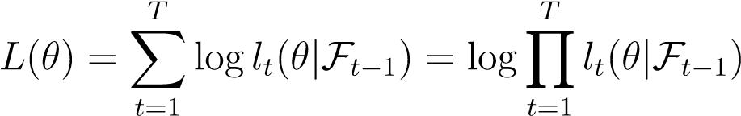*,*

where

*lt*(*θ*) = *F*(*ri*|*θ*) *i* = 0*,*1*,*2*,...,T,*

where *F* is the conditional probability density function for *rt* given the parameters of the model, *θ*[6]. Then the Maximum likelihood function with a Student’s t density is given as

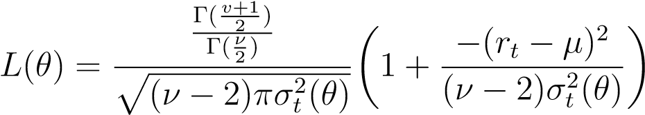*.*

with and the gamma function Γ(·). When maximizing the maximum likelihood function, the reslutingestimates of the parameters are the estimates that make the data we observe most likely. The maximum of the Maximum Likelihood function cannot be found analytically. Instead, a consistent estimate, *θ*ˆ, can be found via numerical optimization given some initial guess of *θ*.

. Under specific parameter conditions the data of the model is shown to be weakly stationary For GJR-GARCH(1,1), the data is weakly stationary when *α* + *β* + 0*.*5*κ <* 1 with the conditions from the ARCH(1) and GARCH(1,1) contained within as a special case of the GJR-GARCH(1,1)[7]. Suppose the model’s data is weakly stationary given the stated conditions. In that case, the law of large numbers applies which implies that the Maximum likelihood estimator is consistent. The estimates, *θ*ˆ, then converge to the true value of the parameters, *θ*0, i.e. *θ*ˆ → *θ*0 in probability as *T* → ∞.

## 3.3 Multivariate GARCH models

In the univariate case, we consider one asset and the variance of this single asset. But an investor will almost always care about multiple assets and how their variances and covariances develop over time. Luckily, a natural extension of the univariate GARCH model exists into a multivariate GARCH model, MGARCH. Now, consider *N* assets with an *N* × 1 vector of returns, *rt*, given by a similar constant mean model to the univariate case, but now of vectors 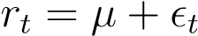 (12)

with *µ* being a *N* × 1 vector of the empirical mean of the individual assets and *t* being an

*N* × 1 vector of error terms.

In the univariate case, ensuring positive variance required restricting a few parameters. However, for MGARCH models, this is much more complicated. To ensure that the *N* × *N* covariance matrix, Ω*t*, is indeed a covariance matrix, it must be positive definite for all *t*. The challenge is thus to parameterize the model such that Ω*t* is positive definite for all *t*.

### BEKK MGARCH

A mathematically simple MGARCH model that solves the parameterization problem is the BEKK GARCH by [Engle and Kroner, 1995] where the conditional covariance matrix resembles the univariate GARCH in form of a BEKK GARCH(1,1)

 (13)  (14)

with initial values taken as given and *t* = 1*,*2*,...,T*. Ω is positive definite and *A* and *B* are *N* × *N* dimensional matrices. *θ* is a vector of parameters where {Ω*,A,B*} ∈ *θ* and *D* is some multidimensional distribution where we have chosen to use a multivariate Student’s tdistribution for similar reasons as in section 3.2, the probability density function of multivariate Student’s t-distribution can be found in appendix A.1. Unfortunately, it is next to impossible to get a meaningful interpretation of the individual components of the matrix of parameters for *A* and *B* but the overall interpretation of *A* is completely analogous to *α* in the univariate case and the same for *B* to *β*.

A nice feature of the BEKK GARCH is that Ω*t*(*θ*) is positive definite for all *t* for any *A* and *B* and thus, the BEKK GARCH easily solves the parameterization problem.[8]

However, the BEKK MGARCH is empirically impractical as the number of parameters explodes as *N* increases as the number of parameters is *N*(*N* + 1)*/*2 + 2*N*2. For *N* = 4, it is 42 and for *N* = 10 it is 255, thus this model is only empirical practical when analyzing a small group of assets like *N <* 10. One way around this problem is to simplify the model in the *scalar BEKK(1,1)* where *A* and *B* become scalars.

 (15)

This comes a great loss to generality as all conditional (co)variances respond similarly to shocks and have similar persistence, which is a debatable assumption at best. The data of BEKK(1,1) is stationary and ergodic with E||*X*||2 *<* ∞ when

*%*((*A* ⊗ *A*) + (*B* ⊗ *B*)) *<* 1 (16)

where ⊗ is the tensor product and *%*(·) is the spectral radius. If the condition in equation (16) holds then estimates of A and B can be estimated consistently by maximum likelihood. For the scalar-BEKK(1,1), the condition simplifies to *a*+*b <* 1.[9] This model can be estimated via maximum likelihood estimation where the maximum log likelihood function has a multivariate Student’s t density given as

*L*BEKK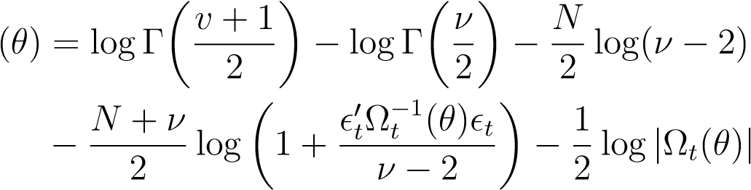

where Ω*t*(*θ*) is given by equation (14) for the regular BEKK or (15) for the scalar BEKK and Γ(·) being the gamma function.[10] Similar to the univariate models, numerical optimization of the likelihood function is the only way to find the maximum. If the condition in equation (16) holds then the law of large numbers apply and the maximum likelihood estimator is consistent.[11]

Similarly to univariate GARCH models, there exist multiple different Multivariate GARCH models, one of which is the Dynamical Conditional Correlation MGARCH or DCC MGARCH by [Engle, 2002], which have another way around the parameterization problem.

### DCC MGARCH

As the regular BEKK is empirically impractical, we use a DCC MGARCH model with a scalar BEKK for modeling conditional correlations. Consider the constant mean model given by equation (12) but now the conditional covariance is given by a *DCC MGARCH model*. This model exploits the fact that the *N* × *N* covariance matrix, Ω*t*, in equation (13) can be decomposed into two variances matrices, Var*t*, and a correlation matrix, Γ*t*,

Ω*t* = Var*t*Γ*t*Var*t* (17)

Where

Var*t* = diag 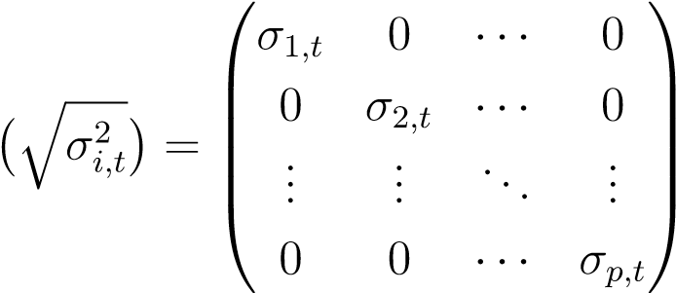 (18)

and each diagonal element is given by a univariate GARCH process. This GARCH process can be any univariate GARCH process like a GJR-GARCH(1,1) or a GARCH(1,1) as below.

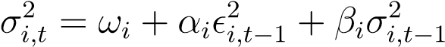 for *i* = 1*,*2*,...,N ωi >* 0*,αi,βi* ≥ 0 (19)

These are weakly stationary given the conditions described in section 3.2. The correlation matrix is given as

|  |  |  |  |  |
| --- | --- | --- | --- | --- |
|   1  *ρ*21*,t* Γ*t* = diag(*Qt*)−1*/*2*Qt*diag(*Qt*)−1*/*2 =  ...      *ρN*1*,t* | *ρ*12*,t*  1 ...  *ρN*2*,t* | ···  ··· ...  ··· | *ρ*1*N,t* *ρ*2*N,t* ...     1 | (20) |

where *Qt* is the pseudo correlation which follows a scalar BEKK(1,1) MGARCH process given by

 (21)

where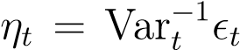 is a *N* × 1 matrix of standardized (or devolatized) disturbances of the correlations.

The ability to decompose the conditional covariance matrix allows us to estimate this model in two stages. First, we estimate the parameters in the *N* univariate GARCH models for the *N* assets using the maximum likelihood estimation explained in section 3.2. Second, we estimate a multivariate scalar BEKK for the conditional correlation using the maximum likelihood estimation for the BEKK above. This reduces the number of parameters to estimate. However, by using a scalar BEKK(1,1) for the conditional correlations, we assume that the conditional correlations have identical responsiveness to shocks and persistence which is not as restrictive an assumption as one would think given that the conditional covariances still respond differently to shocks as the conditional variances are modeled individually. Note that this multivariate specification of the conditional correlation given by equation (20) and (21) will remain the same throughout the thesis.

The DCC MGARCH model with univariate GARCH(1,1) for the conditional variances and a multivariate scalar BEKK(1,1) for the conditional correlations has 3*N* + 3 parameters. In comparison to the BEKK(1,1) for *N* = 4, the DCC MGARCH(1,1) has 12 parameters and 33 for *N* = 10. So the number of parameters for DCC MGARCH(1,1) still grows fast, and thus, to truly model a large number of assets, Eigenvalue MGARCH or *λ*-MGARCH models are preferable but since this thesis does not explore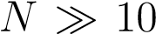, we stick to the simpler DCC MGARCH model.

#### 3.3.1 One-period forecast of the conditional covariance, Ω*t*+1

A very useful feature of any GARCH type model is the ability to forecast future (co)variance. Specifically, Ω*t*+1 can be forecast with F*t*-measurable variables using equation (17)-(21). Let the forecast of a variable *Xt*+1 given F*t* be denoted *Xt*+1|*t* such that the forecast of

Ω*t*+1 is given as Ω*t*+1|*t* and similarly for the variance matrix Var*t*+1|*t* and the correlation matrix Γ*t*+1|*t*. Recall from (17) that the conditional covariance matrix, Ω*t*+1, can be decomposed into the conditional variance and conditional correlation matrices such that the forecast, Ω*t*+1|*t* can be written as Where: 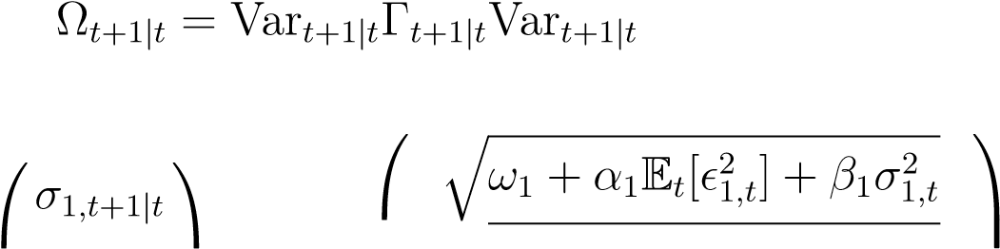

Var*t*+1|*t* = diag 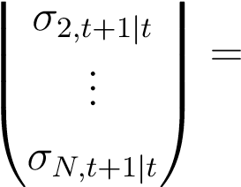 diag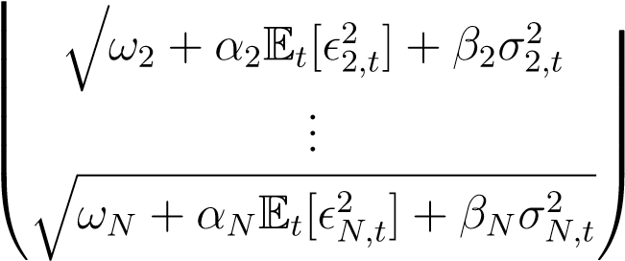

and 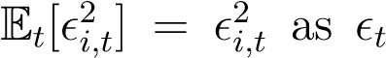 is known in period *t*. We can also decompose the forecast of the conditional correlation as:

Γ*t*+1|*t* = diag(*Qt*+1|*t*)−1*Qt*+1|*t*diag(*Qt*+1|*t*)−1

With *Qt*+1|*t* being forecast as



where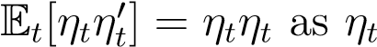 is known in period *t*. Note that this is a forecast and thus subject to errors which will become highly relevant during portfolio optimization.

#### 3.3.2 Shrinkage of the covariance matrix

Using the estimated covariance matrix, Ω*t*+1|*t*, but mainly the sample covariance matrix, Σ, introduces problems when these are used in portfolio optimization thoroughly explained within [Jobson and Korkie, 1980] and [Jagannathan and Ma, 2003]. To summarize, any estimation error may introduce extreme coefficients into the covariance matrix which will be used in the mean-variance optimization to place the biggest positions based on these extreme coefficients as these positions have the biggest theoretical utility for the investor. But these positions are very unreliable given the estimation error causing inefficiencies, a phenomenon which [Michaud, 1989] dubbed "error-maximization".

An easy approach to reduce this problem is to "shrink" the estimates of the covariance matrix towards the identity matrix *I* by some proportion *δ* as explained in [Ledoit and Wolf, 2004]

ΣˆShrunk = *δI* + (1 − *δ*)Σˆ (22)

where we apply a shrinkage of 50% corresponding to *δ* = 0*.*5 similar to [Gârleanu and Pedersen, 2013]. We don’t apply this shrinkage to the entire covariance matrix, but to *Q*¯ as this is the only part of the model estimated via a sample estimate corresponding to a pseudo sample correlation matrix such that

*Q*¯Shrunk = *δI* + (1 − *δ*)*Q*¯

Which when used in Ω*t*+1|*t* gives ΩShrunk*t*+1|*t* . Throughout the theoretical section and section 4 on Dynamic programming, we use Ω*t*+1|*t* in the derivations to reduce awkward notation, but in the empirical section in 6 we use the shrunken version, 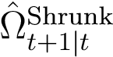.

#### 3.3.3 Multivariate GARCH models in Portfolio theory

Consider the investor’s problem for *N* assets presented in section 2.2.1. Now, rather than having the covariance matrix be given as a constant, Σ, we use the time-varying covariance matrix, Ω*t*, that comes from the constant mean DCC MGARCH(1,1) model from equation (12) and (17)-(21). The investor minimizes the variance of his portfolio given that the weights of the portfolio sum to 1.

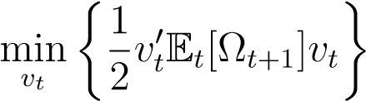 s.t. 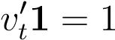

As explained in section 3.3.1, the value of Ω*t*+1 can forecast using F*t*-measurable variables such that E*t*[Ω*t*+1] = Ω*t*+1|*t* i.e., the conditional expectation of the covariance matrix in period *t* + 1 given period *t* is the forecast, Ω*t*+1|*t*. The Lagrangian is given as

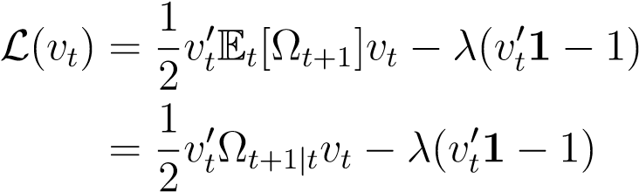

Taking the first-order conditions wrt. *vt* and solving for *vt* and *λ* as in section 2.2.1 yields the minimum variance portfolio after some light algebra. The proof is in appendix A.3.1

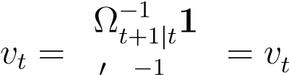 MVP (23)

1 Ω*t*+1|*t*1

The result is rather intuitive as Ω*t*+1|*t* simply replaces the constant Σ and, thus, it has the same interpretation. It is likewise easy to replace Ω*t*+1|*t* with the shrunken version 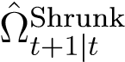.

# 4 Dynamic Trading Strategies

We have explored replacing Σ with the covariance matrix of an MGARCH model, Ω*t*+1|*t* as the covariance of financial assets is time-varying. However, to truly use the possible benefit from the added complexity of MGARCH models, we need to consider a *multi-period problem* where the dynamics of the MGARCH model can be seen over multiple periods to obtain an optimal dynamic trading strategy. We apply the *dynamic programming* framework introduced by [Bellman, 1966] to solve multi-period problems. We use notation similar to [Gan and Lu, 2014] and [Gârleanu and Pedersen, 2013].

## 4.1 Dynamic programming techniques

Consider an agent that seeks a policy that defines the optimal action the agent should take at time *t* in state *s*. The policy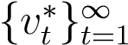 maximizes the present value of current rewards and future expected rewards, *f*(*vt,st*), discounted by (1−*ρ*) ∈ (0*,*1] given some general constraint *g*(*vt,st*), that could be a budget constraint or a weight constraint.

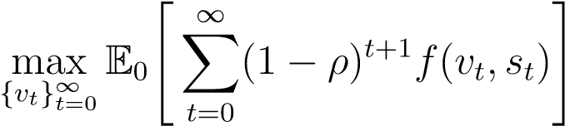 s.t. *g*(*vt,st*) = 0 (24)

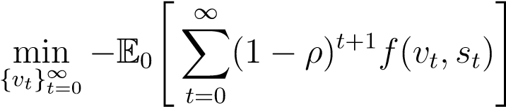E0[·] is the conditional expectation given the filtration in period 0 i.e. E0[·] = E[·|F0]. Since a maximization problem can be converted to a minimization problem,14 equation (24) is equivalent to

s.t. *g*(*vt,st*) = 0 (25)

Consider an agent facing the minimization problem in (25). The tools of dynamic programming decompose this multi-period problem into a two-period problem, "now" and "later". This is done by rewriting the sum by taking the first period *t* = 0, out.

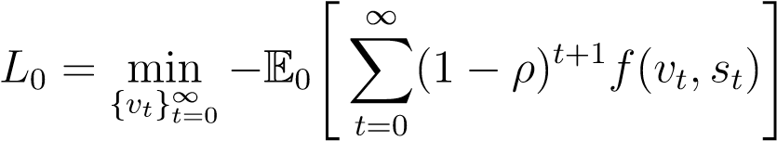 s.t. *g*(*vt,st*) = 0

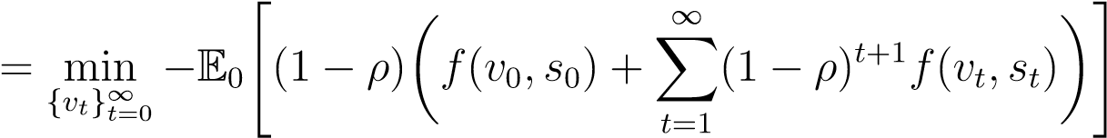 s.t. *g*(*vt,st*) = 0

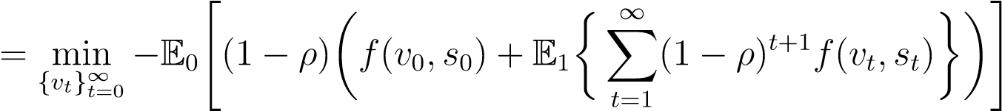 s.t. *g*(*vt,st*) = 0

s.t. *g*(*vt,st*) = 0

=

min

*v*

0

−

E

0

"

(1

−

*ρ*

)

*f*

(

*v*

0

*,s*

0

)

|

z

{

}

(

*j*

)

+

min

{

*v*

*t*

}

∞

*t*

=1

E

1

∞

X

*t*

=1

(1

−

*ρ*

)

*t*

+1

*f*

(

*v*

*t*

*,s*

*t*

)

|

z

{

}

(

*jj*

)

#

| {z }

(*jjj*)

Here we have the immediate reward, *(j)*, and future reward,*(jj)*, under some constraint, *(jjj)*, which we transform to a Lagrangian type constraint with a time-varying Lagrangian multiplier,

*λt*.[12]



This final part can be written as *the value function*, *V* (*s*0). We note that *(jj)* can be written as it own dynamic problem just one period into the future as *V* (*s*1) such that

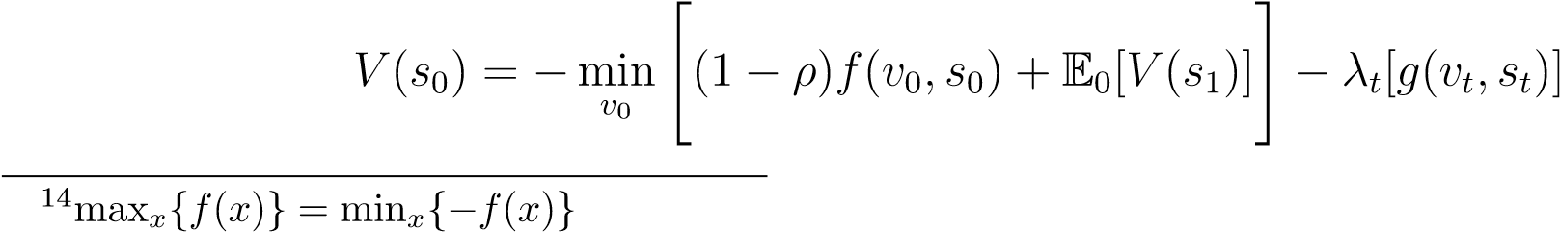

Generalizing the value function to period *t*, we have

*V*

(

*s*

*t*

)=

−

min

*v*

*t*

"

(1

−

*ρ*

)

*f*

(

*v*

*t*

*,s*

*t*

)

|

z

{

}

(

*j*

)

+

E

*t*

[

*V*

(

*s*

*t*

+1

)]

|

{

z

}

(

*jj*

)

#

−

*λ*

*t*

[

*g*

(

*v*

*t*

*,s*

*t*

)]

|

{

z

}

(

*jjj*

)

The optimal policies for the agent are the solutions to the optimization problem contained within the value function, *V* (*st*), for each period *t*. In our case, the policies are optimal portfolio weights.

## 4.2 Optimal dynamic strategies for multiple risky assets

Equipped with methods from dynamic programming, we now proceed to derive optimal dynamic trading strategies. First, for an investor that ignores transaction costs, and lastly for an investor that adjusts for transaction costs.

### 4.2.1 Derivation of the simple strategy (ignoring transaction costs)

Consider *N* assets with *N*×1 vector of returns, *rt* = (*r*1*,t,r*2*,t,...,rN,t*)0 given by a constant mean DCC MGARCH(1,1) model given by equation (12) and (17)-(21). The investor has meanvariance preferences given by equation (1) and seeks a dynamic trading strategy, 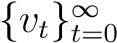, that solves the following multi-period minimization problem

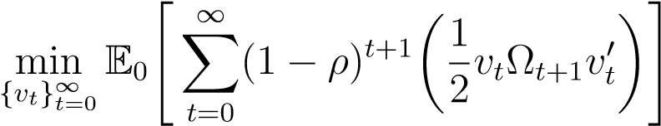 s.t. 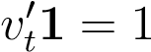 (26)

with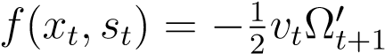 and *g*(*xt,st*) = 0 ⇒ *vt*01 − 1 = 0 ⇔ *vt*01 = 1. Multiplying (−1) into

the minimization problem yields the investor’s objective function

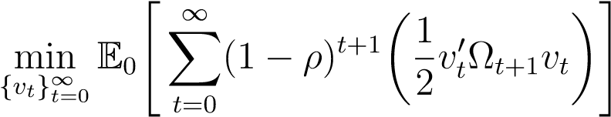 s.t. 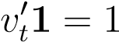 (27)

The problem can be solved via dynamic programming using the method in section 4.1. Denote the minimization problem in (27) as denoted *L*GARCH*t*

*L*GARCH*t* 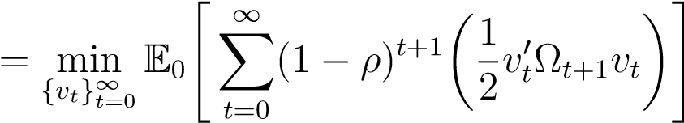 s.t. 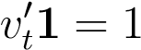

Following the same argument as in section 4.1 we get

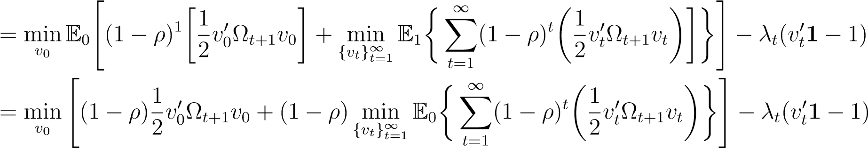

Generalizing to period *t* − 1, we get that the value function, *V* (*vt*−1) is given by

*V*

(

*v*

*t*

−

1

min

)=

*v*

*t*

"

(1

−

*ρ*

)

1

2

*v*

*t*

E

*t*

[Ω

*t*

+1

]

*v*

0

*t*

|

z

{

}

(

*i*

)

+

E

*t*

[

*V*

(

*v*

*t*

)]

|

{

z

}

(

*ii*

)

#

−

*λ*

(

*v*

0

*t*

1

−

1)

|

{

z

}

(

*iii*

)

The investor needs a measure of the next period’s covariance matrix, Ω*t*+1 which is a random variable at period *t*. But given the MGARCH structure of the covariance matrix. E*t*[Ω*t*+1] can be given as the forecast value Ω*t*+1|*t* (See section 3.3.1).

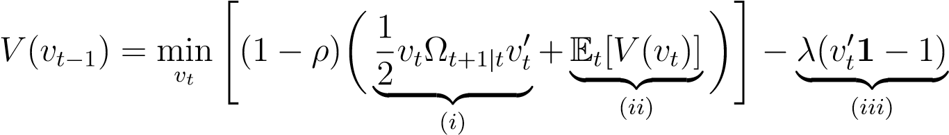 (28)

The value function measures the value of the portfolio, in terms of utility for the investor, at time *t* with the weight *vt*−1 of the risky assets. Additionally, the value function utility for the current period *(i)* and future periods *(ii)* under the constraint that the weights sum to 1, *(iii)*.

Solving for the optimal weights requires solving the first-order conditions wrt. to the weights *vt*. But first, we look into the conditional expectation of the value function in period *t*:

!

Notice that none of the terms in E*t*[*V* (*vt*)] contain *vt*. This turns the dynamic minimization problem into a series of one-period static problems. We can therefore proceed by solving the problem for one general period *t*, and reuse this result every period:



The constraint requires that *vt*01 = 1, which can be used to solve for the Lagrangian multiplier *λ*



Now, we insert the expression into the weights *vt*

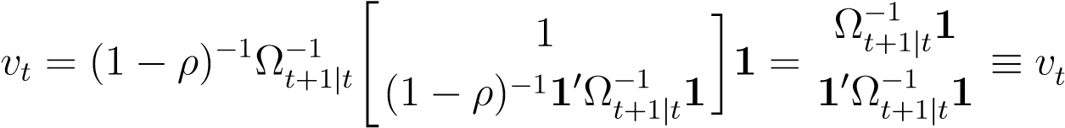MVP

Given that the covariance matrix, Ω*t*+1|*t* is time-varying, the weights, *vt*, are likewise timevarying. The interpretation is that the investor forecasts the covariance matrix of the asset returns in the feasible set every period using the information at time *t*. The investor can with some accuracy forecast the covariance matrix within the near future or, at the very least, the investor believes he can forecast the covariance matrix one period into the future.

This result is not surprising as, in the absence of trading costs, the investor can rebalance the portfolio each period to the new minimum variance portfolio at no cost. This is in line with [Gârleanu and Pedersen, 2013] and [Mei and Nogales, 2018] who both find that the aim portfolio i.e. the desired portfolio in the absence of transaction costs, is the Markowitz portfolio which corresponds to the minimum variance portfolio when the objective is to minimize volatility.

### 4.2.2 Derivation of the sophisticated strategy (adjusting for transaction costs)

Consider again *N* assets with returns, *rt*, given by a constant mean DCC MGARCH(1,1) model from equation (12) and (17)-(21). An investor incurring transaction costs seeking to minimize the risk of his portfolio faces the following problem when seeking a dynamic investment strategy:

 s.t. 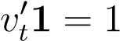

(29)

with transaction costs taking the form 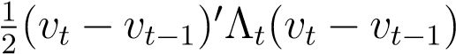. The second term containing the transaction cost penalization is discounted in period *t* and not *t*+1 since transaction costs are incurred immediately. The investor now has to trade-off rebalancing his portfolio given new information with the cost of trading. We assume that the transaction costs, Λ*t*, are given as

Λ*t* = Ω*t*+1|*tγD* (30)

meaning that transaction costs are time-varying as Ω*t*+1|*t* is time-varying and *γD* is the riskaversion parameter. This might seem odd at first glance but similarly to [Gârleanu and Pedersen, 2013], one can think of it as a dealer taking the opposite side of the trade ∆*vt* that our investor makes. The dealer holds this position for a period and then sells it back to the market. During this period, his risk is equivalent to 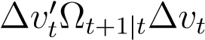. The transaction costs can thus be interpreted as compensation for the dealer’s risk the level of which depends on his risk-aversion, *γD*.

We solve this problem by using the method in section 4.1. Denote the minimization problem in (29) as *L*TC*t*



Following the same argument as in section 4.1 we get

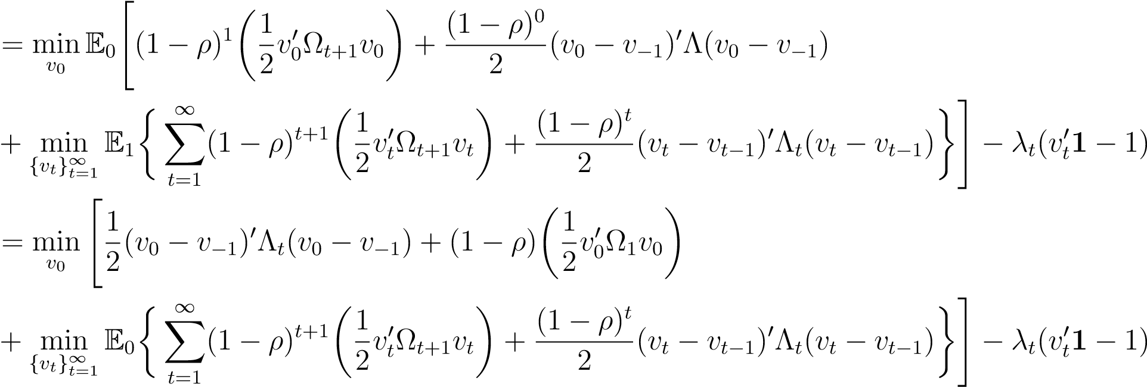

Where *v*−1 is the weight of the investor’s initial portfolio which sums to 1. Generalizing to period *t*, we get that the value function, *V* (*vt*−1) is given by

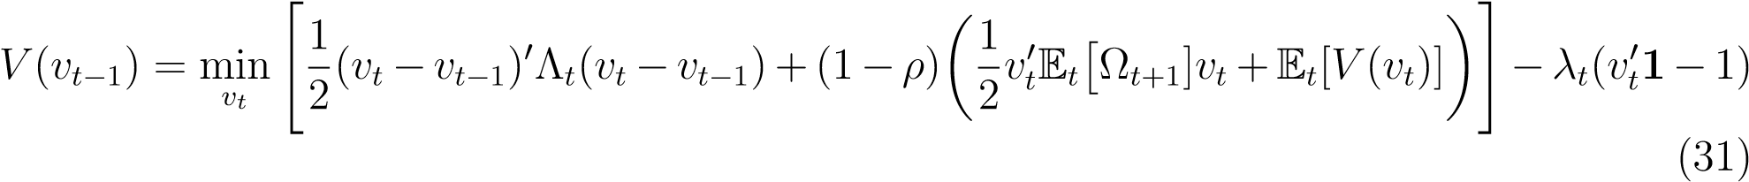

Similar to section 4.2.1, the investor needs a measure of the next period’s covariance matrix,

Ω*t*+1 which is a random variable at period *t*. E*t*[Ω*t*+1] can be given as the forecast value Ω*t*+1|*t* (See section 3.3.1) with an analogous interpretation as in section 4.2.1.

In contrast to the problems without transaction costs in section 4.2.1, E*t*[*V* (*vt*)] also becomes relevant as transaction costs add persistence between periods i.e. *vt* now also affects the value function of the next period. Thus, we need to find an expression for next period’s *V* (*vt*). Following the method of [Gârleanu and Pedersen, 2013], we apply the ’guess and verify’ method, which can be divided into 6 steps:

1. Make an ansatz of the form of the value function
2. Set up the Bellman equation of the guessed value function
3. Find the first-order conditions and solve for the optimal policy (the weights)
4. Insert the optimal policy (the weights) into the value function
5. Compare the new value function with the ansatz and verify it solves the problem
6. Solve for coefficients

Our ansatz for *V* (*vt*) is

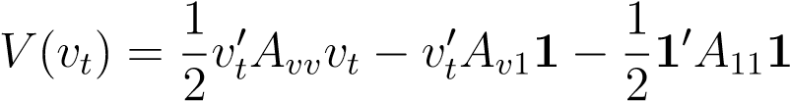

Very tedious algebra can show that this is indeed a solution. The proof is in appendix A.3.2 along with expressions for *Avv*, *Av*1 and *A*11. Now, we solve for the optimal weights by taking the partial derivative with respect to *vt*−1 as the optimal solutions for *vt* are already embedded within the guessed value function and its parameters, *Avv*, *Av*1 and *A*11. This boils down to the investor finding the optimal weights in period *t*−1 given what the investor believes about the optimal weights in period *t*. Differentiating the Bellman equation (31) with respect to *vt*−1 yields:

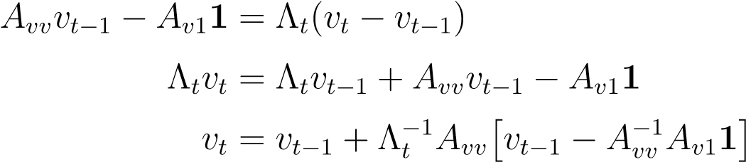

Define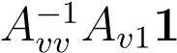 as *the aim portfolio*, aim*t* and insert Λ*t* = *γD*Ω*t*+1|*t*

 (32) This result has an intuitive interpretation similar to [Gârleanu and Pedersen, 2013]. The investor starts with the previous period’s weights, *vt*−1. He then estimates the aim portfolio, aim*t*, which is the investor’s preferred portfolio given no transaction costs. Then given how costly it is to trade in the period, *γD*Ω*t*+1|*t*, the investor changes his portfolio to a combination of *vt*−1 and aim*t* resulting in *vt*.

Finally, we check if the weights *vt* sum to 1 using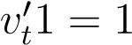

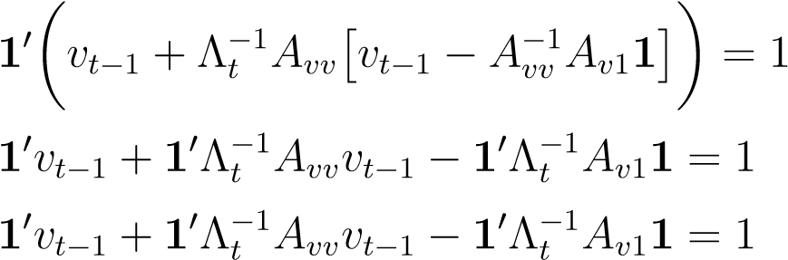

They clearly don’t sum to 1 which is certainly a problem. This means we must have made a mathematical error in A.3.2 or used an incomplete approach to begin with, for example with too few constraints. However, we still think we have made substantial progress in the effort of unifying GARCH models with dynamic trading strategies. In order to be able to move on, we therefore enforce that the aim portfolio and the next periods portfolio weights sum to 1, so equation 32 becomes:

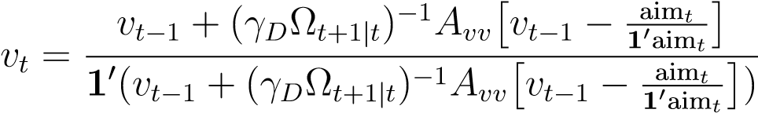 (33)

We also restrict the aim portfolio to sum 1, which might seem odd, but we later show empirically that the normalized aim portfolio is very similar to the simple strategy. This result intuitively makes sense, leading us to speculate that a mathematically correct solution should be possible. However, this is a topic for further research as the time constraints of this project force us to move on. Notice that the normalized portfolio requires

 and 10aim*t* 6= 0 which is not necessarily fullfilled. However, this has not led to any problems in our implementation of the theory, except for one observation in one model, where we alleviated the problem of numerical instability when dividing by a number close to zero, by setting the aim portfolio to last periods aim portfolio, which we reckon is harmless.

Below in figure 3, we summarize how the investor gains new information and updates his portfolio. Here, is a small time-step just before market close.

Figure 3: The trading cycle of the investor

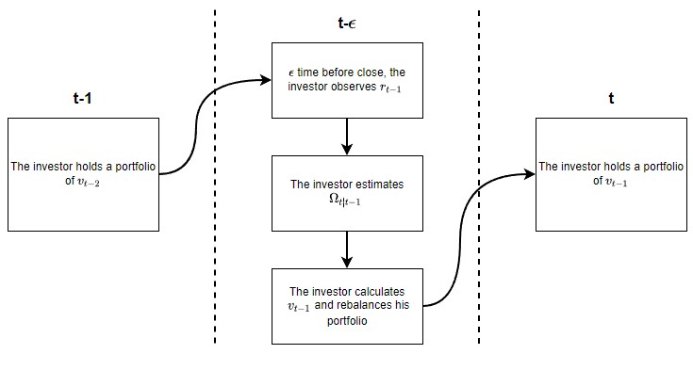

# 5 Description of data

We have chosen multiple different assets to test the dynamic strategies. We are primarily interested in stock ETFs, but we also try the strategy on gold and crude oil and two bond ETFs. The mix of assets covers a broad range of the financial markets without the need for thousands of individual assets. We purposefully chose diversified assets to minimize the risk of spurious empirical results because of the development in a specific sector or region. The indexed time series of these assets are displayed in figure 4. Here, we see that traditionally safer assets like gold and bonds steadily increase and generally avoid big crashes around crises like the 20+ year treasuries around 2008 and 2020. In contrast, stocks typically suffer substantial drops in value around the same market crashes, but in turn, achieve higher average returns. This pattern is not surprising as finance theory predicts that exposing yourself to higher risks, in general, is rewarded with higher returns. This pattern becomes even more apparent when looking at table 2, where the stock ETFs generally have the highest annualized returns at the cost of the highest risk. In contrast, bonds typically have lower returns at much lower risk. We note that the commodities are primarily uncorrelated with the rest of the assets, as shown in table 1.

Figure 4: Indexed prices of our asset sample

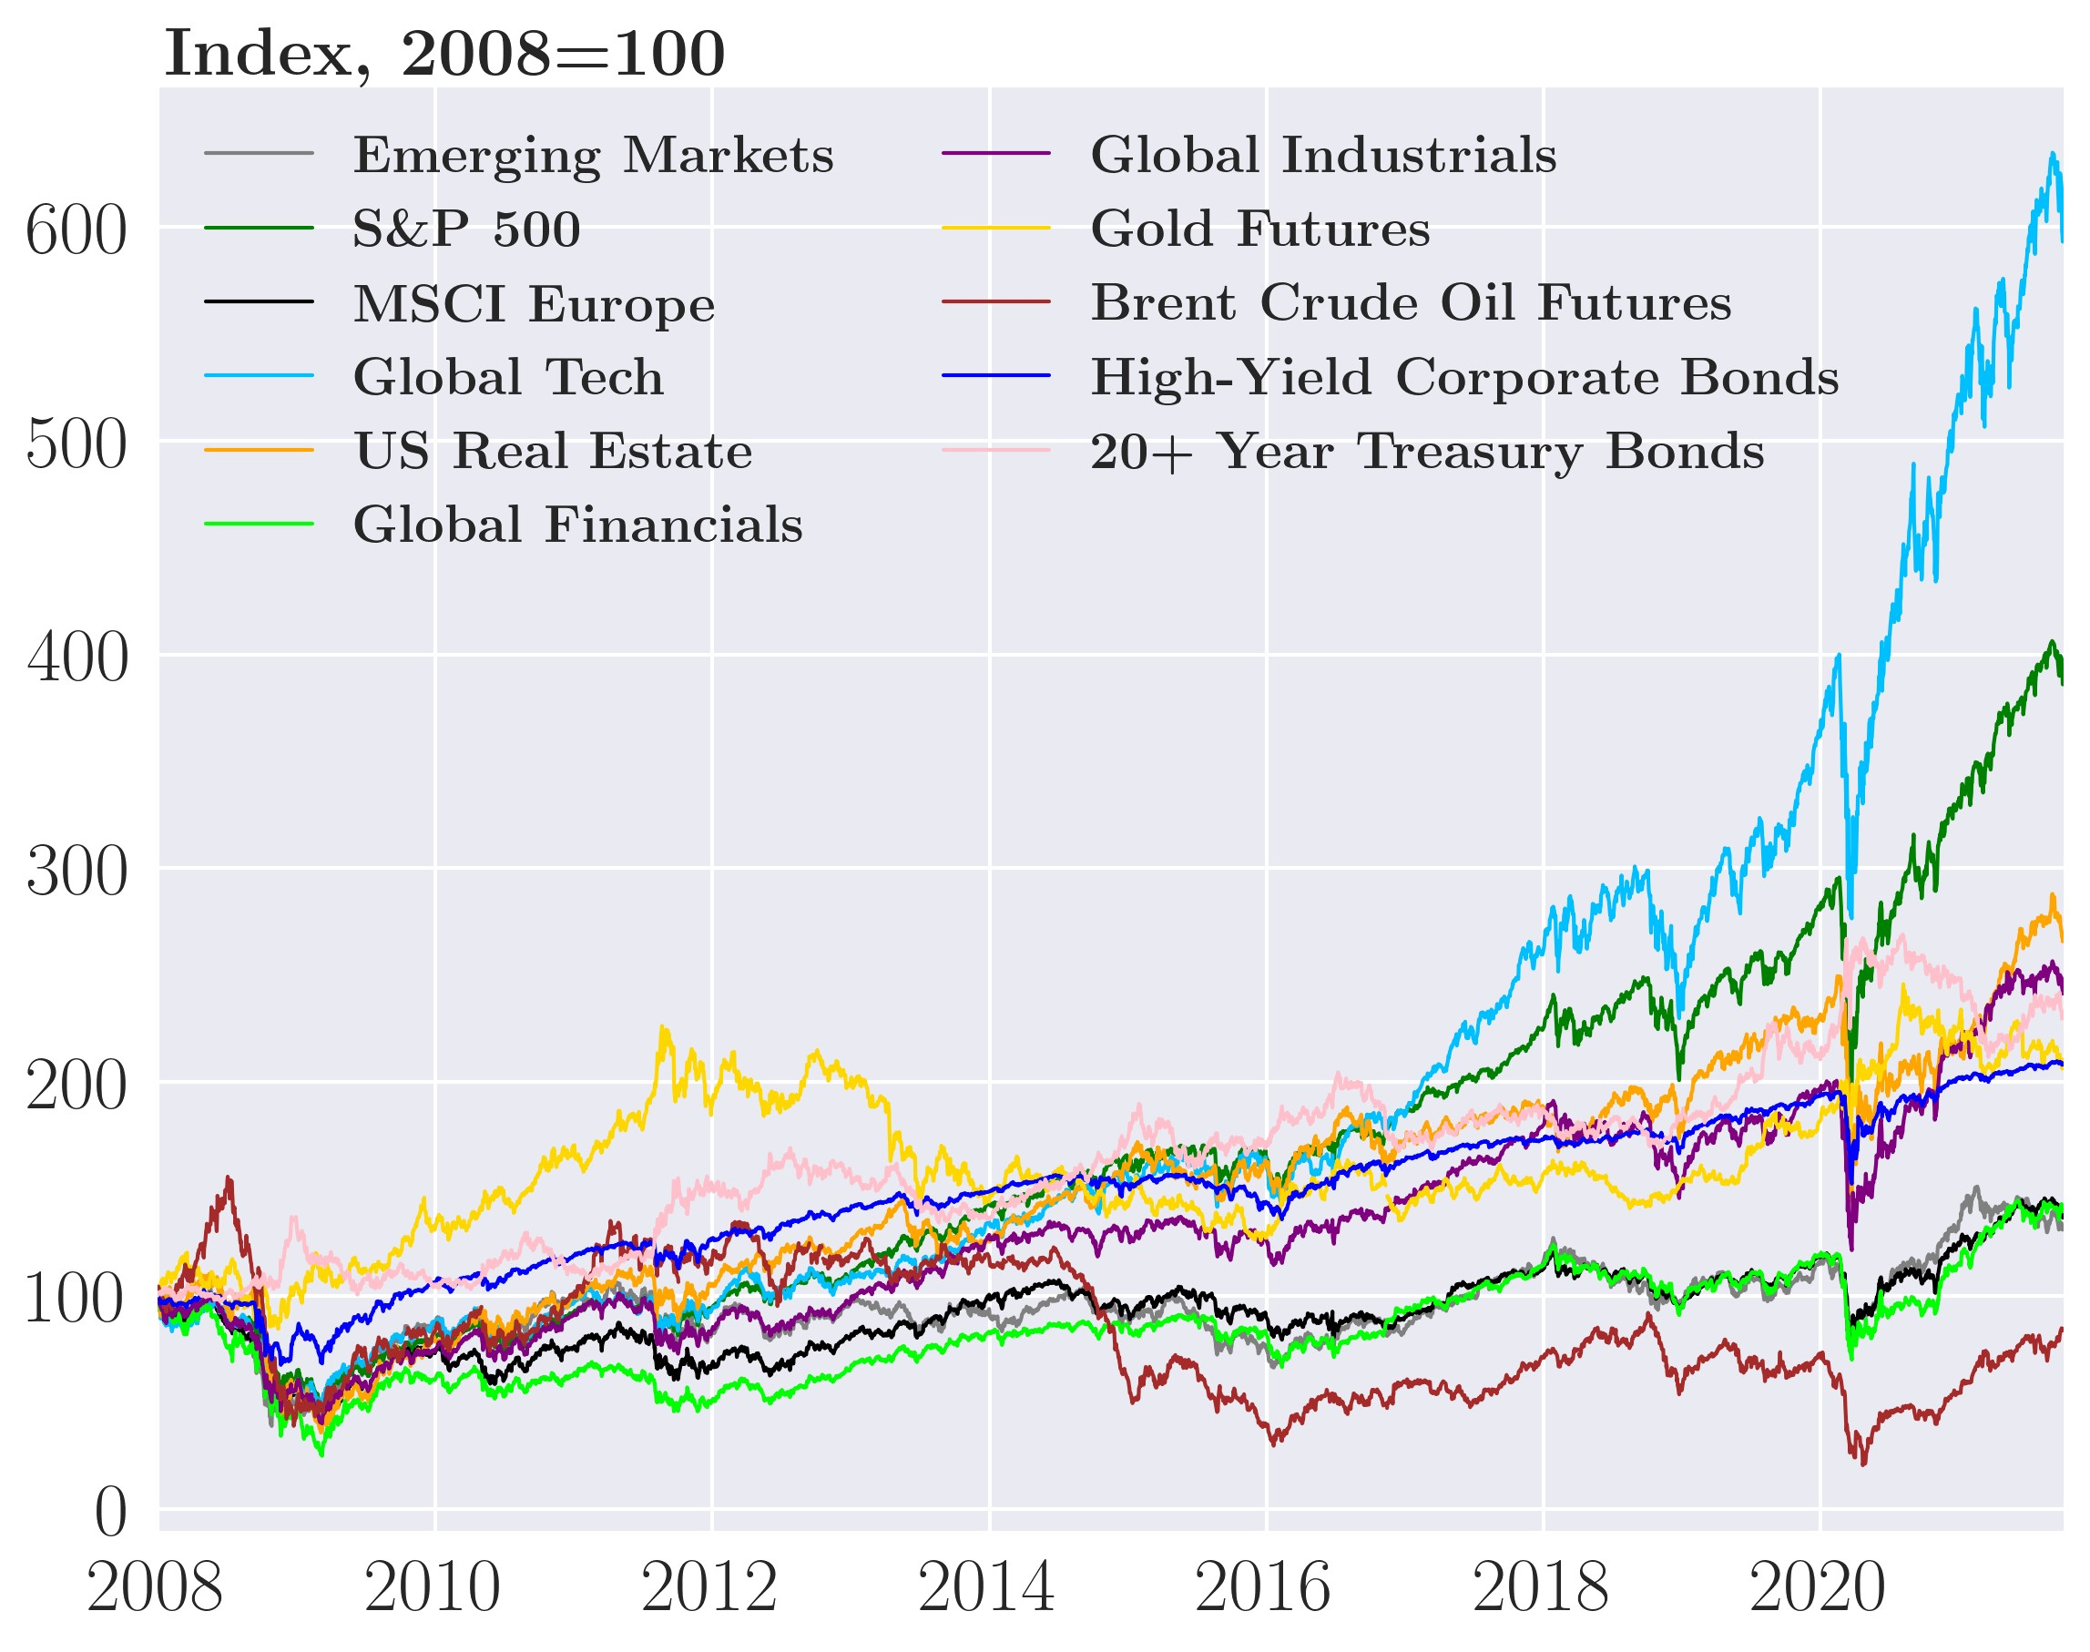

Specifically, gold (GC=F) is very close to being uncorrelated with any of the assets except perhaps Brent crude oil (BZ=F), which itself has a low positive correlation to most assets. In sharp contrast, all the stock ETFs, EEM to EXI, are highly positively correlated with each other, having a correlation coefficient above 0.7 in all cases, and correlates with the high-yield bonds (HYG) with a coefficient of about 0.65. Finally, the 20 year+ treasuries (TLT) negatively correlate with all assets except Brent crude oil (BZ=F). The correlations are essential in forming the minimum variance portfolio because they create diversification benefits for investors, which increases as assets get more negatively correlated. As mentioned

Table 1: Correlation matrix of selected asset returns

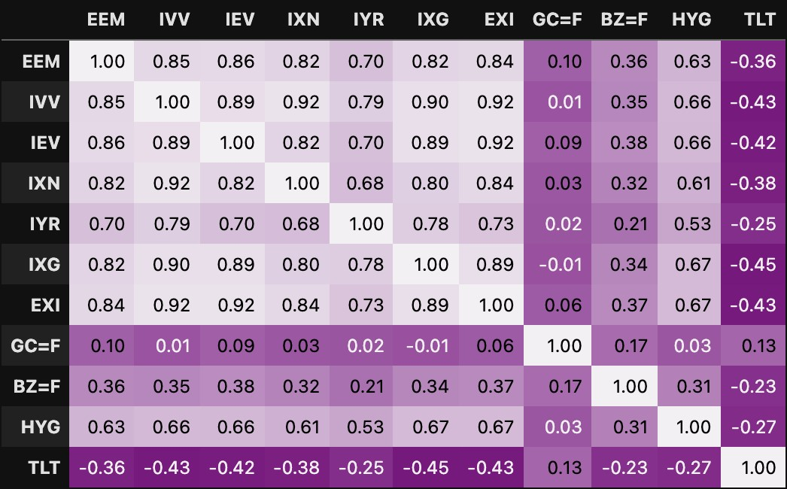

in the theoretical section, returns of financial time-series are not Gaussian, a point thoroughly proven by the p-values of Jarque-Bera test of normality being 0% for every asset in our sample, thus, rejecting the null of normality. We see this in figure 5 (a)-(c), where the fitted Gaussian densities are far from the shape of the histogram of the actual data. Here, the Generalized Error Distribution (GED) or a non-central Student’s t-distribution is a far better fit. The latter takes the slight edge as the GED often has excess kurtosis. Thus, we have likewise provided the parameters for the fitted non-central Student’s t-distribution for each asset in table 2.[13]

Table 2: Descriptive statistics, tests, and distribution fit

Mean Std. Dev Normality DF Non central

|  |  |  |
| --- | --- | --- |
| Annualized |  | NC Student’s t parameters |

Emerging Markets (EEM) 6.394% 29.919% 0.0 % 2.793 -0.199

S&P 500 (IVV) 11.921% 20.353% 0.0 % 2.154 -0.156

Europe (IEV) 5.333% 24.651% 0.0 % 2.473 -0.188

Global Tech (IXN) 15.511% 22.825% 0.0 % 2.612 -0.195

Real estate (IYR) 12.097% 31.307% 0.0 % 1.815 -0.127

Global financials (IXG) 6.659% 28.924% 0.0 % 2.105 -0.165

Global Industrials (EXI) 8.997% 22.549% 0.0 % 2.498 -0.178

Gold (GC=F) 6.880% 18.071% 0.0 % 3.067 -0.092

Brent crude oil (BZ=F) 5.992% 38.229% 0.0 % 2.484 -0.081

High-yield bonds (HYG) 5.998% 11.827% 0.0 % 1.732 -0.064

20+ year treasuries (TLT) 7.140% 15.017% 0.0 % 5.705 -0.146

*Source:* Yahoo Finance, *Note*: Data from January 1st 2008 to October 1st 2021

For backtesting purposes, the choice distribution is not as important as for simulations as the parameters for the MGARCH model can be consistently estimated via quasi maximum likelihood using the Gaussian distribution or using maximum likelihood using the Student’s t-distribution as explained in section 3.3.

Lastly, we consider the dependency structure provided by a GARCH type model. Recall from the section 3.1 on stylized facts that daily returns are dependent across time; thus, drawing returns IID would be inaccurate. From figure 5 (d)-(f), we see that one can fit GJRGARCH(1,1) models to the time-series for gold, S&P500, and high-yield bonds such that the dependency structure of the simulated data mimics the historical time series data.

Figure 5: Asset return densities and time series plots

(a) Gold densities (b) HYG bond densities

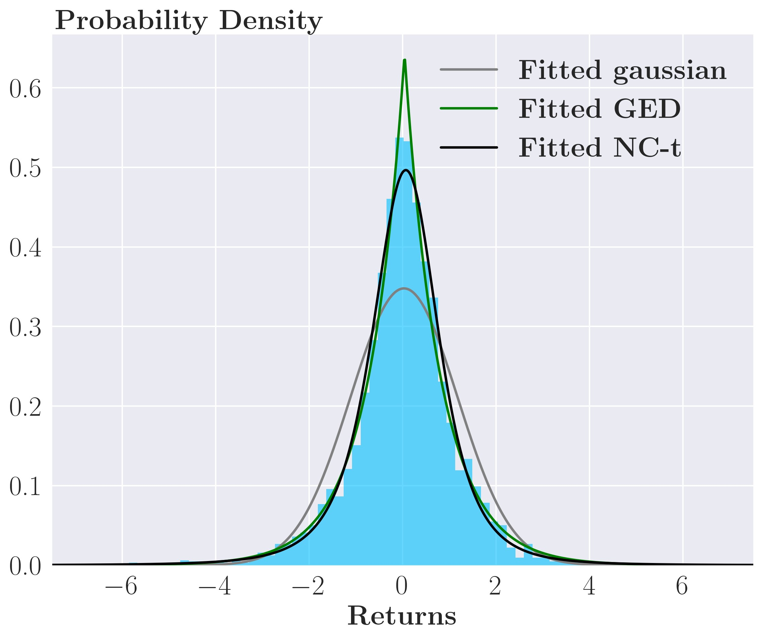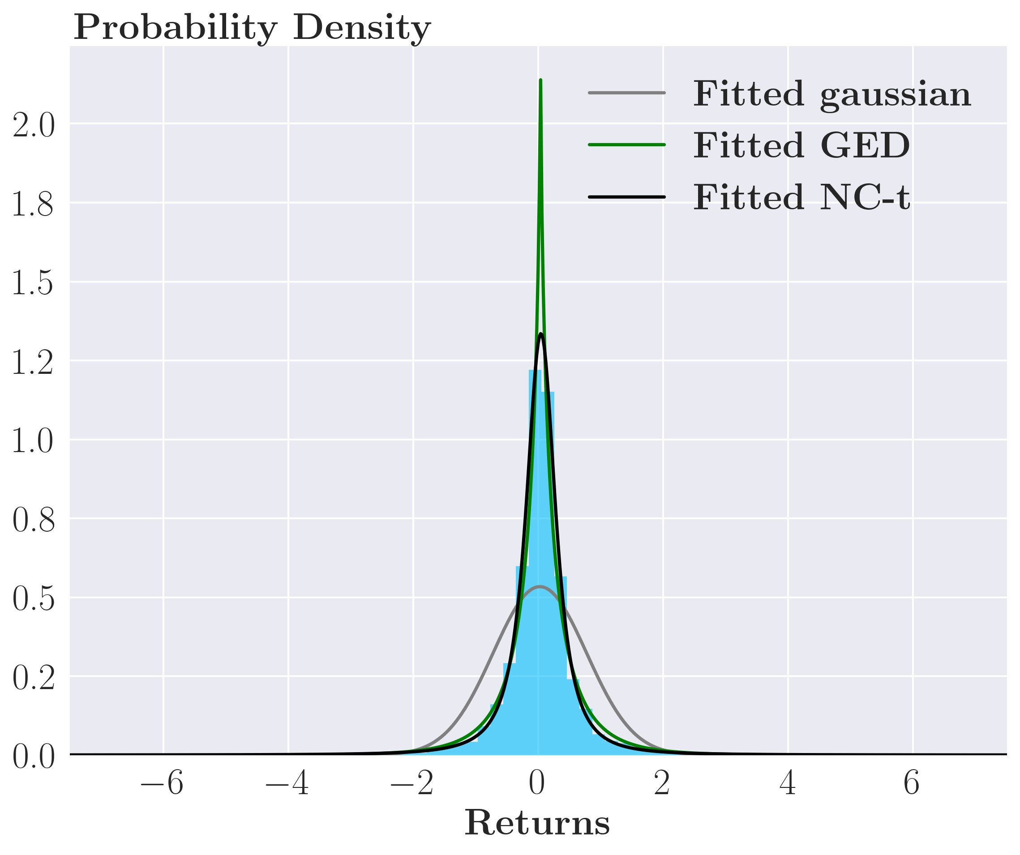

(c) S&P500 densities (d) Gold GJR-GARCH(1,1) time-series

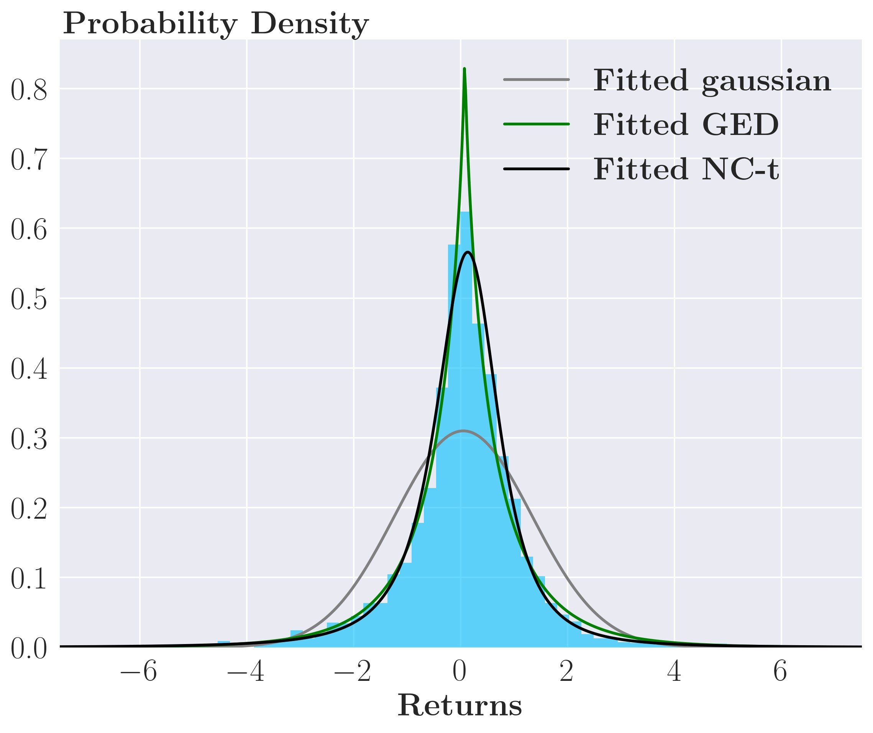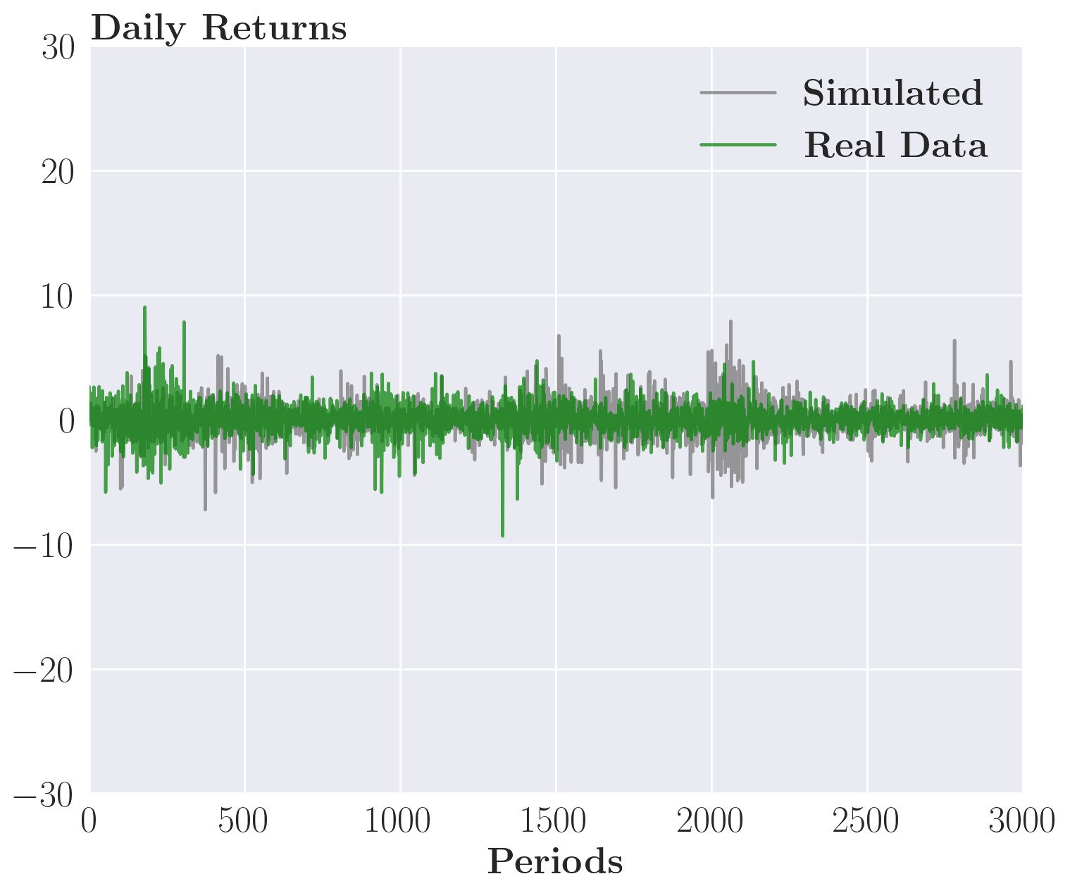

(e) HYG bond GJR-GARCH(1,1) time-series (f) S&P500 GJR-GARCH(1,1) time-series

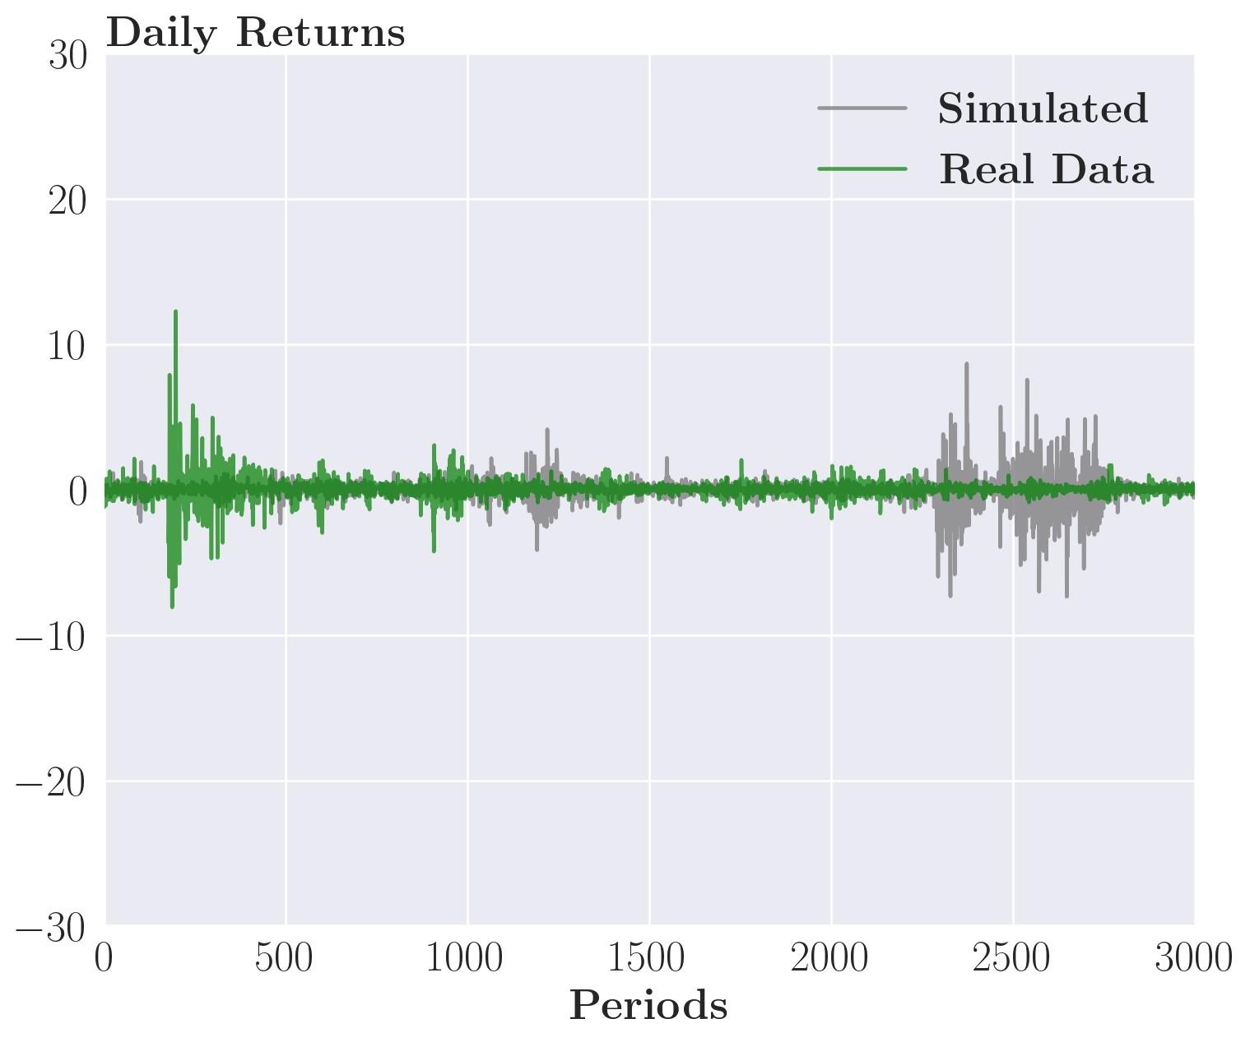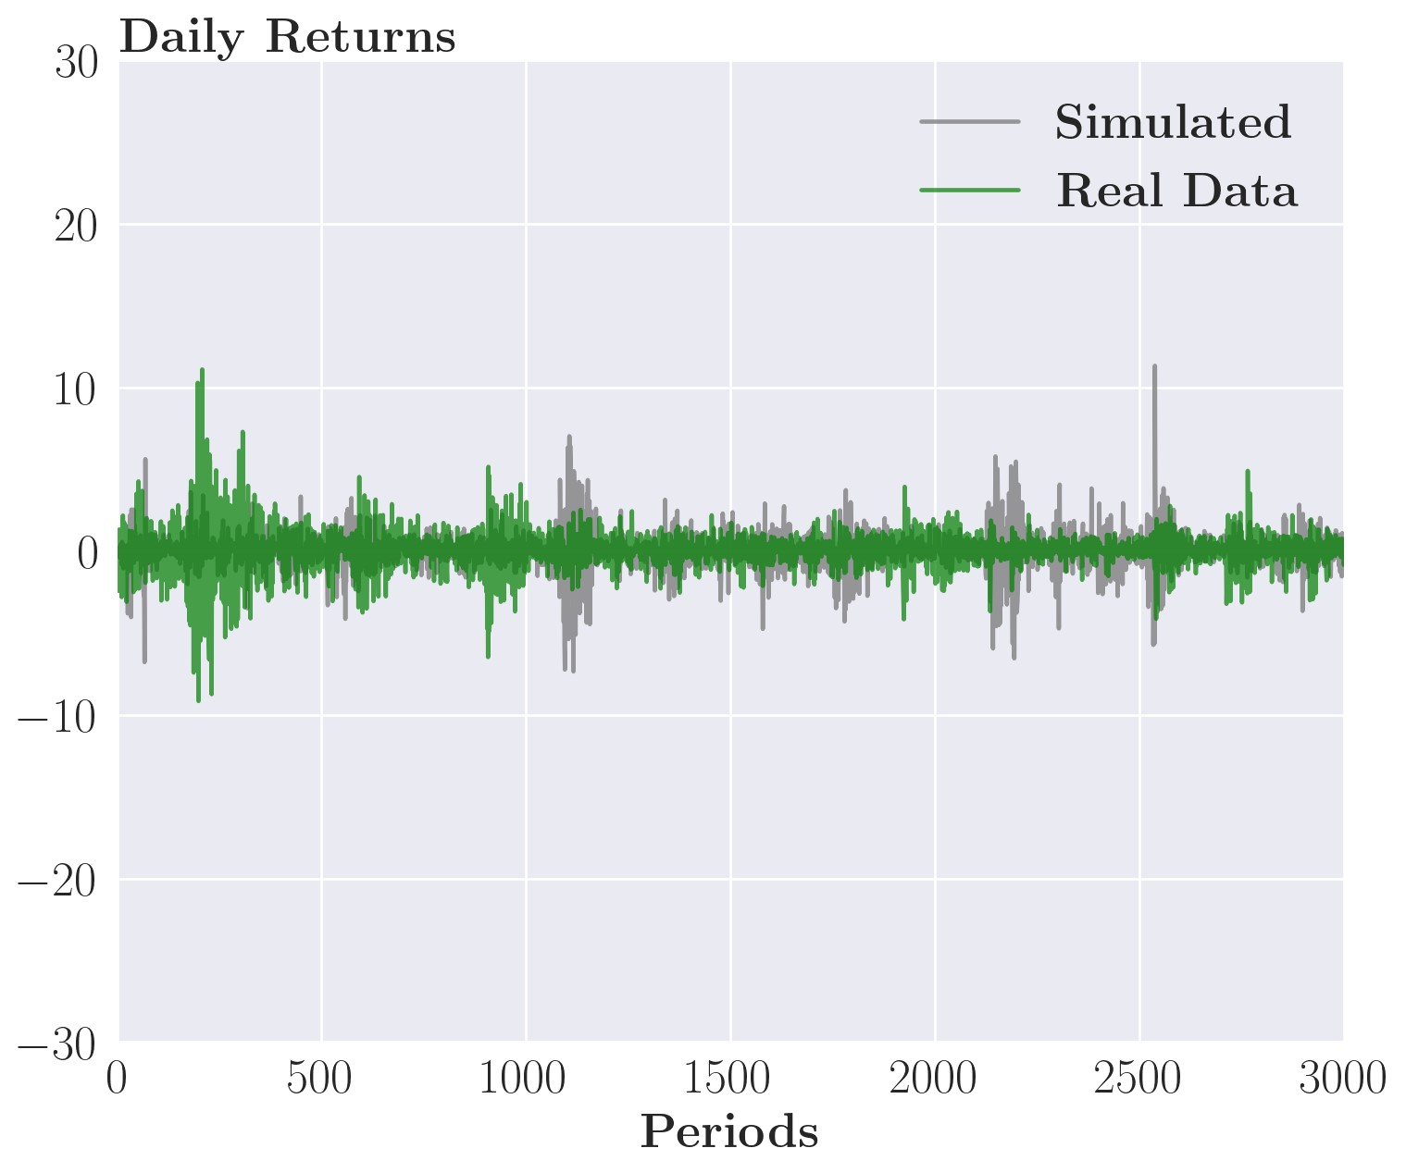

*Note*: The model for the simulated data is fitted on the historical data in the plots

The ARCH(1) and GARCH(1,1) models can also fit the time series of many different asset classes in the same way, so we only display the GJR-GARCH(1,1) for the sake of brevity. Notice how the shocks of the simulated data are of a similar size and that they are clustered together similar to the historical data. Keep in mind the location of the shocks for the simulated data is random as the data is simulated.

Combining the non-central Student’s t-distribution with a GARCH type process captures the stylized facts about returns. The returns simulated from the process will be non-Gaussian because they follow the abovementioned distribution. They will also be uncorrelated as the conditional mean has no correlation structure. Furthermore, they will be time dependent as the conditional variance is correlated across time, again in line with the stylized facts from section 3.1. All of this is to say that our chosen (G)ARCH models are flexible enough to match all statistical properties of the time series in our data sample. We test whether this promising result can lead to superior portfolio risk management on historical data in the next section.

# 6 Empirical results

In this section, we apply our theoretical results to real-world data to assess the performance and characteristics of the theoretically derived minimum variance portfolios. We compare our strategy with two benchmark strategies: an Equal-weight strategy with daily rebalancing and a Buy-and-hold strategy with the same initial portfolio as the simple and sophisticated strategies but with no rebalancing. This initial portfolio is the minimum variance portfolio given by the sample covariance matrix using in-sample data with the correlations shrunk 50%. We consider the cases for which we have theoretical results

* An investor ignoring transaction costs, ’the simple strategy’
* An investor adjusting for transaction costs, ’the sophisticated strategy’

By ’ignoring transaction costs,’ we mean whether the investor’s objective function penalizes transaction costs or not, corresponding to minimizing either equation (29) or (26).

We test the simple and sophisticated strategy for three different univariate GARCH specifications. ’Simple’ or ’sophisticated’ refers to the type of dynamic investment strategy used, whereas ARCH(1), GARCH(1,1), or GJR-GARCH(1,1) refers to the kind of variance model used to forecast conditional variance. For example, the simple ARCH(1) strategy is a dynamic minimum variance portfolio using the conditional covariance estimate, Ω*t*+1|*t* of a DCC MGARCH model where the univariate GARCH models of the variance are ARCH(1) models where the investor ignores transaction costs. Similarly, for the sophisticated GARCH(1,1), a dynamic minimum variance portfolio using the conditional covariance estimate, Ω*t*+1|*t* of a DCC MGARCH model where the univariate GARCH models of the variance are GARCH(1,1) models, and the investor adjusts for transaction costs. Notice that the structure of the multivariate model is the same, but the structure of the univariate models changes.

First, we test whether a GARCH estimate of the conditional variance can improve portfolio performance compared to a myopic approach with a static covariance estimate. Second, we perform model fit and calibration of model parameters, mainly *γD*. Third, we examine the dynamics of the MGARCH volatility model and its effect on the optimal weights. Lastly, we evaluate the performance of the dynamic strategies.

6.1 Can the conditional covariance estimate from a GARCH model reduce risk?

To motivate our choice of the GARCH volatility model, we showcase the difference a GARCH model can make in volatility forecasting compared to a myopic approach. Specifically, we compare the conditional covariance forecast from a GARCH(1, 1) model to the sample covariance estimate from our out-of-sample dataset. First, an overview of a typical GARCH conditional variance estimate of the S&P 500 compared to the myopic estimate seen in figure 6 panel (a). We only show S&P 500 for the sake of brevity, but the conditional volatility estimates for the other assets are similar in nature.

Figure 6: Comparison of sample covariance estimate vs. GARCH conditional estimate

(a) Volatility estimates *σt*... (b) ...resulting in portfolio weights, *vt*MVP

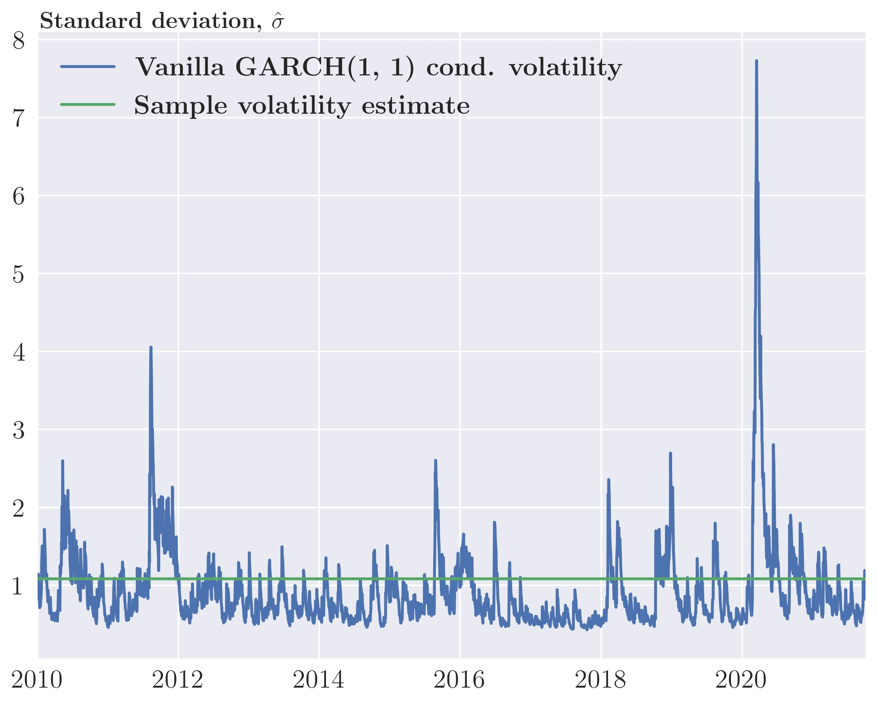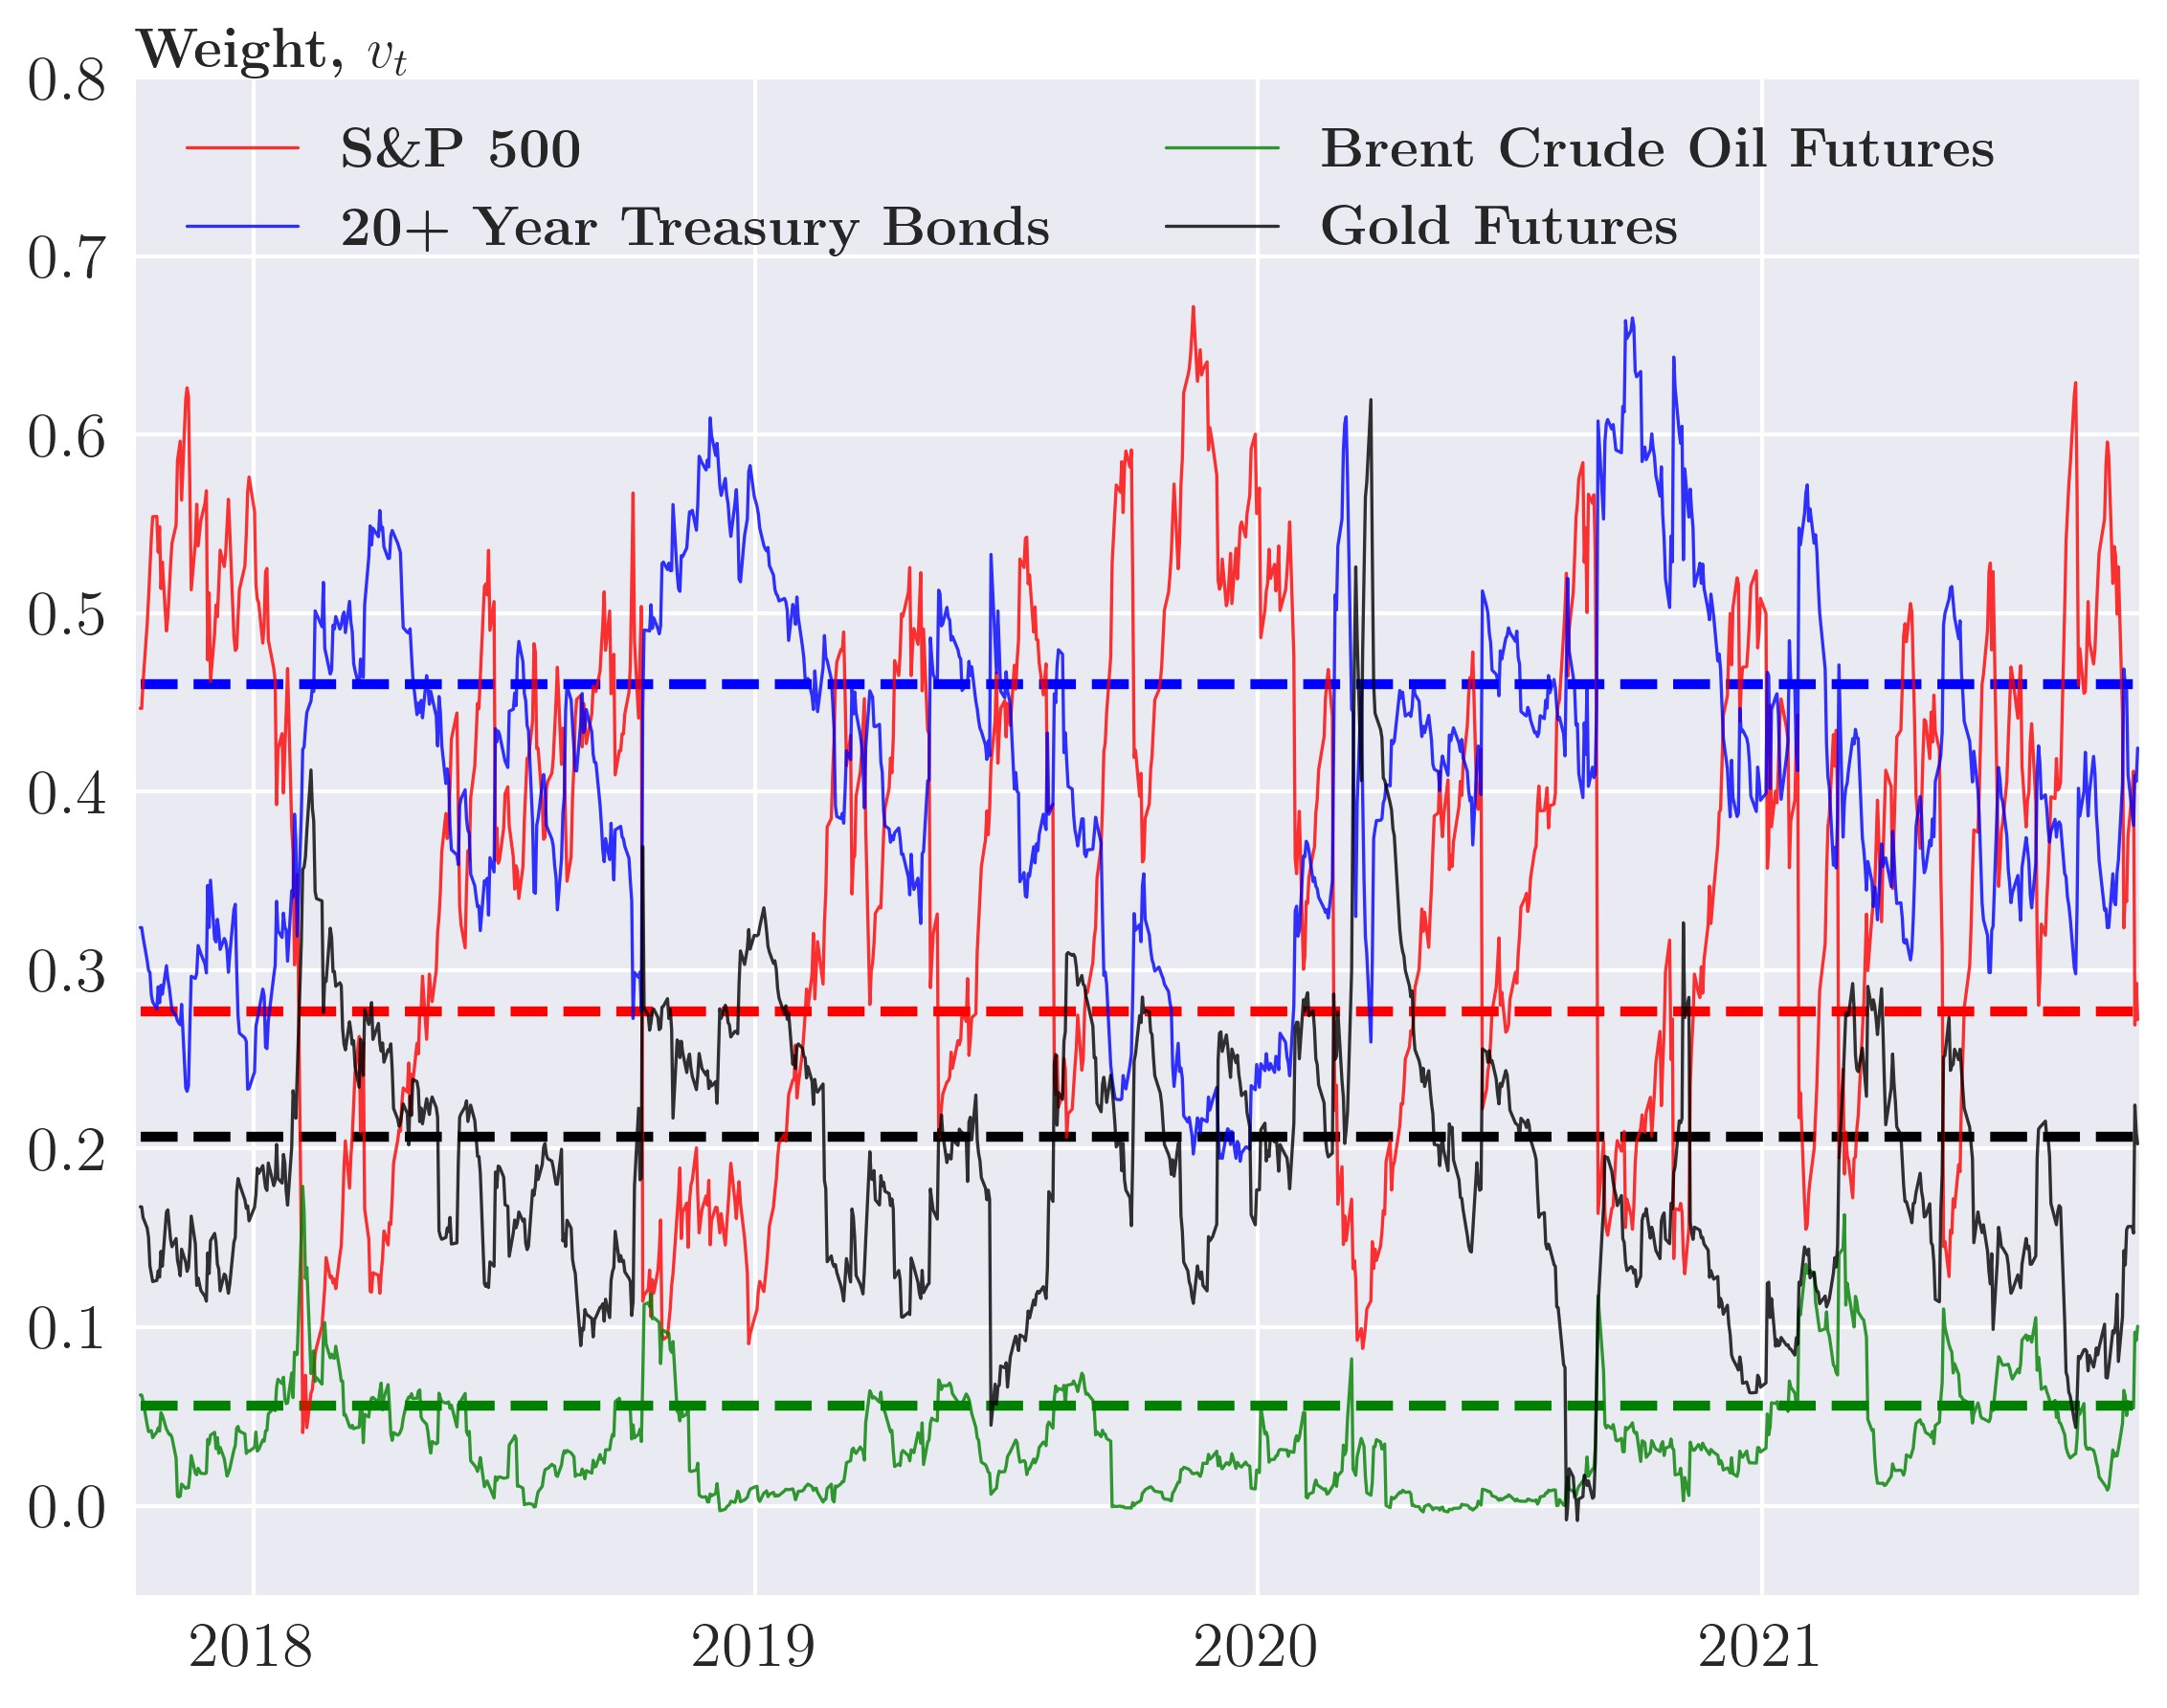

*Note*: In panel(b), the dotted lines are the MVP weights given a sample covariance estimate, and the solid lines are the weights given by the MGARCH covariance estimate.

In panel (a), we first observe that both estimates seem to forecast the same average volatility levels roughly. Secondly, the GARCH estimate is dynamic and sensitive to shocks compared to the static estimate. This dynamic nature of the GARCH estimate will later prove to lead to costly rebalancing for the GARCH model strategies. In panel (b), we backtest the two methods of volatility estimation using four assets [14] for simplicity with the strategy from equation (28) with a 50% regularization applied to the correlations.

Table 3: Annualized performance in gross return

Strategy Std. deviation Return Sharpe ratio

GARCH(1,1) 0.0661 0.0537 0.8125

Sample estimate 0.0775 0.0823 1.0615

Unsurprisingly, the fixed estimate results in a portfolio with constant weights. In the following sections, we will use this as the Buy-and-hold benchmark strategy to test if this result holds for other volatility models and asset classes.

Even though this is just one case, we see that at least for these assets and the GARCH(1, 1) model, there seem to be significant potential improvements from using a GARCH conditional covariance estimate compared to the myopic approach. However, the myopic approach results in a strategy with low transaction costs, which could offset the worse performance before transaction costs for other asset classes and volatility models. We will explore this trade-off after the next section.

## 6.2 Calibration and model fit

Before we apply our theoretical results, we calibrate the dealer’s risk preference *γD* from equation 30. We define a portfolio, *ψ*, as a time-series of weights *vt*. We lag the weights since the investor rebalances the portfolio at the end of each trading day. The portfolio’s *rψ,t* daily return is the product of the lagged weights and the asset returns: 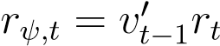. The standard deviation of the portfolio returns *σ*ˆ*ψ* is measured as the sample standard deviation:

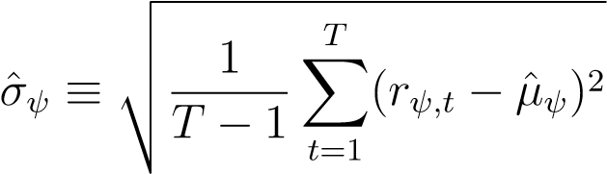 (34)

Since we seek optimal minimum variance portfolios, the essential measure is the standard deviation of the portfolios. With inspiration from [Hautsch and Voigt, 2019], we measure the daily turnover of the portfolio in percentage points as:

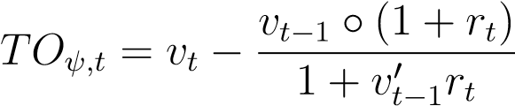 (35)

This specification includes the intraday return effects on the weights before rebalancing instead of assuming flat intraday returns. Notice that this is only measurable from period *t* = 2.

We calibrate *γD* the same way as [Gârleanu and Pedersen, 2013], even though our returns are measured in relative terms and not in dollar terms. We can always convert the dollar-cost back into relative costs with ∆*xt* = *TOt* ◦*Pψ*¯ *v*, where ∆*xt* is a *N* ×1 matrix of the number of shares traded, *ψv* is the total portfolio value of $1bn and *P*¯ is a *N* × 1 vector of average asset prices. We do this to use the result of [Robert et al., 2012] that find costs of 10 basis points (bp) of the average price per asset when trading 1.59% of the daily volume. Combining the turnover equation (35) with quadratic transaction costs, we obtain the daily transaction costs in dollar terms:

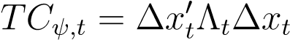 (36)

Now, we calibrate *γD* from our specification of transaction costs where Λ*t* = Ω*tγD*, similar to [Gârleanu and Pedersen, 2013]. In the following, we make a simplifying assumption and use the average daily volume of shares traded in the market V¯*i*. We know from [Robert et al., 2012] that.

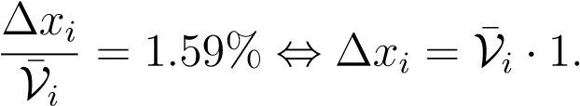59%

and

*TCi* = 10*bp* · *P*¯*i* Combining these results yields:

10*bp* · *P*¯*i* = V¯*i* · 1*.*59% · Λ*i* = V¯*i* · 1*.*59% · *σi*2*γD*

*γD* = 10*bp* · *P*¯*i*(1*.*59% · *σi*2V¯*i*)−1

We estimate *σi* using the sample standard deviation of asset returns for the in-sample period. As an example, we calibrate *γD* for IVV (S&P 500). We estimate the following empirical values for IVV:

*σi* = 1*.*7389 V¯*i* = 4*,*190*,*495 *P*¯*i* = 136*.*82 This yields *γD* for IVV:

*γD* = 1*.*73892(136*.*82 · 4190495 · 0*.*0159)−1 · 0*.*001 · 1e9 = 1*.*41e−5

Repeating this for all assets, we get an average *γD* of 3*.*37e−5 and a median of 1*.*52e−6. To get the relative loss from transaction costs in our backtesting, we divide the dollar transaction costs we have just formulated with the total portfolio value. Algorithm 3 in the appendix summarizes the procedure.

Moving on to the fit of the MGARCH model, where we estimate the parameters via maximum likelihood. As mentioned in section 3.3, a DCC MGARCH model comprises *N* univariate GARCH type models, one for each asset, and a single multivariate model for the correlation structure.

From table 4, we see the estimates of the *N* = 11 univariate GARCH(1,1) models. These estimates all lie within the expected range with *β* around 0.8-0.9, *α* around 0.1, and *α*+*β <* 1 such that the parameters are estimated consistently. Additionally, we see that *α* + *β* ' 1, meaning that GARCH models are very persistent and close to being integrated. Similar to table 2, there is a wide range of estimates of *ν* for the Student’s t-distribution. The higher the *ν*, the closer the asset is to a Gaussian distribution with 20+ year treasuries (TLT) being the closest though still quite far from being Gaussian. The least Gaussian asset returns are the commodities and High yield bonds (HYG). Estimates for the ARCH(1) and GJR-GARCH(1,1) univariate models are in table 9 and 10 in the appendix.

Table 4: Estimates of a DCC MGARCH(1,1) with univariate GARCH(1,1) - *tν* errorterms

Univariate GARCH

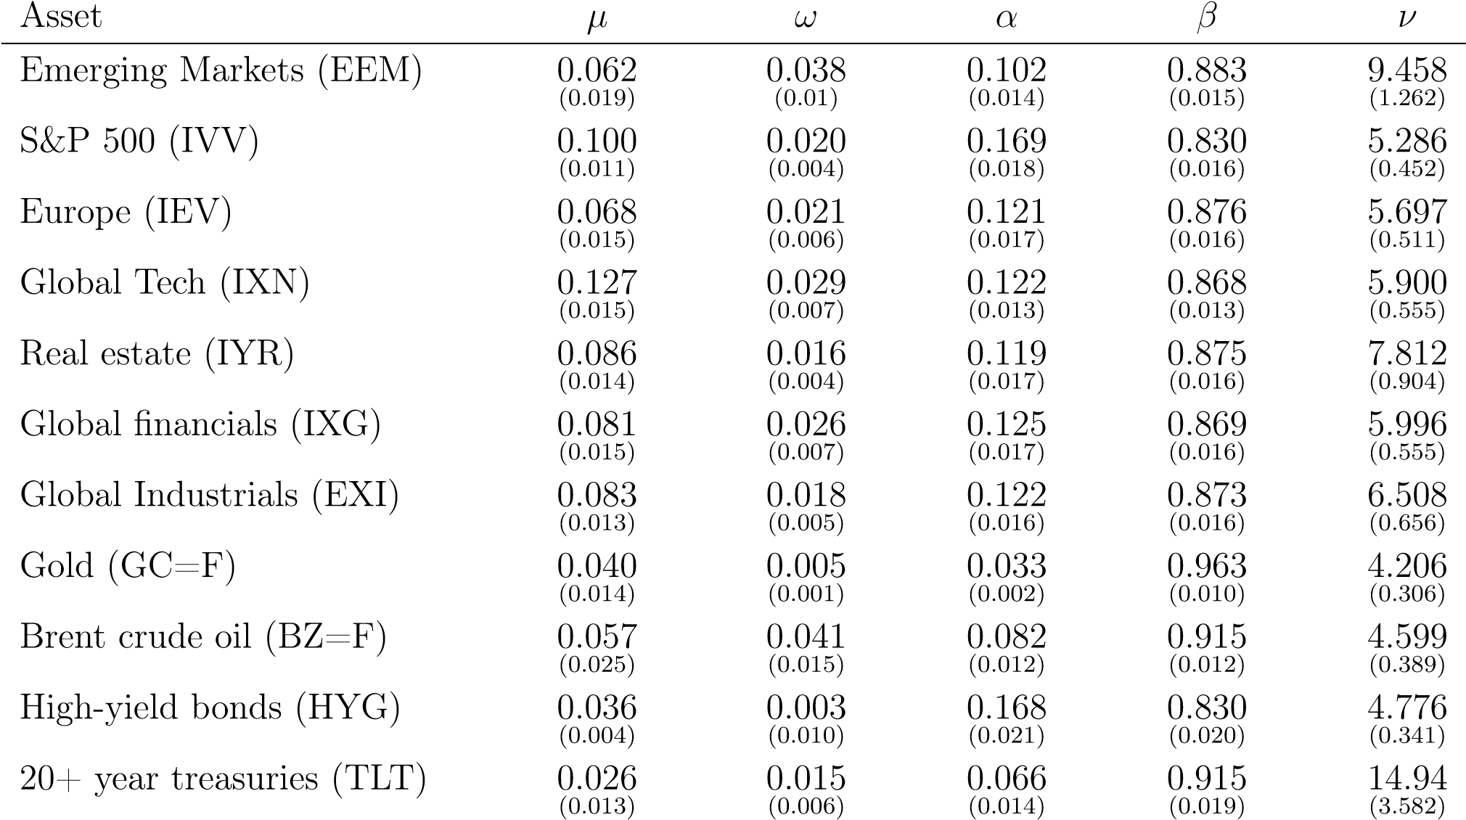

Multivariate GARCH

*a b ν*

Scalar-BEKK(1,1) 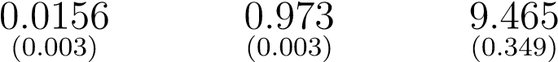

*Note*: Estimated via MLE using data from January 1st 2008 to October 11th 2017. Robust standard errors in (·).

## 6.3 Simple strategy (ignoring transaction costs)

We start with the simple strategy where the investor ignores transaction costs in his objective function corresponding to equation (26). First, we delve into the dynamics of the model to understand how shocks impact this equation and thereby the weights this equation. Then, we show performance before (gross return) and after subtracting transaction costs (net return) to highlight the importance of adjusting for transaction costs.

### 6.3.1 Understanding the dynamics of the simple strategy

As explained in section 3, the GARCH type models capture the persistent variances and covariances of asset returns. For an investor seeking to minimize the variance of his portfolio, the effects of past shocks and conditional (co)variances on future (co)variances are vital to understanding how past shocks to returns affect current optimal weights.

For the simple dynamic strategy, there are two primary effects to consider: how the variance responds to shocks and how persistent the impact of the shock is for the conditional variance in the model. How the variance responds to a shock is dictated by *α* and *κ* for the GJR-GARCH model. The higher the value of these parameters, the more the conditional variance of the assets increases in the period following a shock. *β* models the persistence of the shock for the conditional variance - the closer *β* is to one, the more persistent the process is.

To illustrate this, we model three of the assets for 10.000 periods from *t* = −5000 to *t* = 5000 and give a single shock of -2% to S&P500 ETF at *t* = 0, and plot how the weights of the different assets change and converge back to their long-run equilibrium. We model all correlations with a scalar-BEKK(1,1) from equation (12) and (17)-(21) and only vary the variance model for the individual asset returns. Keep in mind that this is a very artificial setup with only one shock in 10.000 periods which does not replicate real time series.

Let’s begin with the conditional variances from an ARCH(1) model from equation (7). In figure 7 we plot the optimal weights for the simple ARCH(1) strategy and the conditional volatility estimates.

Figure 7: The impulse response function of *vt*MVP for the simple ARCH(1) strategy

(a) Portfolio weights, *vt*MVP (b) Volatility, *σt*

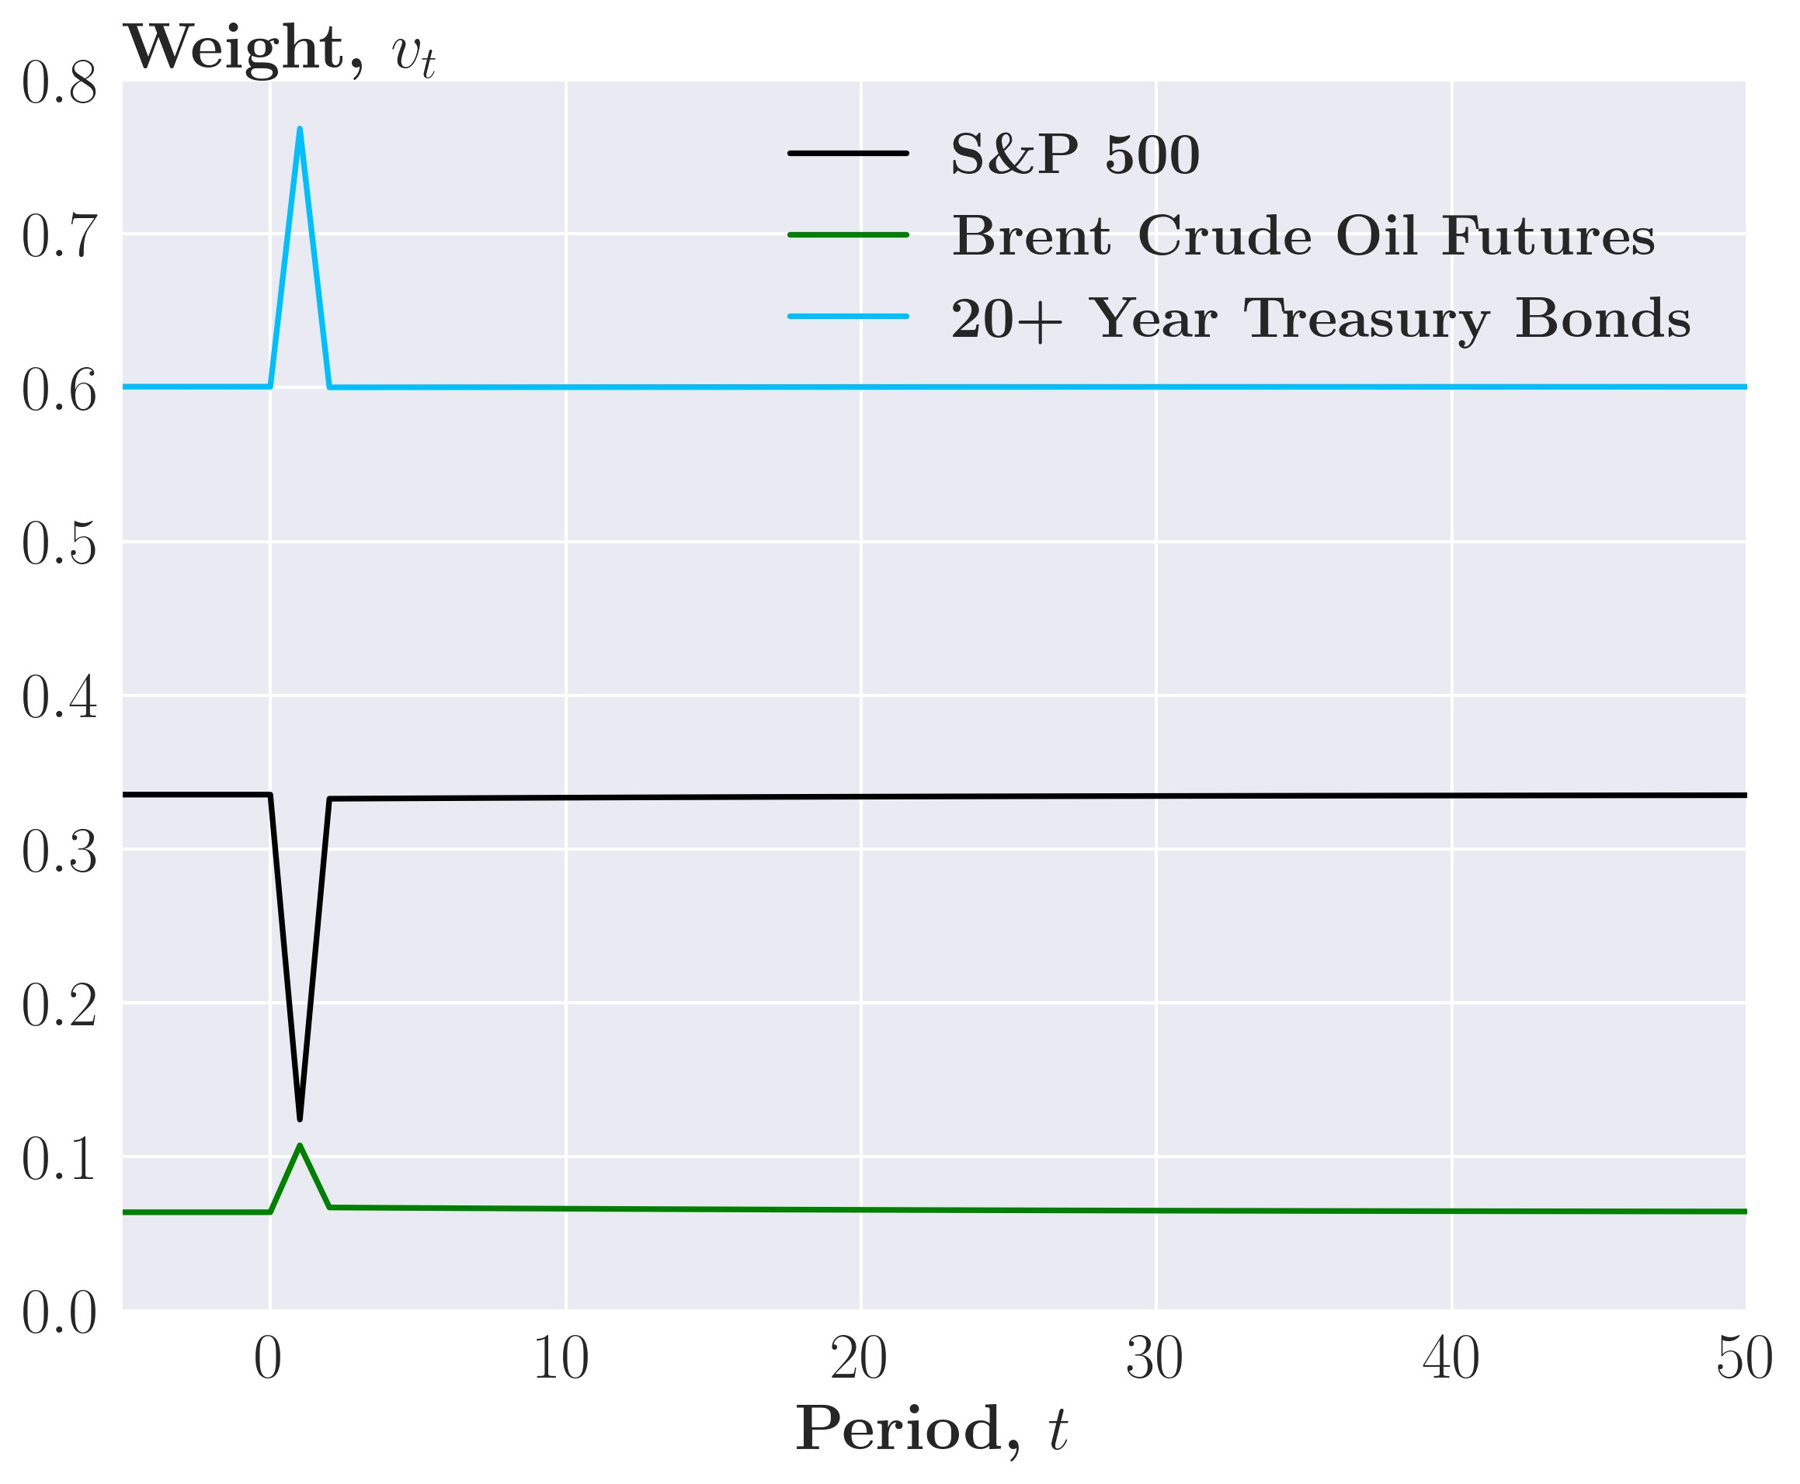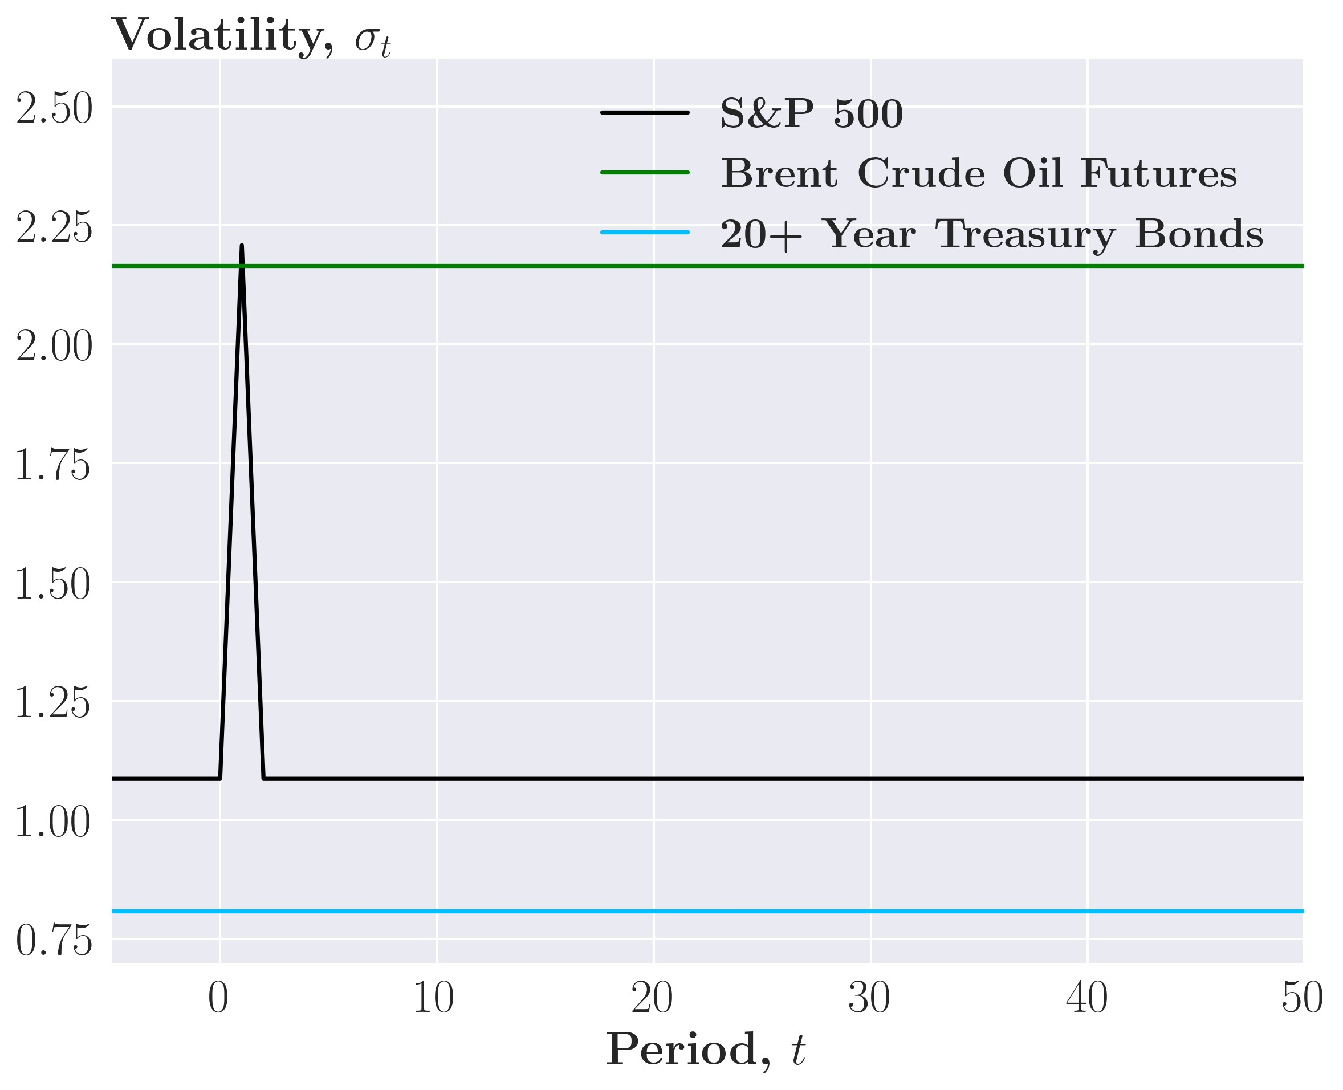

Consider first panel (b) in figure 7, where the volatility of the S&P500 ETF spikes from 1.1 to 2.2 from period *t* = 0 to *t* = 1 as the shock of −2 hits. Then in period *t* = 2, the volatility goes back to 1.1 as the shock exits the model thus, there is no persistence in the volatility. Looking at the weight of the S&P500 ETF, the allocation drops at period *t* = 0 as the investor now perceives the asset as riskier than the other assets. Still, at period *t* = 2, the allocation goes back very close to the pre-shock value as the shock is now out of the model, but the model still shows some very mild persistence. This persistence, although barely visible, comes from the correlations between the asset returns, which the shock also affects at period *t* = 1. These are very persistent as *b* ≈ 0*.*96 in the scalar-BEKK model for the correlations. Thus, the conditional correlations and weights slowly converge to the long-return equilibrium at around 100 periods after the shock. Using the ARCH(1) model for the conditional variances, we see no persistence of the volatility affected by the shock, with the correlation exhibiting a tiny but very persistent response to the shock. Recall from section 3.2, that the ARCH(1) converged back too quickly to its unconditional variance compared to empirical estimates, which also shows in the weights, which converge back very soon after the shock.

We continue with the simple GARCH(1,1) strategy where the investor models the conditional variance with a GARCH(1,1) from equation (8).In figure 8 we see the conditional volatility and weights after an identical shock of -2%. Here we see a different dynamic than

Figure 8: The impulse response function of *vt*MVP for the simple GARCH(1,1) strategy

(a) Portfolio weights, *vt*MVP (b) Volatility, *σt*

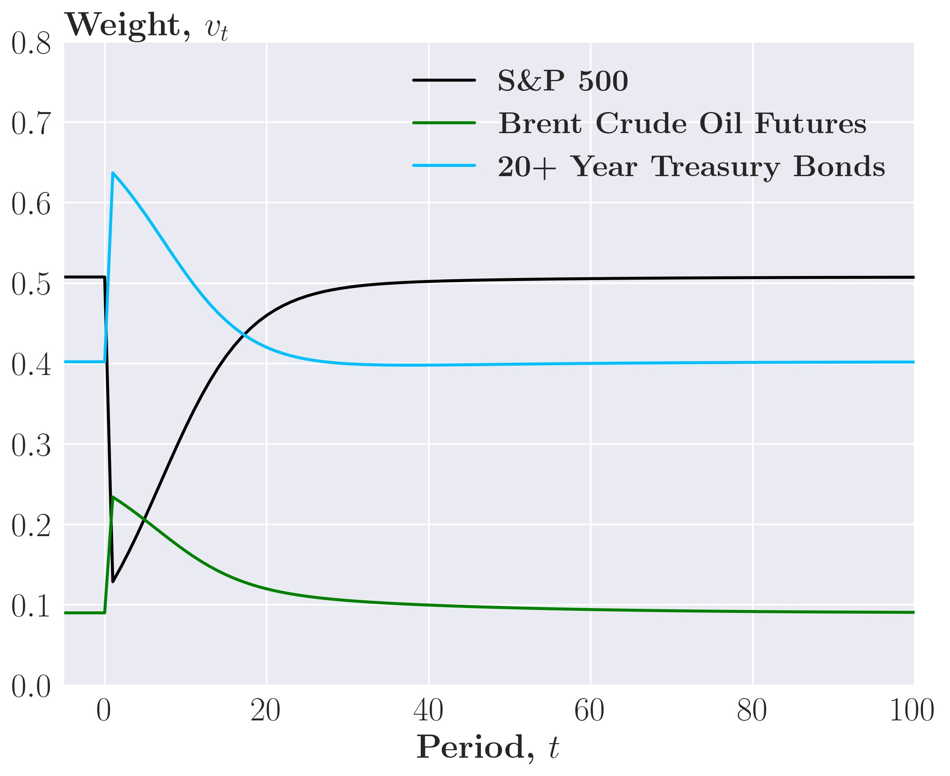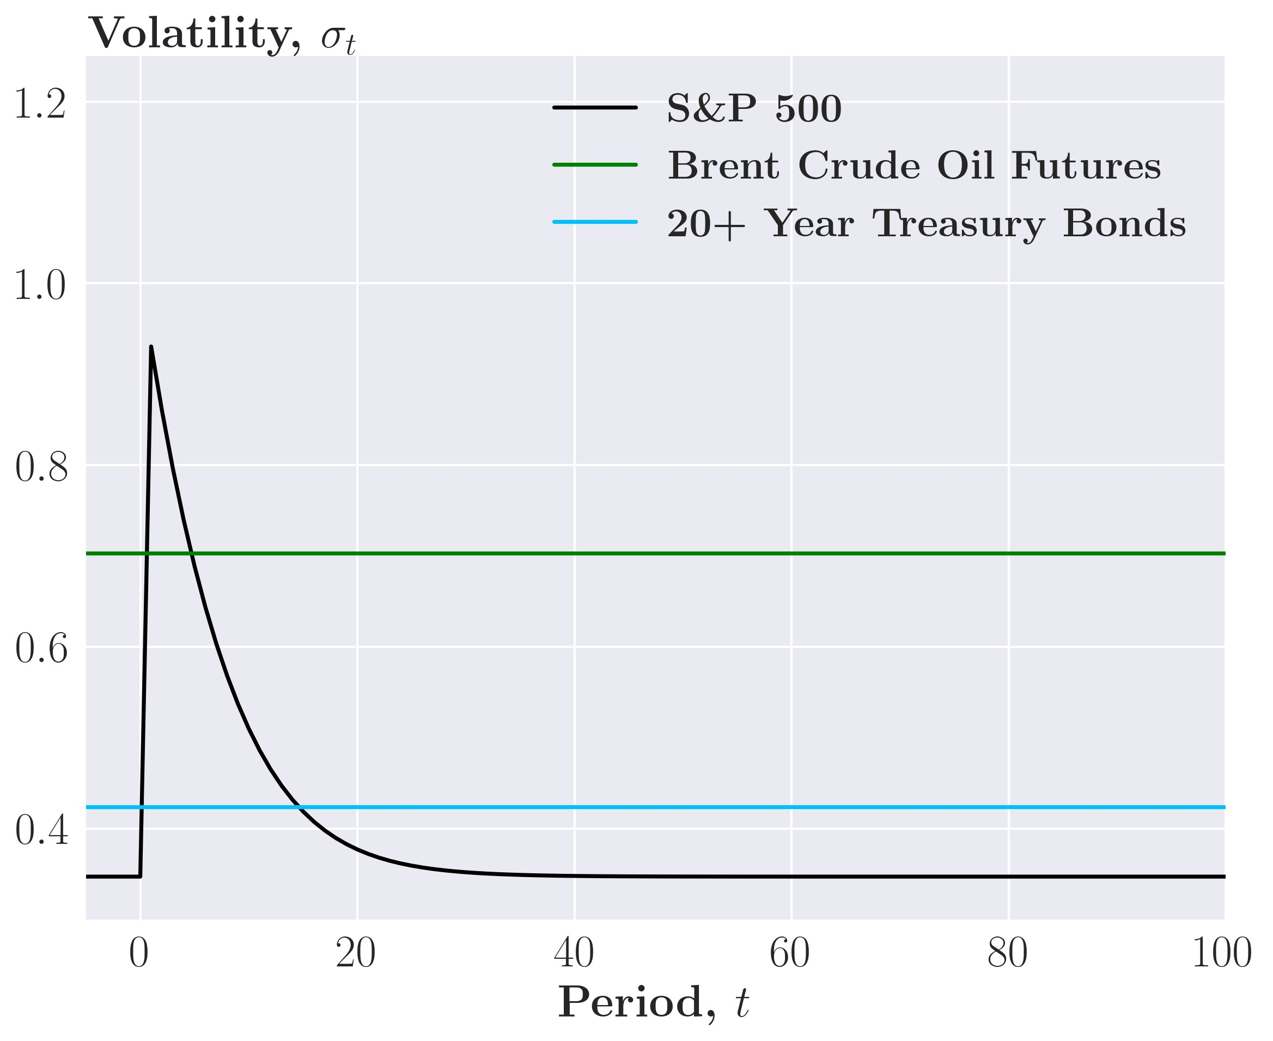

the simple ARCH(1) strategy. In figure 8 panel (b), we see that the volatility of the S&P500 ETF increases less, courtesy of lower *α* estimates, but it is now persistent and decays exponentially back to the minimum conditional variance after roughly 30 periods at *t* = 30. The persistence profoundly affects the weights where we observe a ’two-stage’ convergence. In the first stage, both the conditional correlations and conditional variances converge back, roughly from period *t* = 1 to *t* = 30. Afterward, the conditional variances converge back, leaving the second stage where the conditional correlations slowly converge. This effect is visible in panel (a), where the weight of the S&P500 ETF converges fast in period *t* = 1 to *t* = 30 and then very slowly for the remaining periods where the conditional correlations converge. In conclusion, the addition of persistence of the conditional variance adds much more persistence in the weights of assets.

Recall from section 3.2, that negative shocks generally have a more significant effect on the variance than positive shocks, dubbed the "leverage effect." The univariate GJR-GARCH(1,1) captures the leverage effect with *α* parameter to positive shocks and *α* + *κ* parameters to negative shocks.

In figure 9 panel (b), we see that the volatility of the S&P500 ETF increases to 1.2 in period *t* = 1. Note that this is a larger increase than the GARCH(1,1) model, which increased to 0.9. The simple GJR-GARCH(1,1) strategy exhibits similar convergences and persistence as the Figure 9: The impulse response function of *vt*MVP for the simple GJR-GARCH(1,1) strategy

(a) Portfolio weights, *vt*MVP (b) Volatility, *σt*

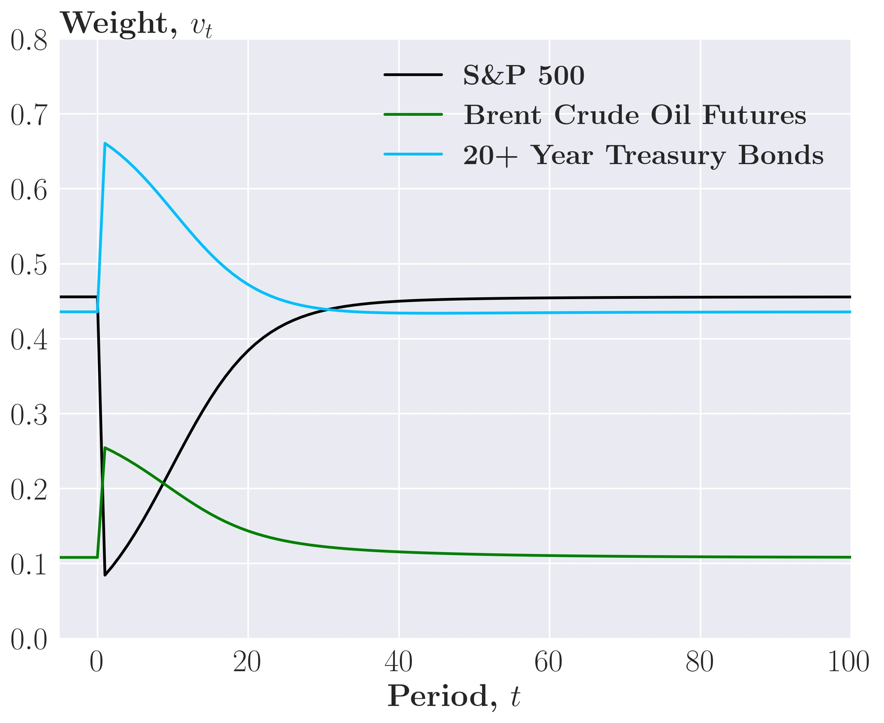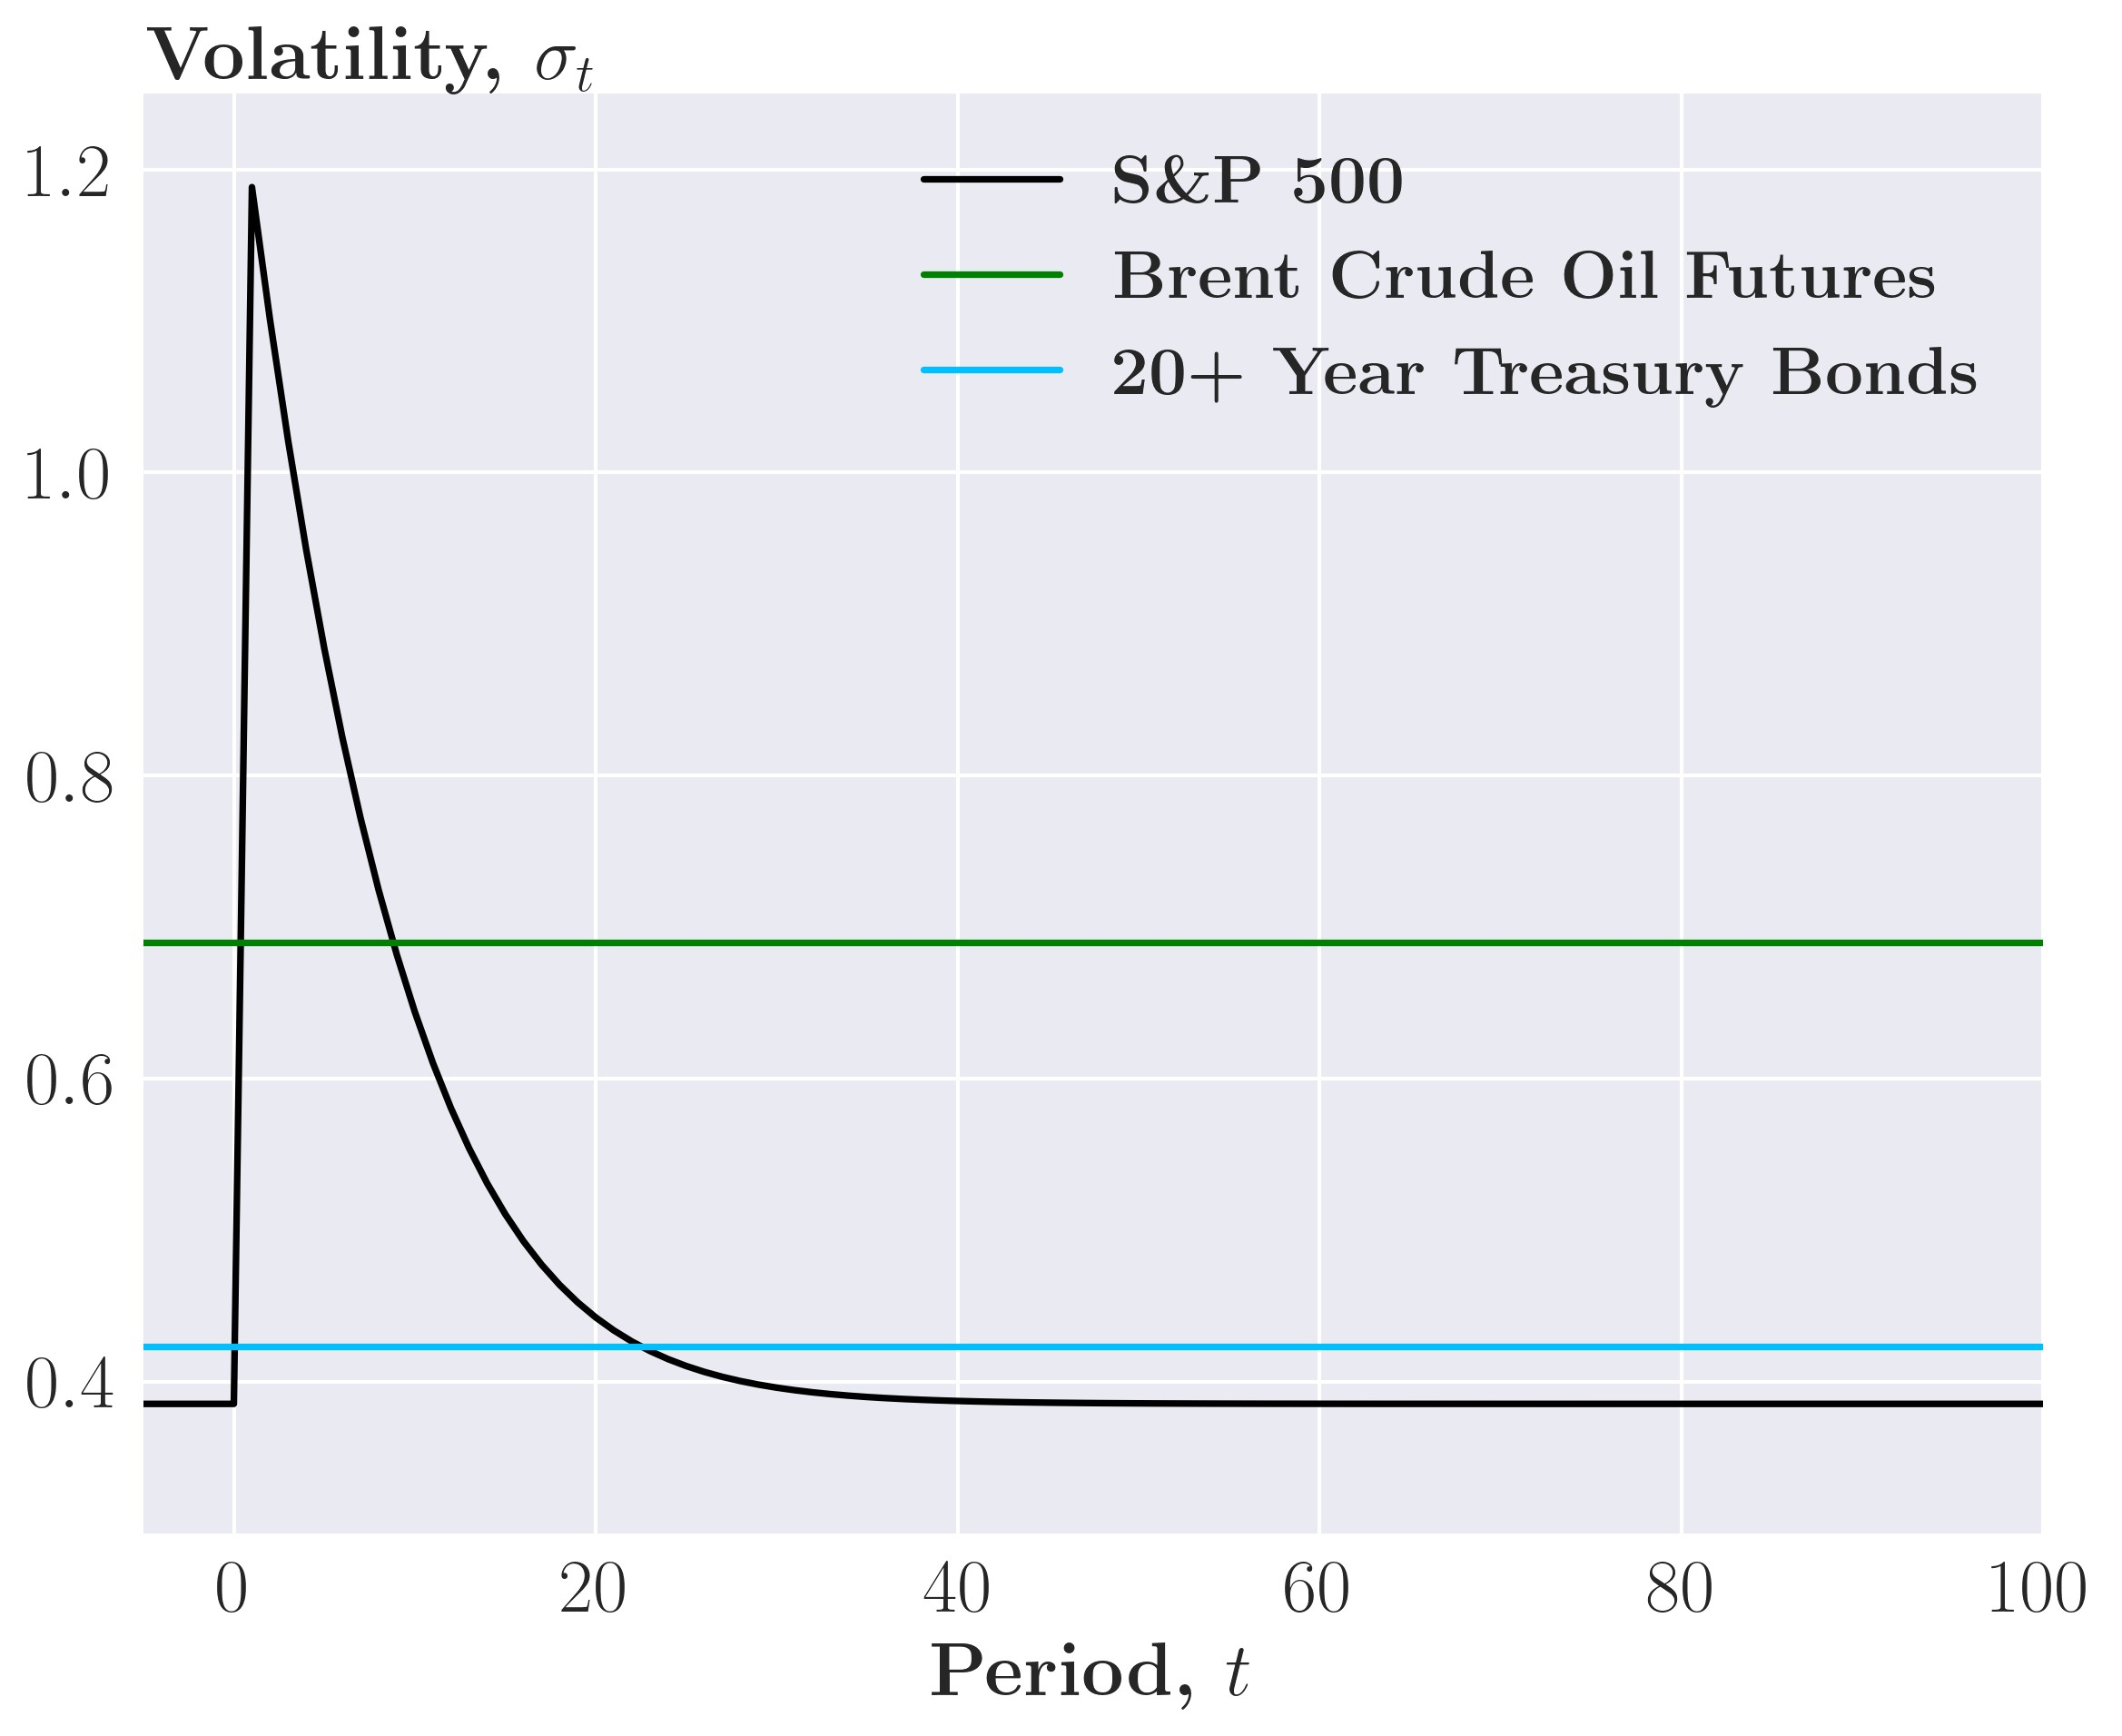

simple GARCH(1,1) strategy with the ’two-stage’ convergence, resulting in a similar pattern to the weights in panel (a). The differences show in the long-run weights due to different minimum conditional variances of the two models. In the GJR-GARCH models, estimates of *α* are often around 0 and estimates of *κ* around 0.2; thus, positive shocks do not affect the conditional variance. We see this in figure 23 in the appendix where we change the shock to the S&P500 ETF to a positive shock of 2%. The sign change results in no change in the conditional variance and thus results in small changes to the weights. Only changes to the convergence of the conditional correlations impact the weights, which shows how the optimal weights converge if there is no effect from the conditional variance.

In the IRF plots, the conditional covariance matrix and the weights exhibit clear dynamics that strongly depend on the type of univariate model used. Keep in mind, that in the real world, the conditional covariance matrix never fully converges back to its minimum conditional covariance as the assets returns are hit by shocks of varying sizes daily. However, the overall dynamics that the investor allocates more capital to assets that are perceived as riskier immediately after a shock hits and then slowly change his allocation back as the volatility subsides, will not change moving to real-world data.

Another feature of our model, is that portfolio weights oscillate around the weights from the unconditional covariance matrix. To illustrate this, we plot the weights for three assets from the unconditional covariance matrix (the dotted lines) and the weights from the (G)ARCH model’s conditional covariance matrix (the solid lines).

Looking at figure 10, we see that the conditional weights roughly oscillate around the unconditional weights. The effect is evident in the simple ARCH(1) strategy, where the weights jump back to the unconditional value when a shock ends. The oscillation is more persistent for the simple GARCH(1,1) and the simple GJR-GARCH(1,1) strategy, and the conditional weights have extended periods below and above their unconditional counterpart.

Figure 10: Portfolio weights from the unconditional and conditional covariance matrix

(a) Simple ARCH(1) (b) Simple GARCH(1,1)

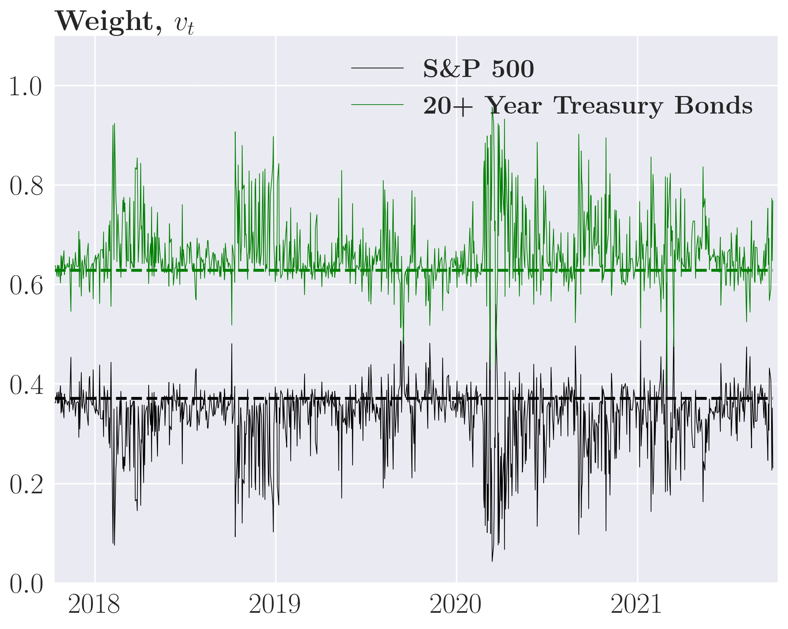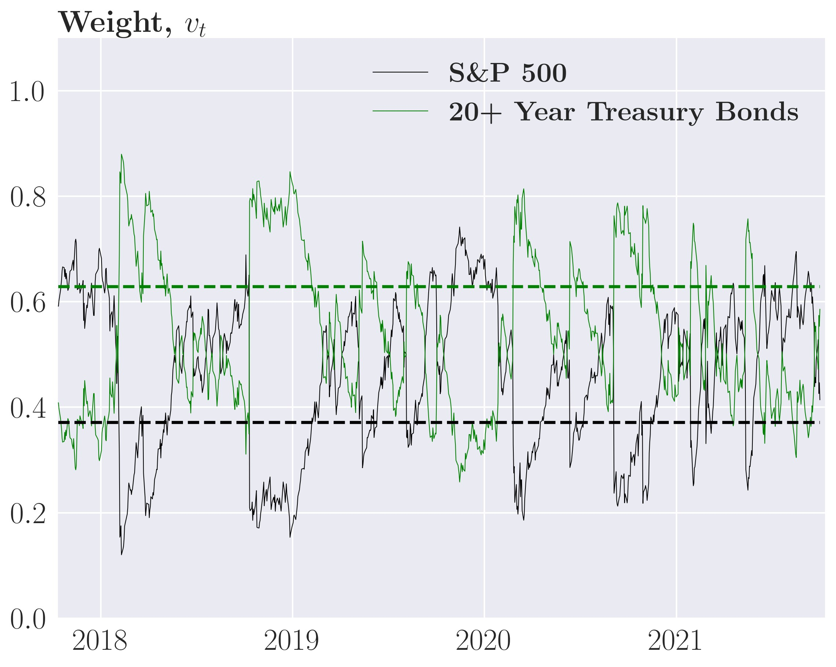

*Note*: The dotted lines are the weights from the unconditional covariance matrix

With a thorough understanding of the underlying dynamics of the model, we move from the artificial setup to backtesting the simple strategy with real-world data to examine the performance of the minimum variance portfolio using the MGARCH model.

### 6.3.2 Backtesting the simple strategy

In this section, we test the dynamic trading strategies using historical prices. The general idea is to fit the models on a sample period and test them out-of-sample to avoid polluting the optimization process with "future" data. Our out-of-sample period is 1.000 days and begins October 12th 2017 and ends October 2nd 2021. The model is thus only fitted with data from before this period. We calculate the optimal MVP weights for each period using the fitted model, with rebalancing assumed to be feasible at closing prices. See algorithm 1 in the appendix for a detailed write-up of the backtesting procedure. We first evaluate the performance of the simple strategy from section 4.2.1 where the investor ignores transaction costs, i.e., an investor who has the objective function of equation (26). To be clear, we consider performance both before (gross return) and after subtracting transaction costs (net returns).

We start by considering the minimum variance portfolio weights of the simple ARCH(1) strategy in figure 11 panel (a). Here, we see that the weights fluctuate heavily around the weights given by the unconditional covariance matrix as shown in section 6.3.1. Recall from the section on dynamics that the ARCH(1) shows very little persistence in the weights, which is present for all assets but easily spotted for 20+ year government bonds and High-yield bonds. Thus, every time a shock hits, the investor rebalances depending on the size of the shock, which will be very costly in transaction costs.

Moving on to the simple GARCH(1,1) strategy, where the minimum variance portfolio Figure 11: Portfolio weights of the simple strategy, all assets

(a) ARCH(1) weights, *vt*MVP (b) GARCH(1,1) weights, *vt*MVP

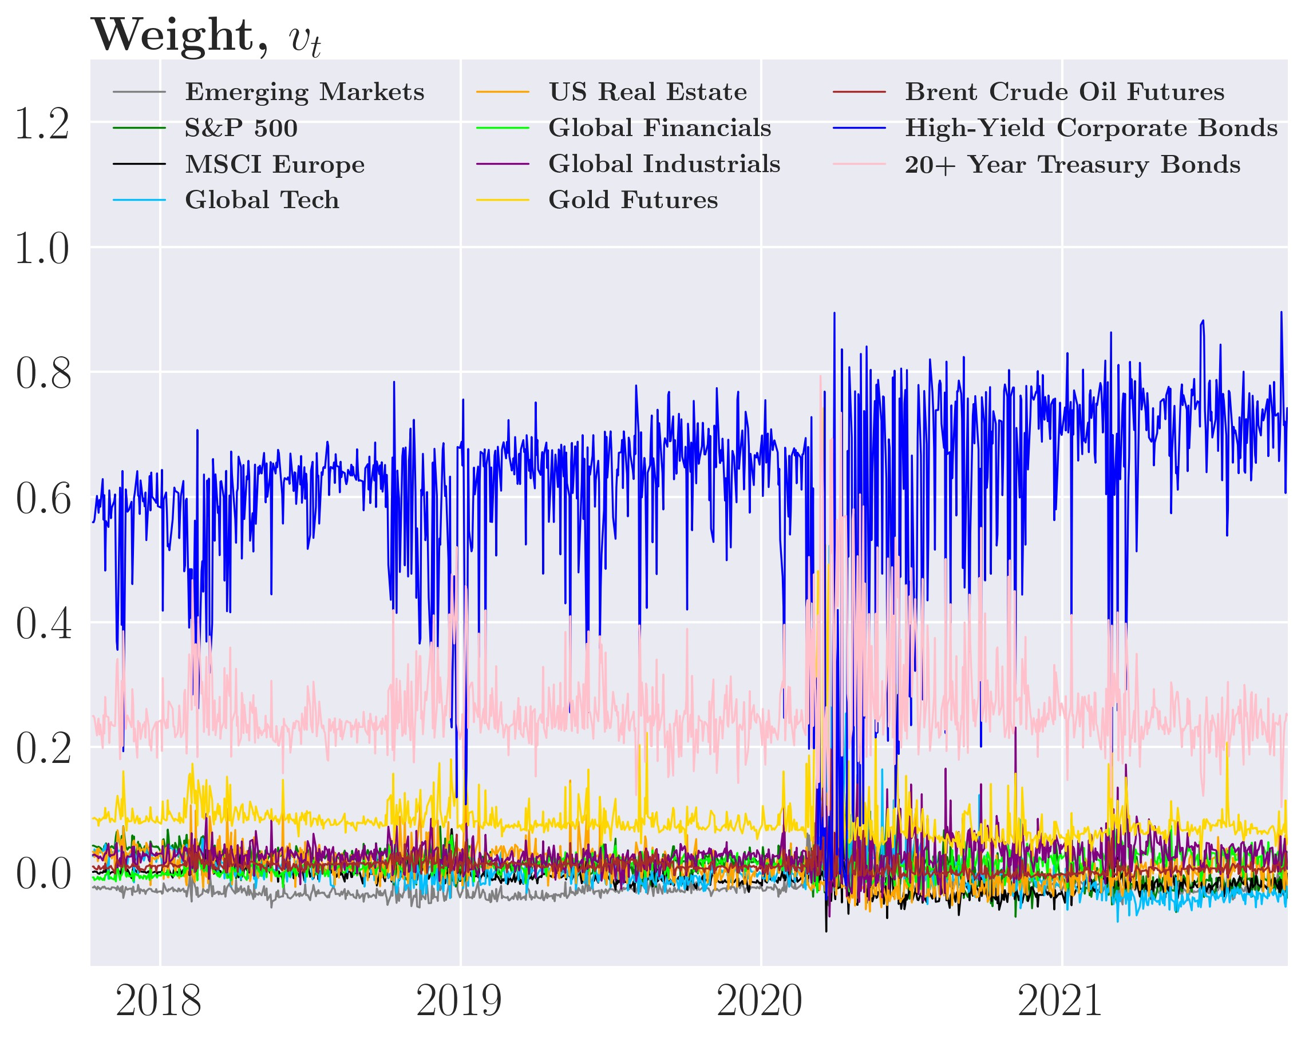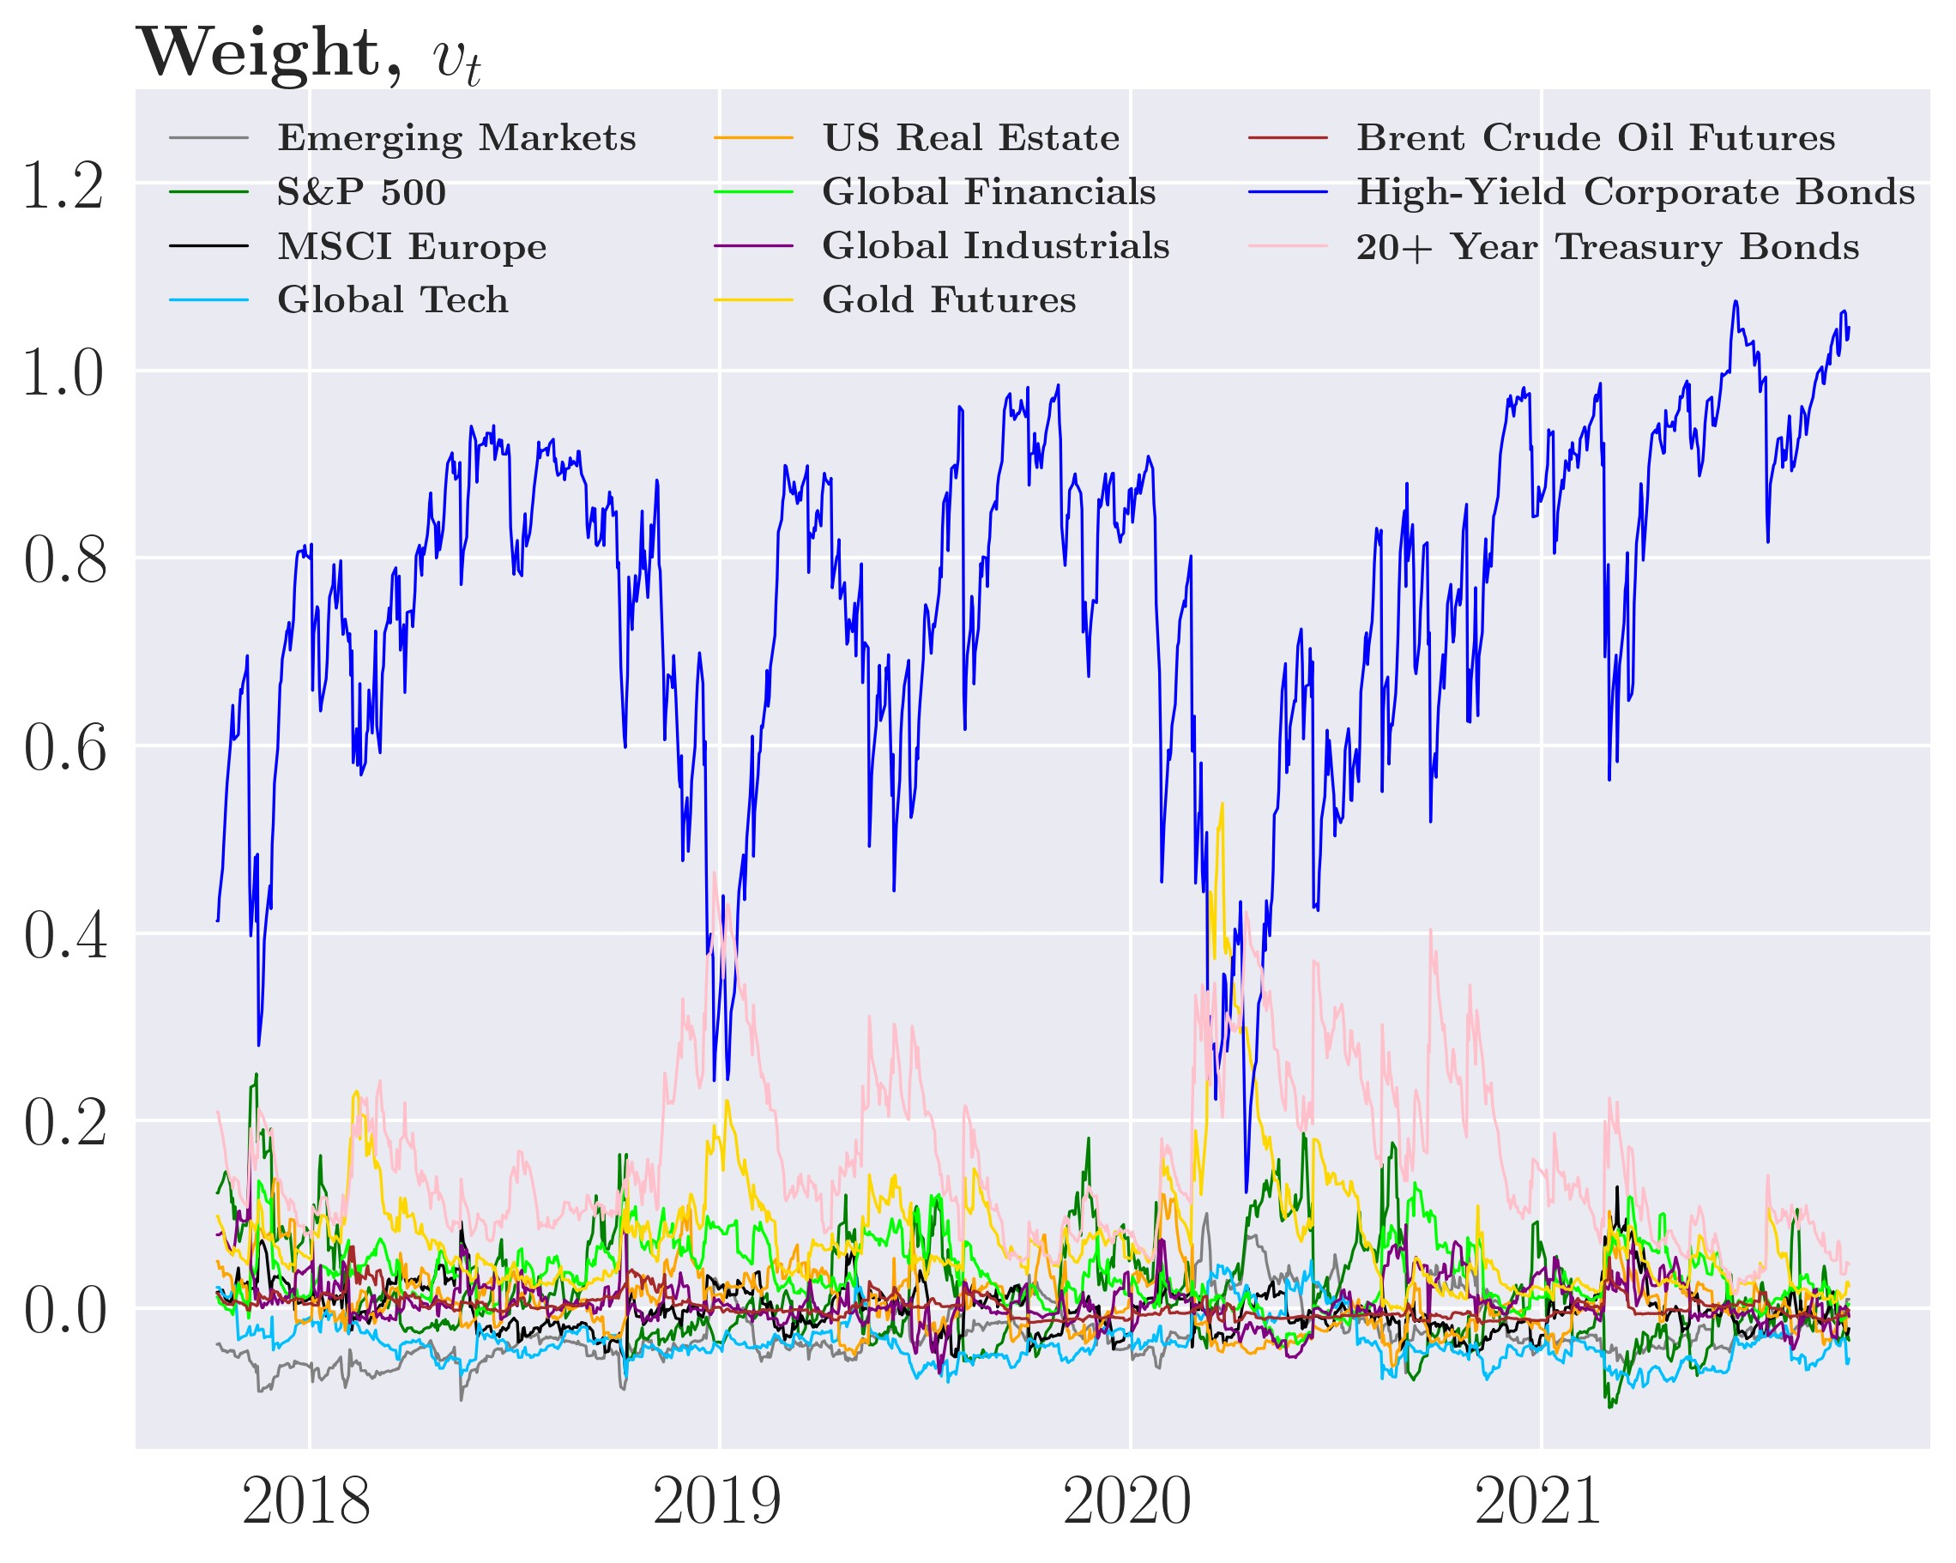

Figure 12: Cumulative returns of the simple strategy, all assets

(a) Gross return (b) Net return

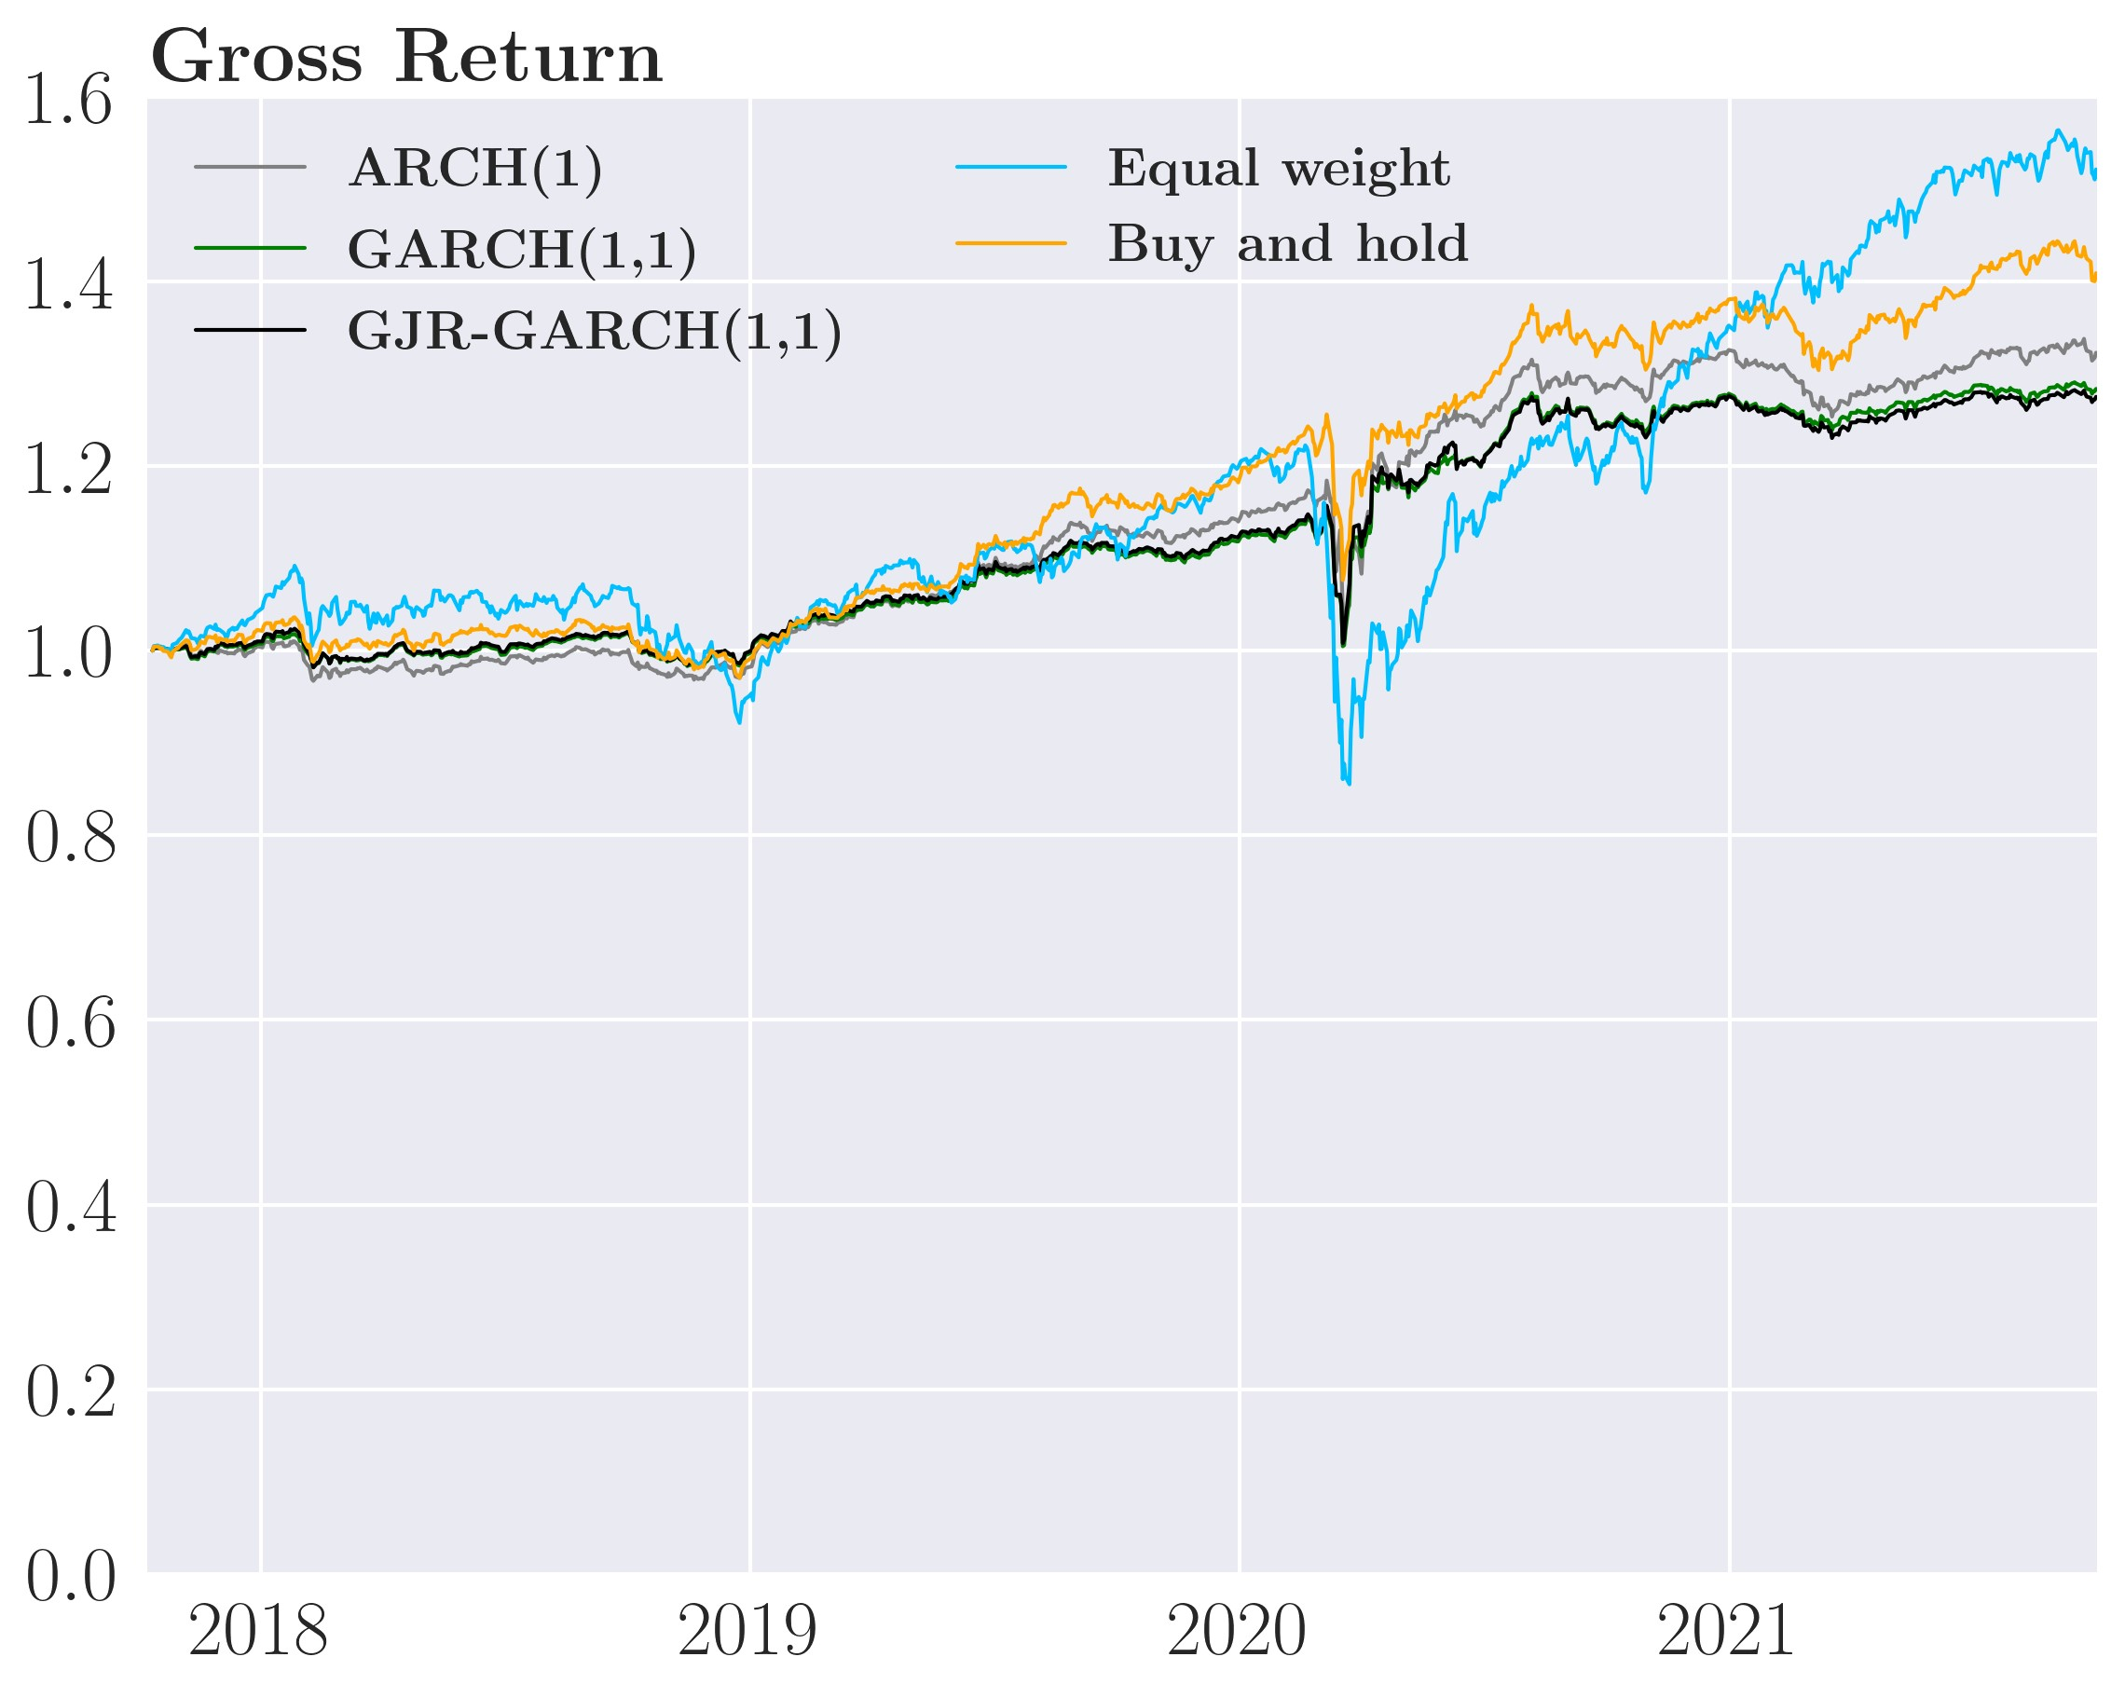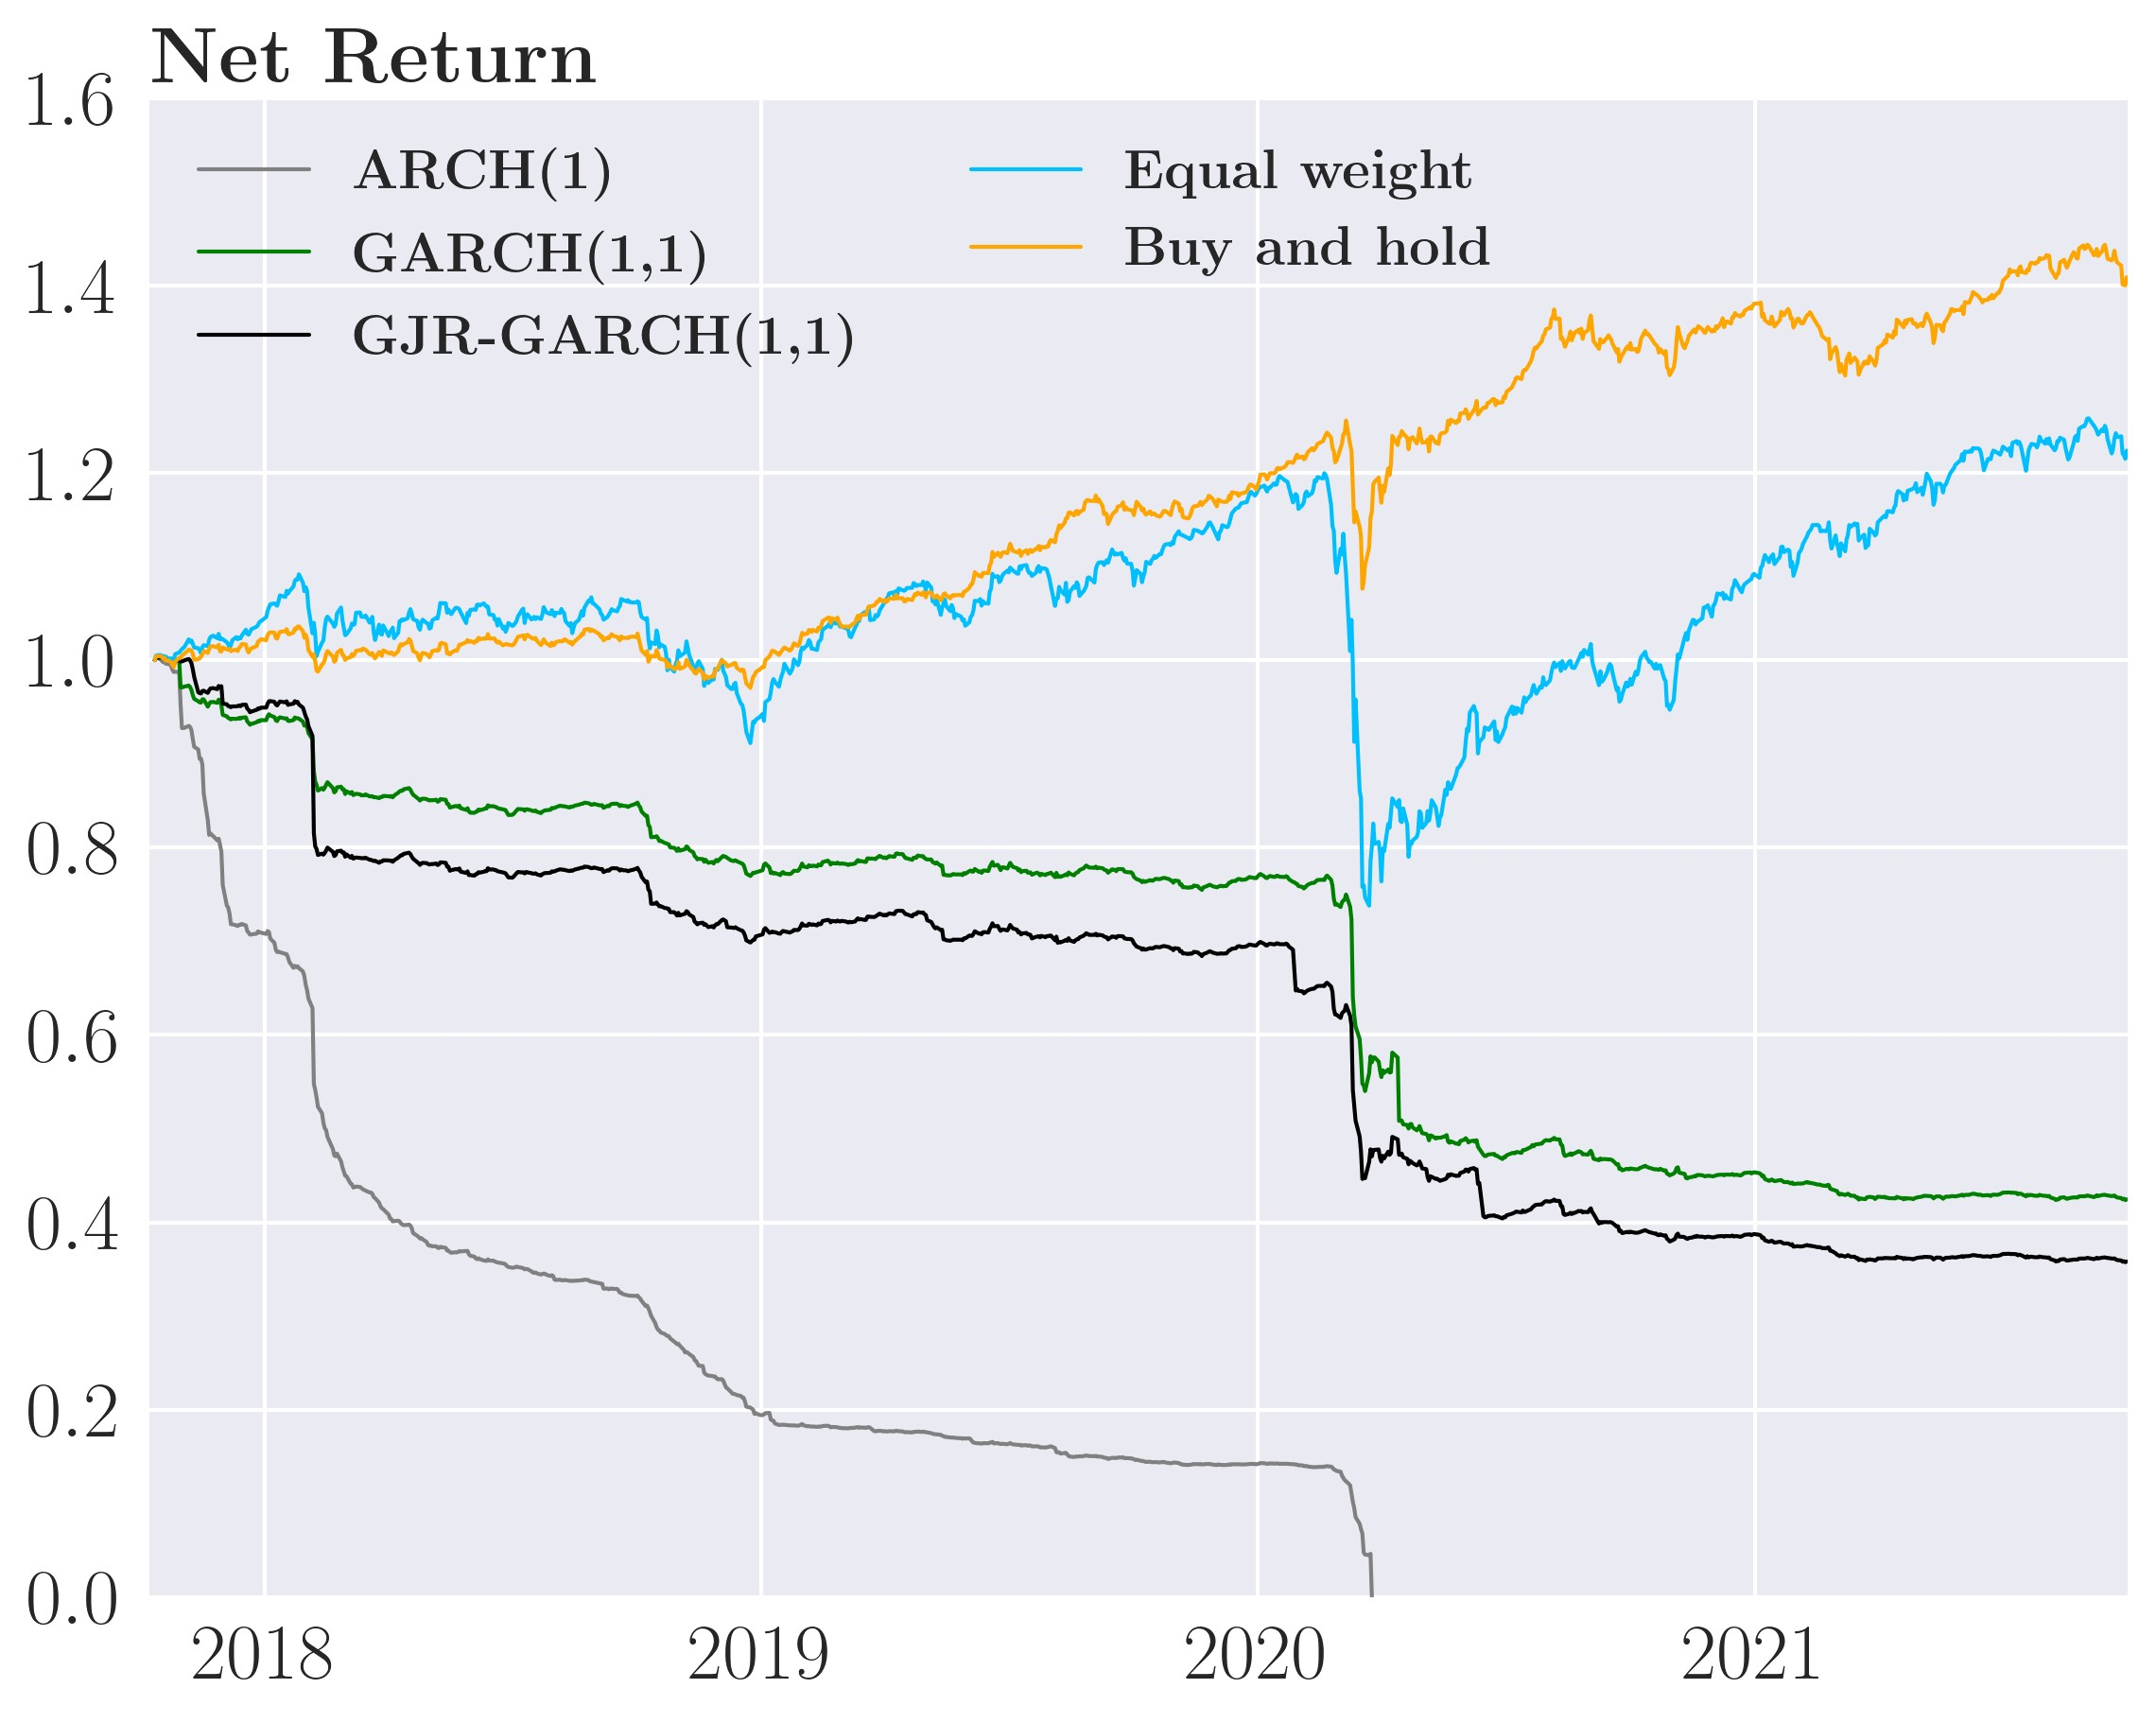

weights are plotted in figure 11 panel (b). In contrast to the weights of the simple ARCH(1) strategy in panel (a), the weights given by the simple GARCH(1,1) strategy are clearly more persistent and slowly converge to back as explained in section 6.3.1 rather than jump back as in the simple ARCH(1) strategy. The main differences between the IRF plots and this being the number of shocks to hit the model such that model never fully converge back in the real world.

The weights given of the simple GJR-GARCH(1,1) strategy shown in figure 25 in the appendix are very similar to those given by the simple GARCH(1,1) strategy. The main difference between the two is that the drops in the weights given by the simple GJR-GARCH(1,1) strategy are slightly larger than the simple GARCH(1,1) strategy caused by the asymmetric responses to shocks in the GJR-GARCH(1,1). The larger adjustment of the weight for the simple GJR-GARCH(1,1) strategy are the most costly as transaction costs are quadratic, which will become relevant later when considering performance after transaction costs.

For the simple strategies, it is evident that significant portfolio changes happen during the market crash caused by the COVID-19 pandemic of March and April 2020, especially for the ARCH(1). These major changes become very costly for the investor after transaction costs. Additionally, the bond ETFs unsurprisingly dominate the portfolio regardless of model choice because they have the lowest estimated volatility of all assets, which is attractive for minimum variance investors.

Continuing with performance measurements of the simple strategy benchmarked against an Equal-weight strategy that maintains a 1*/N* weight in each asset and a Buy-and-hold strategy that holds a minimum variance portfolio from the first period across time with no rebalancing. Recall that we are interested in minimum variance portfolios, which makes the standard deviation the most important performance measure, but we of course also report the average return and Sharpe ratio as a low-risk strategy that looses all it money is not desirable.

Table 5: Annualized performance of the simple strategy, all assets

Strategy Std. deviation Return Sharpe ratio Transaction costs

|  |  |  |  |
| --- | --- | --- | --- |
|  |  | Before transaction costs |  |
| ARCH(1) | 0.0788 | 0.0724 0.9186 |  |
| GARCH(1,1) | 0.0628 | 0.0644 1.0246 |  |
| GJR-GARCH(1,1) | 0.0650 | 0.0626 0.9632 |  |
| Equal-weight | 0.1565 | 0.1105 0.7062 |  |
| Buy-and-hold | 0.0780 | 0.0894 1.1462 |  |
|  |  | After transaction costs |  |
| ARCH(1) | 0.6869 | -1.0000 -1.4559 | 100.00% |
| GARCH(1,1) | 0.1098 | -0.1928 -1.7553 | 24.144% |
| GJR-GARCH(1,1) | 0.1227 | -0.2263 -1.8442 | 27.137% |
| Equal-weight | 0.1626 | 0.0517 0.3182 | 5.2374% |
| Buy-and-hold | 0.0780 | 0.0894 1.1462 | 0% |

Before transaction costs, the simple GARCH(1,1) has the lowest annualized standard deviation of 6.3%, closely followed by the GJR-GARCH(1,1) with a standard deviation of 6.5%. Even when the variance is modeled by the very simple ARCH(1,1), the annualized standard deviation is 7.8% where the Equal-weight and Buy-and-hold have an annualized standard deviation of 15.7% and 7.8% respectively. Thus, all strategies where the covariance matrix is modeled by a (G)ARCH model have lower or similar annualized standard deviations before transaction costs. In terms of Sharpe ratio, Buy-and-hold strategy has the highest Sharpe ratio of 1.15, closely followed by the simple GARCH(1,1) strategy with a Sharpe ratio of 1.03 and with the Equal-weight as the worst-performing with a Sharpe ratio of 0.70.

After transaction costs, the simple strategy unsurprisingly do far worse. Especially the simple ARCH(1) strategy as the trading volume of the strategy is significant, as can be seen in figure 11 panel(a) and from table 5, where the ARCH(1) loses 100% of its portfolio value to transaction costs. The effects of this are twofold. First and most importantly, the simple ARCH(1) strategy trades away all its wealth and becomes worthless after 2.5 years. Secondly, transaction costs causes greater volatility as the payments made in transaction costs leads to massive drops in portfolio value which causes increased volatility. This comes as a result of the dynamics of the simple ARCH(1) strategy as it rebalances heavily in the event of a shock which happens frequently in the real world. With quadratic transaction costs, the large and frequent rebalancing of the simple ARCH(1) strategy are very costly and hurts performance measured in net returns. Overall this results in an annualized return of -100% as the investor goes bankrupt. This likewise increases the annualized volatility to 68.7%. Note that the interpretation of the Sharpe ratio becomes rather difficult with negative returns as the simple ARCH(1) strategy has a better Sharpe ratio then the simple GARCH(1,1) and simple GJRGARCH(1,1) strategy though the simple ARCH(1) strategy has much lower annualized returns and much higher standard deviation.

In contrast to the simple ARCH(1) strategy, the effects of transaction costs in the simple GARCH(1,1) strategy are much less profound as the more persistent covariance estimates of GARCH(1,1) cause less trading and as such it annually loses 24.1% of its portfolio value to transaction costs compared to the 100% of the simple ARCH(1) strategy. This results in negative annualized net returns of -19.3% and a higher annualized standard deviation of 11%. The main reason the simple GARCH(1,1) strategy performs better than the simple ARCH(1) strategy can found in its dynamics. Mainly, due to the different responses to shocks where the weights of the simple ARCH(1) strategy responds more to shocks courtesy of much higher *α* estimates than the simple GARCH(1,1) strategy. Secondly, where the simple ARCH(1,1) strategy converges back immediately after a shock leaves the model the GARCH(1,1) converges back exponentially. This leaves the simple ARCH(1) strategy making one very large adjustment when a shock hits and one often equally large adjustment back as the shock leaves whereas the simple GARCH(1,1) strategy makes one moderate adjustment when the shock hits and then several smaller adjustment back afterwards. The latter is far less costly and explains part of difference in net return, the other reason being superior volatility predictions of the GARCH(1,1).

The simple GJR-GARCH(1,1) strategy is very similar to the simple GARCH(1,1) strategy but performs a bit worse. The strategy earns annualized net return of -22.6% with a standard deviation of 12.3%. The simple GJR-GARCH(1,1) strategy performance is poorer due to asymmetry of the GJR-GARCH(1,1) variance model such that when a negative shock hits the simple GJR-GARCH(1,1) adjusts slightly more than the simple GARCH(1,1) strategy and since we have quadratic transaction costs, this extra adjustment is the most costly which adds up over the four year period. This is quite evident from table 5 where the simple GJRGARCH(1,1) strategy annually loses 27.1% of its portfolio value to transaction costs which 3 percentage point more than the simple GARCH(1,1) strategy, which adds up over the 4 year period.

The Buy-and-hold strategy is unaffected as it doesn’t trade and thus take the lead in lowest annualized standard deviation after transaction costs. The Equal-weight strategy is only moderately affected by transaction costs as it only needs to make minor adjustments along the period which halves the annualized return and nearly doubles the volatility.

To summarize, the simple strategy is able to reduce the portfolio risk when measuring gross returns compared to the Buy-and-hold and Equal-weight strategies. This is done while having Sharpe ratios greater or similar to the Buy-and-hold strategy and higher than the Equal-weight strategy . However, after transaction costs, the simple strategy perform much poorer as costly rebalancing chisel away at the value of the portfolio.

From the weight in figure 11, we see that the minimum variance portfolios heavily favors non equity ETFs. In gross return, the GARCH strategy have success with reducing risk. Does this also apply when only considering equity ETFs?

### Backtesting the simple strategy with stocks only

From figure 11 panel (a)-(b), it is evident that the minimum variance portfolios mainly consist of 20+ years treasuries and high-yield corporate bonds which leaves the question of whether the forecast of Ω*t*+1, Ω*t*+1|*t* can help the investor reduce the risk of his portfolio in the case where the investor do not have access to these less risky assets with low correlations to market risk. Therefor, we consider the case where the investor must invest in stock ETFs thus leaving out commodities and bonds.

Figure 13: Portfolio weights of the simple strategy, stocks

(a) ARCH(1) weights, *vt*MVP (b) GARCH(1,1) weights, *vt*MVP

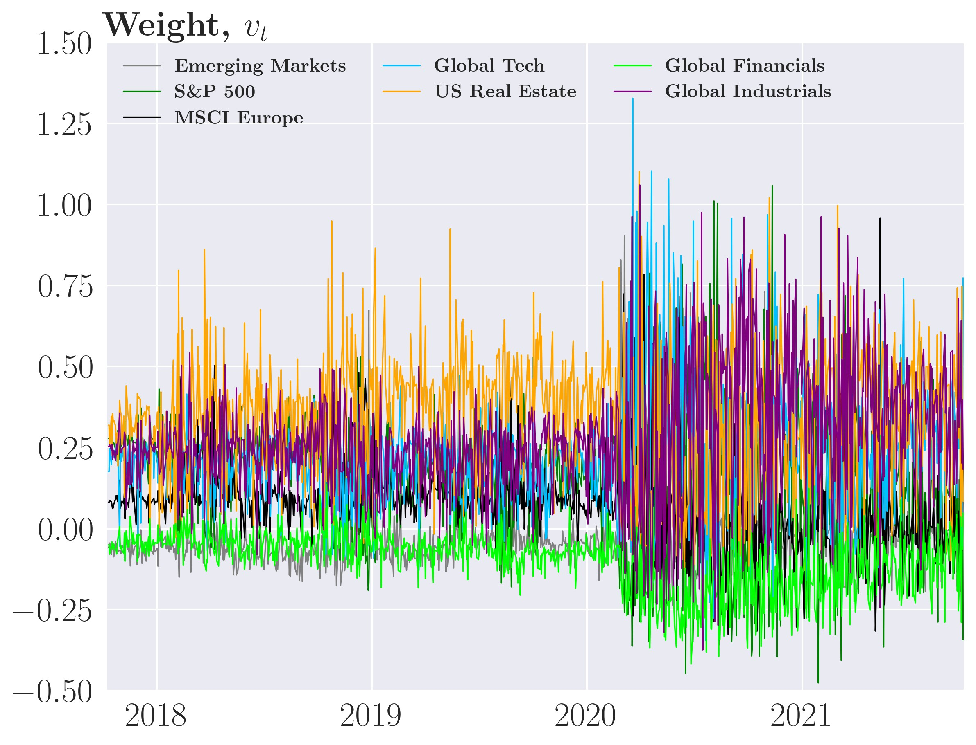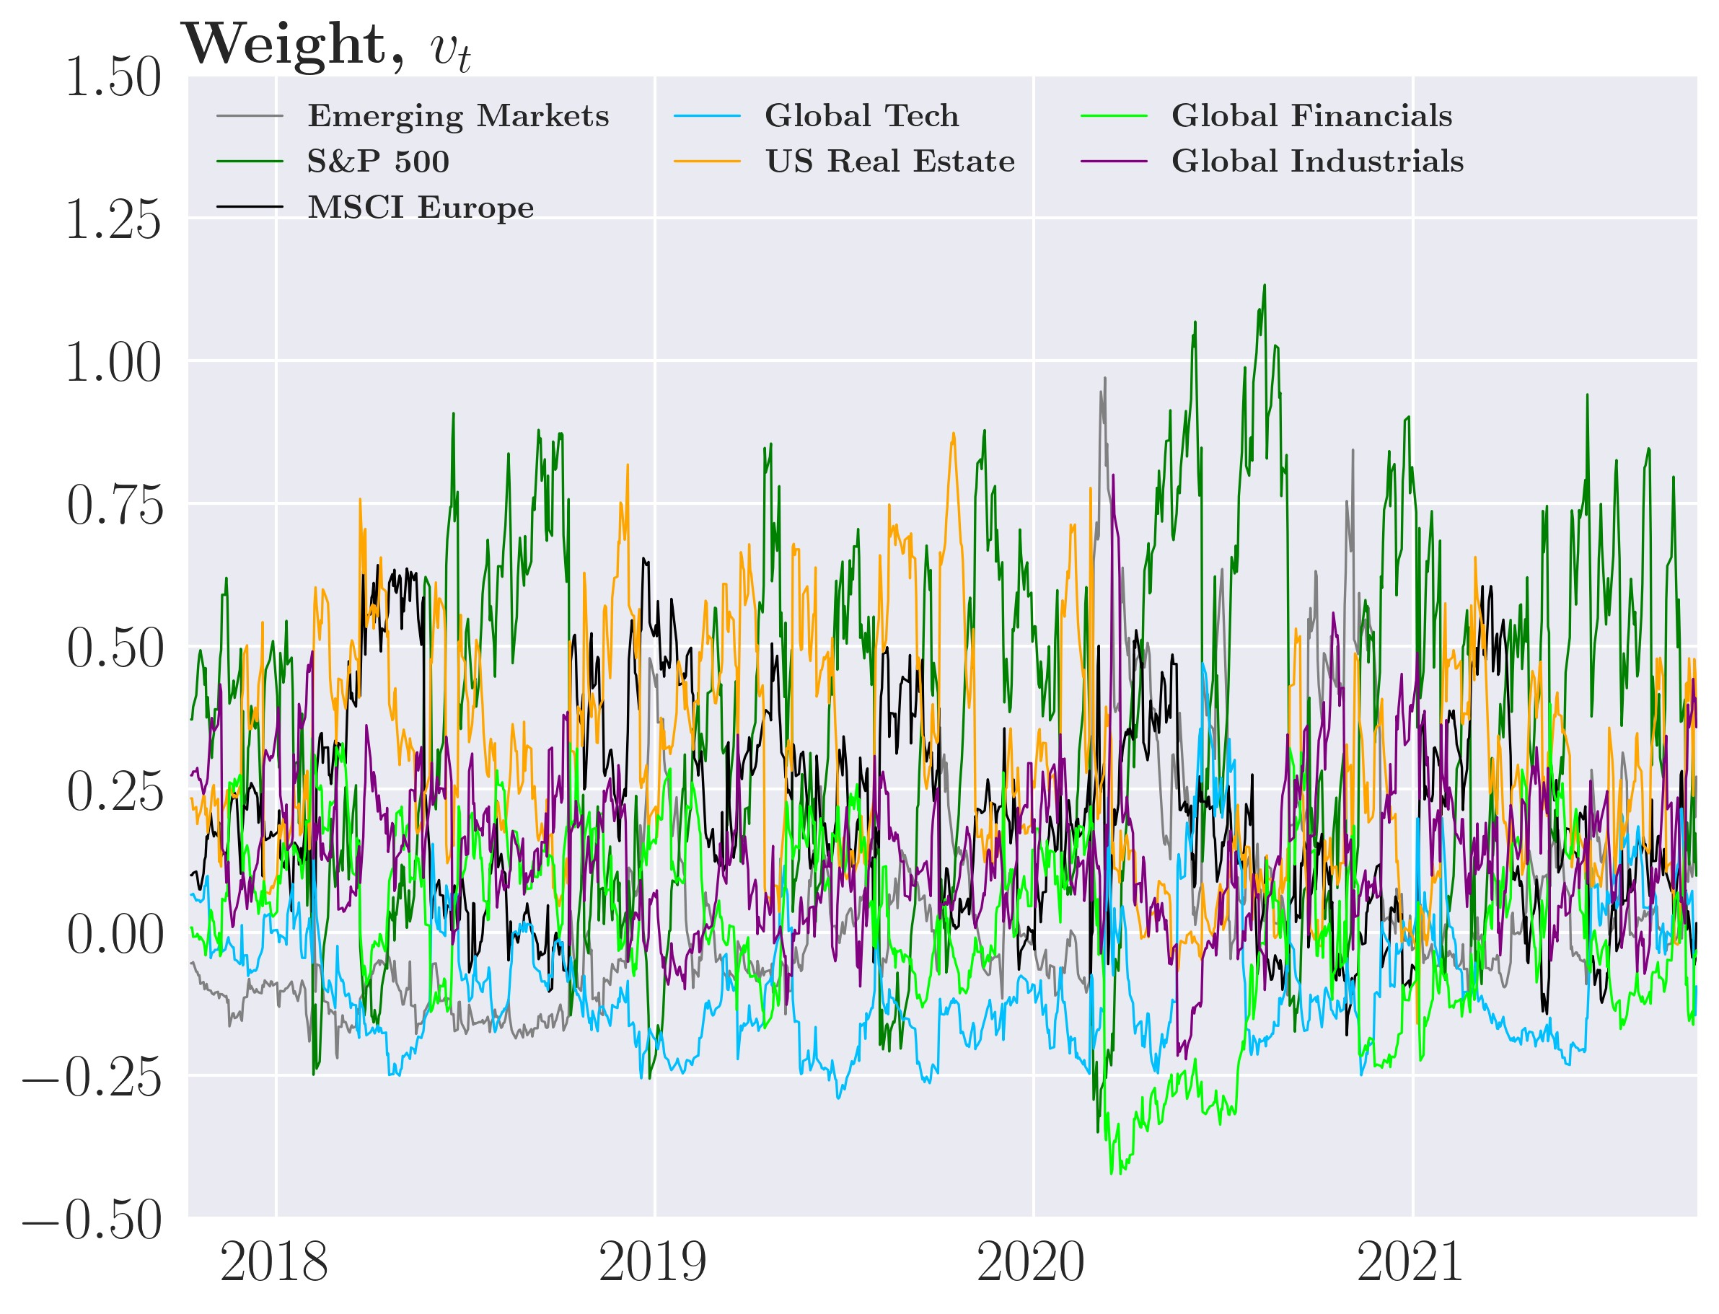

From figure 13 panel (a)-(b),[15] we see that the dynamics of the weight for simple strategies do not change from the case including commodities and bonds ETFs. However, there is greater span in the weight from -50% to 125% indicating that the optimization needs to go to more extreme weights to find the lowest possible risk. Additionally, this causes even large sudden change in the different positions of the investors portfolio. Consider S&P 500 index, that changes from having weights of around 125% to as low as -25% for the simple ARCH(1) strategy. After the Covid-19 pandemic market crash of March and April 2020, we see greater volatility to the weight of three simple strategies, however, it is most viable for the simple ARCH(1) strategy in panel(a). This is naturally a result of the higher volatility of this period caused by the Covid-19 pandemic.

These frequent and large changes are very costly which is evident from the the differences in between gross returns in panel (a) and net returns in panel (b) of figure 14. For the simple ARCH(1) strategy, it takes just 14 days for the strategy to lose 100% of the portfolio value almost exclusively from transaction costs. For the simple GARCH(1,1) and GJR-GARCH(1,1) strategies, it takes roughly 2 years then both strategies have lost everything to almost exclusively to transaction costs with both of them annually losing 84% to transaction costs. From table 6, the simple strategies ends up losing the vast majority of their portfolio value to transaction costs.

The impact of transaction costs can likewise be seen in table 6, where the simple ARCH(1) strategy earns an average annualized gross return of 11% which is translated to a net annualized average return of -100%. For the GARCH(1,1) and GJR-GARCH(1,1) case, they are earning an average annualized gross return of 8.9% and 9.1% respectively and a net annualized average return of -100%. This undoubtedly shows why investors must adjust for transaction costs for these investment strategies to be viable.

Figure 14: Cumulative performance of the simple strategy, stocks only

(a) Gross return (b) Net return

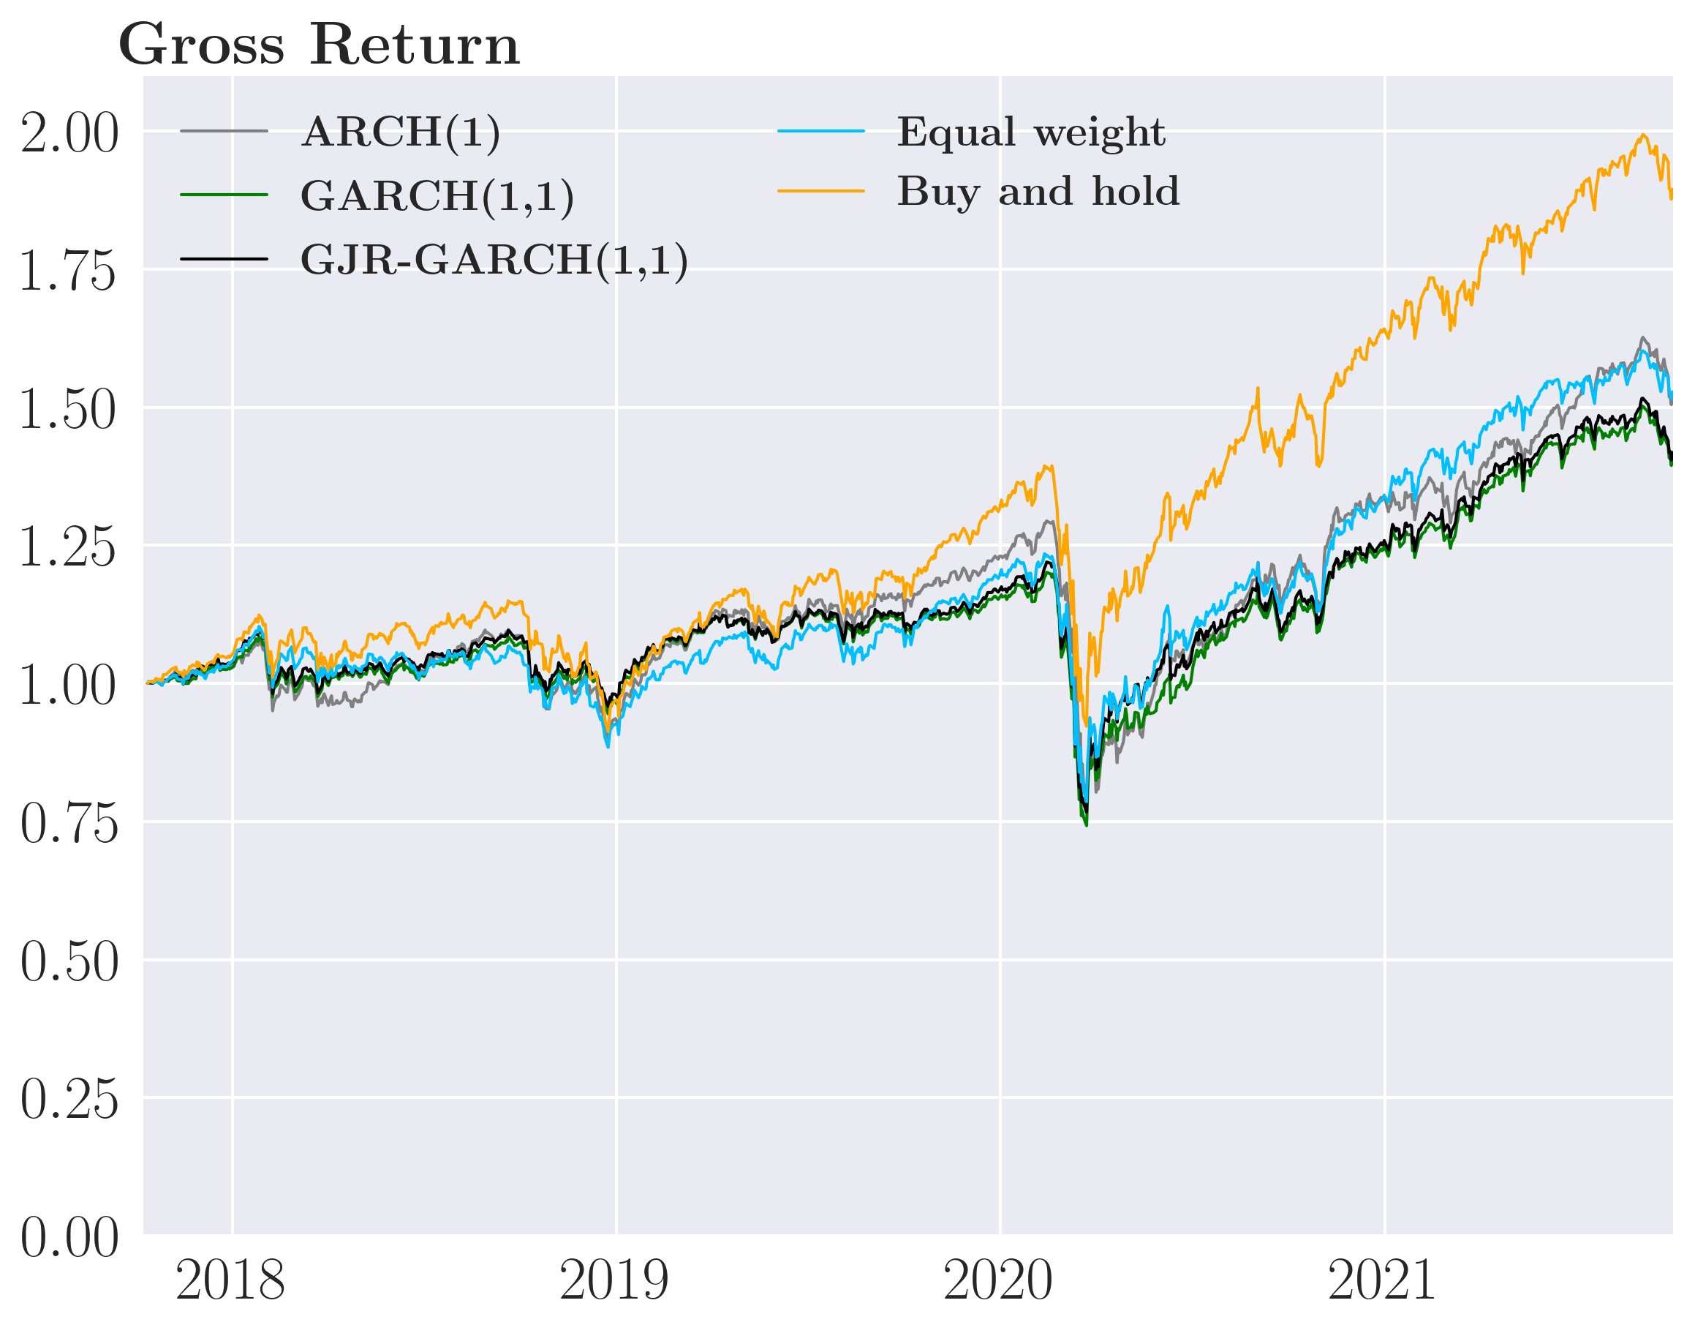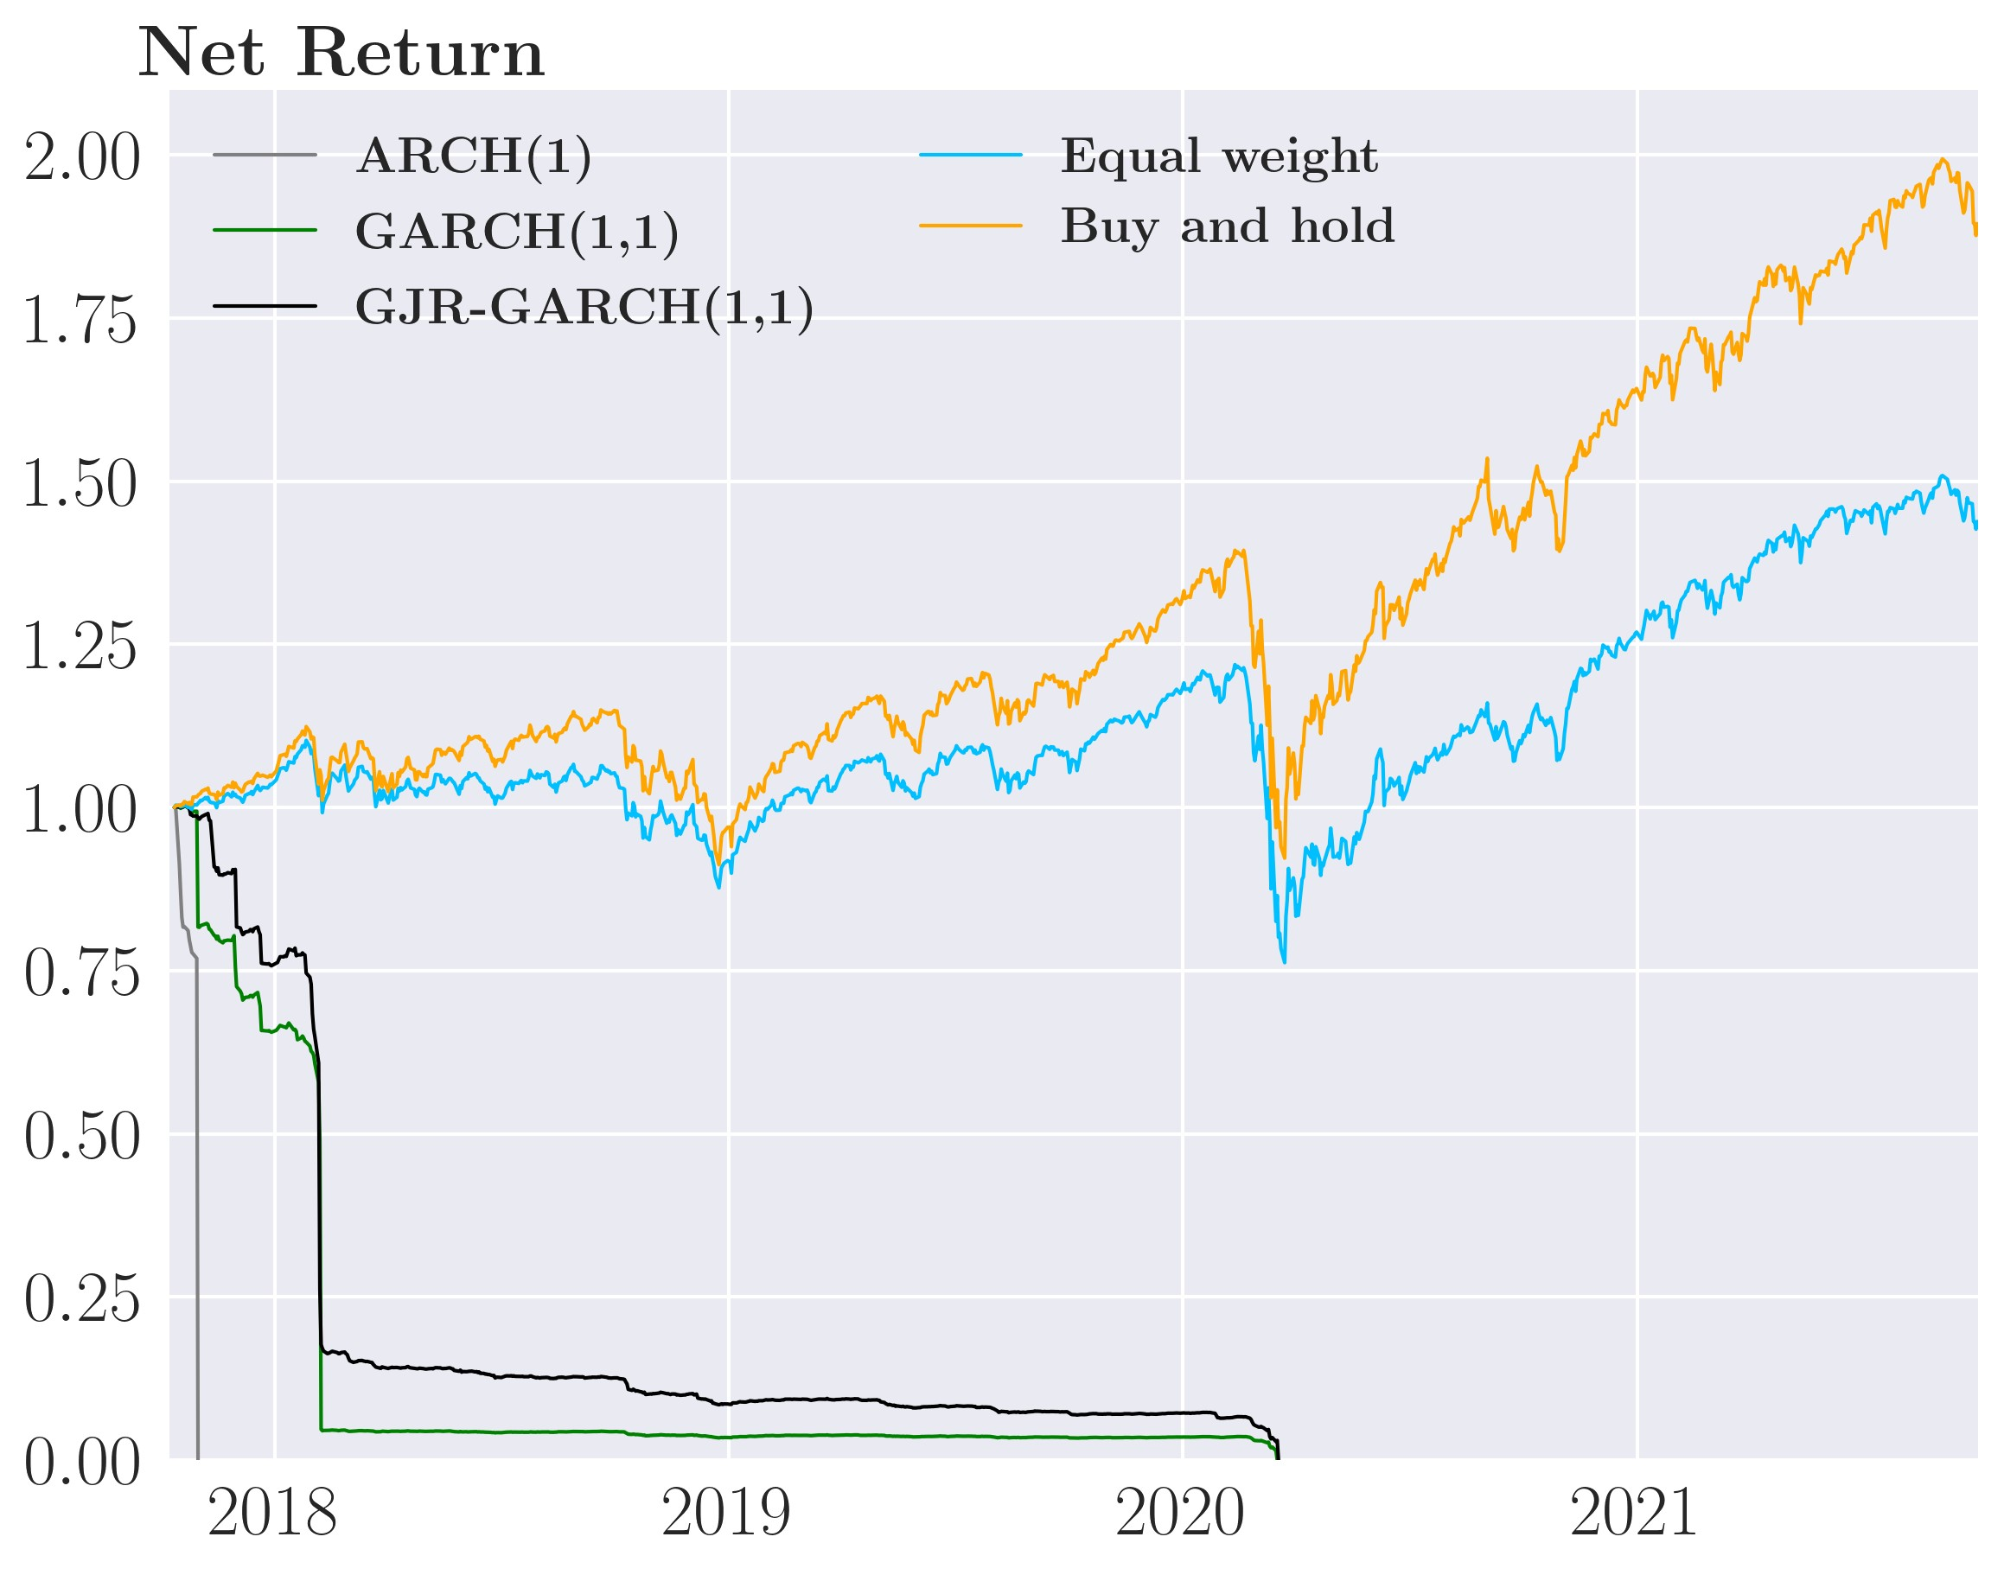

But in a world free of transaction costs, we still see that the simple strategies are able to reduced risk with the simple GARCH(1,1) strategy having the lowest annualized standard deviation of 18.7% closely following by the simple GJR-GARCH(1,1) strategy of 18.9% compared to 22% for Buy-and-hold strategy and 20.8% for the Equal-weight strategy. Though this does not apply when considering net returns where the performance of the simple strategies suffers heavily from very high trading volume and therefor very high transaction costs payments. Additionally, the Equal-weight and Buy-and-hold have betters Sharpe Ratios both in gross returns and net returns.

Table 6: Annualized performance of the simple strategy, stocks

Strategy Std. deviation Return Sharpe ratio Transaction costs

|  |  |  |  |
| --- | --- | --- | --- |
|  |  | Before transaction costs |  |
| ARCH(1) | 0.2082 | 0.1105 0.5306 |  |
| GARCH(1,1) | 0.1876 | 0.0892 0.4755 |  |
| GJR-GARCH(1,1) | 0.1898 | 0.0912 0.4808 |  |
| Equal-weight | 0.2082 | 0.1117 0.5366 |  |
| Buy-and-hold | 0.2197 | 0.1732 0.7882 |  |
|  |  | After transaction costs |  |
| ARCH(1) | 4.3101 | -1.0000 -0.2320 | 100.00% |
| GARCH(1,1) | 0.9179 | -1.0000 -1.0894 | 83.949% |
| GJR-GARCH(1,1) | 0.8117 | -1.0000 -1.2320 | 83.779% |
| Equal-weight | 0.2083 | 0.0951 0.4565 | 1.4989% |
| Buy-and-hold | 0.2197 | 0.1732 0.7882 | 0% |

The main takeaway is that it is vital to adjust for transaction costs when setting up an investment strategy. As seen in the performance table above, a good strategy before transaction costs can be downright terrible strategy after transaction costs if the portfolio changes are sufficiently large. Therefore, we move on and now penalize the investor for trading by adding quadratic transaction costs into the investors objective function using the objective function in equation (29), the "sophisticated" strategy.

## 6.4 Sophisticated strategy (adjusting for transaction costs)

We continue with the more complex case where the investor adjusts for transaction costs (the sophisticated strategy). The investor adjusts for transaction costs in his objective function (see equation 29) by being penalized for the change the investor makes Λ*t*(*vt* −*vt*−1). We show performance both before and after subtracting transaction costs to highlight the importance of adjusting for them. We also explore the dynamics of the model by understanding how shocks impact Ω*t*+1|*t* and thereby the optimal weights *vt* and how the investor rebalances his portfolio given that doing so is costly.

### 6.4.1 Understanding the dynamics of the sophisticated strategy

First, we address the point in section 4.2.2 about the normalized aim portfolio being almost equivalent to the simple strategy from equation (28), i.e., a time-varying minimum variance portfolio. Below, we plot the weights for two random assets of both portfolios over an outof-sample period of 1000 days: We observe very similar weights in both portfolios, except for

Figure 15: Similarity between the normalized aim portfolio (red) and the simple strategy (green)

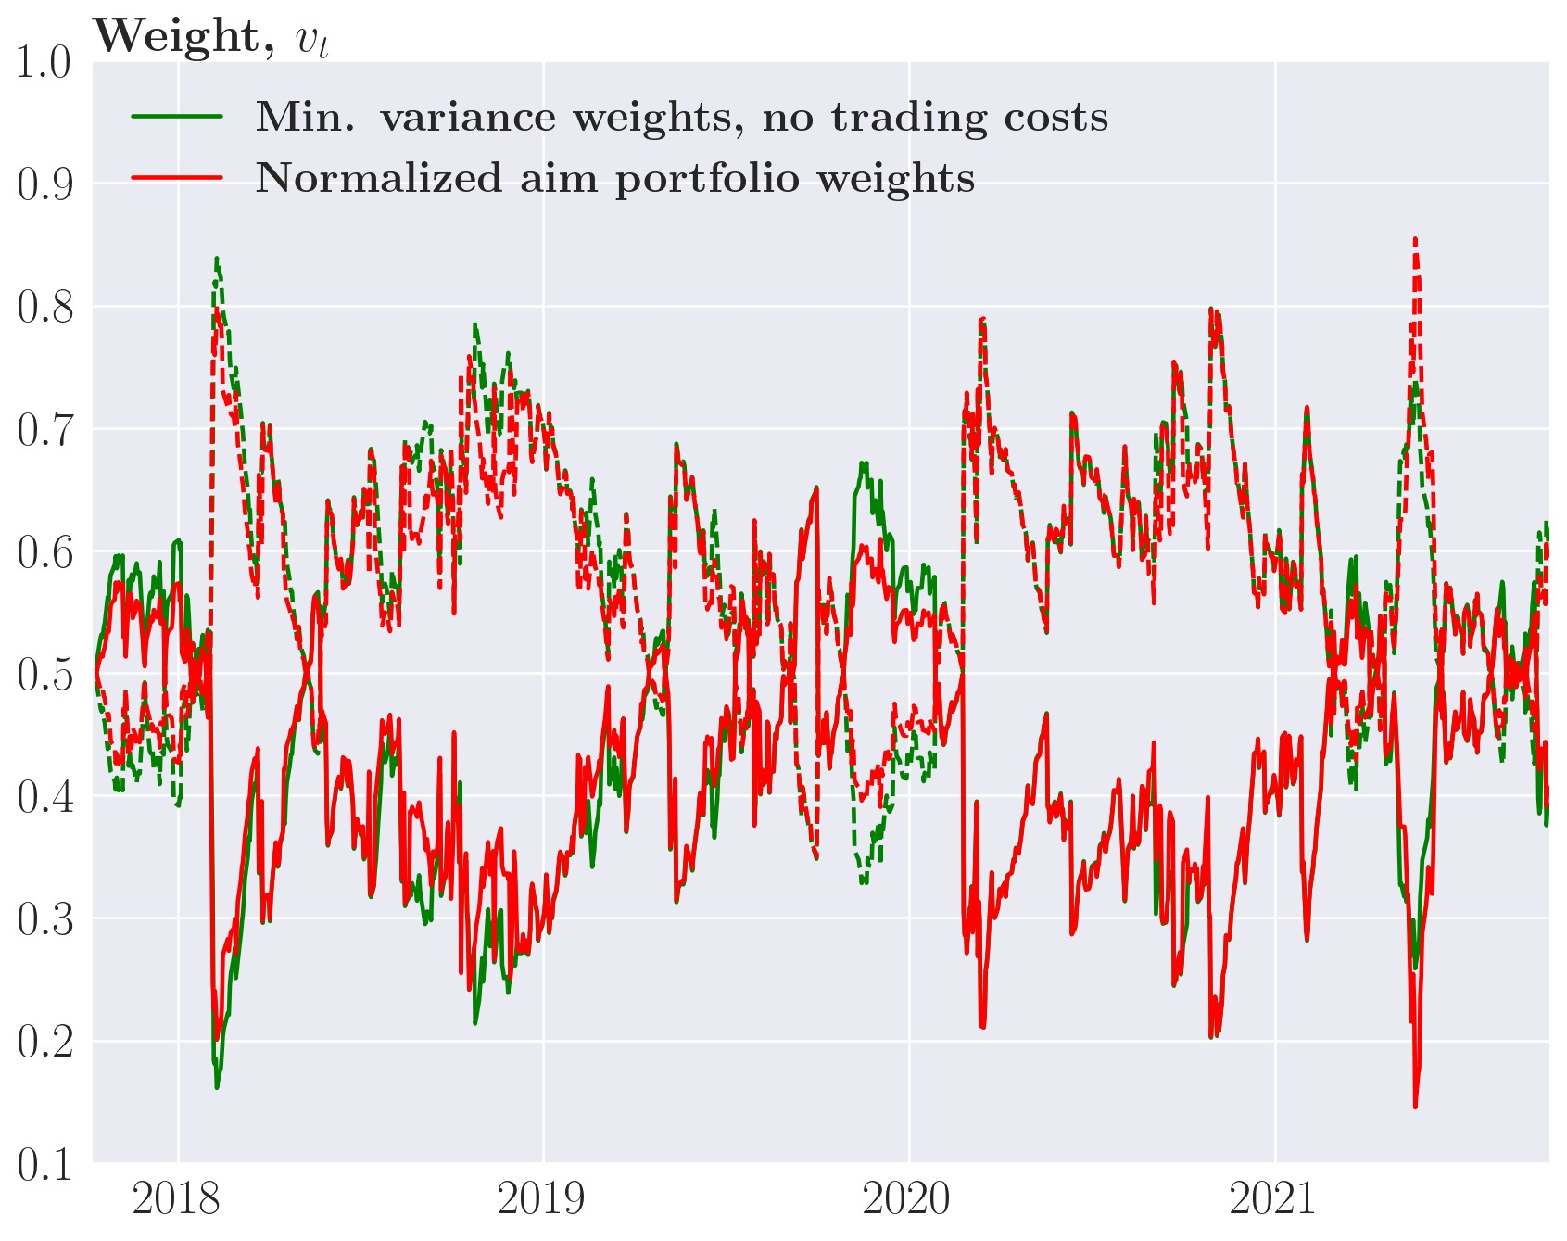

*Note*: The two assets are S&P500 (solid line) and 20+ year Treasuries (dotted line)

some noise that we have verified to be partly due to instability when normalizing the weights of the aim portfolio when the aim portfolio nearly sums to 0. This is promising for our otherwise incomplete theoretical results; the thing missing is the aim portfolio is summing to 1 in the end, which we also verified in the theoretical section. As we haven’t solved this correctly, we, unfortunately, have to leave it as a topic for further research and move on. It is however comforting that the normalized aim portfolio closely resembles the simple strategy because this is the minimum variance portfolio when ignoring transaction costs. So, we interpret the sophisticated strategy as having the same target as the simple strategy, but with an additional element to optimally account for transaction costs.

Similar to the case where investors ignore transaction costs, we illustrate the dynamics by modeling three assets for 10.000 periods from *t* = −5000 to *t* = 5000. We give a single shock of -2 to S&P500 ETF at *t* = 0 and plot how the weights of the different assets change and converge back to their long-run equilibrium.

An essential factor in the dynamics is the size of transaction costs mainly determined by

*γD*, which can be interpreted as the risk-aversion of the dealer. Intuitively, the bigger *γD* is, the less the investor trades as transaction costs increase. For the calibrated value of *γD*, the convergence towards the aim portfolio happens quickly in all our models, which turns out to be very costly with quadratic transaction costs where large portfolio changes are punished heavily. To remedy this, we implement an idea similar in spirit to [Hautsch and Voigt, 2019] where we increase the parameter *γD* above the empirically calibrated value, in order to punish portfolio changes more. We find that increasing ex-ante transaction costs imply putting more weight on a Buy-and-hold strategy. Note that this does not increase the actual cost of transactions but the investor thinks it does ex-ante or he at least perceives transaction costs as higher. This specifically changes equation (33) which now becomes:

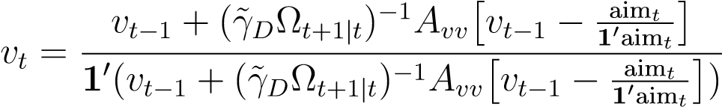

Where *γ*˜*D* is the parameter we tune. Increasing *γ*˜*D* increases the penalty of trading such that

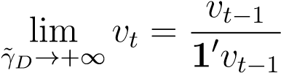

holding all else equal. To illustrate this we plot the dynamics for the sophisticated strategies for *γ*˜*D* ∈ {1*.*52e−6*,*3e−6*,*1e−5}, where 1*.*52e−6 is the empirically calibrated value. Increasing the ex ante transaction costs of the investor highlights the trade-off the investor makes between transaction costs and a portfolio with lower risk.

Let’s start with considering the sophisticated ARCH(1) strategy. In figure 16 panel (a), we see that volatility spikes one period after the shock hits, which is identical to the simple strategy. The volatility spike causes the investor to adjust his positions where the size of the adjustment depends both on the dynamics of the simple strategy shown in 6.3.1 in the aim portfolio and now on the size of *γ*˜*D*.

In figure 16 panel (b), we consider the sophisticated ARCH(1) strategy with *γ*˜*D* equal to the empirically calibrated *γD* i.e. *γ*˜*D* = 1*.*52e−6. At this level of ex-ante transaction costs, the investor completely adjusts his portfolio (solid line) to the aim portfolio (dotted line). We interpret this as the investor believing that the future reduced risk from changing his portfolio completely outweigh the transaction costs associated with the rebalancing. Thus, the dynamics are very similar to the simple strategy in section (6.3.1).

Now, we increase ex-ante transaction costs *γ*˜*D* to 3e−6. In figure 16 panel (c), we now see that the investor adjusts roughly halfway towards the weights dictates by the aim portfolio. After the shock subsides, the aim portfolio immediately returns to the pre-shock weight given the dynamics of the simple ARCH(1) strategy. However, the investor’s portfolio only slowly returns to the pre-shock weight, as changing the portfolio is now perceived as costlier with the convergence to the aim portfolio taking roughly 5 periods.

In figure 16 panel (d), we see that further increasing *γ*˜*D* to 1e−5, results in even smaller adjustment steps towards the aim portfolio and an even slower adjustment back to aim portfolio after the shock subsides. Despite the small reaction to the shock, the investor’s portfolio takes Figure 16: Impulse response function of *vt*MVP for the sophisticated ARCH(1)

(a) Volatility, *σt* (b) Portfolio weights, *vt*MVP, *γ*˜*d* = 1*.*52e−6

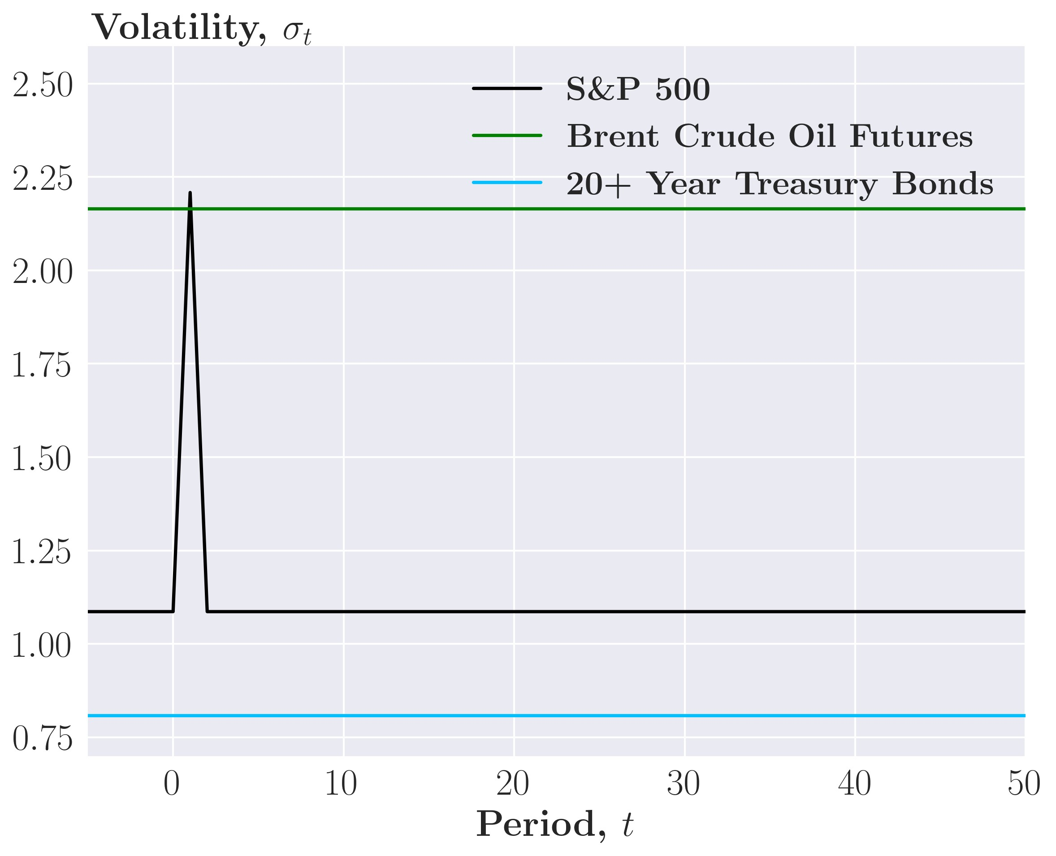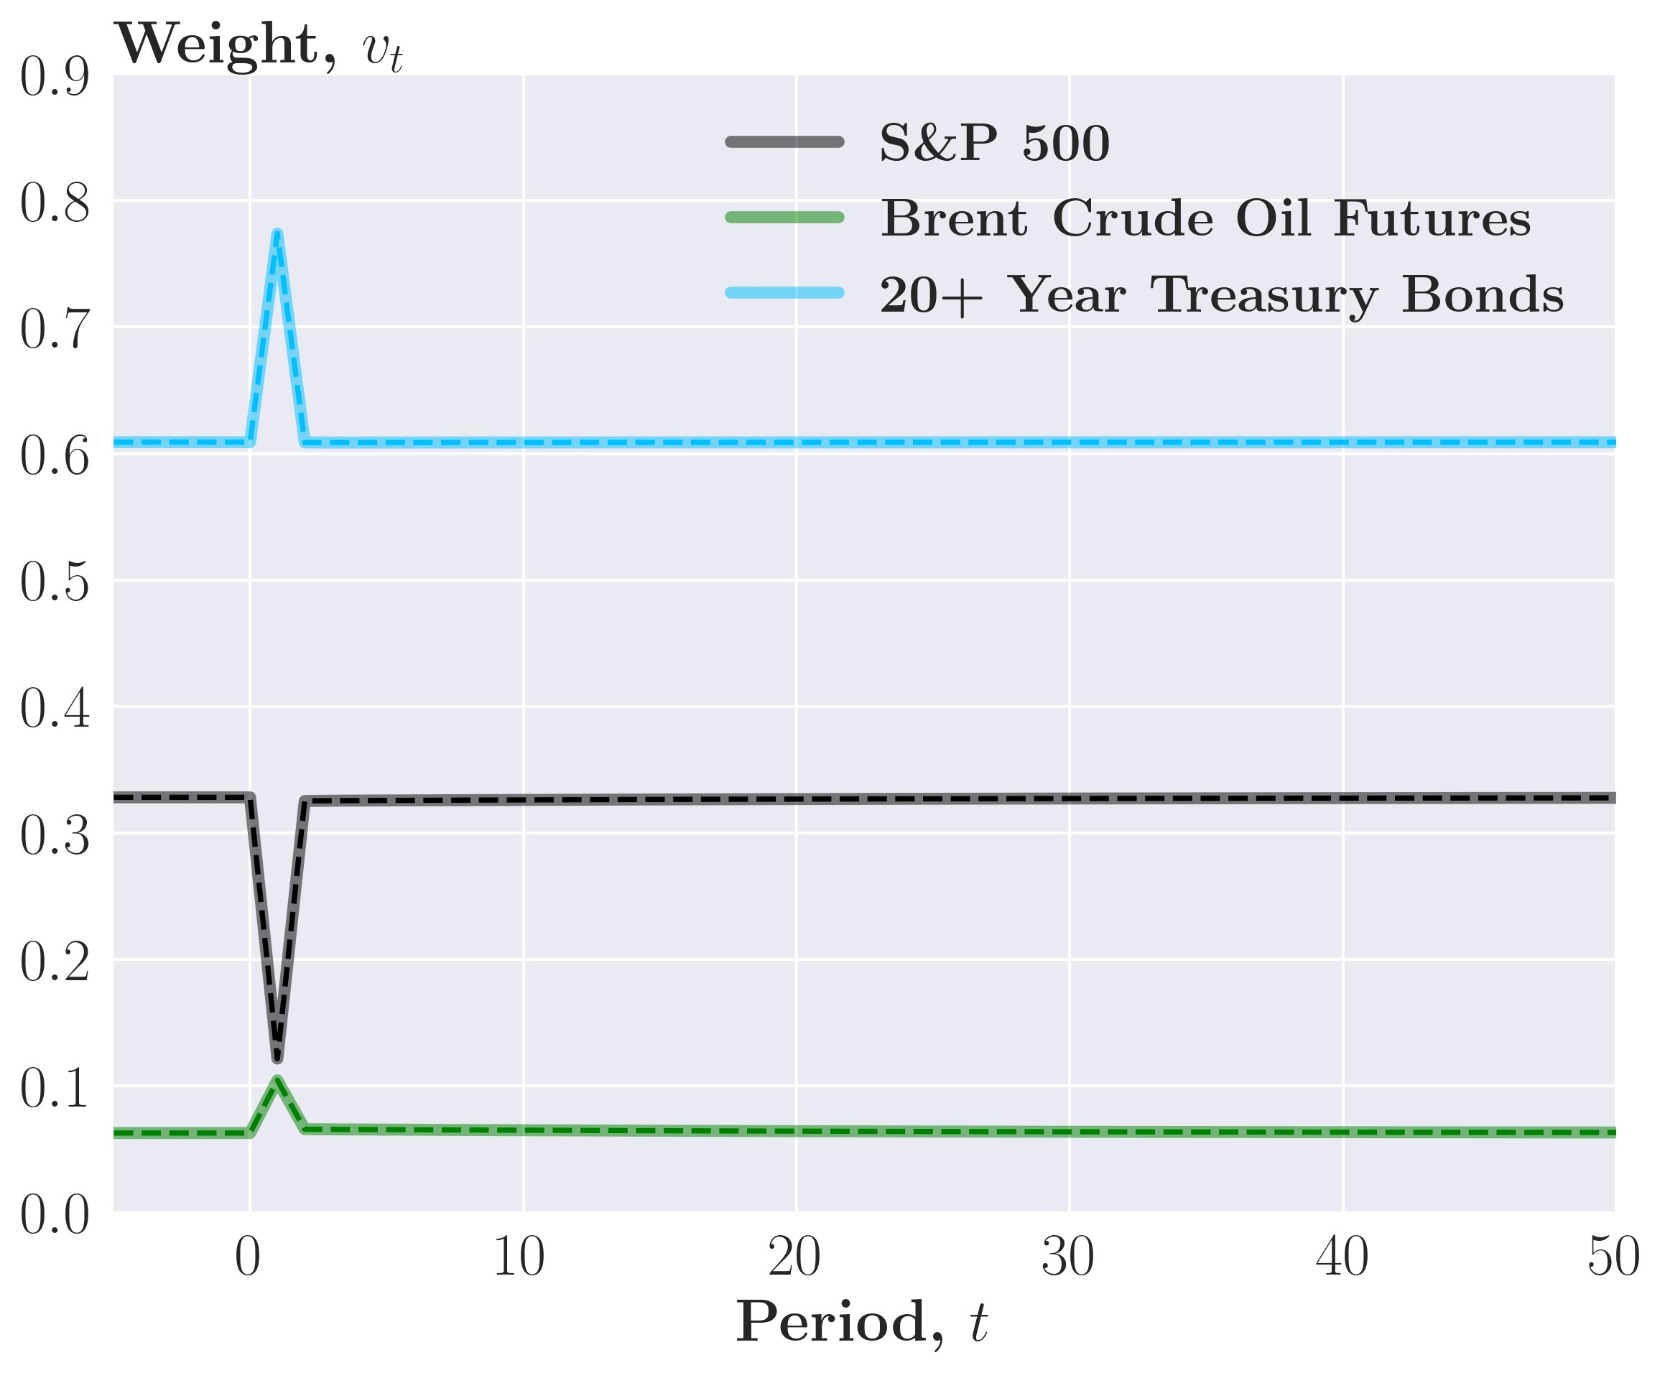

(c) Portfolio weights, *vt*MVP, *γ*˜*d* = 3e−6 (d) Portfolio weights, *vt*MVP, *γ*˜*d* = 1e−5

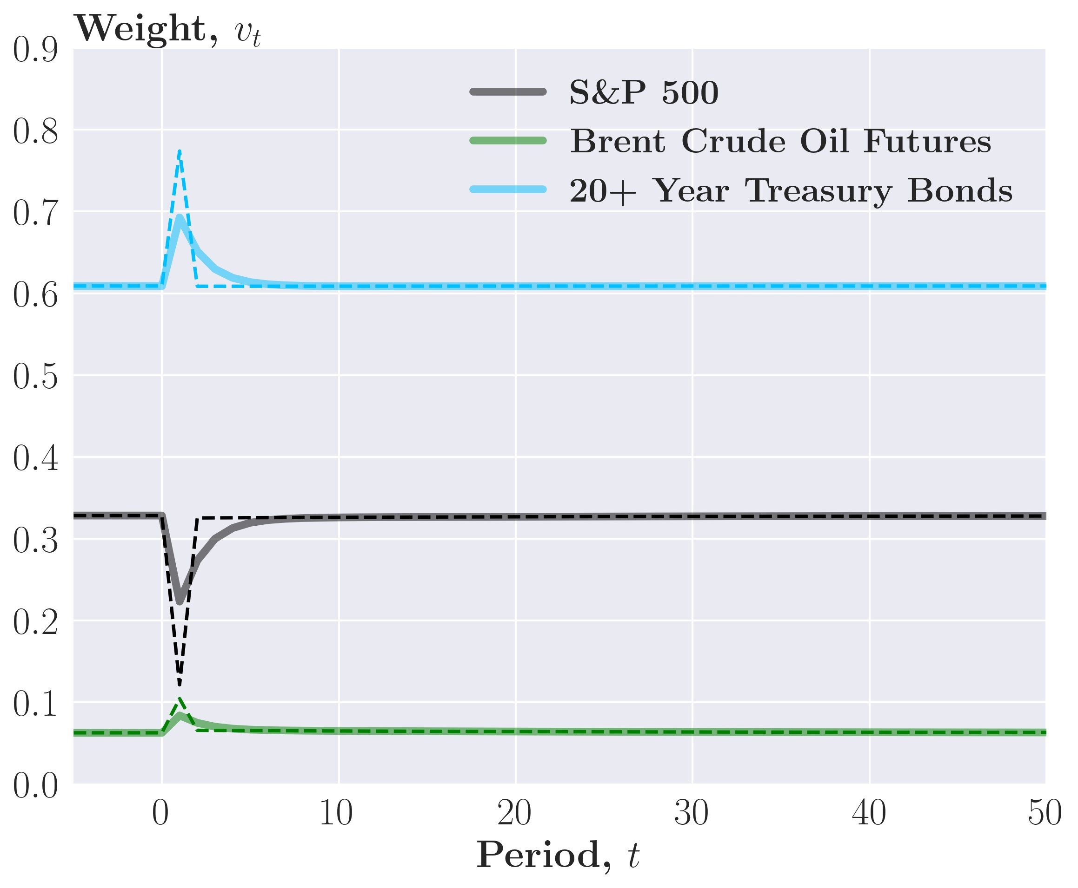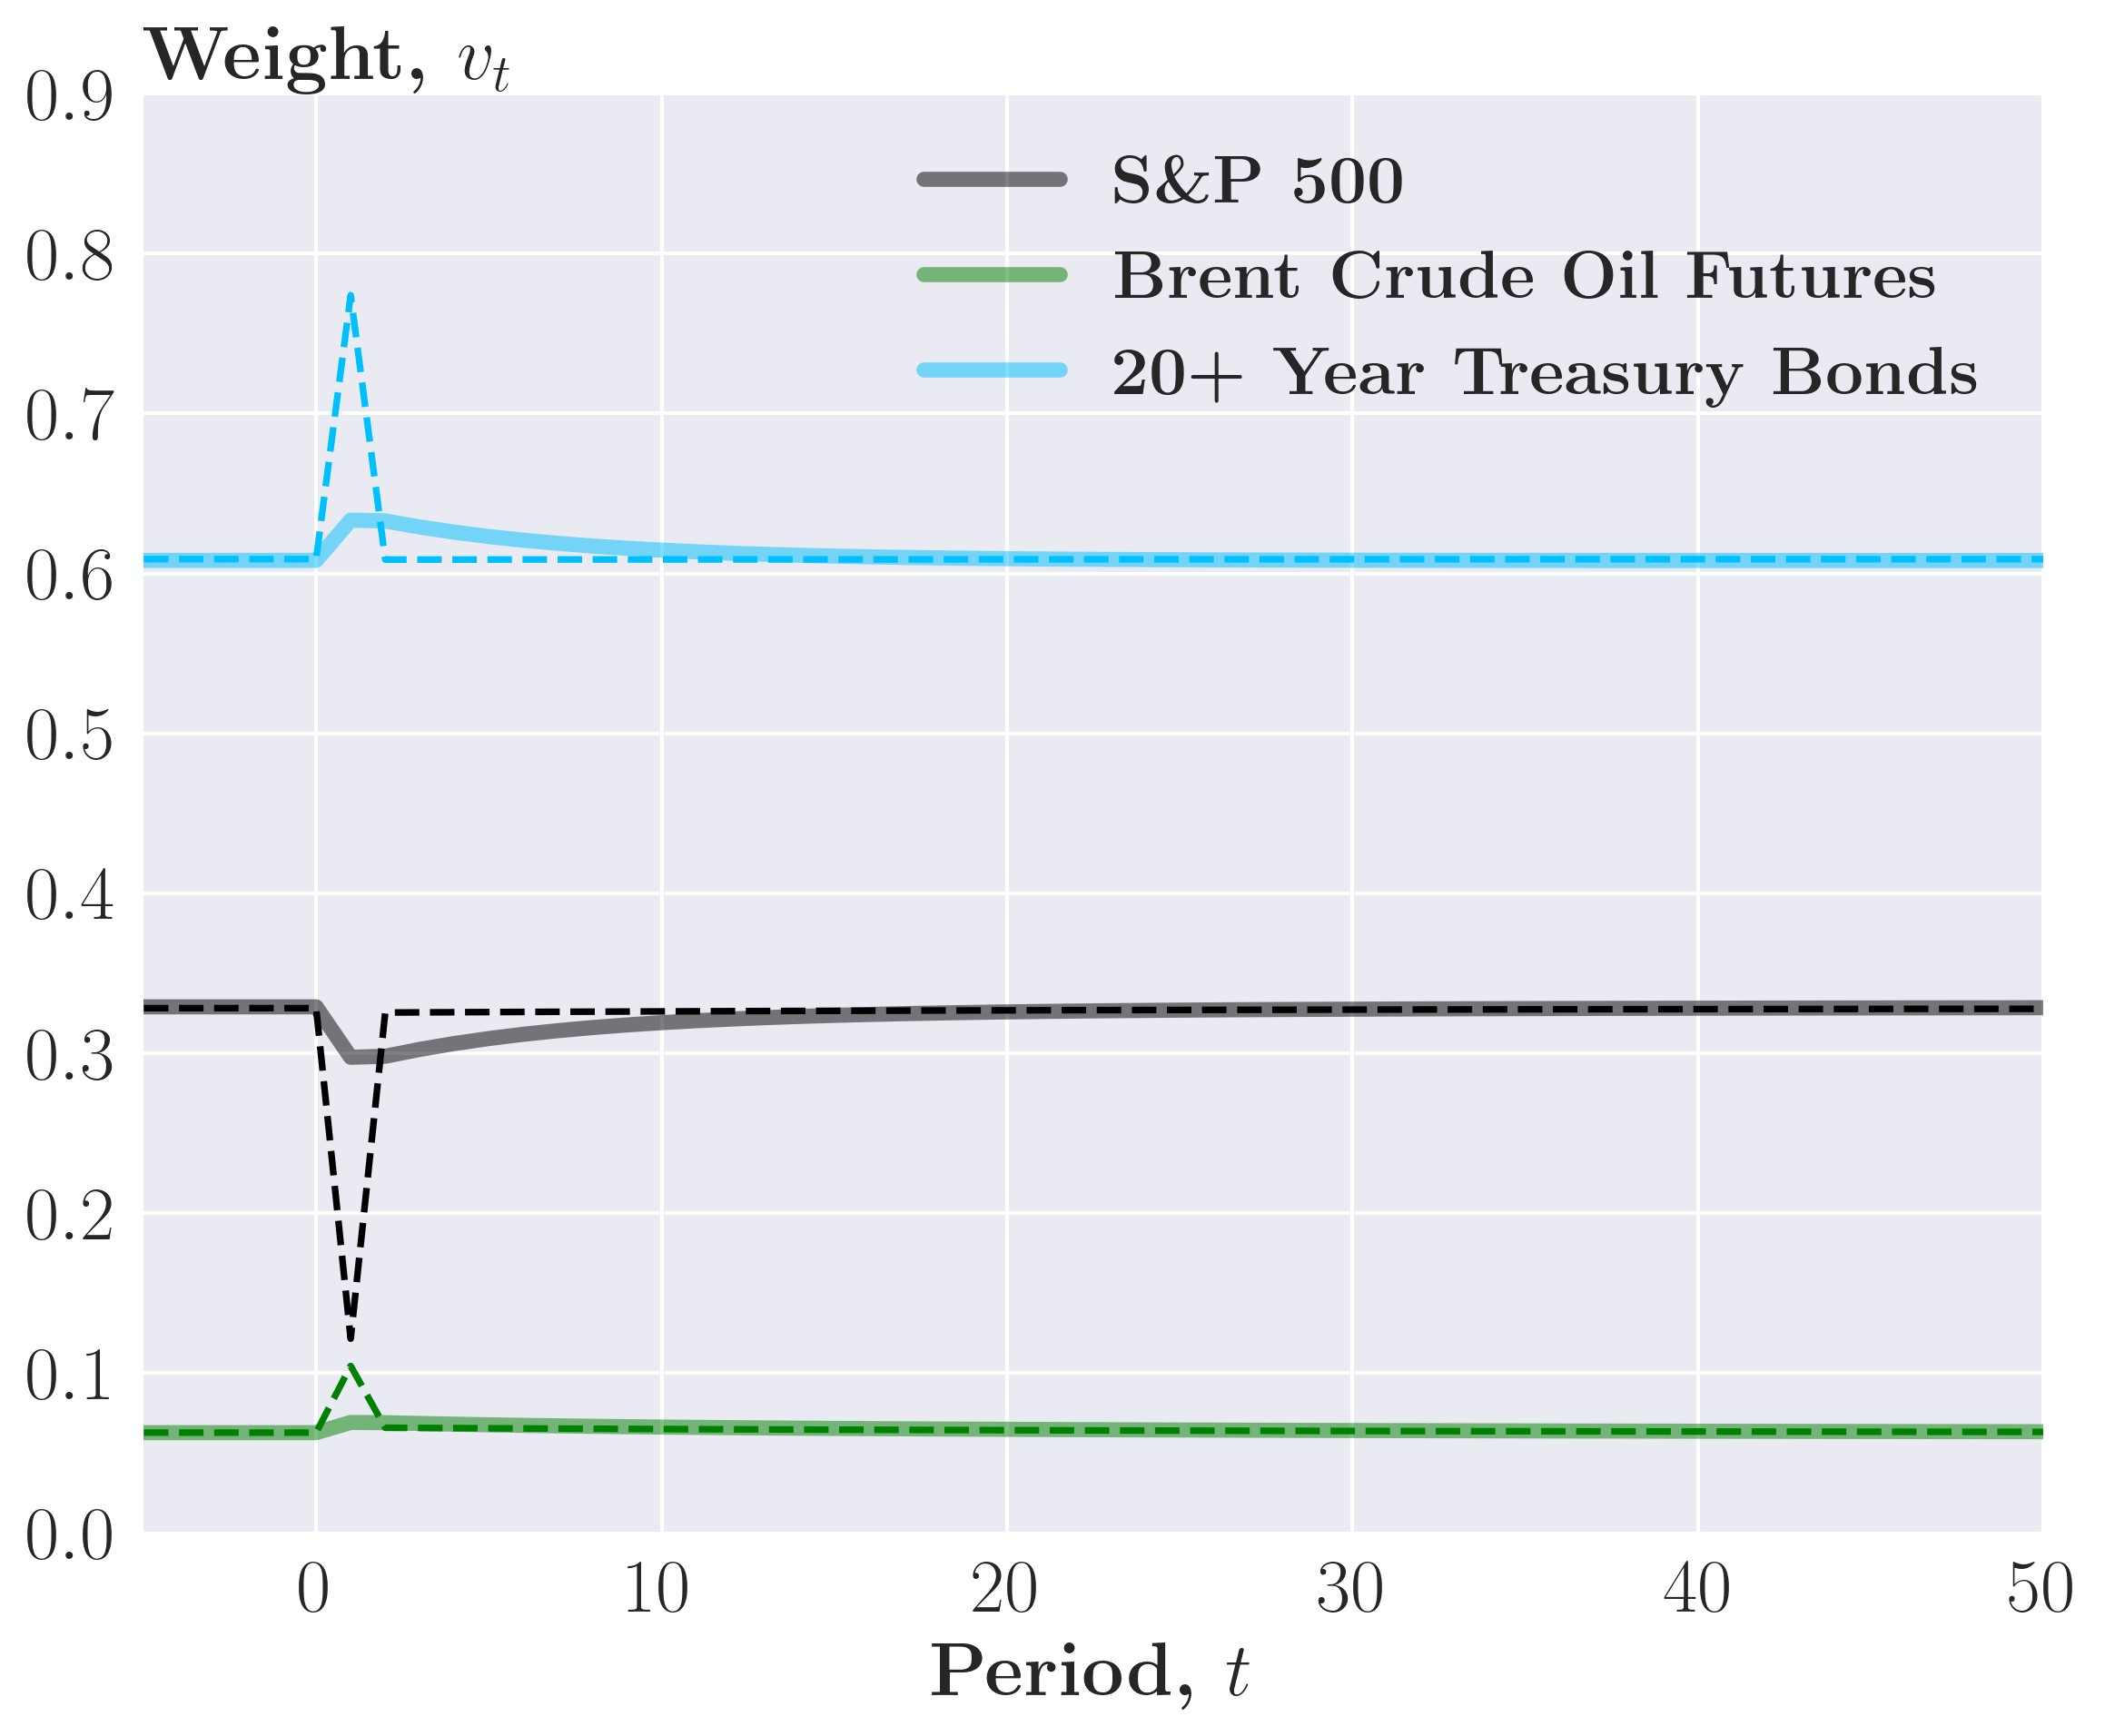

*Note*: The aim portfolio is the dotted lines, the optimal portfolio weights are the solid lines roughly 15 periods to converge to the aim portfolio. Note that the aim portfolio is identical across different values of *γ*˜*D* and the only the adjustment of the investor’s actual portfolio change.

Let’s move on to the GARCH(1,1) case depicted in figure 17. Like the simple strategy, the conditional volatility plotted in panel (a) spikes and then exponentially converges to the equilibrium value. In panel (b) where *γ*˜*D* = 1*.*52e−6, we see the investor immediately adjusts to the aim portfolio, behaving almost identically to the simple strategy.

In panels (c) and (d), the investor’s portfolio first undershoots and then overshoots the aim portfolio. This is most clear in the case where *γ*˜*D* = 1e−5, where the aim portfolio spikes one period after the shock, which the investor slowly adjusts to as trading is costly. Then, as the volatility converges back to equilibrium, the aim portfolio converges faster than the optimal Figure 17: Impulse response function of *vt*MVP for the sophisticated GARCH(1,1)

(a) Volatility, *σt* (b) Portfolio weights, *vt*MVP, *γ*˜*d* = 1*.*52e−6

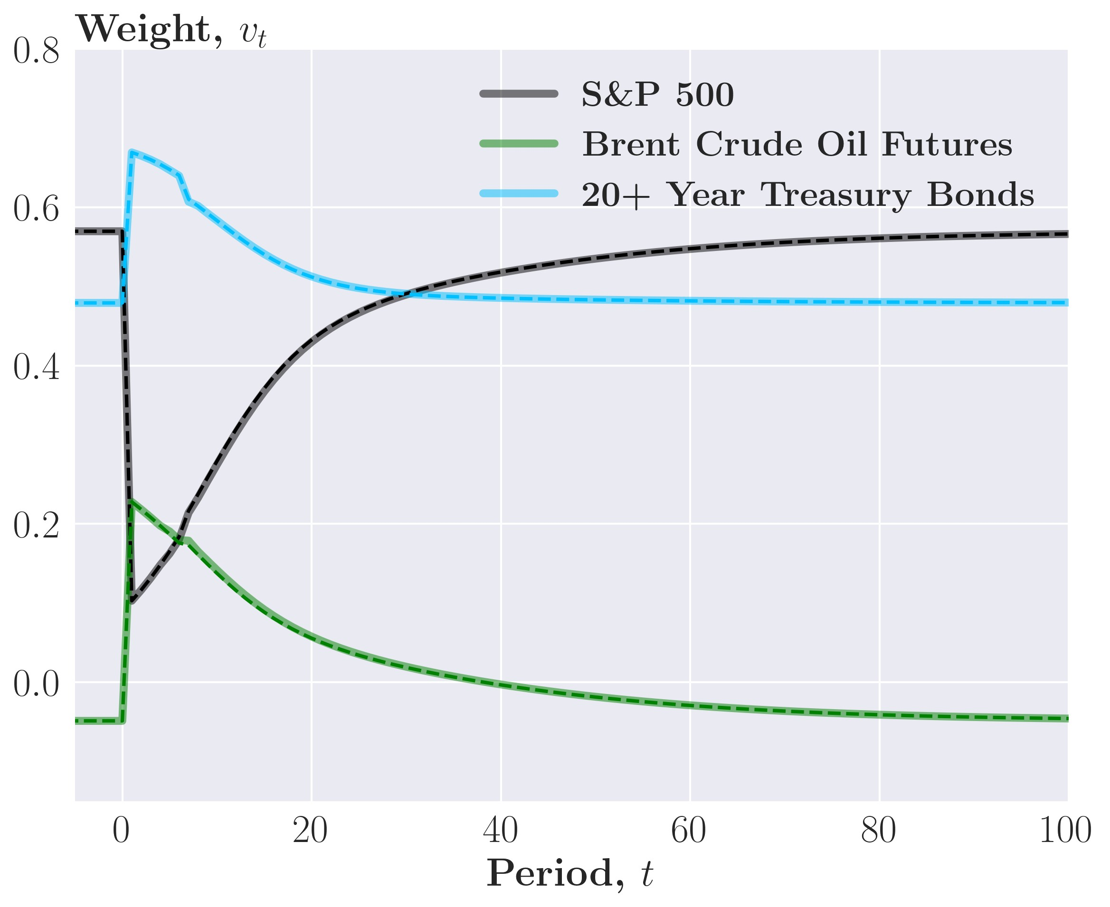

(c) Portfolio weights, *vt*MVP, *γ*˜*d* = 3e−6 (d) Portfolio weights, *vt*MVP, *γ*˜*d* = 1e−5

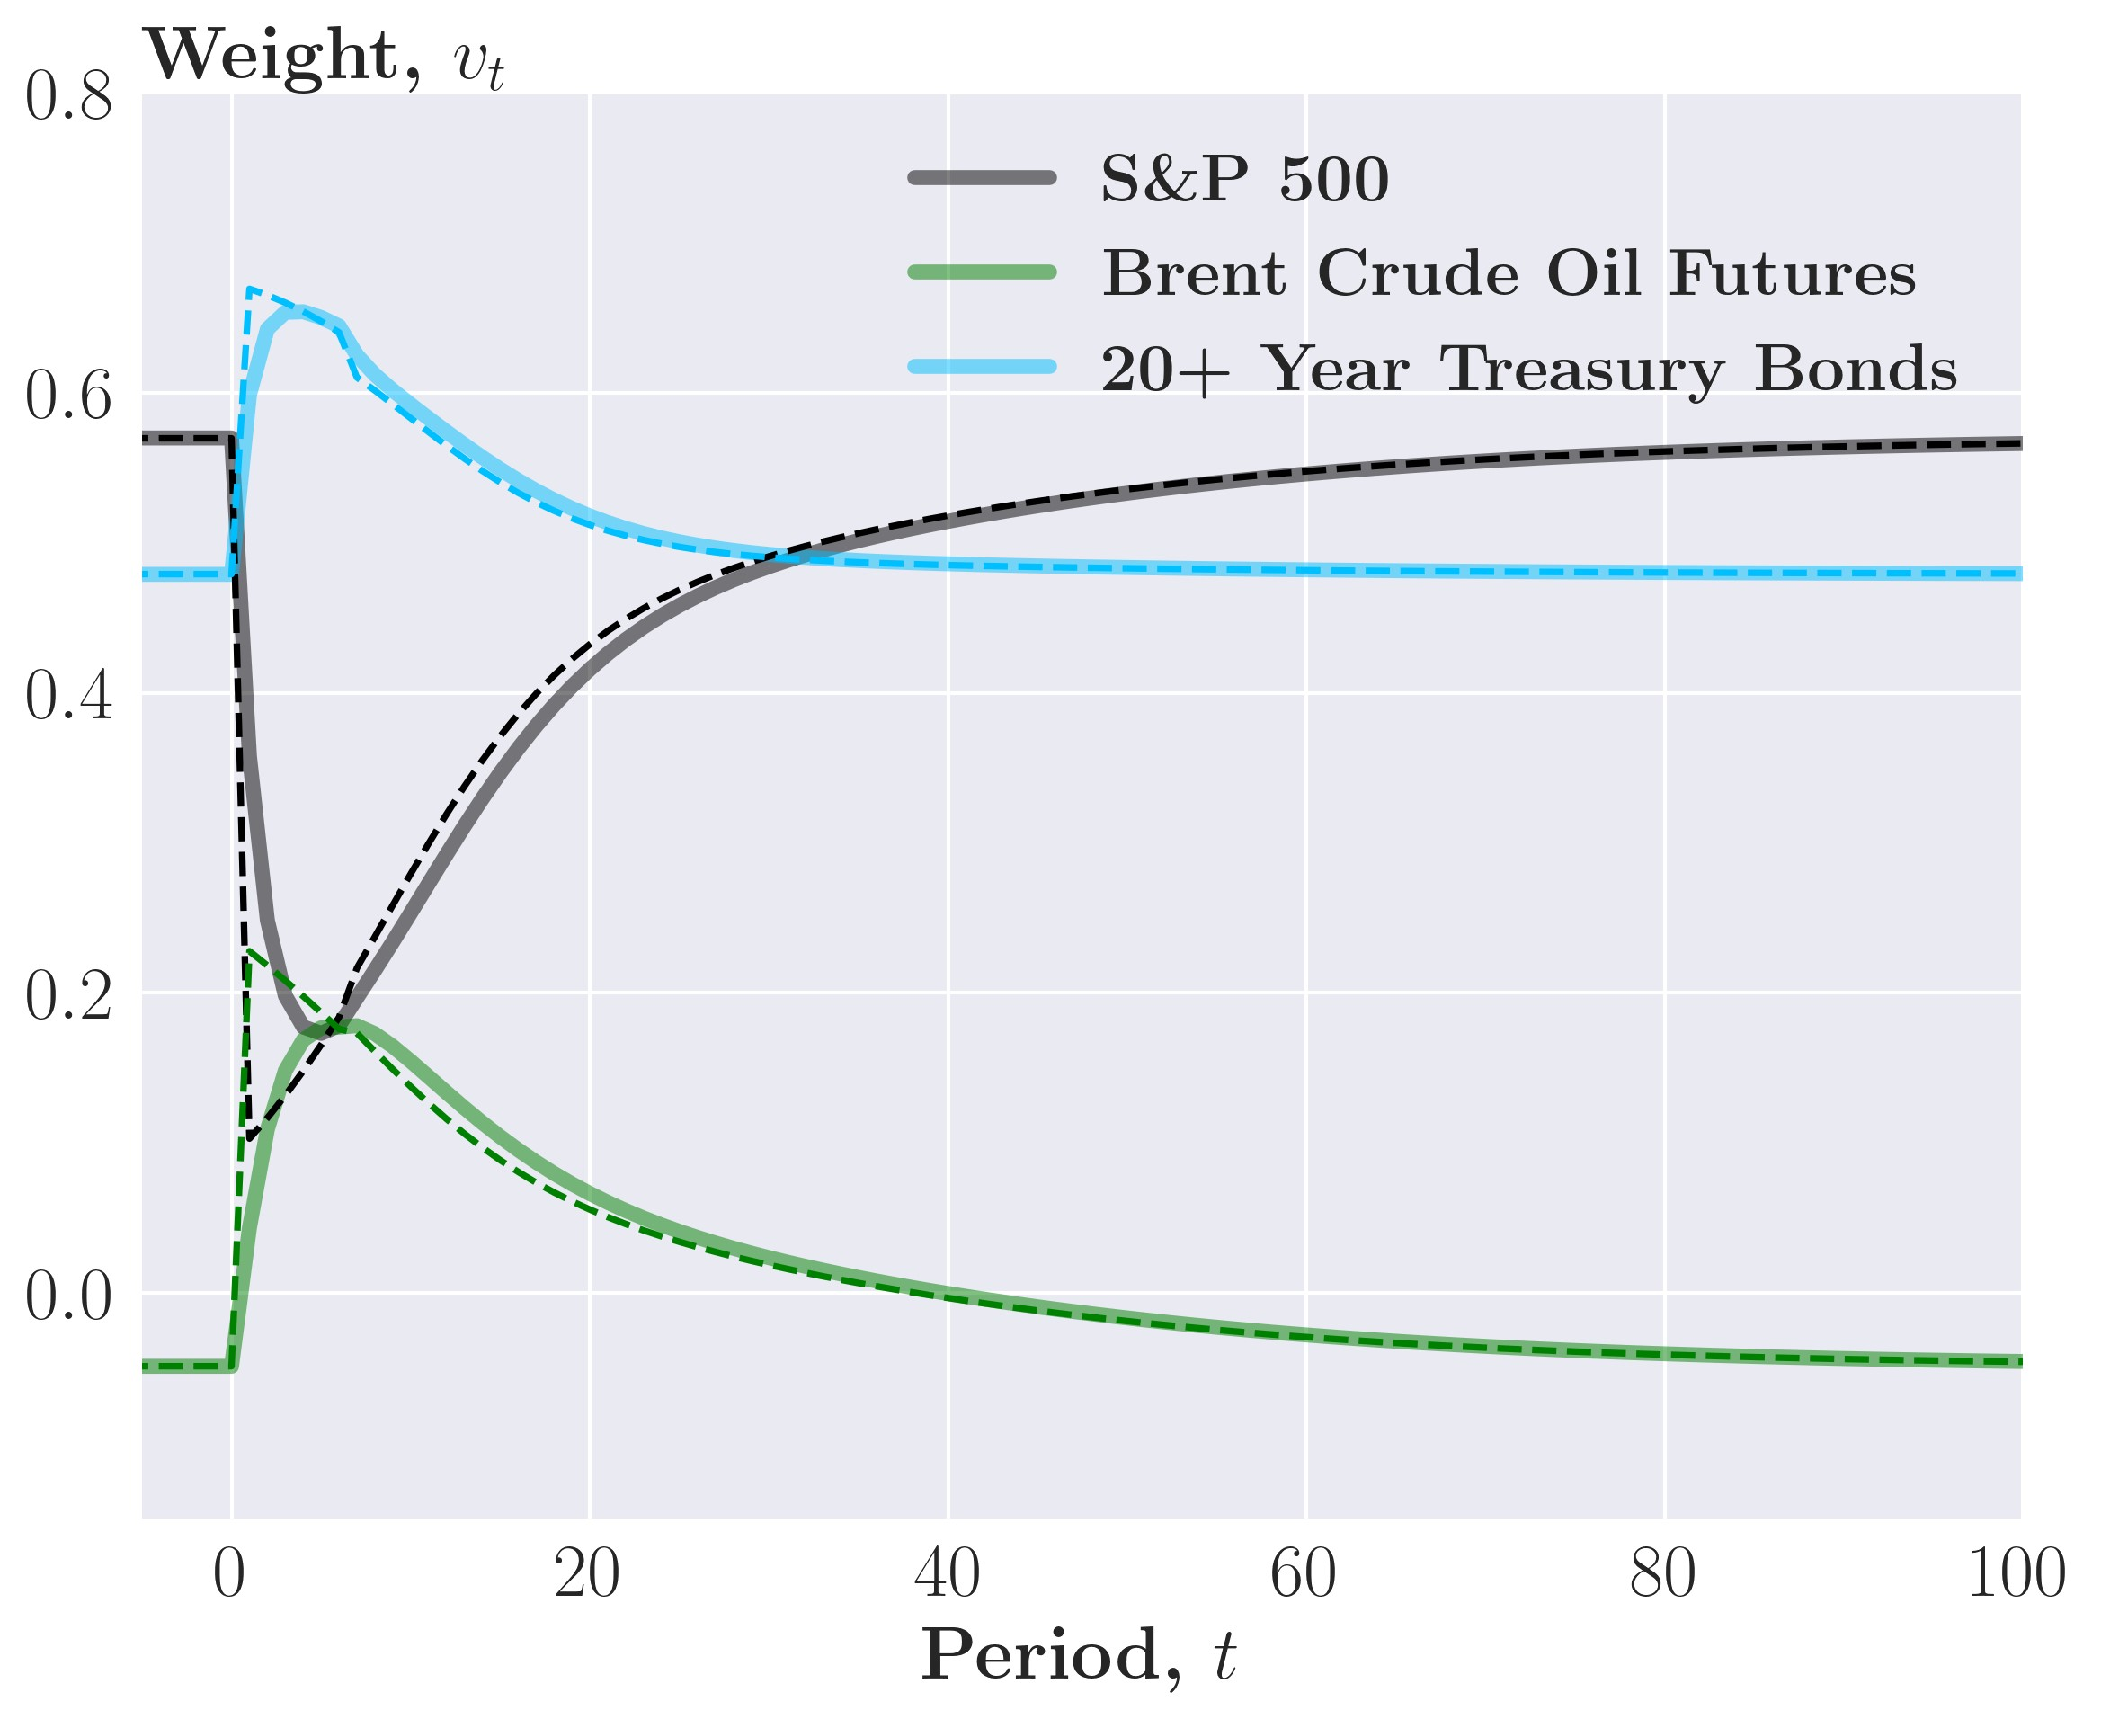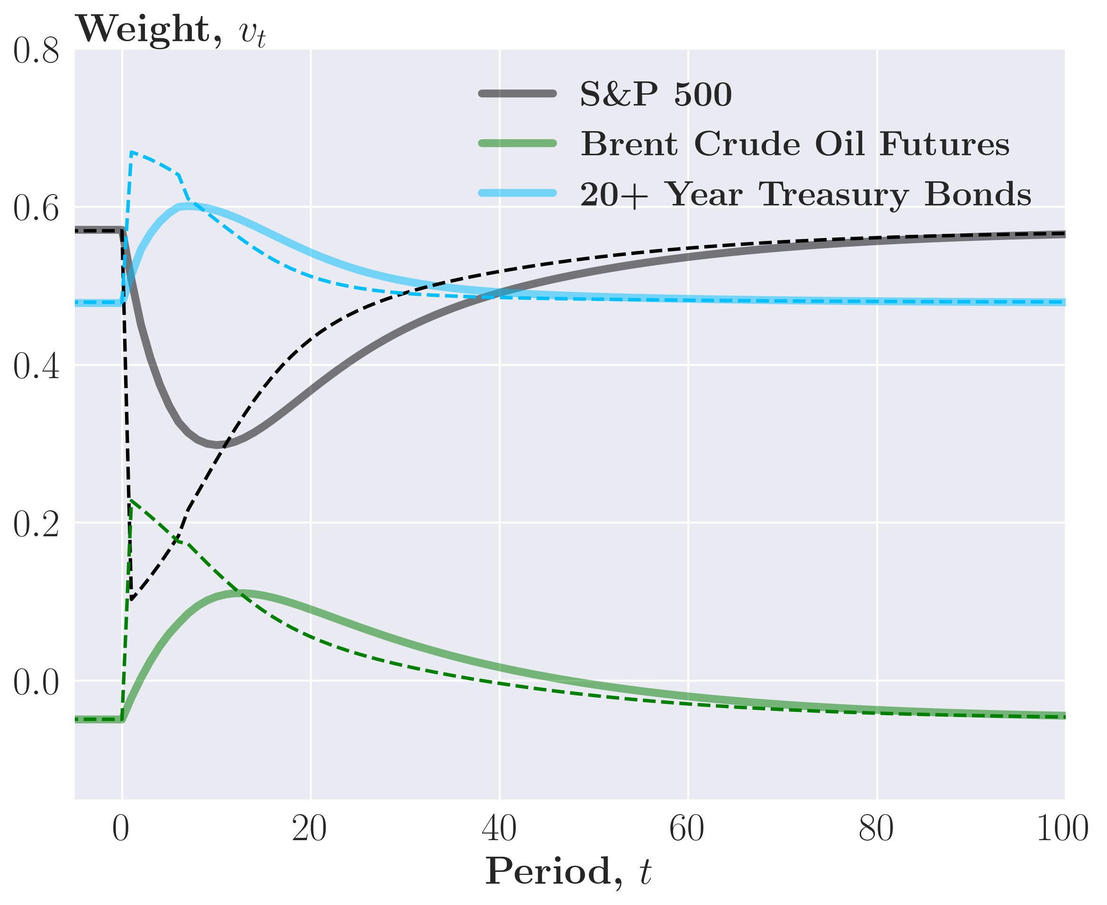

*Note*: The aim portfolio is the dotted line, the optimal portfolio weights are the solid lines

weights which adjust rather slowly and are thus overtaken by the aim portfolio.

The case for the GJR-GARCH(1,1) in figure 18 is very similar to the GARCH(1,1) case but with a more significant effect from the shock given the asymmetry of the GJR-GARCH(1,1). Thus, we see the investor react more for the GARCH(1,1) in the cases where *γ*˜*D* is equal to 3e−6 and 1e−5. As transaction costs are quadratic, the extra adjustment is very costly for the investor, which significantly affects performance.

Across volatility models, we see trading volumes decrease as *γ*˜*D* increase. This is both unsurprising as the investor perceives trading as more costly and is similar to the result of proposition 2 of [Gârleanu and Pedersen, 2013].

As mentioned, the forecast of Ω*t*+1 is not necessarily accurate and might not reflect how the future covariance matrix will be. Thus, it might be beneficial to consider backtesting for a Figure 18: Impulse response function of *vt*MVP for the sophisticated GJR-GARCH(1,1)

(a) Volatility, *σt* (b) Portfolio weights, *vt*MVP, *γ*˜*d* = 1*.*52e−6

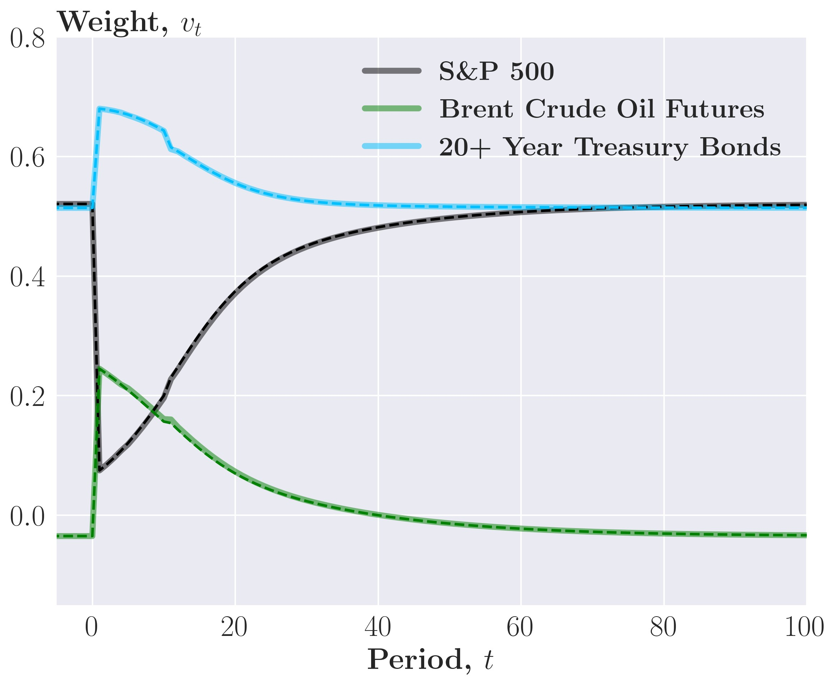

(c) Portfolio weights, *vt*MVP, *γ*˜*d* = 3e−6 (d) Portfolio weights, *vt*MVP, *γ*˜*d* = 1e−5

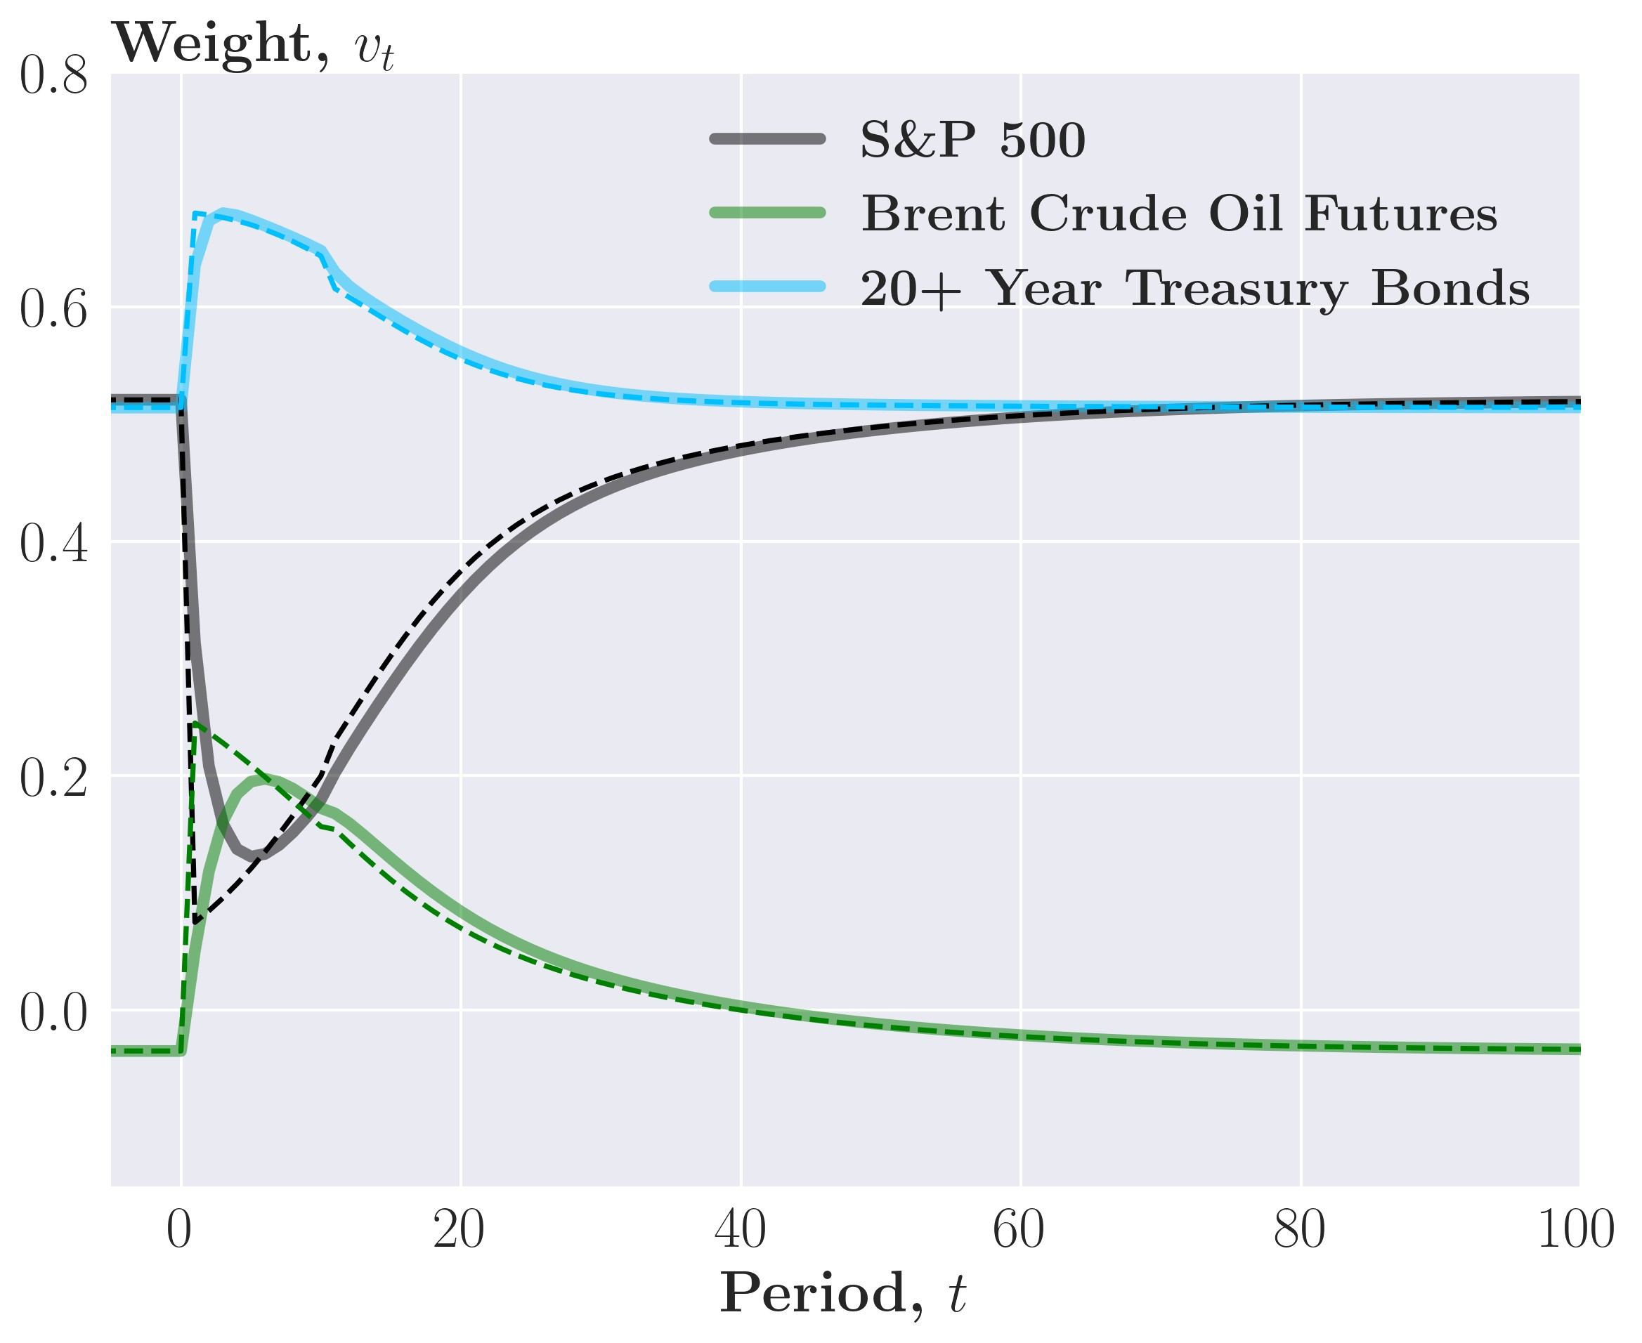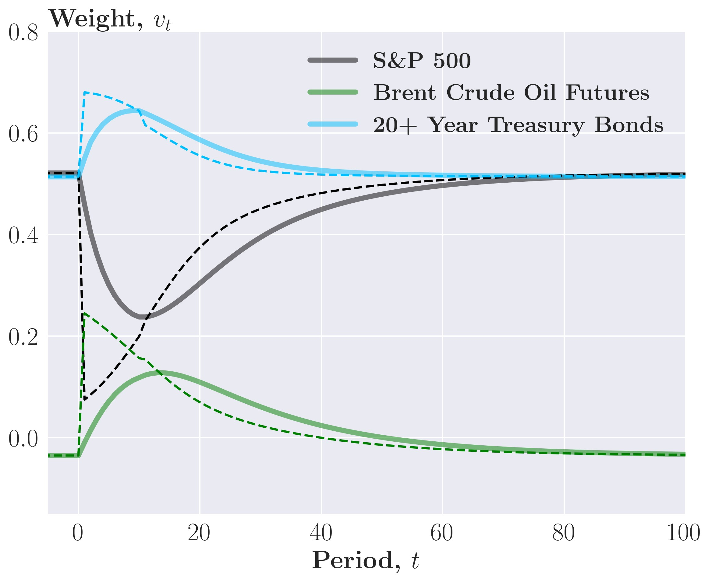

*Note*: The aim portfolio is the dotted lines, the optimal portfolio weights are the solid lines

higher *γ*˜*D* than empirically calibrated above to limit extreme and costly portfolio movements. To display the effects of tuning *γ*˜*D* and find the optimal value, we plot the annualized portfolio standard deviation and Sharpe ratio across different values of *γ*˜*D*.

Looking at figure 19 panel (a) and (b), we see that for a portfolio of all 11 assets the minimum annualized standard deviation is reached for a *γ*˜*D* of around 1*.*3e−5 with the Sharpe ratio converging to the Buy-and-hold portfolio as *γ* increases. Thus, a clear trade-off between lowering risk and increasing the Sharpe ratio is evident for the case with all 11 assets. In contrast, if the investor’s asset universe is limited to the two commodities (figure 19 panel (c) and (d)), a singular optimal *γ*˜*D* of around 1e−4 yields both a higher Sharpe ratio and a lower standard deviation than the Buy-and-hold and Equal-weight.[16]

Figure 19: Annualized performance for different values of *γ*˜*D* for GARCH(1,1) (log på y-akse i (a) og (c))

1. Standard deviation, all assets
2. Sharpe Ratio, all assets

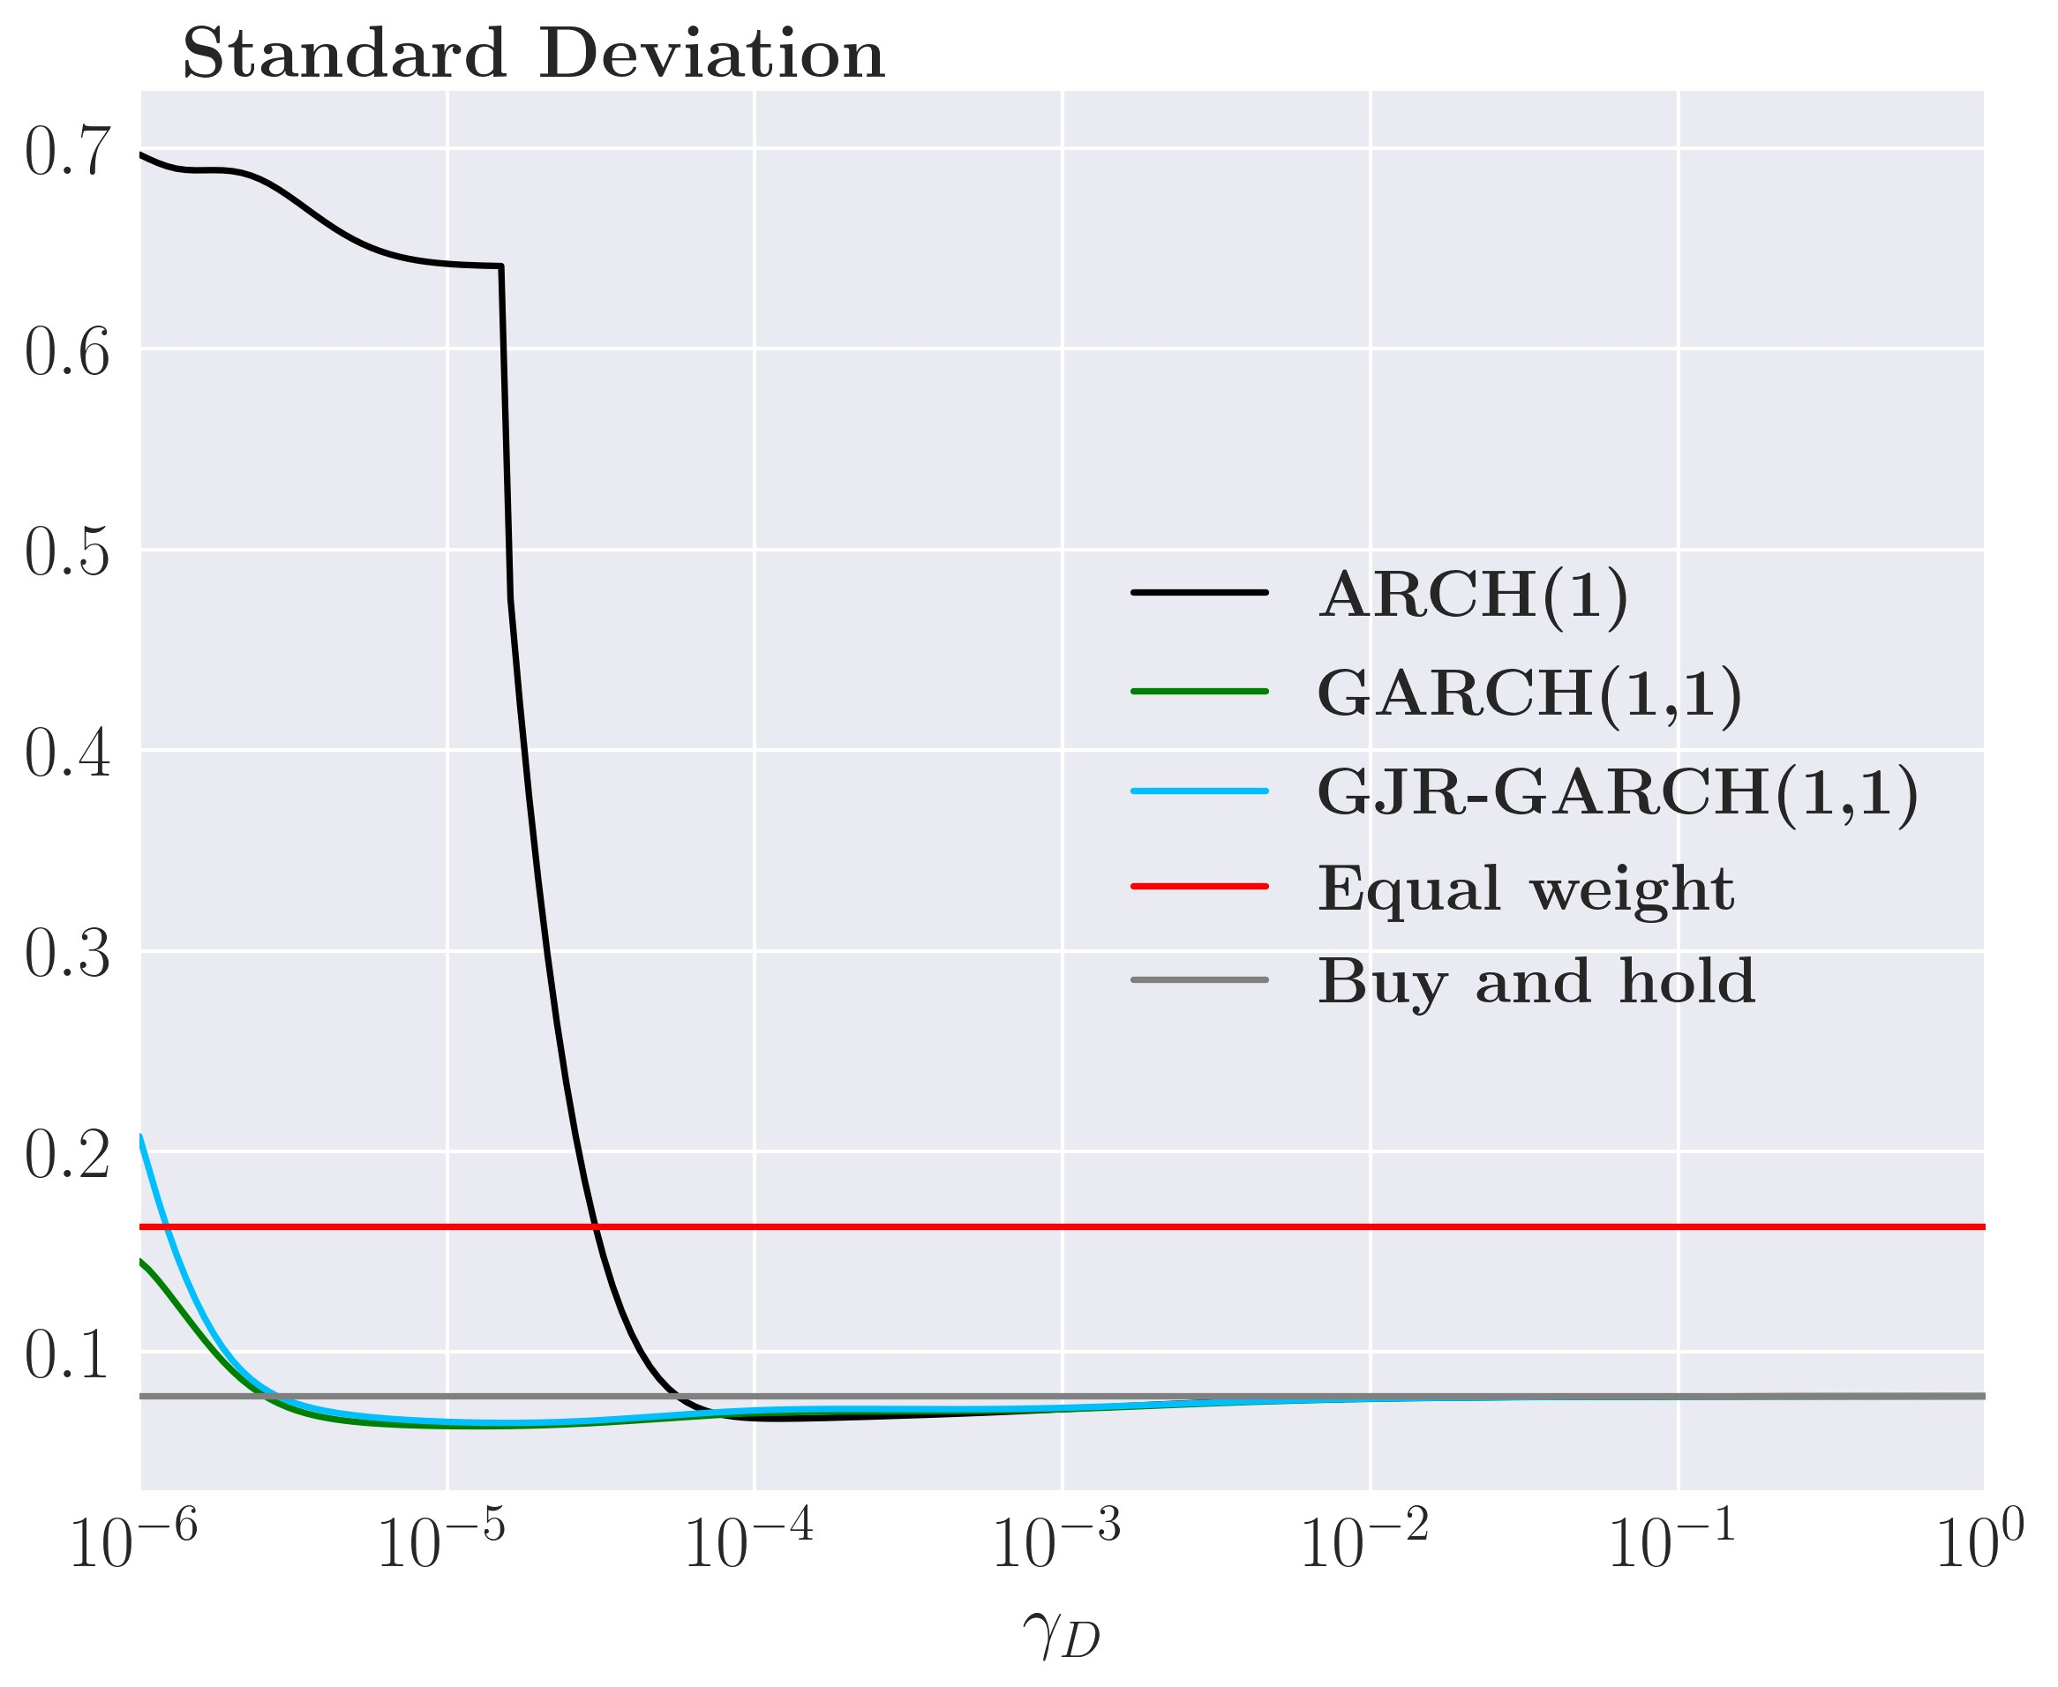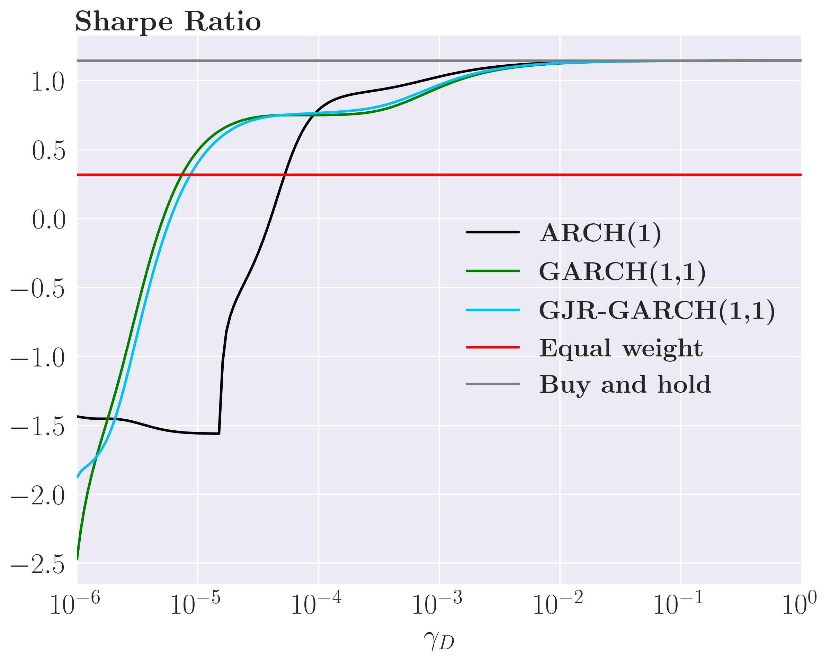

1. Standard deviation, commodities (d) Sharpe Ratio, commodities

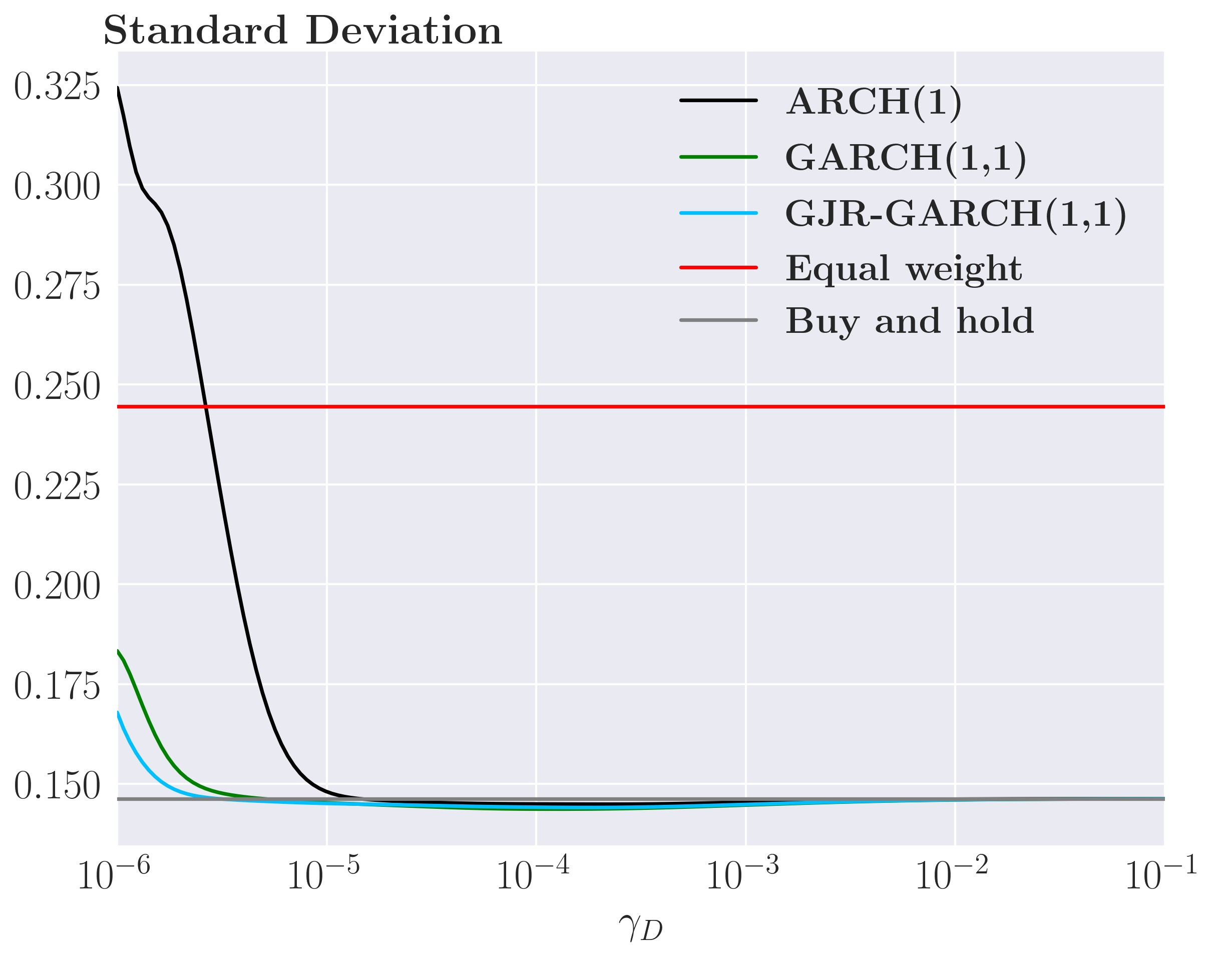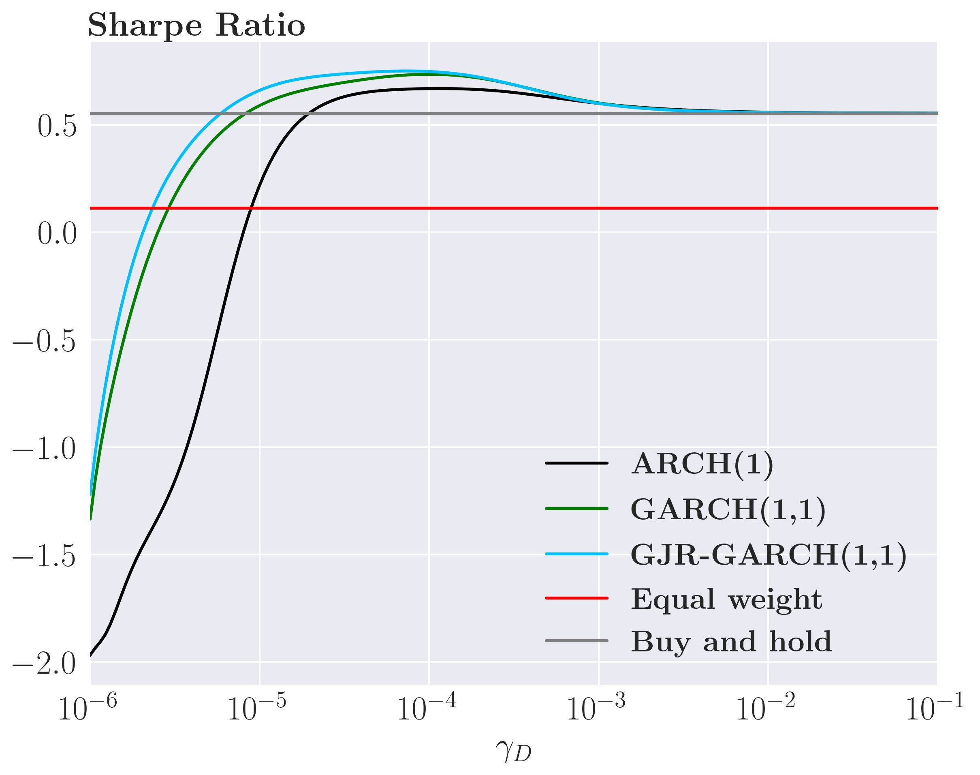

Unsurprisingly, as *γ*˜*D* increases, the performance of all GARCH portfolios converges towards the performance of the Buy-and-hold portfolio as the strategies trade less and less as *γ*˜*D* increases.

### 6.4.2 Backtesting the sophisticated strategy

We now proceed with historical backtesting for an investor that minimizes his portfolio risk and who is penalized for trading corresponding to an investor with an objective function given by equation (29). The exact process of backtesting can be seen in algorithm 2 in the appendix.

As mentioned in the section above, different values of ex-ante transaction costs may greatly benefit the performance of the investor’s portfolio. Therefore, we backtest for multiple values of *γ*˜*D*

As for the sophisticated strategy, we first plot the portfolio weights for each variance model

for *γ*˜*D* equal to 1*.*52e−6,1*.*3e−5 and 1e−4. The case where *γ*˜*D* = 1*.*52e−6 is almost identical to the case where the investor ignores transaction costs and thus, these plots has been left to the appendix.[17].

First, consider the sophisticated ARCH(1) strategy in figure 20 panel (a)+(b). Recall from section 6.3.2 that the optimal weights fluctuated heavily in the simple ARCH(1). In figure 20 panel (a)+(b) with *γ*˜*D* of 1*.*3e−5 and 1e−4, the weights are clearly much more persistent and any changes to the weights happens over a far greater period than in the simple strategy.

The main differences between *γ*˜*D* of 1*.*3e−5 and 1e−4 is that the changes are smaller when *γ*˜*D* is 1e−4 and that the small fluctuations present in the case with 1*.*3e−5 are almost gone for *γ*˜*D* = 1e−4 as the weight here are closer to a smooth line. The reason for this smoothing is

Figure 20: Portfolio weights of the sophisticated strategy, all assets

(a) ARCH(1), *γ*˜*D* = 1*.*3e−5 (b) ARCH(1),*γ*˜*D* = 1e−4

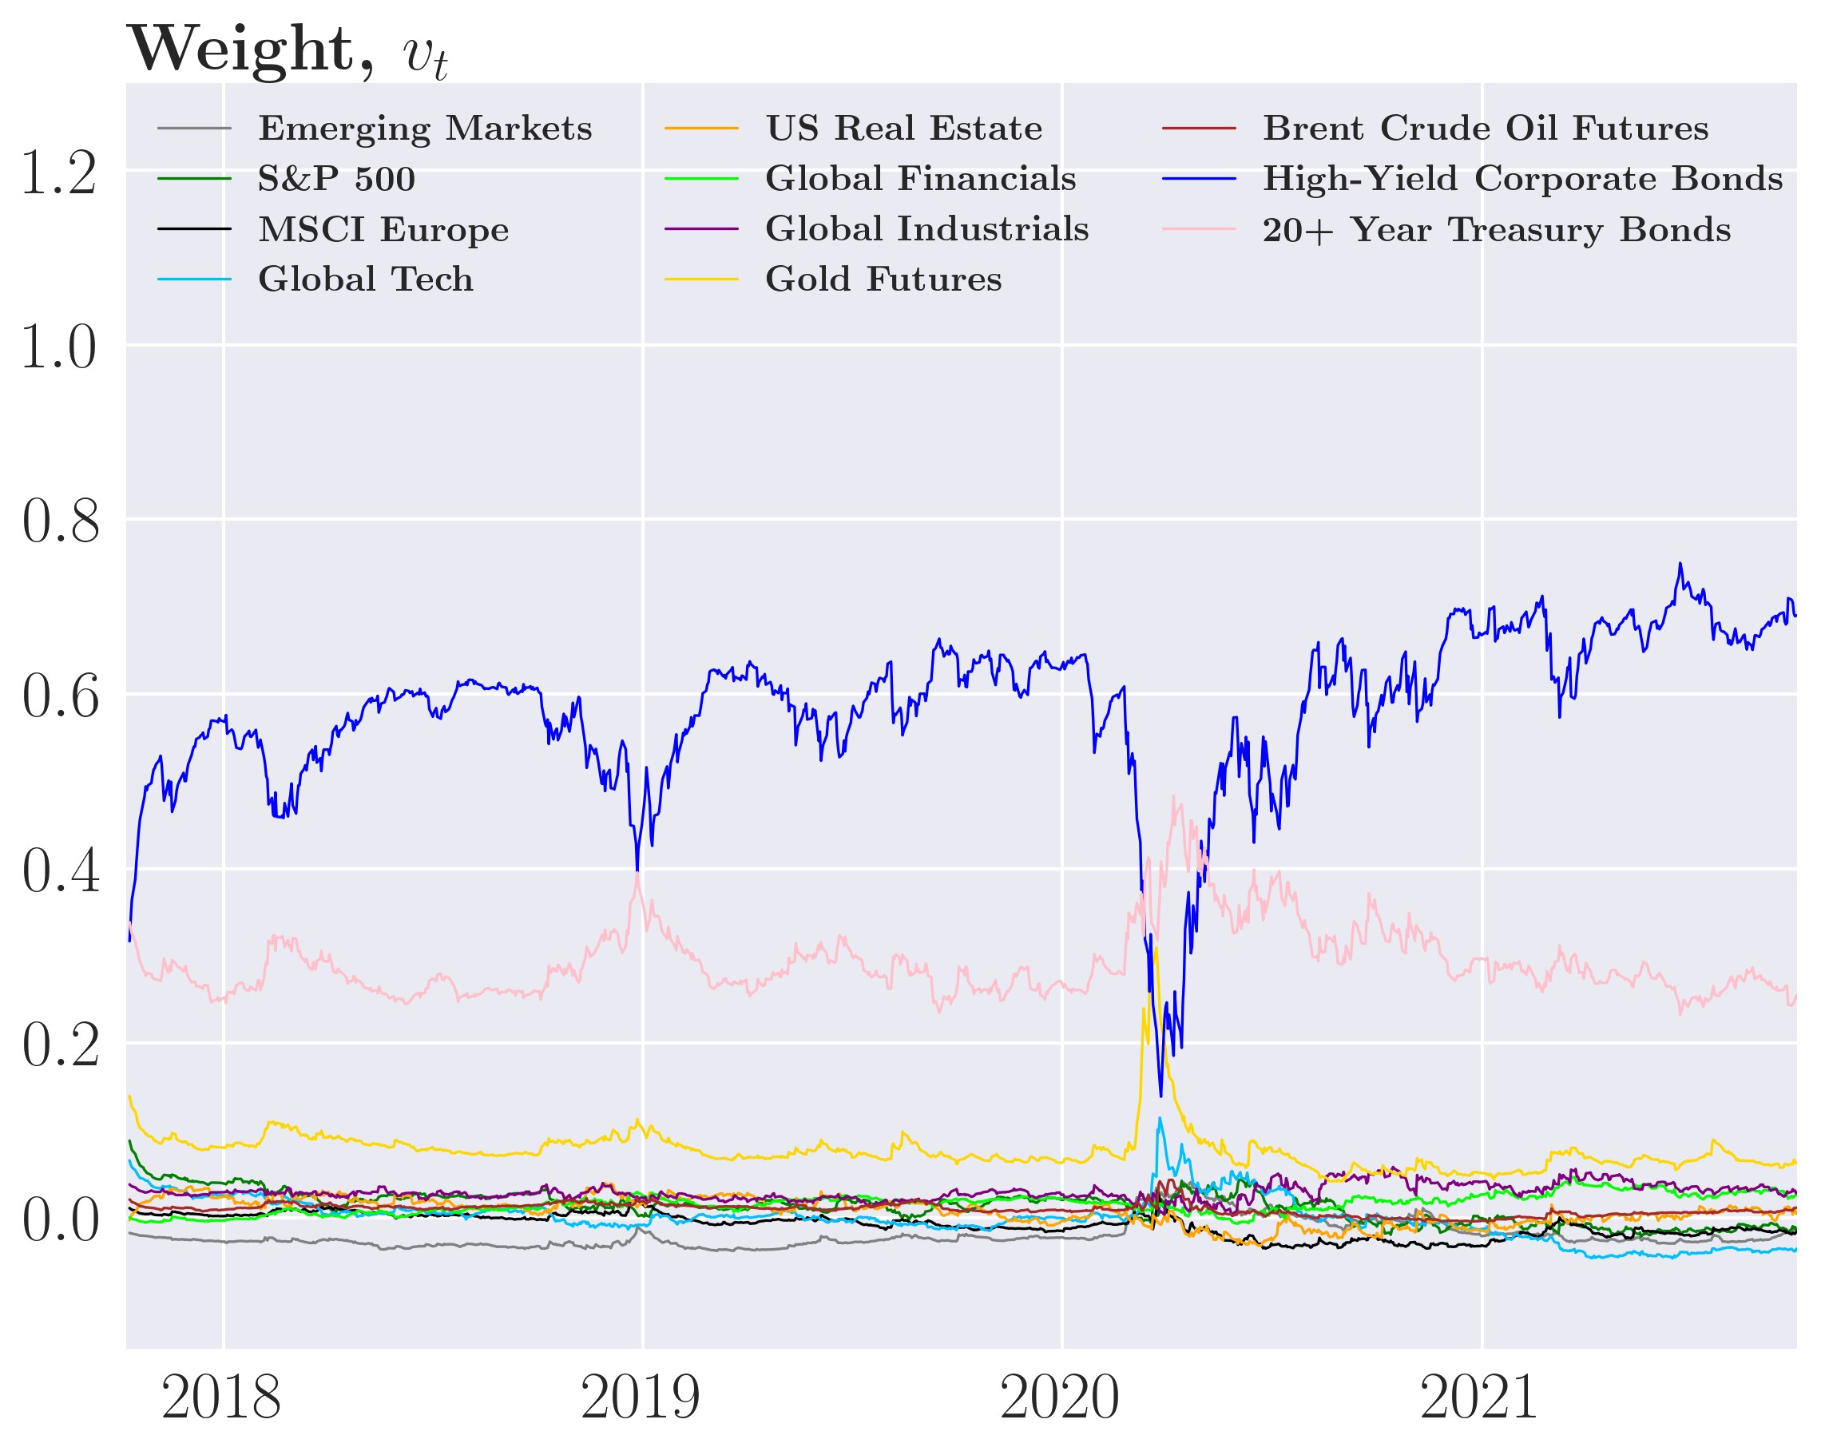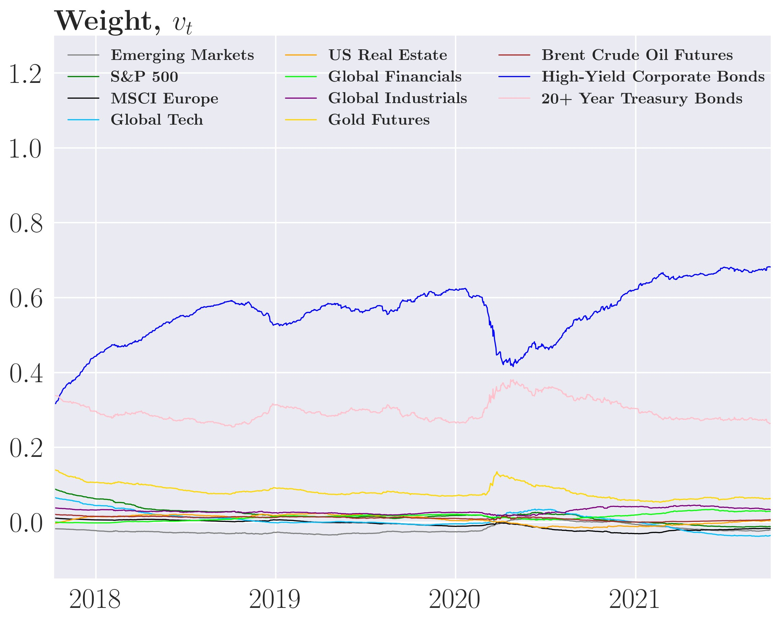

(c) GARCH(1,1), *γ*˜*D* = 1*.*3e−5 (d) GARCH(1,1), *γ*˜*D* = 1e−4

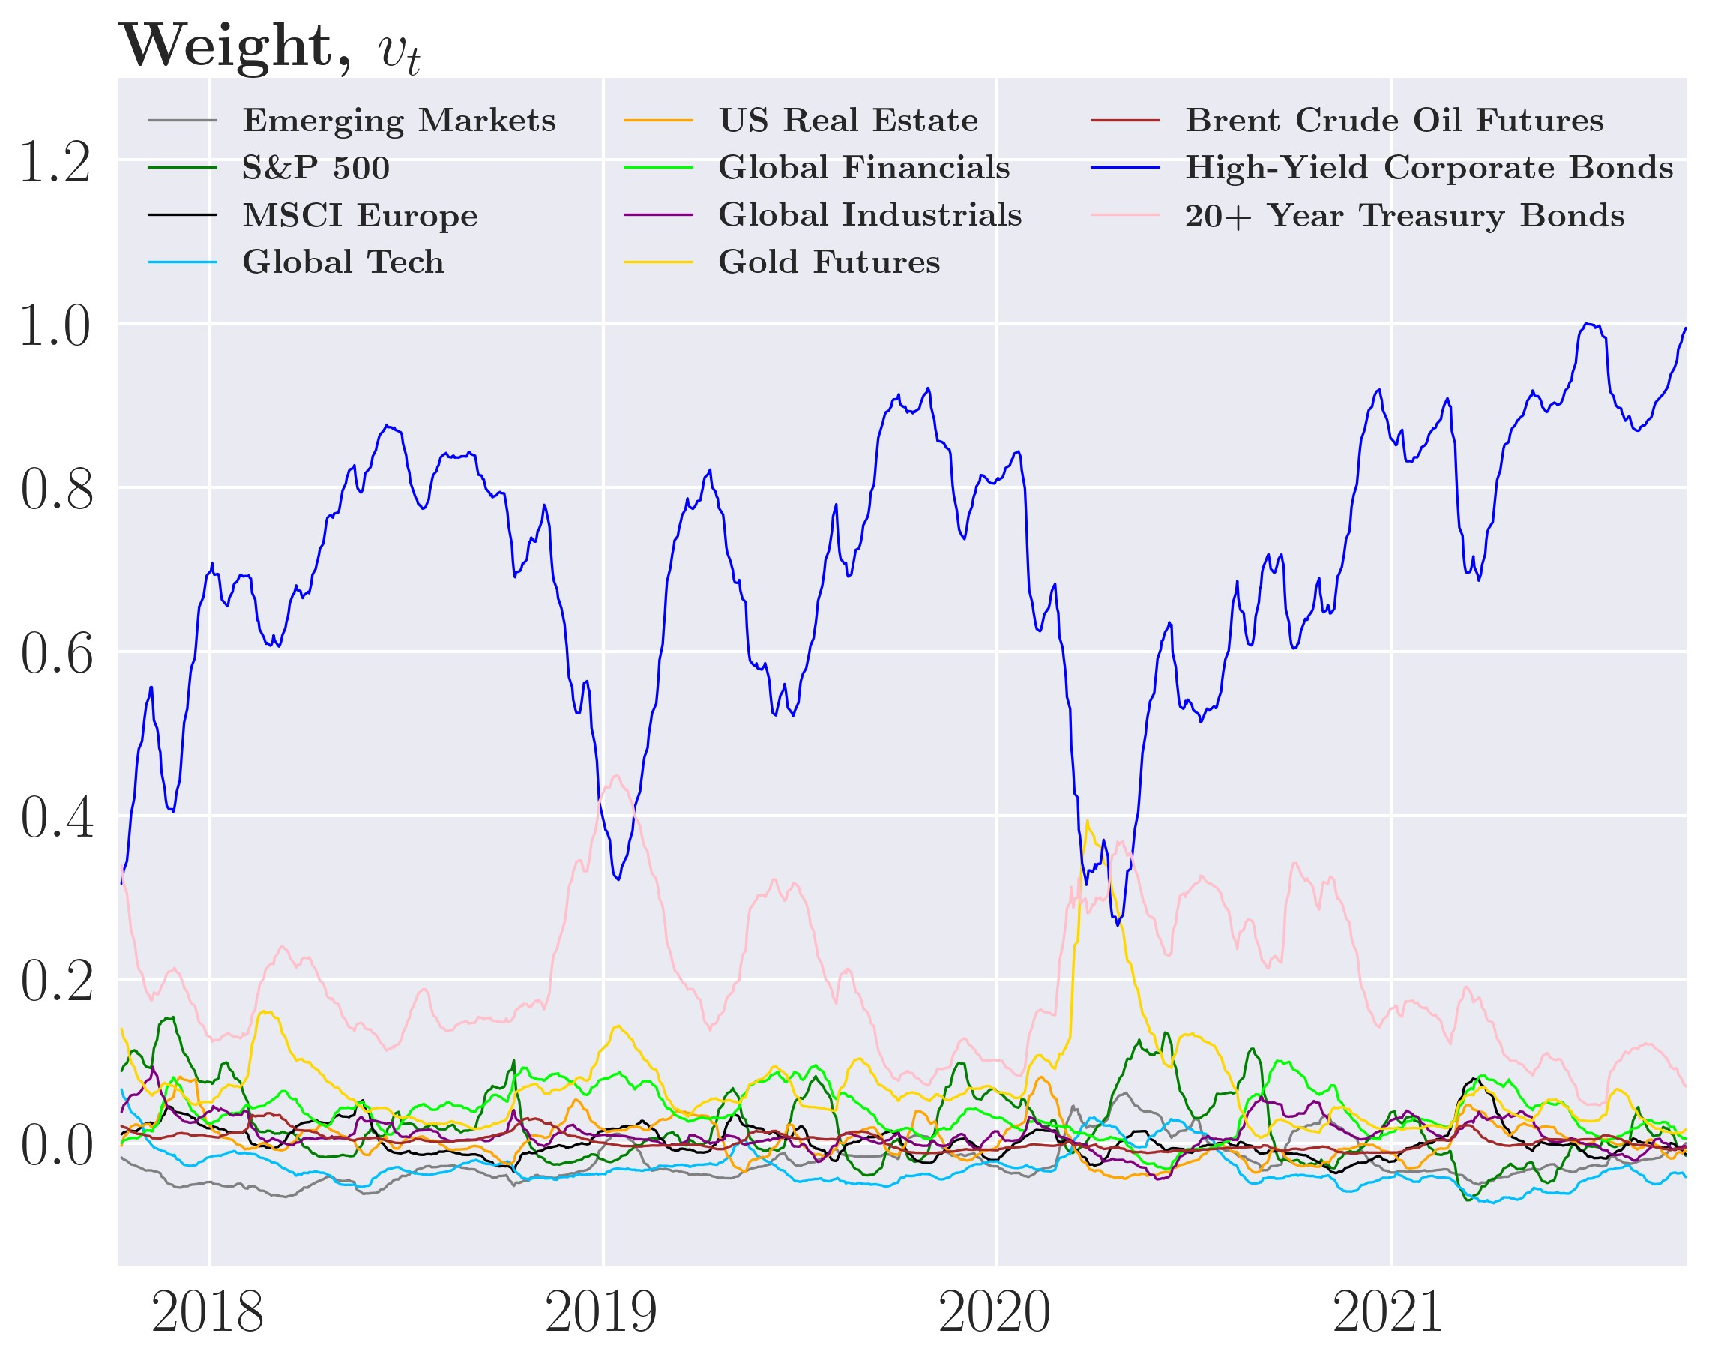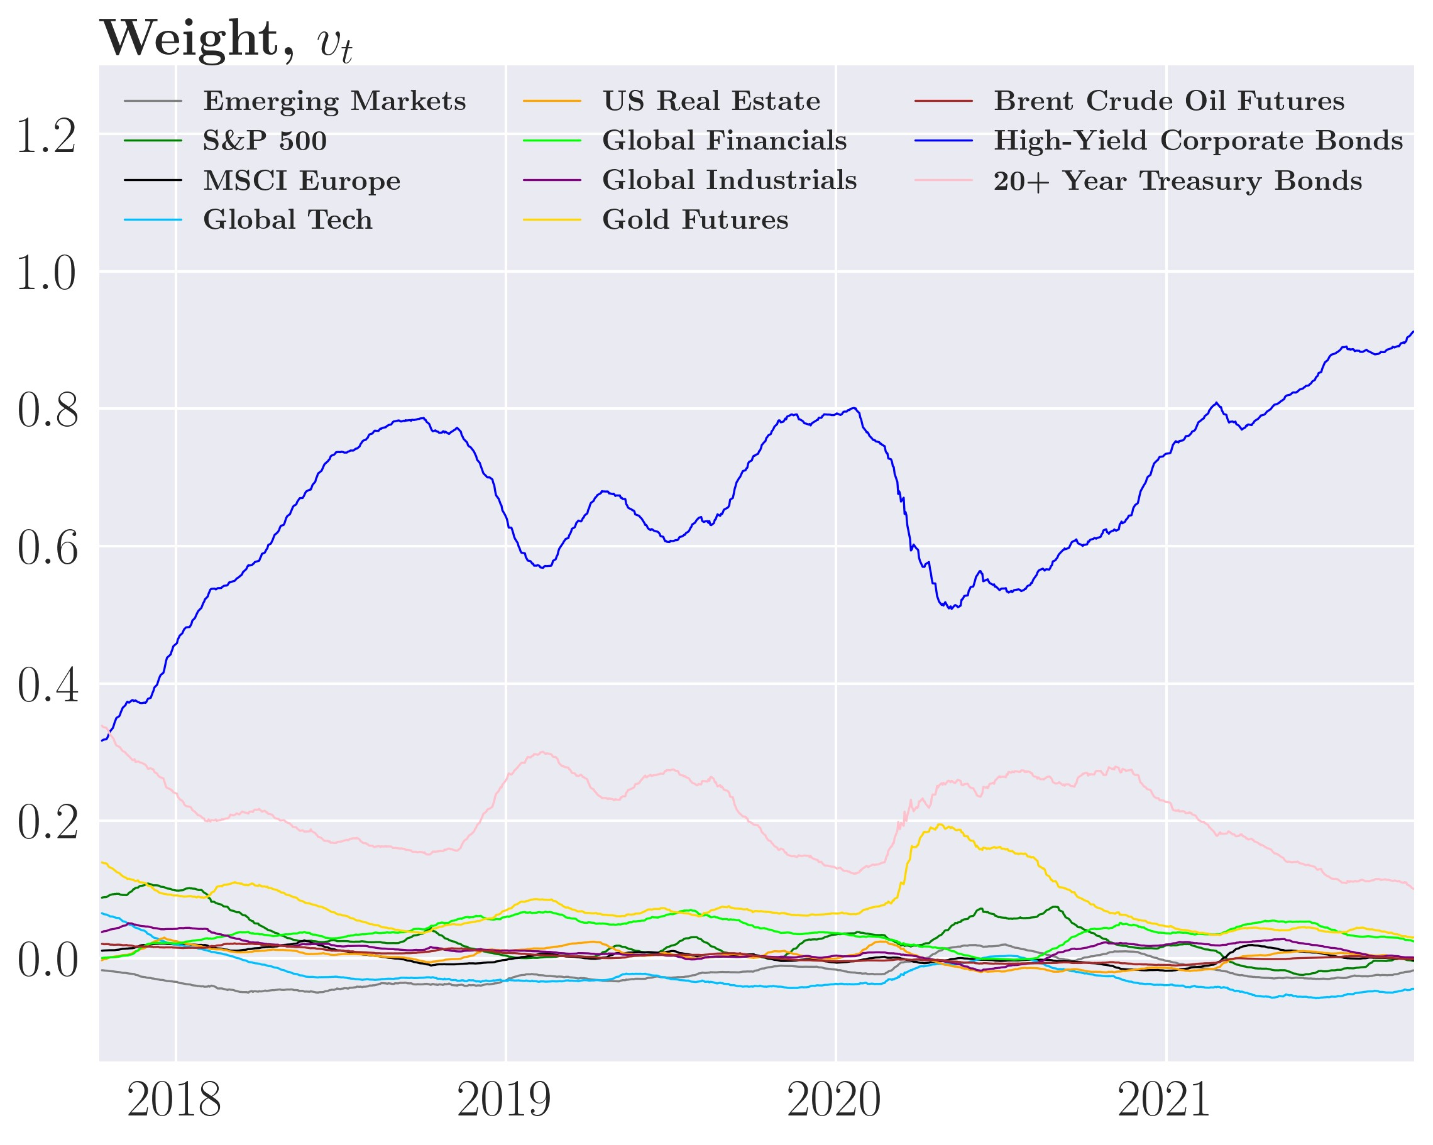

*Note:* The weight for the sophisticated GJR-GARCH(1,1) can be found in figure 27 in the appendix

that the higher ex-ante transaction costs act as a dampener on the fluctuating aim portfolio as explained in section 6.4 which can be interpreted as the investor adjusting more for transaction costs and large adjustment requires multiple shocks over an extended time period like seen in March and April 2020.

Moving on to the optimal weights from the GARCH(1,1) model depicted in figure 20 panel (c) and (d). Compared to the simple ARCH(1) portfolio, we see that the changes become smoother and slower, thus, adding an extra layer of persistence in the form of transaction costs. The sophisticated GARCH(1,1) is completely analogous to the sophisticated GJRGARCH(1,1) in figure 27, which have almost identical dynamics and very similar weights. The weights of the three different models become more and more similar as *γ*˜*D* increased as they all converge to the Buy-and-hold strategy as trading decreases.

Now let’s consider the performance measurements for the sophisticated strategies. First, we see that the gross return in figure 21 panel (a) is almost identical to the simple strategy in figure 12 panel (a). Therefore, in terms of gross return, the sophisticated GARCH strategies have very similar performance to the simple strategies for example the sophisticated GARCH(1,1) has gross returns of 6.5% and volatility of 6.3% compared to 6.4% and volatility of 6.3% in the simple GARCH(1, 1).

After transaction costs, the sophisticated GARCH strategies only perform mildly better than their simple counterparts. Using the empirically calibrated *γD* only causes a minor dampening of the investor’s trading activity and thus only mildly improves the performance, which ideally shouldn’t be the case. Recall that the simple GARCH(1,1) strategy earns a net return of -19.3% at 11% volatility, compared to the sophisticated version, which yields a net return of -18.4% at 11% volatility, a rather insignificant improvement. Similarly for simple GJR-GARCH(1,1) strategy earns a net return of -22.6% at 12.3% volatility where its sophisticated counterpart has net return of -21.3% at 12.6% volatility. This is far worse than the Equal-weight and Buy-and-hold. Thus, the empirically calibrated *γ* don’t improve performance for the sophisticated strategies significantly. This is further backed by the very small drop in transaction costs in table 7 where the sophisticated ARCH(1) strategy loses 100% annually, identical to the simple ARCH(1). The sophisticated GARCH(1,1) strategy loses 23.5% and the sophisticated GJR-GARCH(1,1) strategy loses 26.1% which for both are very similar to their simple cases.[18]

This naturally begs the question as to why this penalization does note improve performance? The primary reason is probably forecast errors as the investor believes that the changes he makes to his portfolio will reduce the risk of his portfolio in the next period to such a degree that the significant transaction costs the investor pays is made up for in lower future expected risk. But as Ω*t*+1|*t* is a forecast and not the true covariance matrix the changes to the Figure 21: Cumulative performance of the sophisticated strategy

(a) Gross returns (b) Net returns for *γ*˜*D* = 1*.*52e−6

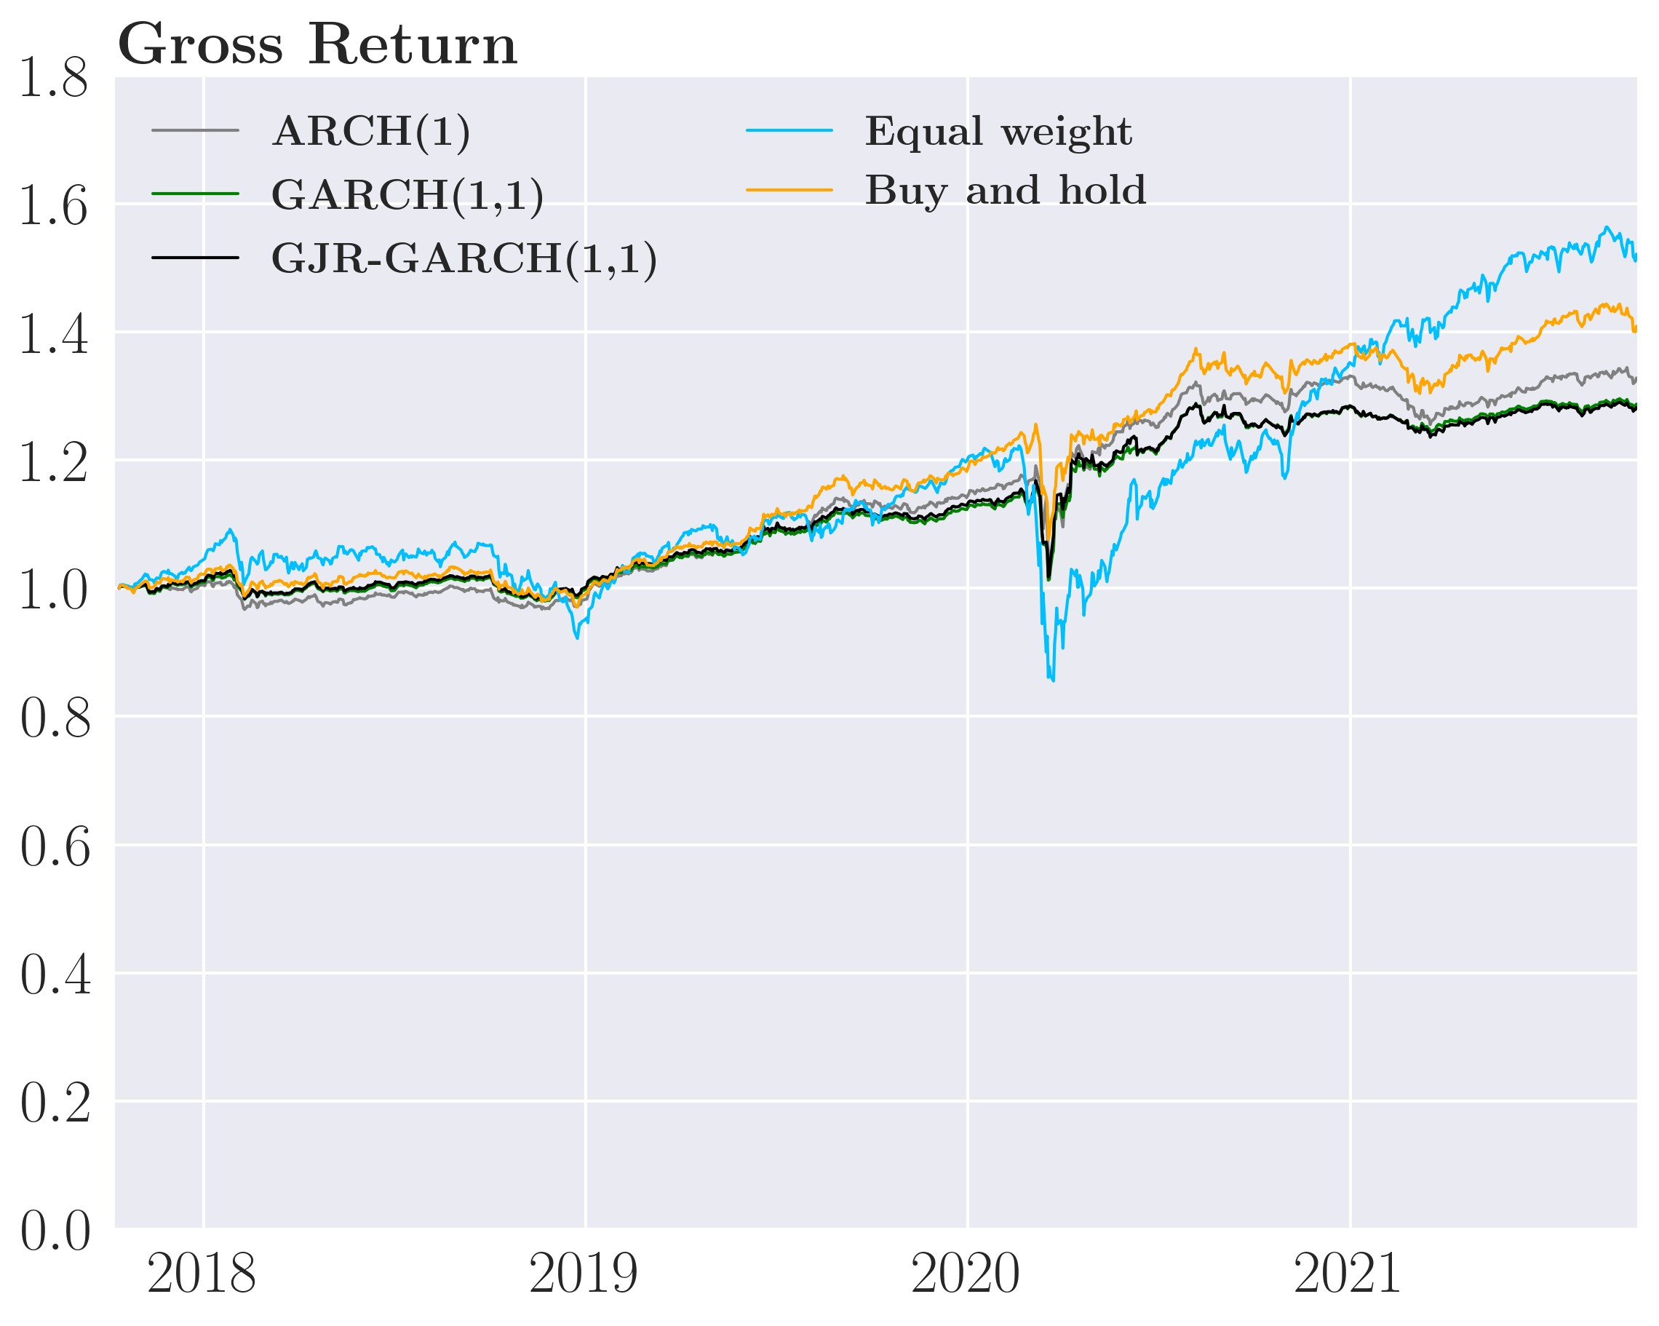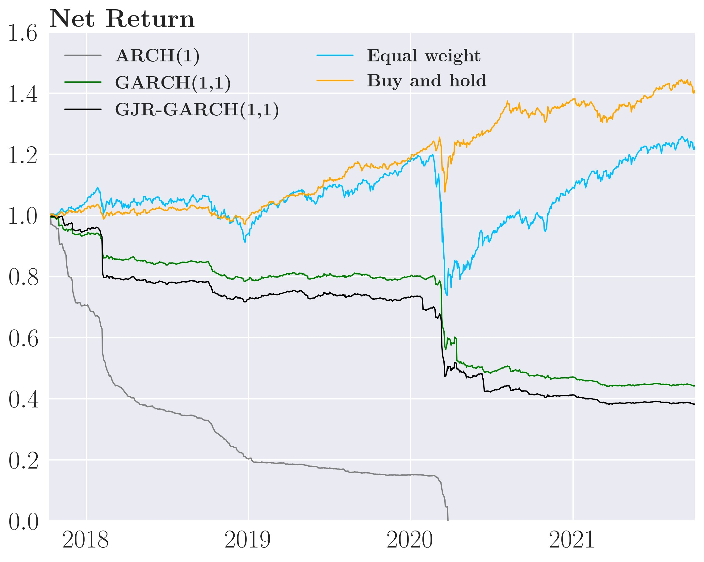

(c) Net returns for *γ*˜*D* = 1*.*3e−5 (d) Net returns for *γ*˜*D* = 1e−4

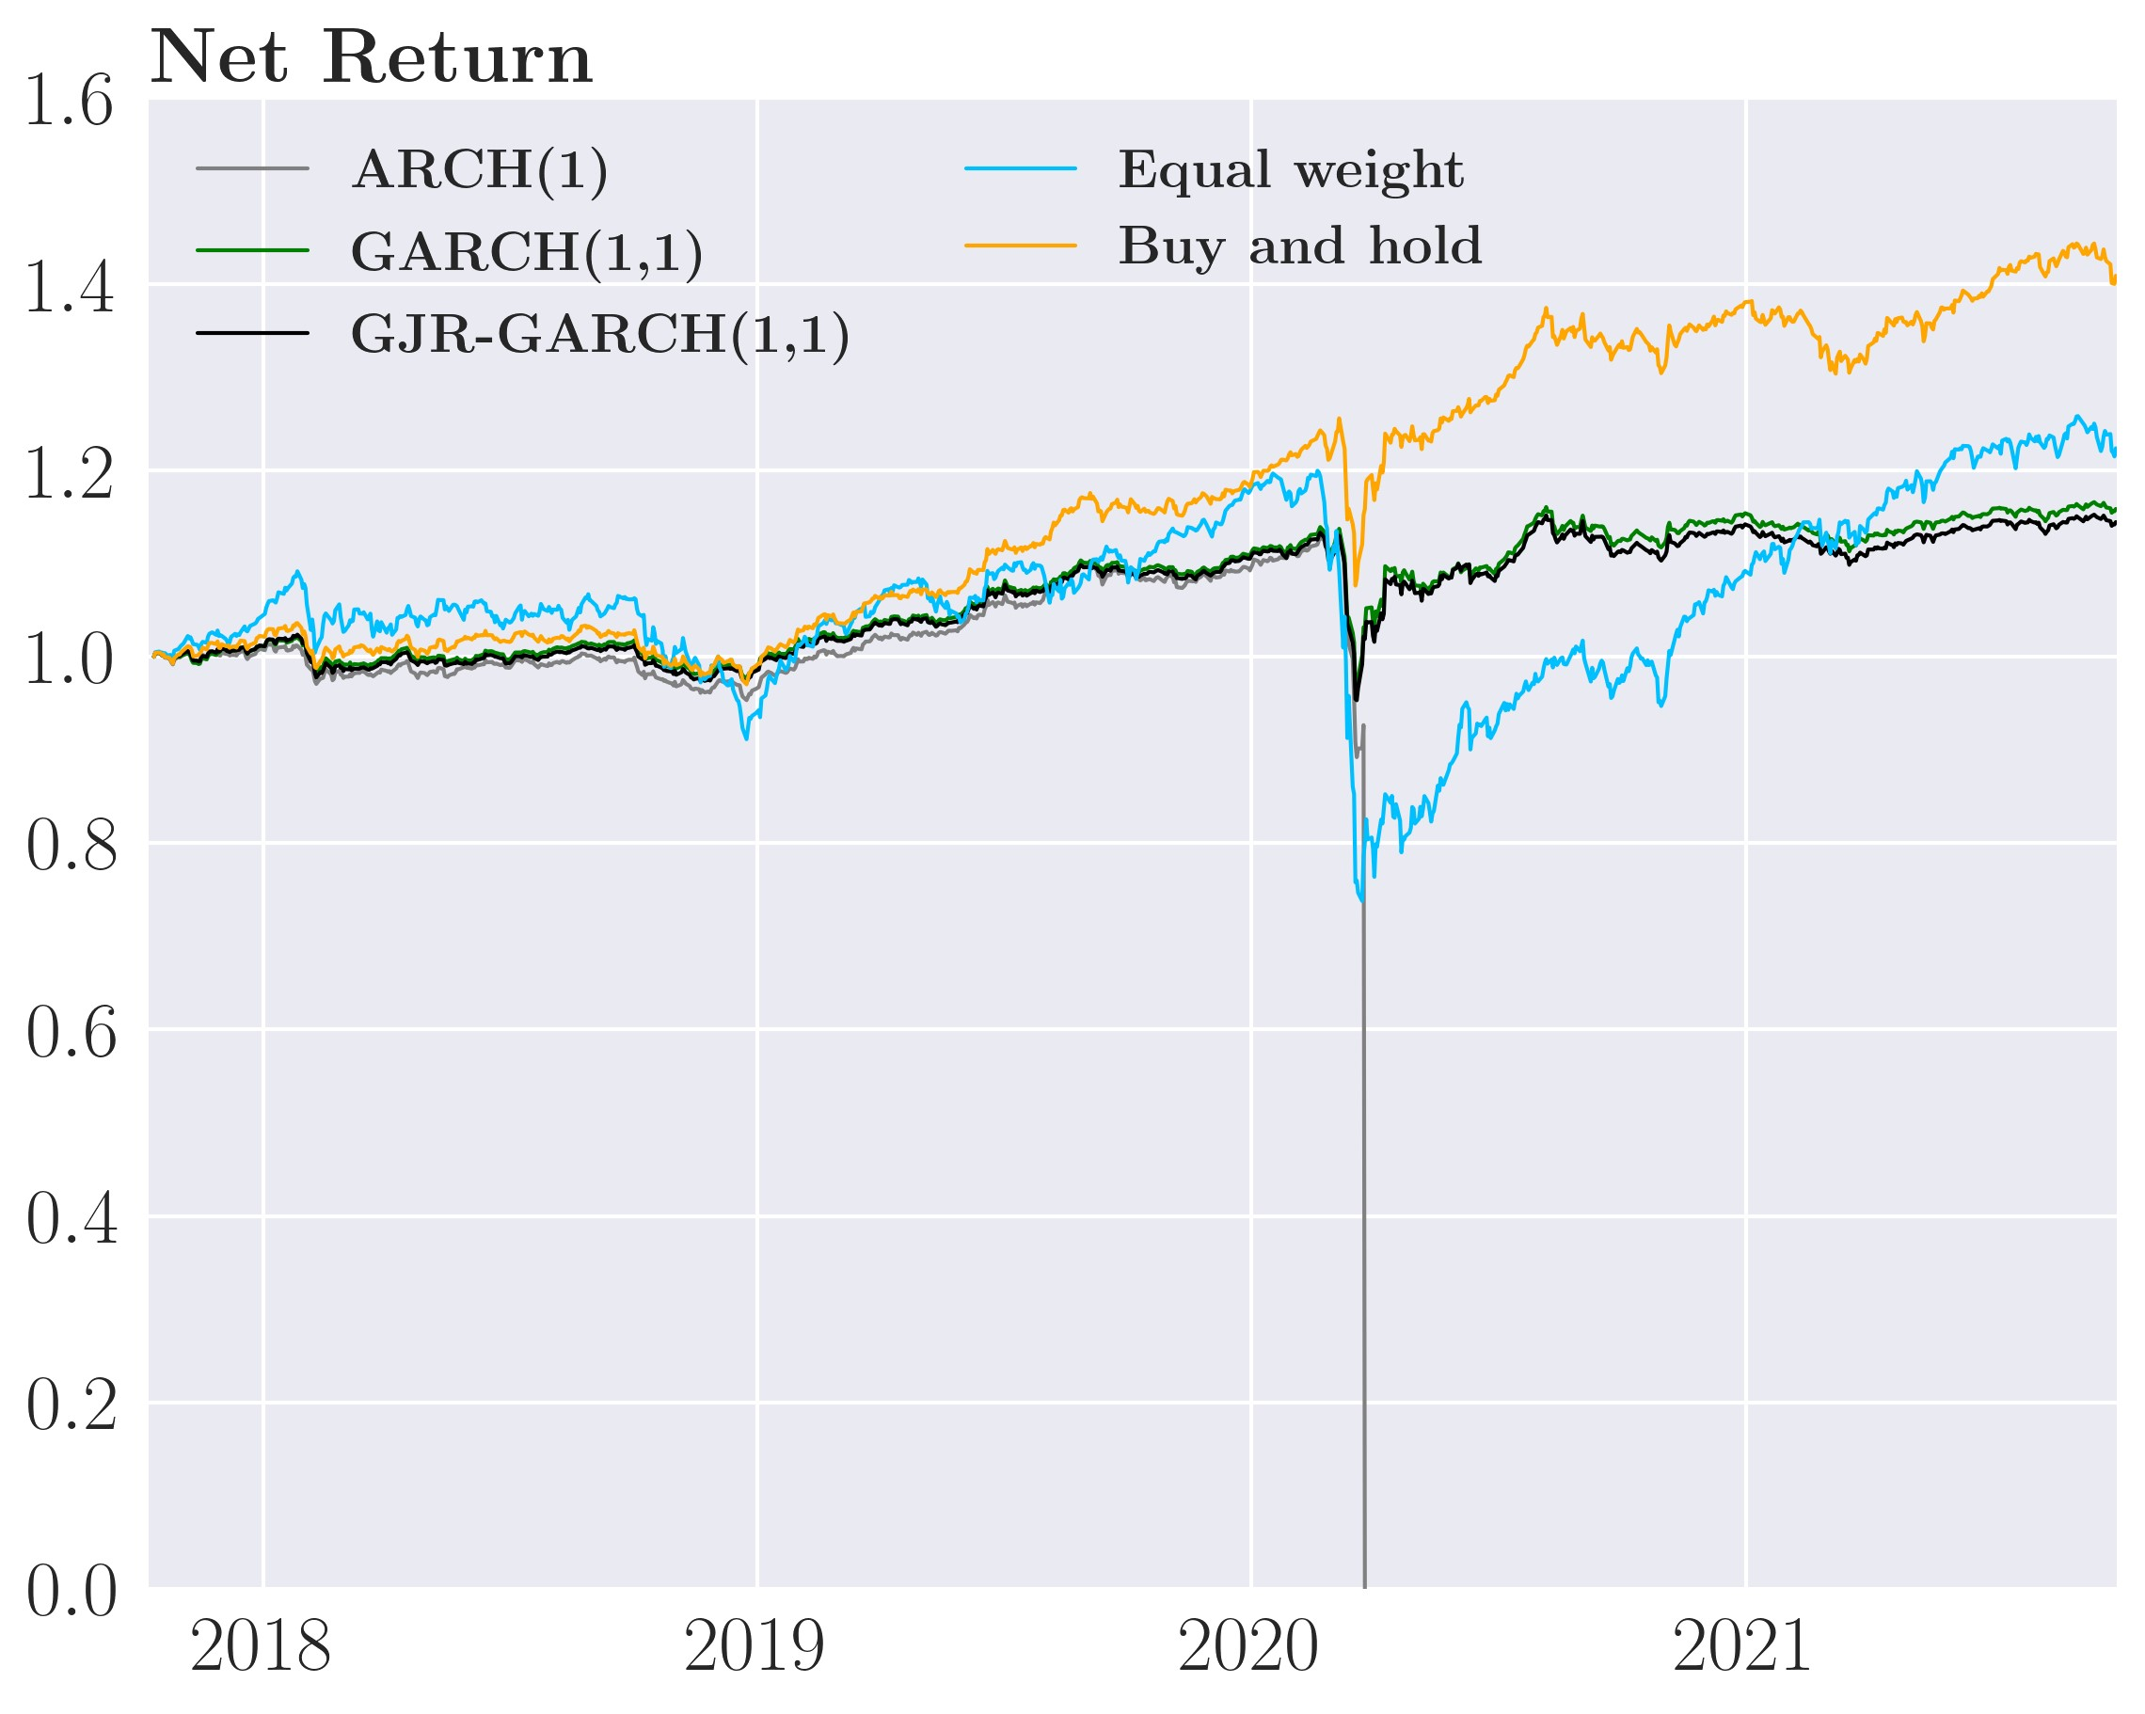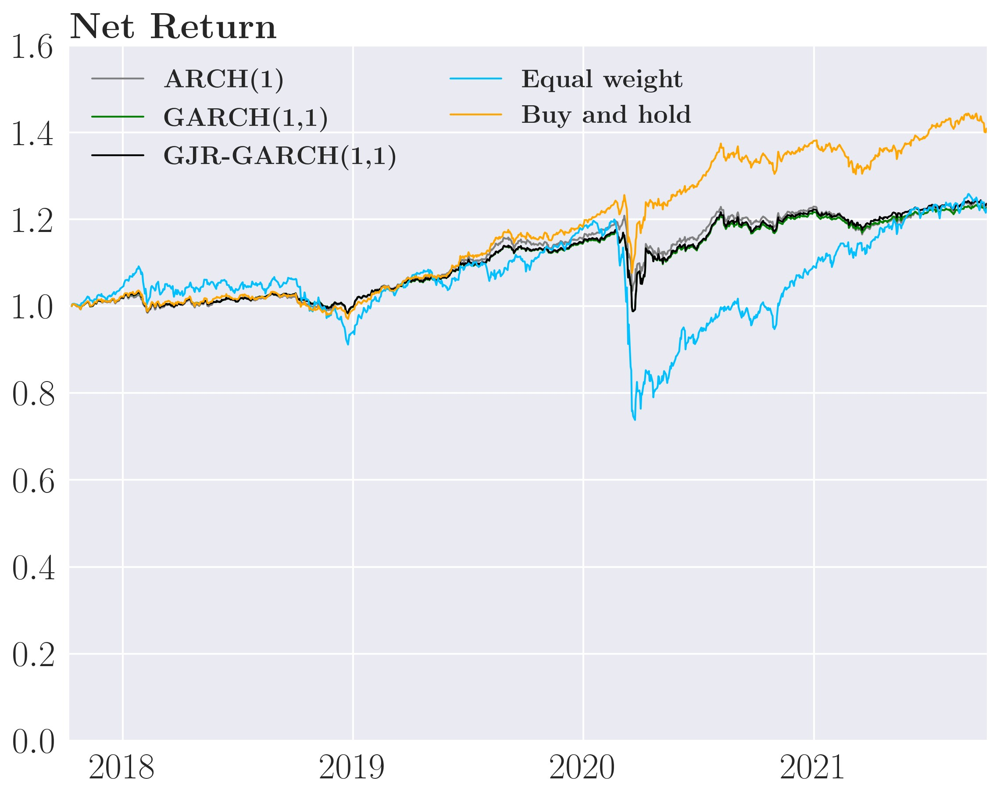

weights might end up not being as beneficial as the investor believes. Thus, further reducing the trading volume may be beneficial because the investor will then only make the changes he deems absolutely necessary for risk reduction thereby reducing the transactions cost paid and reducing the more extreme positions the investor would otherwise make for a few periods if not limited by transaction costs. A secondary reason is the transaction costs payments themselves as transaction costs payments decreases the portfolio value which when combined with a negative return causes a bigger drop in portfolio value which we measure as additional volatility.

Increasing ex-ante transaction costs *γ*˜*D* to 1*.*3e−5 causes the investor to reduce his trading volume, and by extension, the transaction costs the investor pays. This drastically improves the performance of the sophisticated GARCH(1,1) and sophisticated GJR-GARCH(1,1) strategies. In table 7, the sophisticated ARCH(1) strategy does not improve as it is still wiped out by annual transaction costs of 100%, though it does have slightly lower volatility of 64%.

In stark contrast, the GARCH(1,1) and GJR-GARCH(1,1) perform admirably, earning a

Table 7: Annualized performance of the sophisticated strategy, all assets

Strategy Std. deviation Return Sharpe ratio Transaction costs

|  |  |  |  |
| --- | --- | --- | --- |
|  |  | Before transaction costs | |
| ARCH(1) | 0.0794 | 0.0735 0.9257 | |
| GARCH(1,1) | 0.0632 | 0.0651 1.0299 | |
| GJR-GARCH(1,1) | 0.0654 | 0.0640 0.9788 | |
| Equal-weight | 0.1565 | 0.1105 0.7062 | |
| Buy-and-hold | 0.0780 | 0.0894 1.1462 | |
|  |  | After transaction costs *γ*˜*D* = *γD* = 1*.*52e−6 | |
| ARCH(1) | 0.6890 | -1.0000 -1.4514 | 100.00% |
| GARCH(1,1) | 0.1114 | -0.1846 -1.6569 | 23.553% |
| GJR-GARCH(1,1) | 0.1257 | -0.2136 -1.7000 | 26.174% |
| Equal-weight | 0.1626 | 0.0517 0.3182 | 5.0201% |
| Buy-and-hold | 0.0780 | 0.0894 1.1462 | 0% |
|  |  | After transaction costs *γ*˜*D* = 1*.*3e−5 |  |
| ARCH(1) | 0.6415 | -1.0000 -1.5588 | 100.00% |
| GARCH(1,1) | 0.0630 | 0.0375 0.5943 | 2.0706% |
| GJR-GARCH(1,1) | 0.0648 | 0.0343 0.5291 | 2.4152% |
|  |  | After transaction costs *γ*˜*D* = 1e−4 |  |
| ARCH(1) | 0.0670 | 0.0529 0.7890 | 0.1038% |
| GARCH(1,1) | 0.0696 | 0.0522 0.7507 | 0.01630% |
| GJR-GARCH(1,1) | 0.0709 | 0.0543 0.7660 | 0.01902% |

*Note*: The actual transaction costs the investor pays is identical for each *γ*˜

net return of 3.8% at 3.4% with volatility at 6.3% and 6.5% respectively. In this case, the GARCH(1,1) and GJR-GARCH(1,1) have lower annualized volatility than the Equal-weight and Buy-and-hold but at a lower net return. The Buy-and-hold yields the highest Sharpe ratio of 1.14. Because of the lower trading volume the sophisticated GARCH(1,1) and GJRGARCH(1,1) strategies loses only 2.1% and 2.4% annually to transaction costs, which is a drastic reduction. The increased perceived transaction costs cause lower trading volume and thus lower transaction costs, boosting net returns and lowering volatility. We still see that the sophisticated ARCH(1) strategy performs poorly, however for the sophisticated GARCH(1,1) and GJR-GARCH(1,1) strategies, *γ*˜*D* = 1*.*3e−5 is the optimal *γ*˜*D* in terms of reducing volatility, i.e., the optimal trade-off between rebalancing in the face of new information to reduce future risk and transaction costs from implementing these changes.

The investor still pays a moderate sum in transaction costs, so lets increase the perceived transaction costs even further to *γ*˜*D* = 1e−4. In figure 21 panel(d), we see that all the sophisticated strategies perform very similarly and closely follow each other throughout the four years. This is due to the huge perceived transaction costs such that the differences between the covariance predictions of the models are reduced greatly which results in the sophisticated ARCH(1), GARCH(1, 1), and GJR-GARCH(1,1) strategies only having annual transaction costs of 1%, 0.2% and 0.2% respectively. The consequences of this is that the models have nearly identical performance which the sophisticated ARCH(1) strategy yielding the lowest volatility of 6.6% earning a net return of 5.1% followed by the sophisticated GARCH(1,1) strategy with volatility of 6.9% with a net return of 5.2%. Lastly, the sophisticated GJRGARCH(1,1) strategy has volatility of 7.1% with a net return of 5.4% which results in nearly identical Sharpe ratios of around 0.76 for all the sophisticated strategies. This thoroughly beats the Equal-weight strategies in both volatility and net return. The Buy-and-hold strategy is also beat in terms of volatility, but it has a higher Sharpe Ratio than the sophisticated strategies.

In summary, for the empirically calibrated *γD*, the sophisticated strategies do not sufficiently adjust for transaction costs resulting in negative net return or bankruptcy for the sophisticated ARCH(1). We see significant performance improvements when the perceived transaction costs increase, especially for lowering volatility. There is a clear trade-off between decreasing risk and increasing net returns as *γ*˜*D* = 1e−4 has the highest net return of the three cases, but with higher volatility than *γ*˜*D* = 1*.*3e−5. Either the investor can trade more to reduce his risk but at the cost of higher transaction costs or the investor can trade less, changing less in the face of market change with lower transaction and higher net return at higher volatility.

### Backtesting the sophisticated strategy with commodities only

As shown in figure 19, the GARCH strategies was able to outperform the Buy-and-hold when only considering commodities which in our case is gold and oil. Additionally, gold and oil are the same commodities that [Gârleanu and Pedersen, 2013] used in their back testing which make rough comparisons possible. Therefore, we explore this case in greater detail.

We will not focus on the weight, although these are plotted in figure 28, 29 and 30 in the appendix. Though they exhibit the exact same dynamics as the case with all assets and the same reduction in trading volume as *γ*˜*D* increases.

In term of gross returns in figure 22 panel (a), the sophisticated strategies have similar or slightly lower volatility than the Buy-and-hold of around 14.6% and easily beat the Equalweight which have 24.1%. But all have higher gross return than the Buy-and-hold which earns 8.2% annualized. Thus, the sophisticated strategies have the highest Sharpe Ratio with the sophisticated ARCH(1) strategy having the highest of 0.74. It seem that the high trading volume of the ARCH(1) is able to give it an edge over the remaining strategies in terms of gross returns. Carefully comparing to [Gârleanu and Pedersen, 2013] given different sample periods, where their dynamic portfolio earn a Sharpe ratio of 0.62 in gross return, we see very similar performance.

When considering the net returns given the empirically calibrated *γD* in figure 22 panel (b), Figure 22: Cumulative performance of the sophisticated strategy, commodities

(a) Gross returns (b) Net returns for *γ*˜*D* = 1*.*52e−6

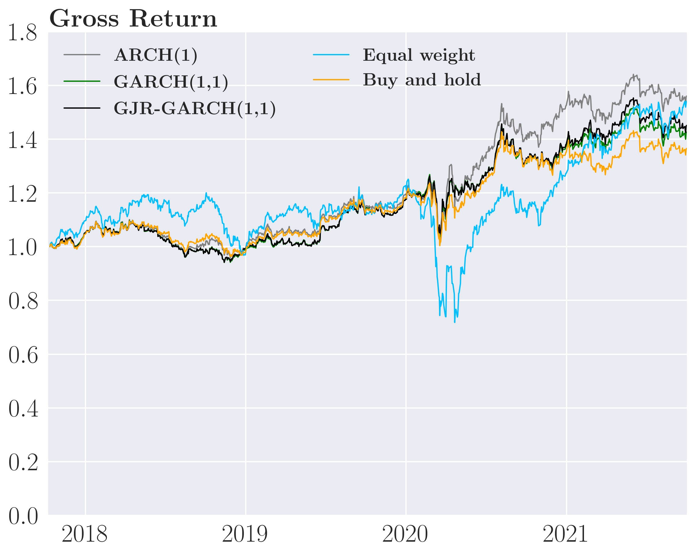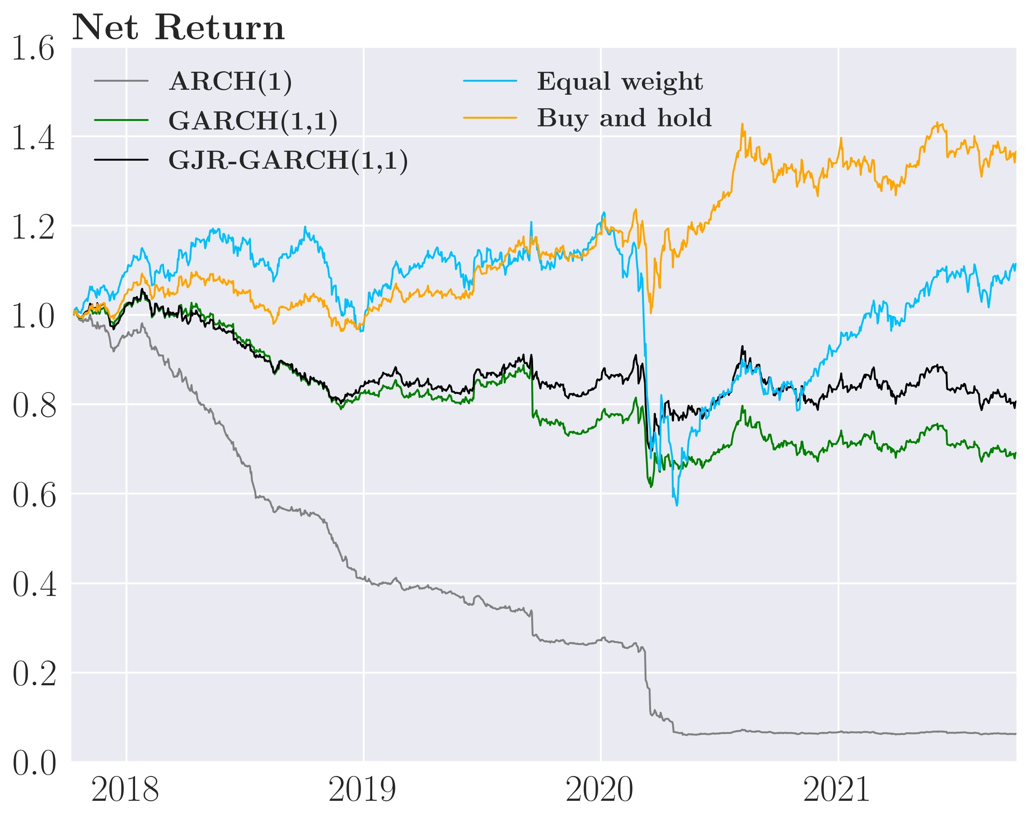

(c) Net returns for *γ*˜*D* = 2*.*3e−5 (d) Net returns for *γ*˜*D* = 1e−4

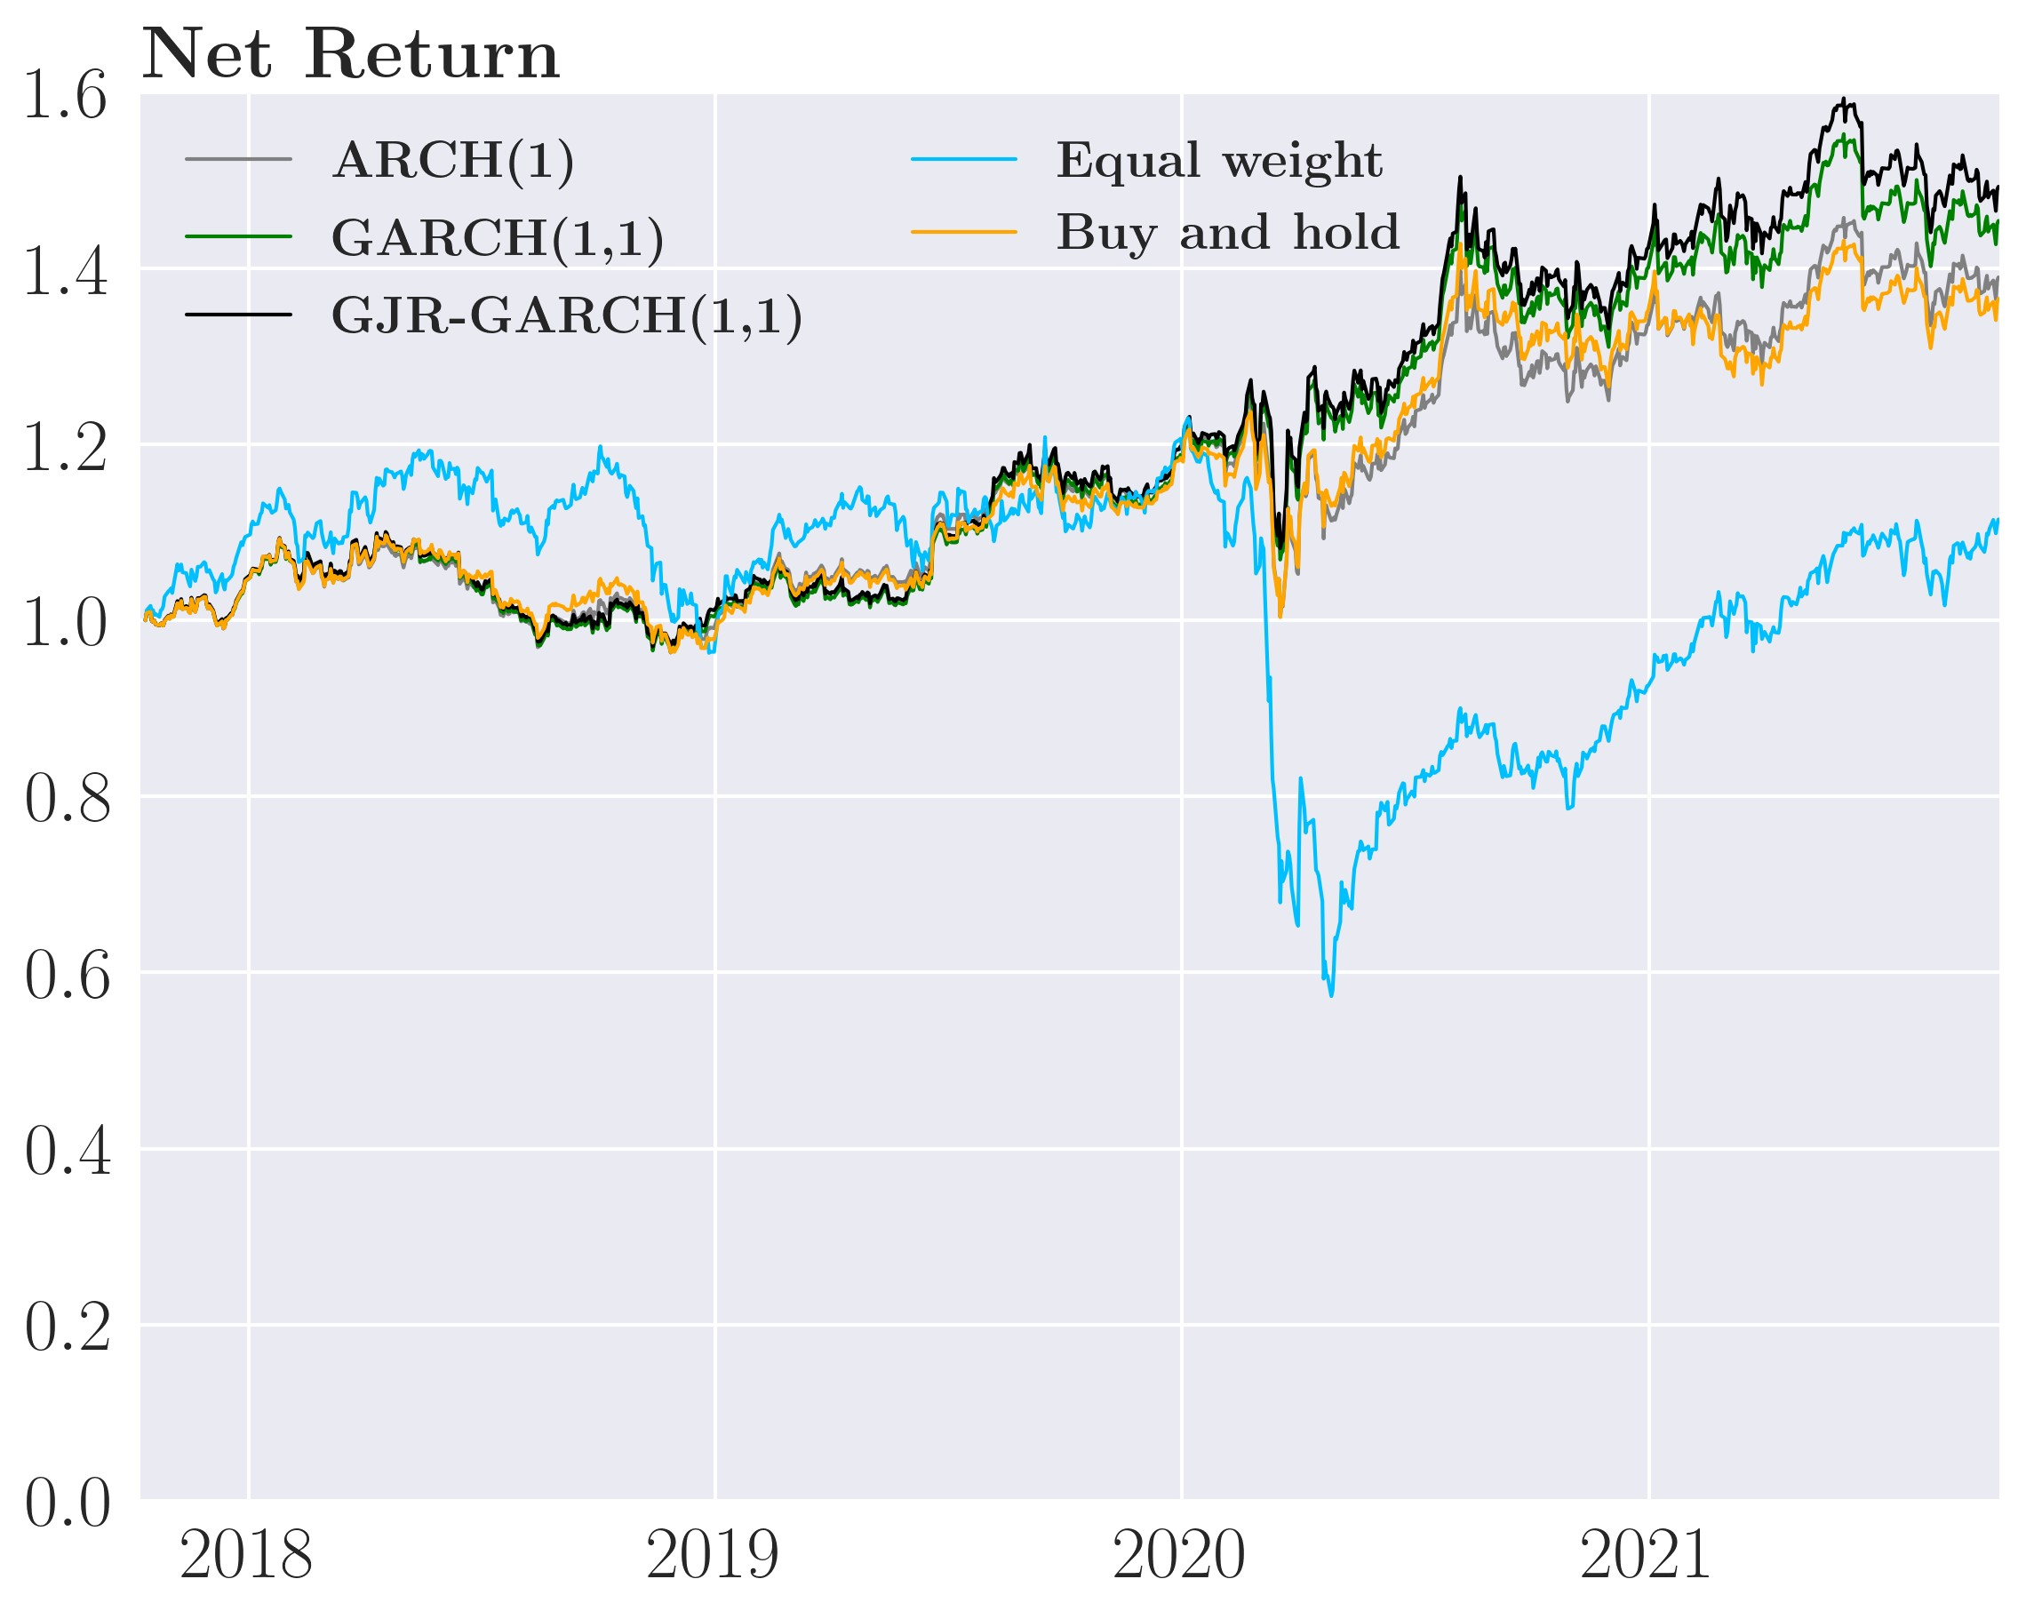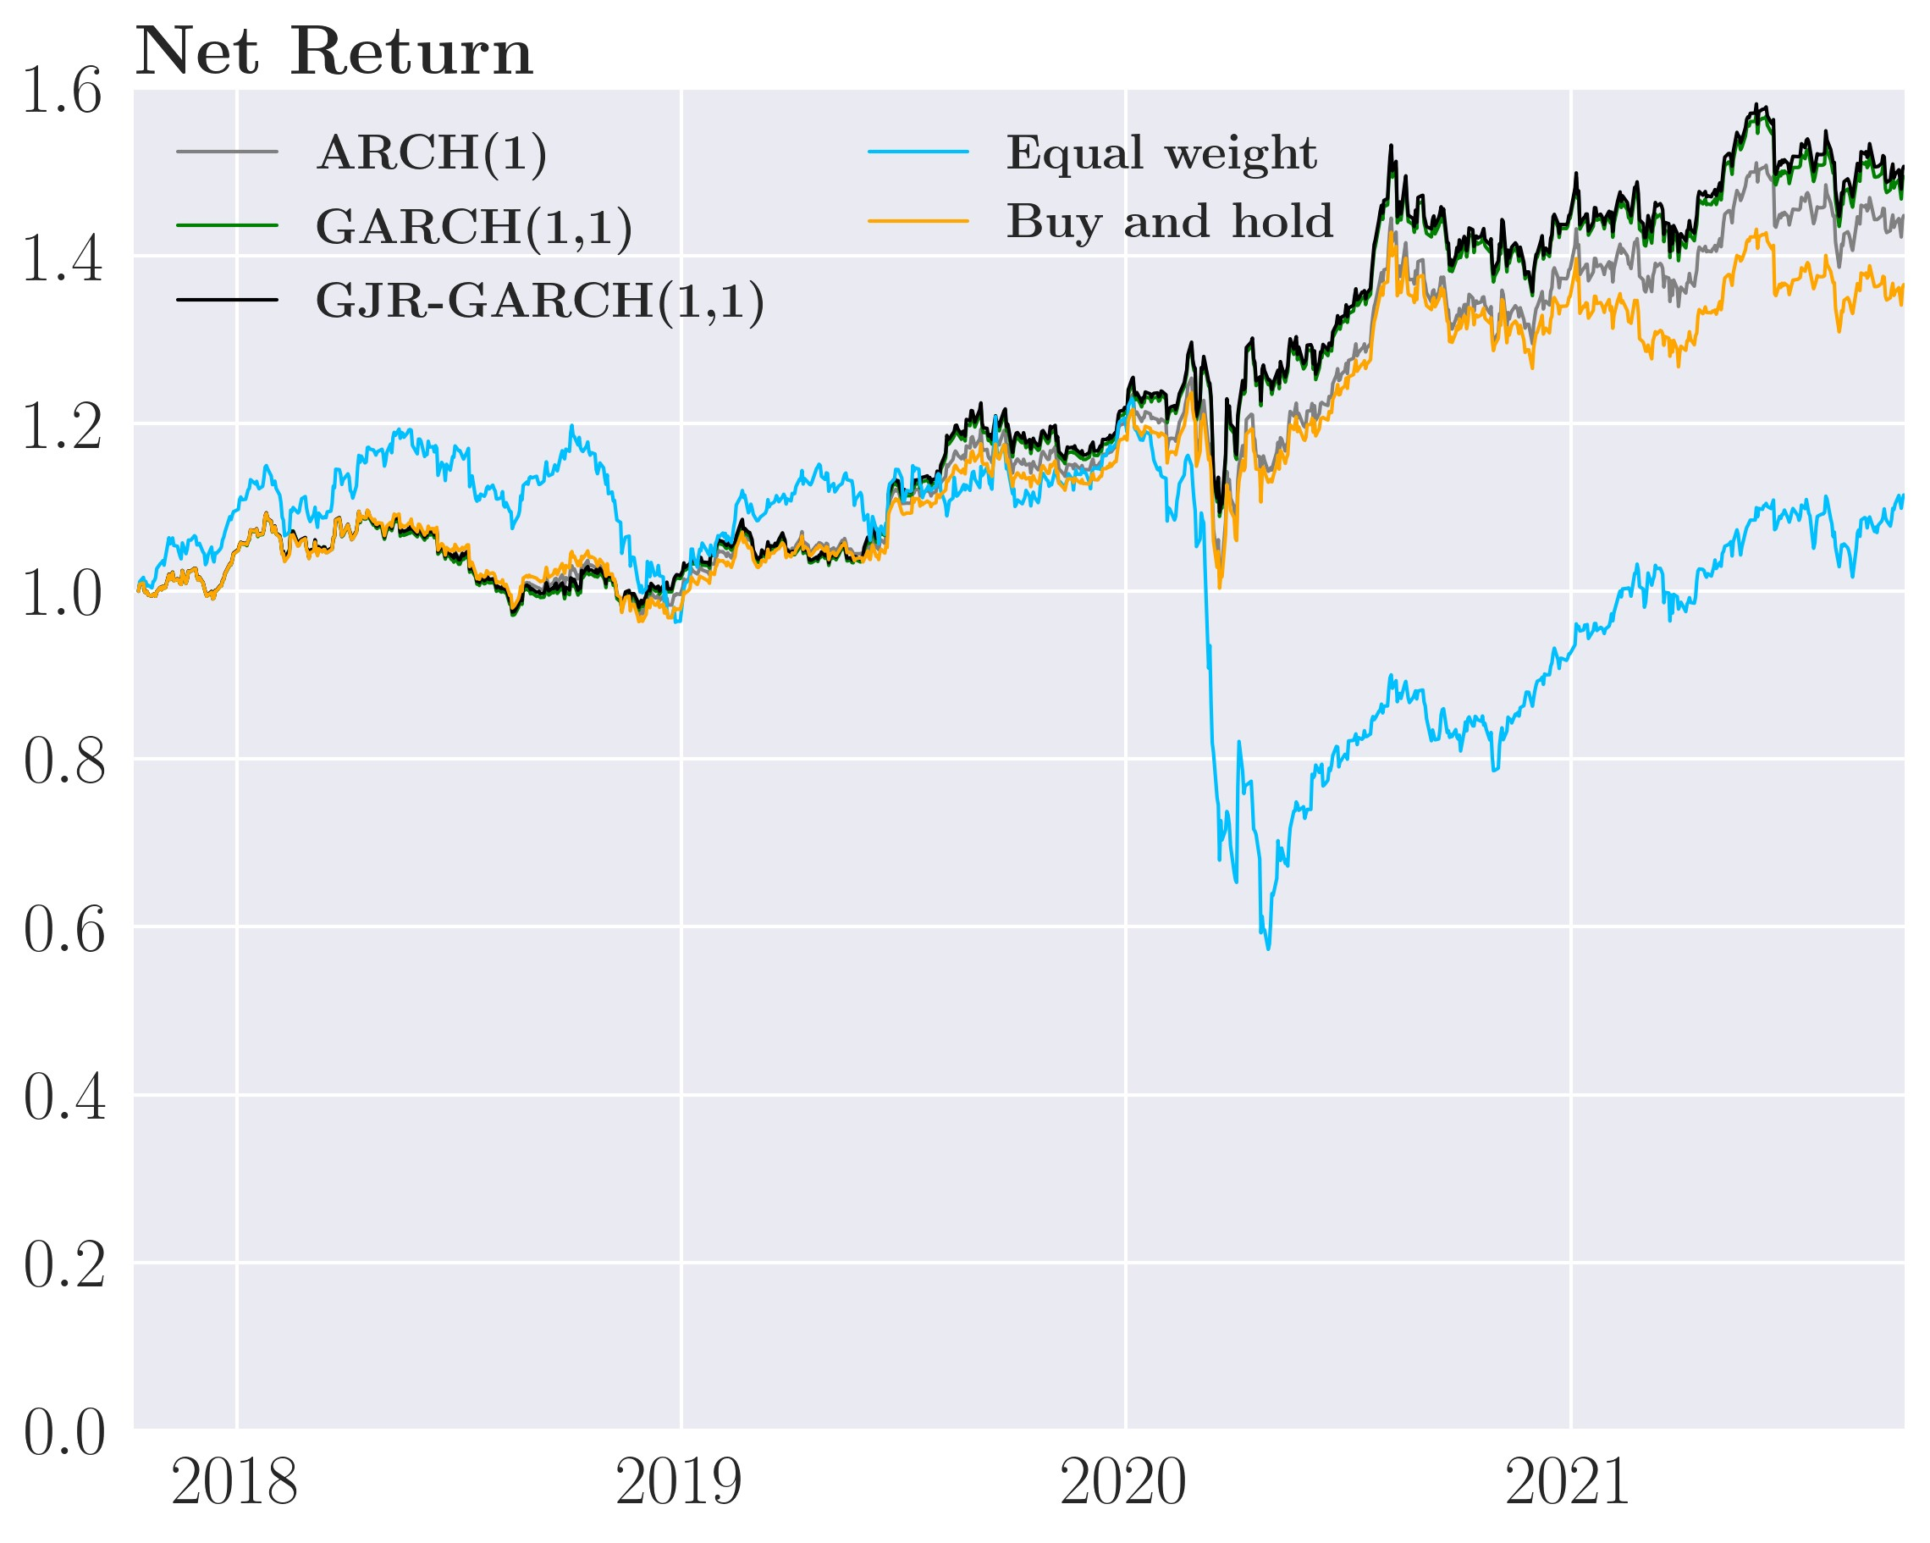

we see decent volatility for the sophisticated GARCH(1,1) and GJR-GARCH(1,1) strategies but subpar net returns of -5.3 % and -8.8% respectively as a result of high transaction costs of 52% and 45%. The sophisticated ARCH(1) strategy performs poorly given the large trading volume with transaction cost of 96% which is costly resulting in net returns of -50% at a volatility of 29.5%. At the empirically calibrated *γD*, the performance of our portfolio is poor, comparing it [Gârleanu and Pedersen, 2013] which earned SR of 0.58 in net returns, we see our sophisticated strategies having negative Sharpe ratios for the same reasons as the sophisticated strategies considering all assets. Thus, we increased the ex ante transaction costs.

Further increasing the tuning parameter to *γ*˜*D* = 2*.*3e−5 yields a substantial increase in performance both in lower volatility but mainly in higher net returns. All the sophisticated strategies have annualized standard deviations of around 14.5% which is similar to the Buy-and-hold. The sophisticated ARCH(1) strategy earns a net return of 8.6%, and the sophisticated GARCH(1,1) and GJR-GARCH(1,1) strategies yield returns of 9.8% and Table 8: Annualized performance of the sophisticated strategy, commodities

Strategy Std. deviation Return Sharpe ratio Transaction costs

|  |  |  |  |
| --- | --- | --- | --- |
|  | Before transaction costs | |  |
| ARCH(1) | 0.1590 0.1176 | 0.7398 |  |
| GARCH(1,1) | 0.1461 0.0929 | 0.6355 |  |
| GJR-GARCH(1,1) | 0.1446 0.0976 | 0.6747 |  |
| Equal-weight | 0.2412 0.1141 | 0.4733 |  |
| Buy-and-hold | 0.1463 0.0809 | 0.5531 |  |
|  | After transaction costs *γ*˜*D* = *γD* = 1*.*52e−6 | |  |
| ARCH(1) | 0.2951 -0.4988 | -1.6905 | 55.432% |
| GARCH(1,1) | 0.1619 -0.0882 | -0.5448 | 16.695% |
| GJR-GARCH(1,1) | 0.1517 -0.0526 | -0.3466 | 13.751% |
| Equal-weight | 0.2446 0.0275 | 0.1125 | 5.2374% |
| Buy-and-hold | 0.1463 0.0809 | 0.5531 | 0% |
|  | After transaction costs *γ*˜*D* = 2*.*3e−5 | |  |
| ARCH(1) | 0.1457 0.0857 0.5885 | | 1.3570% |
| GARCH(1,1) | 0.1446 0.0980 0.6781 | | 0.4540% |
| GJR-GARCH(1,1) | 0.1448 0.1053 0.7272 | | 0.4094% |
|  | After transaction costs *γ*˜*D* = 1e−4 | |  |
| ARCH(1) | 0.1450 0.0969 0.6682 | | 0.0794% |
| GARCH(1,1) | 0.1437 0.1056 0.7347 | | 0.0417% |
| GJR-GARCH(1,1) | 0.1442 0.1078 0.7477 | | 0.0419% |

*Note*: the actual transaction costs the investor pays is identical for each *γ*˜

10.5 % respectively resulting in Sharpe ratios of 0.68 and 0.73. This handily outperform the Equal-weight but also the Buy-and-hold strategies which have Sharpe ratios of 0.11 and 0.52 respectively. The performance of the GARCH strategies is now similar or slightly higher than the result from [Gârleanu and Pedersen, 2013] although a direct comparison cannot be made in a fair manner.

Consider the high version of *γ*˜*D* = 1e−4, we see a moderate increase in performance yet again. The volatility of the sophisticated strategies does not change significantly, and the net return only increases by about one percentage point, which results in Sharpe ratios of 0.74 and 0.75 for the sophisticated GARCH(1,1), and GJR-GARCH(1,1) strategies. The sophisticated strategies comfortably outperform the Equal-weight and slightly outperform the Buy-and-hold strategy and it’s also slightly higher than the Sharpe ratio of 0.58 that [Gârleanu and Pedersen, 2013] found.

For completeness, we briefly consider the sophisticated strategies for the remaining two asset classes, bonds and stocks. Consider figure 24 panel (a) + (b) for stocks along with table 11, we see that the sophisticated strategies outperforms the Equal-weight in term of Sharpe ratios for high values of ex ante transaction costs but never beats the Buy-and-hold. For lower values of *γ*˜*D*, the sophisticated GARCH(1,1) and GJR-GARCH(1,1) strategies have a lower standard deviation than the Equal weight and the Buy-and-hold for for a majority of values. Looking at figure 24 for bonds in panel (c) + (d) and table 12, the sophisticated strategies, especially the GJR-GARCH(1,1), have lower standard deviation than both Equal-weight and Buy-and-hold for all ante transaction costs displayed. In terms of Sharpe ratios, the Equalweight strategy is outperformed for high values of *γ*˜*D* by the sophisticated strategies, similar so for the Buy-and-hold but for a narrower range of ex ante transaction costs. The main takeaway being that the sophisticated strategies perform differently for different asset classes.

To summarize, investors need to consider transaction costs when trading is costly. The difference between ignoring and adjusting for transaction costs is an optimal low-risk strategy and bankruptcy in the worse case with the simple ARCH(1) strategy and some versions of the sophisticated ARCH(1) strategy. Additionally, it is very beneficial for the investor to consider optimization under higher transaction costs than what he incurs. This dampens trading volume and reduces large trades to reduce future risk that might be slightly spurious given estimation uncertainty. Overall, the different sophisticated strategies perform well in gross returns with lower annualized portfolio standard deviations and higher Sharpe Ratios than the Equal-weight and slightly lower than the Buy-and-hold strategy. Furthermore in net returns with higher values of the tuning parameter (*γ*˜*D* ∈ {2*.*3e−5*,*1e−4}), the sophisticated strategies likewise outperformed the Equal-weight across the two measures and yields lower volatility than the Buy-and-hold which in term often had higher Sharpe ratios than the sophisticated strategies. The sophisticated strategy for high *γ*˜*D* shows very similar performances to the dynamic trading strategies of [Gârleanu and Pedersen, 2013].

# 7 Discussion

No one completes a thesis without impactful decisions and tough compromises. Thus, we will attempt to address some of these choices and explain our thought process behind them.

An obvious question to ask two researchers looking at minimum variance portfolio is why we haven’t included a risk-less asset. The answer to this is threefold. Firstly, the investor would always invest 100% into the risk-less asset, reducing his risk the most, which is not the most exciting result. Secondly, a genuinely risk-less asset is a theoretical construction that one could argue doesn’t exist in the real world though often approximated by US treasuries or a bank account. Thirdly and most importantly, we look at minimum variance portfolios as we model the conditional covariance matrix as sample estimates of the mean are a lousy predictor of future returns and not because we are disinterested in the return of the portfolios.

But, if we are interested in the return of our portfolio, why did we not implement a factor-type model or another more complex mean prediction model rather than discard them altogether? First and foremost, it is beyond the scope of this paper to unite factor models and multivariate GARCH models. Secondly, as mentioned in section 2.2.1, [Welch and Goyal, 2008] finds that the estimates of many factor models are unstable, insignificant, and yield spurious results. Thus, we decided to focus on modeling the covariance matrix.

Regarding modeling the covariance matrix, one might question why we don’t update the model parameters with the new information that the investor receives while going through the out-of-sample period. We have multiple reasons why. Firstly, continuously updating the model parameters increases the computational effort needed to solve the model dramatically with little to no benefits in return because the model parameters are unlikely to change significantly with the continuous addition of new information. Secondly, adding this extra dimension will likely cause mild instability given the estimation uncertainty, which makes interpreting the results more difficult as there would be an extra dimension to consider. One could argue that re-estimating the model every year might be a good idea to incorporate the new information into the parameter estimates. We will, however, leave this question for future research. Another interesting future research venture would be to add more sophisticated univariate GARCH models to the DCC MGARCH model. One could consider the EGARCH model by [Nelson, 1991] or with the more frequent use of high-frequency data a Realized GARCH model presented in [Hansen et al., 2012]. Especially the latter could increase the forecast accuracy of the conditional variance and thus improve the forecast of the covariance matrix, decreasing estimation uncertainty and increasing investor utility. Speaking of uncertainty (?)

Continuing with the covariance matrix, we currently shrink the correlations of *Q*¯ by 50%. This number is similar to [Gârleanu and Pedersen, 2013] and is our reason for using it. But it is possible to estimate the optimal amount of shrinkage or intensity, *δ*, which [Ledoit and Wolf, 2004] derives. We could have used an estimate for *δ* rather than simply setting it to 50%, which could have yielded better performance for the simple and sophisticated strategies, but this is beyond the scope of this paper, and we leave it for future research.

We only test real-world data in our current empirical setup, i.e., historical backtesting, which will always be a case study of a particular period for certain assets. Thus, the results will always depend on the sample period, choice of assets, number of assets, etc. This is quite evident in our backtesting, as the performance of the simple and sophisticated strategies vary substantially for different assets classes. However, the biggest flaw of historical backtesting is that past performance is not necessarily an indicator of future performance. Thus, good historical backtesting does not mean that the investment strategy will perform well in the future. Another way to test performance is to use Monte Carlo simulation. We could have used simulated returns from some distribution to allow us to change the data generating process of the returns and investigate how this impacts our results and whether they are robust to changes to the data generating process. However, we will leave Monte Carlo approaches to future research.

Another point of valid critique is why we use ETF’s when an institutional investor can feasibly replicate the index themselves and avoid the administration fees of the ETFs. While this will most likely be true for institutional investors, we would find it computationally highly challenging to estimate multivariate GARCH models for hundreds or thousands of assets with our current setup. The curse of dimensionality would make accurately estimating the covariance matrix of these thousands of assets difficult with the amount of data available. Therefore, modeling the individual assets that compromise the ETF’s we use is beyond the scope of this paper but could certainly be a possible benefit to the investor with more diverse investment opportunities, i.e., increasing his feasible set.

Lastly, we model an investor facing quadratic transaction costs similar to [Gârleanu and Pedersen, 2013]. While these seem the best choice for large institutional investors trading commodities, proportional transaction cost might be the better for institutional investors trading bonds and equity ETFs. These products are very liquid and thus should have more linear than quadratic price changes. [Mei et al., 2016] considers a version of [Gârleanu and Pedersen, 2013]’s model with proportional transaction costs. As such, this change is not new to the literature, and thus, sticking more closely to the model made by [Gârleanu and Pedersen, 2013] made comparisons easier. Another choice regarding transaction costs is only considering the median value of all the assets in the calibrated *γD* rather than using the individual calibrations for each asset. Using the individual values would be more realistic but would also add an extra dimension that would make interpretation more difficult. Sticking to the setup of [Gârleanu and Pedersen, 2013] also allows easier comparisons.

# 8 Conclusion

This thesis derives multi-period dynamic minimum variance trading strategies for an investor that either ignores (simple strategy) or adjusts for quadratic transaction costs (sophisticated strategy). We use multivariate DCC GARCH models to forecast the conditional covariance matrix for both strategies. We derive the optimal trading policy with a closed-form solution for the simple strategy and a sophisticated strategy that requires numerically solving the coefficient matrices.

The two solutions have simple dynamics. In the simple strategy, the investor completely rebalances to the new minimum variance portfolio each period as the investor ignores transaction costs. Thus, the investor responds immediately to shocks with the convergence speed depending on the exact specification of the DCC MGARCH model. For the sophisticated strategy, the investor partially rebalances his portfolio toward the new minimum variance portfolio or aim portfolio, with the amount traded depending on the level of transaction costs. The higher the transaction costs, the lower the amount of trading.

We backtest the two strategies for 1.000 trading days (4 calendar years) using 11 different EFTs from different sections, regions, and assets types. In terms of gross return, we find that the simple strategy achieves lower standard deviation and higher Sharpe ratios when benchmarked against a naive Equal-weight and a Buy-and-hold strategy. Of the three volatility models tested, the GARCH(1,1) fares best as it slightly outperforms the GJR-GARCH(1,1). However, we find abysmal performance in net returns (after transaction costs) as the investor trades heavily, especially for the simple ARCH(1). This is very costly given quadratic transaction costs. For an investor adjusting for transaction costs (sophisticated strategy), the empirically calibrated value the investor adjusts with barely improves the performance. This is because the investor believes rebalancing reduces the expected future risk of his portfolio to such a degree that it is well worth the high transaction costs. Increasing the ex-ante (or perceived) transaction costs increases performance significantly as the investor perceives trading as more costly and thus decreases trading volumes. This reduces extreme positions caused by estimation uncertainty, reducing risk and lowering transaction costs, increasing net returns. For the sophisticated GARCH(1,1) and GJR-GARCH(1,1), the strategies have lower annualized standard deviation than the Equal-weight and Buy-and-hold strategies with higher Sharpe ratios than the Equal-weight. Considering only gold and oil futures like [Gârleanu and Pedersen, 2013], we find similar Sharpe ratios. Our dynamic strategies also outperform the Equal-weight and Buy-and-hold benchmark across all measures when increasing ex-ante transaction costs.

Our contribution to portfolio theory is thus the beginnings of a framework for solving dynamic multi-period with an investor seeking to minimize the variance of his portfolio with quadratic transaction costs and incorporating time-varying covariance estimates model by multivariate GARCH models. Future research with offset in this thesis should first and foremost focus on finishing the theoretical work begun by us and find optimal weights that sum to 1. Additionally, in the theoretical section, one could find an analytical solution or an approximation to the coefficient matrix *Avv*. Afterward, one could incorporate more complex univariate GARCH models like the Realized GARCH or EGARCH for better covariance forecasts. Furthermore, it might be possible to combine the focus of [Gârleanu and Pedersen, 2013] on mean prediction models and our emphasis on covariance prediction into a complete model that incorporates both mean and covariance predictions.

# References

[Bellman, 1966] Bellman, R. (1966). Dynamic programming. *Science*, 153(3731):34–37.

[Bohn Nielsen, 2017] Bohn Nielsen, H. (2017). *Introduction to likelihood-based estimation and inference*. Hans Reitzels, 3 edition.

[Bollerslev, 1986] Bollerslev, T. (1986). Generalized autoregressive conditional heteroskedasticity. *Journal of econometrics*, 31(3):307–327.

[Carhart, 1997] Carhart, M. M. (1997). On persistence in mutual fund performance. *The Journal of finance*, 52(1):57–82.

[Collin-Dufresne et al., 2015] Collin-Dufresne, P., Daniel, K. D., Moallemi, C. C., and Saglam, M. (2015). Dynamic asset allocation with predictable returns and transaction costs. *Available at SSRN 2618910*.

[Constantinides, 1986] Constantinides, G. M. (1986). Capital market equilibrium with transaction costs. *Journal of political Economy*, 94(4):842–862.

[Cont, 2001] Cont, R. (2001). Empirical properties of asset returns: stylized facts and statistical issues. *Quantitative finance*, 1(2):223.

[Engle, 2002] Engle, R. (2002). Dynamic conditional correlation: A simple class of multivariate generalized autoregressive conditional heteroskedasticity models. *Journal of Business & Economic Statistics*, 20(3):339–350.

[Engle, 1982] Engle, R. F. (1982). Autoregressive conditional heteroscedasticity with estimates of the variance of united kingdom inflation. *Econometrica: Journal of the Econometric Society*, pages 987–1007.

[Engle and Kroner, 1995] Engle, R. F. and Kroner, K. F. (1995). Multivariate simultaneous generalized arch. *Econometric theory*, 11(1):122–150.

[Engle and Sheppard, 2001] Engle, R. F. and Sheppard, K. (2001). Theoretical and empirical properties of dynamic conditional correlation multivariate garch. *Department of Economics, UC San Diego, University of California at San Diego, Economics Working Paper Series*.

[Fama, 1965] Fama, E. F. (1965). The behavior of stock-market prices. *The journal of Business*, 38(1):34–105.

[Fama and French, 1993] Fama, E. F. and French, K. R. (1993). Common risk factors in the returns on stocks and bonds. *Journal of Financial Economics*, 33(1):3–56.

[Gan and Lu, 2014] Gan, X. and Lu, W. (2014). A general setting and solution of bellman equation in monetary theory. *Journal of Applied Mathematics*, 2014.

[Gârleanu and Pedersen, 2013] Gârleanu, N. and Pedersen, L. H. (2013). Dynamic trading with predictable returns and transaction costs. *The Journal of Finance*, 68(6):2309–2340.

[Glosten et al., 1993] Glosten, L. R., Jagannathan, R., and Runkle, D. E. (1993). On the relation between the expected value and the volatility of the nominal excess return on stocks. *The journal of finance*, 48(5):1779–1801.

[Hansen et al., 2012] Hansen, P. R., Huang, Z., and Shek, H. H. (2012). Realized garch: a joint model for returns and realized measures of volatility. *Journal of Applied Econometrics*, 27(6):877–906.

[Hautsch and Voigt, 2019] Hautsch, N. and Voigt, S. (2019). Large-scale portfolio allocation under transaction costs and model uncertainty. *Journal of Econometrics*, 212(1):221–240.

[Holt and Laury, 2002] Holt, C. A. and Laury, S. K. (2002). Risk aversion and incentive effects. *American economic review*, 92(5):1644–1655.

[Jagannathan and Ma, 2003] Jagannathan, R. and Ma, T. (2003). Risk reduction in large portfolios: Why imposing the wrong constraints helps. *The Journal of Finance*, 58(4):1651– 1683.

[Jobson and Korkie, 1980] Jobson, J. D. and Korkie, B. (1980). Estimation for markowitz efficient portfolios. *Journal of the American Statistical Association*, 75(371):544–554.

[Ledoit and Wolf, 2004] Ledoit, O. and Wolf, M. (2004). Honey, i shrunk the sample covariance matrix. *The Journal of Portfolio Management*, 30(4):110–119.

[Li and Nadarajah, 2020] Li, R. and Nadarajah, S. (2020). A review of student’st distribution and its generalizations. *Empirical Economics*, 58(3):1461–1490.

[Mandelbrot, 1967] Mandelbrot, B. (1967). The variation of some other speculative prices. *The Journal of Business*, 40(4):393–413.

[Markowitz, 1952] Markowitz, H. (1952). Portfolio selection. *The Journal of Finance*, 7(1):77– 91.

[Mei et al., 2016] Mei, X., DeMiguel, V., and Nogales, F. J. (2016). Multiperiod portfolio optimization with multiple risky assets and general transaction costs. *Journal of Banking & Finance*, 69:108–120.

[Mei and Nogales, 2018] Mei, X. and Nogales, F. J. (2018). Portfolio selection with proportional transaction costs and predictability. *Journal of Banking & Finance*, 94:131–151.

[Merton, 1969] Merton, R. C. (1969). Lifetime portfolio selection under uncertainty: The continuous-time case. *The review of Economics and Statistics*, pages 247–257.

[Michaud, 1989] Michaud, R. O. (1989). The markowitz optimization enigma: Is ‘optimized’optimal? *Financial analysts journal*, 45(1):31–42.

[Nelson, 1991] Nelson, D. B. (1991). Conditional heteroskedasticity in asset returns: A new approach. *Econometrica: Journal of the Econometric Society*, pages 347–370.

[Robert et al., 2012] Robert, E., Robert, F., and Jeffrey, R. (2012). Measuring and modeling execution cost and risk. *The Journal of Portfolio Management*, 38(2):14–28.

[Rossi and Spazzini, 2010] Rossi, E. and Spazzini, F. (2010). Model and distribution uncertainty in multivariate garch estimation: a monte carlo analysis. *Computational statistics & data analysis*, 54(11):2786–2800.

[Taylor, 2011] Taylor, S. J. (2011). *Asset price dynamics, volatility, and prediction*. Princeton university press.

[Virtanen et al., 2020] Virtanen, P., Gommers, R., Oliphant, T. E., Haberland, M., Reddy,

T., Cournapeau, D., Burovski, E., Peterson, P., Weckesser, W., Bright, J., van der Walt, S. J., Brett, M., Wilson, J., Millman, K. J., Mayorov, N., Nelson, A. R. J., Jones, E., Kern, R., Larson, E., Carey, C. J., Polat, İ., Feng, Y., Moore, E. W., VanderPlas, J., Laxalde, D., Perktold, J., Cimrman, R., Henriksen, I., Quintero, E. A., Harris, C. R., Archibald, A. M., Ribeiro, A. H., Pedregosa, F., van Mulbregt, P., and SciPy 1.0 Contributors (2020). SciPy 1.0: Fundamental Algorithms for Scientific Computing in Python. *Nature Methods*, 17:261–272.

[Welch and Goyal, 2008] Welch, I. and Goyal, A. (2008). A comprehensive look at the empirical performance of equity premium prediction. *The Review of Financial Studies*, 21(4):1455–1508.

# A Appendix

## A.1 Student’s t-distribution

Consider *Z* and *Y* as independent random variable, where *Z* ∼ N(0*,*1) and *Y* ∼ *χ*2(*ν*). The

Student’s t random variable can be defined by

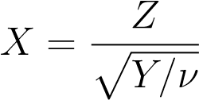

with the probability density function (pdf) given as

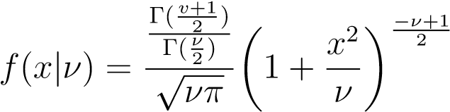

with *ν* degrees of freedom which determines the fatness of the tails and the number of moment which are finite as such *ν >* 2 for the variance to be finite and Γ(·) is the Gamma function. Note that for *ν* → ∞ the student t distribution converges to a normal distribution (See [Li and Nadarajah, 2020] for more).

This distribution is special case of the multivariate Student’s t-distribution. Consider yet again *Z* and *Y* now as independent random vectors, where *Z* is a multivariate standard normal and *Y* ∼ *χ*2(*ν*). The multivariate Student’s t random variable can be defined by

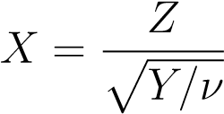

with the multivariate probability density function (pdf) given as

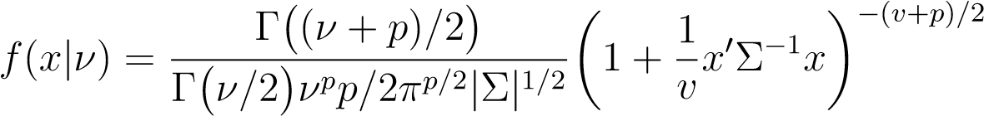

with *ν* degrees of freedom which determines the fatness of the tails and the number of moment which are finite. *p* is the number of dimensions. Note here that Σ is the covariance matrix of the multivariate normal distribution.

## A.2 Non-Central Student’s t-distribution

Consider *Z* and *Y* as independent random variable, where *Z* ∼ N(0*,*1) and *Y* ∼ *χ*2(*ν*). The non-central Student’s t random variable with non-centrality parameter *nc* can be defined by

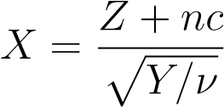

with the probability density function (pdf) given as

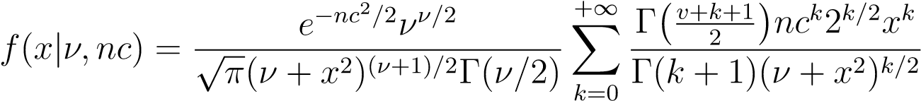

with *Ix*(*a,b*) being the incomplete beta function ratio. Where *nc* dictates which direction the distribution is moved. *ν* is the degrees of freedom which determines the fatness of the tails and the number of moment which are finite as such *ν >* 2 for the variance to be finite and Γ(·) is the Gamma function. Note that for *ν* → ∞ the student t distribution converges to a non-central normal distribution (See [Li and Nadarajah, 2020] for more).

## A.3 Optimal strategies with GARCH volatility models

### A.3.1 Optimal strategy in a static setting with multiple risky assets

Taking first order conditions with respect to the weight, *vt*

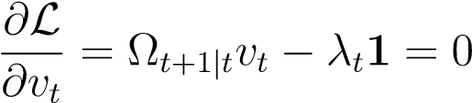

Solving for *vt* yields

*λ*1 = Ω*t*+1|*tvt* ⇔ *vt*Ω*t*+1|*t*1*λt*

The constraint requires that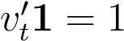, which can be used to solve for the Lagrangian multiplier

*λt*

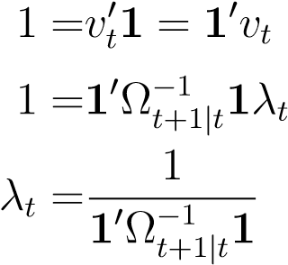

Now, we insert the expression into the weights *vt*

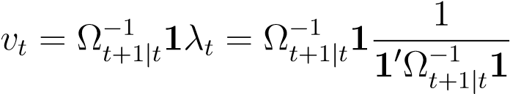

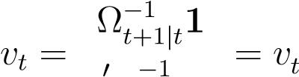MVP

1 Ω*t*+1|*t*1

A.3.2 Optimal dynamic strategy for multiple risky assets when adjusting for

### transaction costs (the sophisticated strategy)

We evaluate the conditional expectation of the guessed value function with E*t*[Ω*t*+1] = Ω*t*+1|*t*

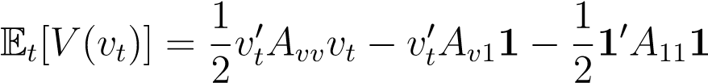

Inserting this into our value function in equation (31) yields the problem:

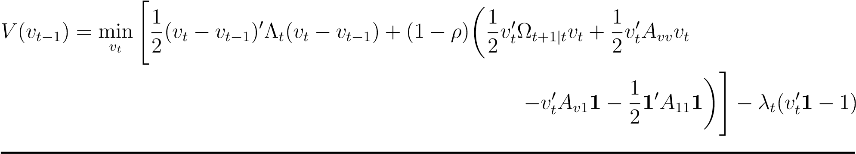

We redefine terms and see the investor minimizes the following quadratic problem:

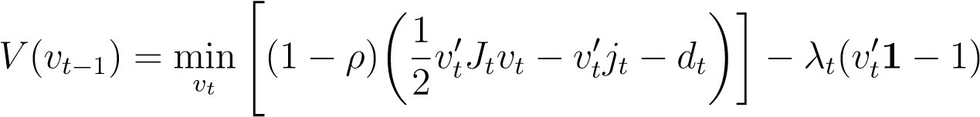 (37)

with

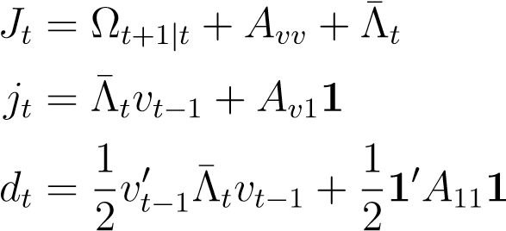

Where we define Λ¯*t* = (1 − *ρ*)−1Λ*t*. Minimize the reformulated problem wrt. to *vt*:

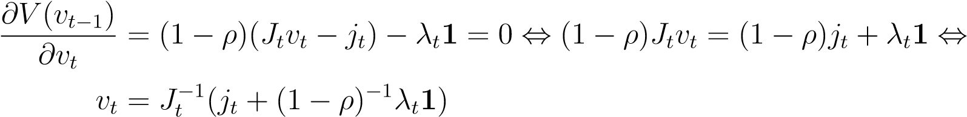

Solve for the Lagrangian multiplier *λt* using the constraint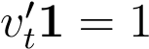



Inserting the Lagrangian multiplier back into the problem yields

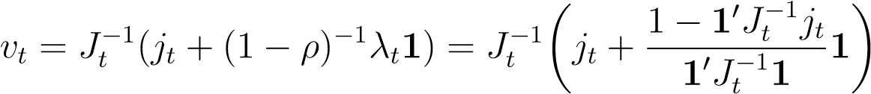

Detour a bit to check that the weights sum to one by inserting *vt* into the constraint, *vt*01 = 10*vt* = 1

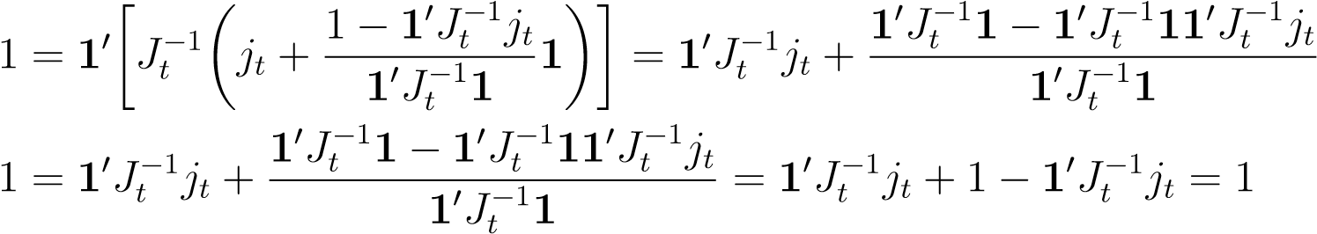

Recall the rewritten version of the quadratic problem *V* (*vt*−1) in equation (37) and define *λ*¯*t* = (1 − *ρ*)−1*λt*, then we insert the solution of *vt* into equation 37 ( Ignore *λt* for the time being)

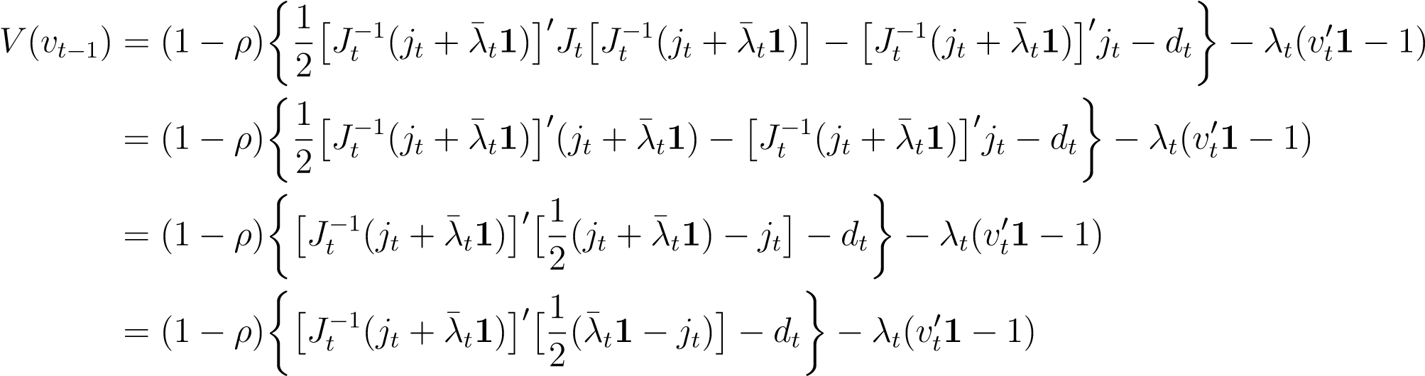

All elements of *Jt* can be chosen as symmetric and because a sum of symmetric matrices is also symmetric *Jt* is symmetric, meaning (*Jt*−1)0 = *Jt*−1.

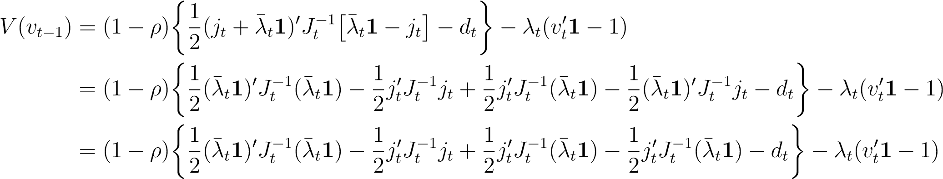

Now insert for *vt* in the constraint 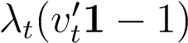

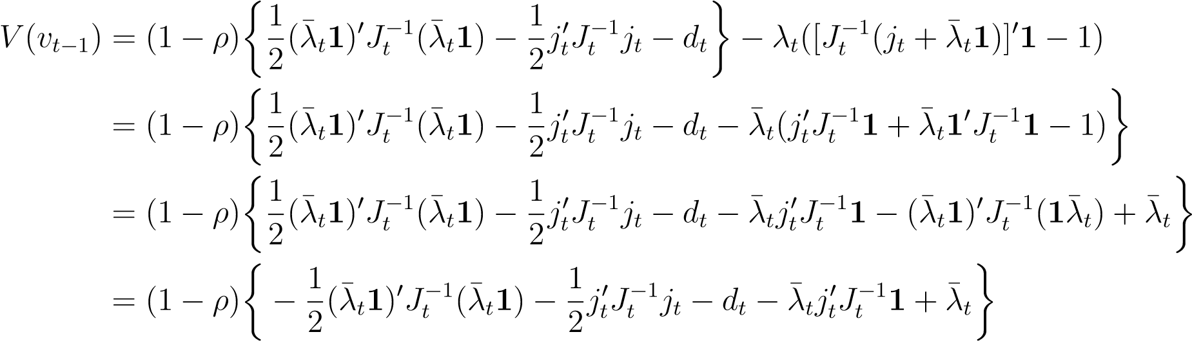

Now, insert for *λ*¯*t*

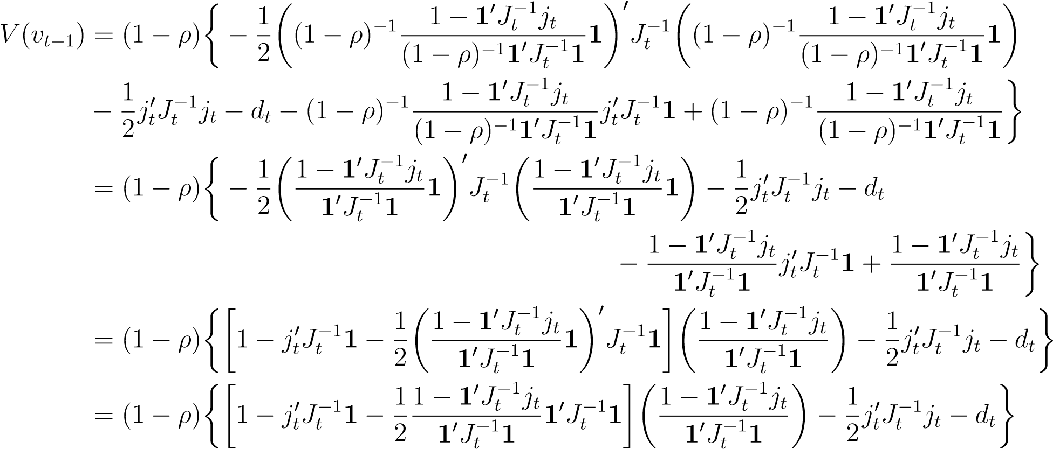

notice that is a scalar such that (*λt*1)0 = *λt*10

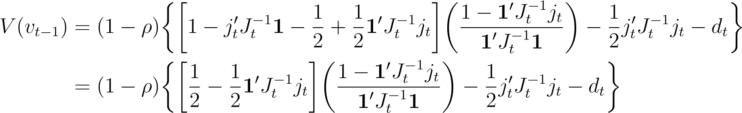

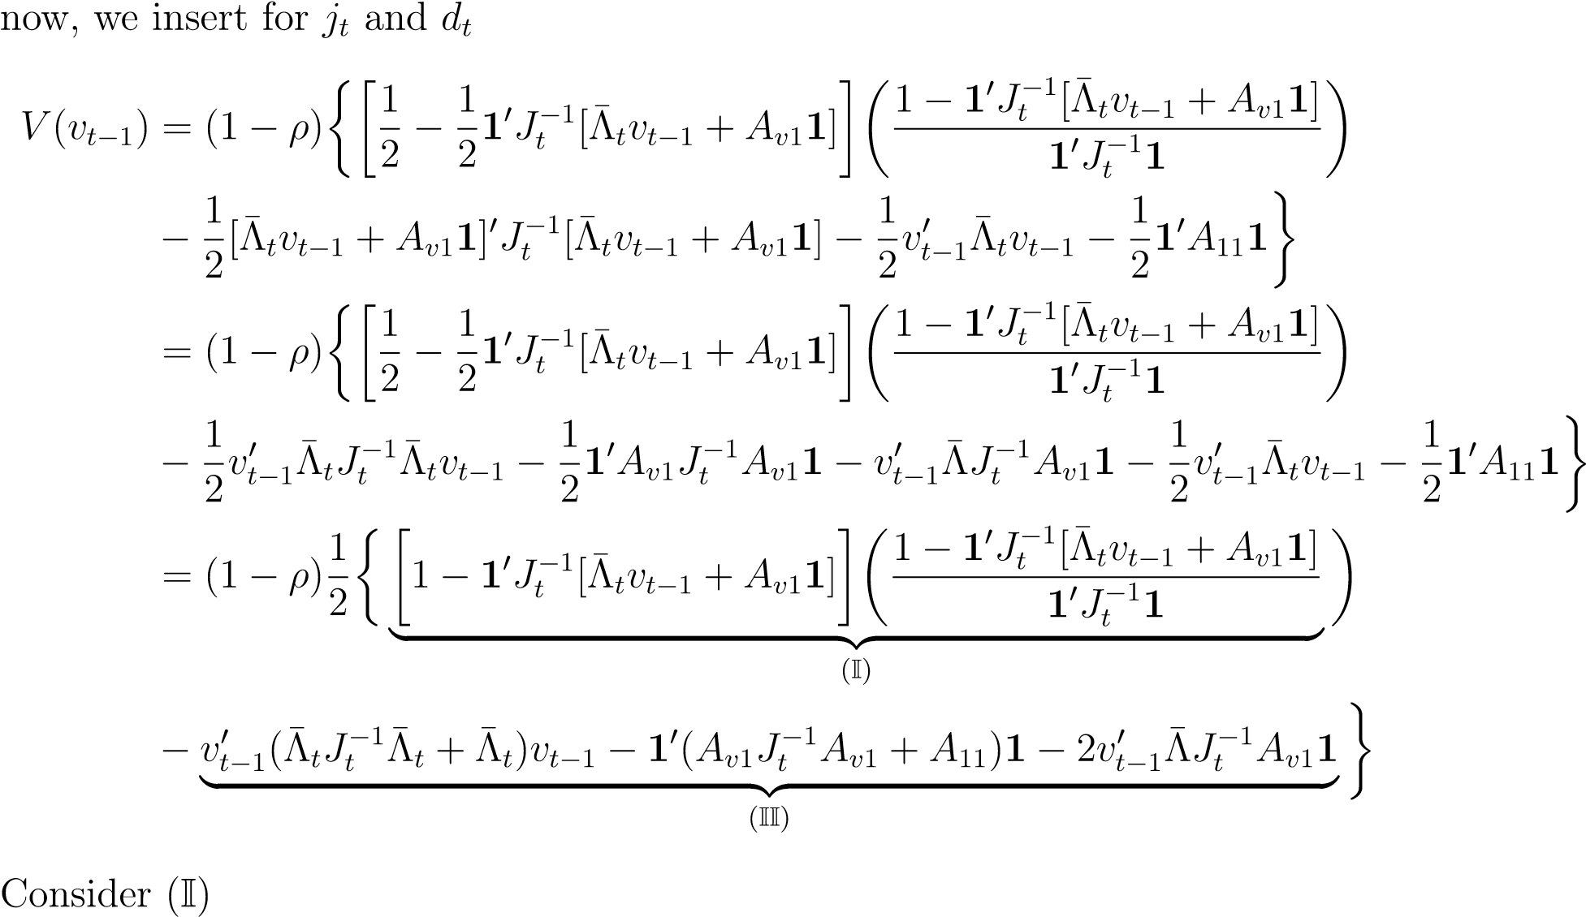

1

−

1

0

*J*

−

1

*t*

[

¯

Λ

*t*

*v*

*t*

−

1

+

*A*

*v*

1

1

]

1

0

*J*

−

1

*t*

1

−

1

0

*J*

−

1

*t*

[

¯

Λ

*t*

*v*

*t*

−

1

+

*A*

*v*

1

1

]

1

−

1

0

*J*

−

1

*t*

[

¯

Λ

*t*

*v*

*t*

−

1

+

*A*

*v*

1

1

]

1

0

*J*

−

1

*t*

1

=

1

1

0

*J*

−

1

*t*

1

−

2

1

0

*J*

−

1

*t*

[

¯

Λ

*t*

*v*

*t*

−

1

+

*A*

*v*

1

1

]

1

0

*J*

−

1

*t*

1

|

z

{

}

(

III

)

+

1

0

*J*

−

1

*t*

[

¯

Λ

*t*

*v*

*t*

−

1

+

*A*

*v*

1

1

]

1

0

*J*

−

1

*t*

[

¯

Λ

*t*

*v*

*t*

−

1

+

*A*

*v*

1

1

]

1

0

*J*

−

1

*t*

1

|

z

{

}

(

IV

)

Lets start with

(

III

)

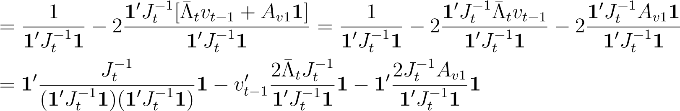

Continuing with (IV)

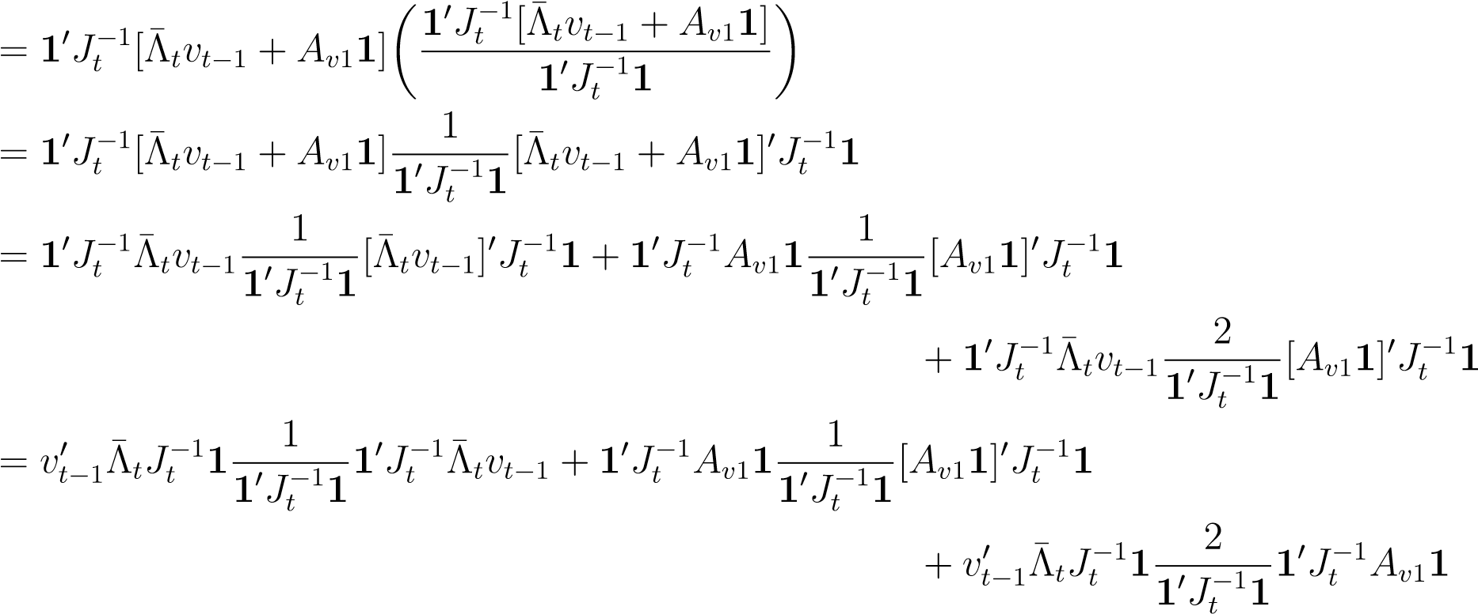

Now insert for (III) and (IV) into (I)

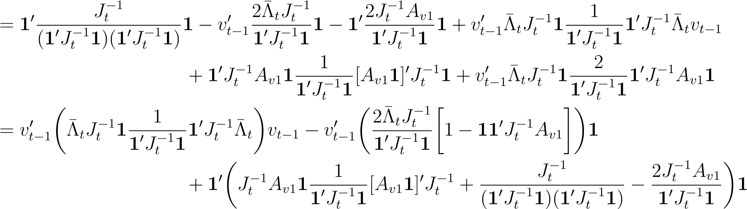

Returning to *V* (*vt*−1) with the calculated expressions for (I) and (II)

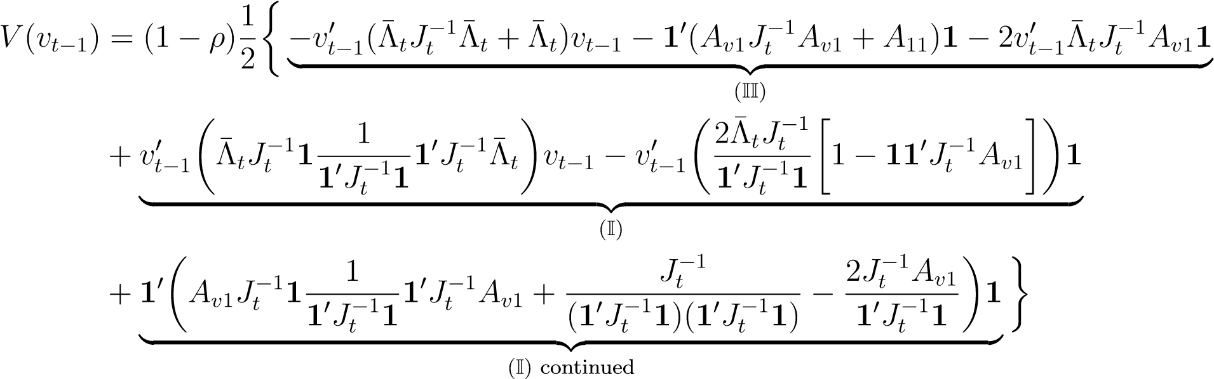

Combining terms with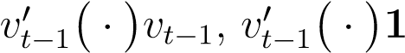 and 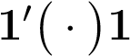

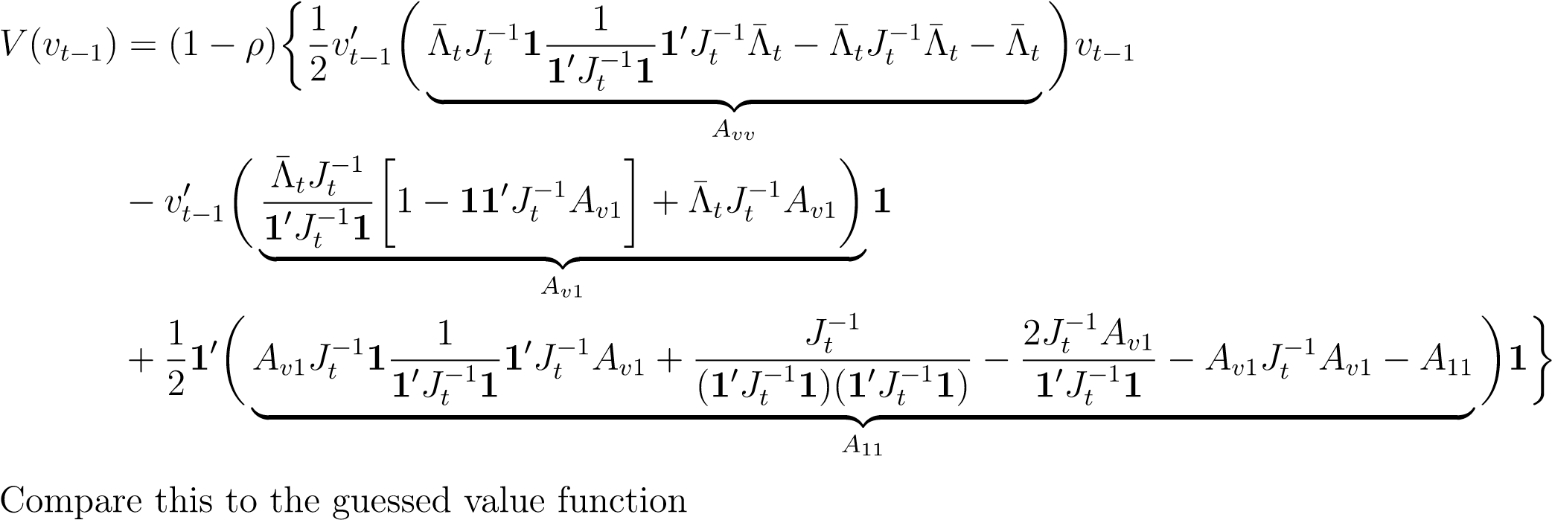

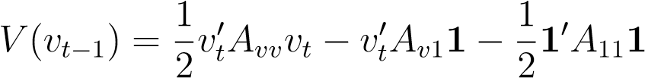

We see that this is indeed a solution. This implies that the following restriction on the coefficient matrices must hold

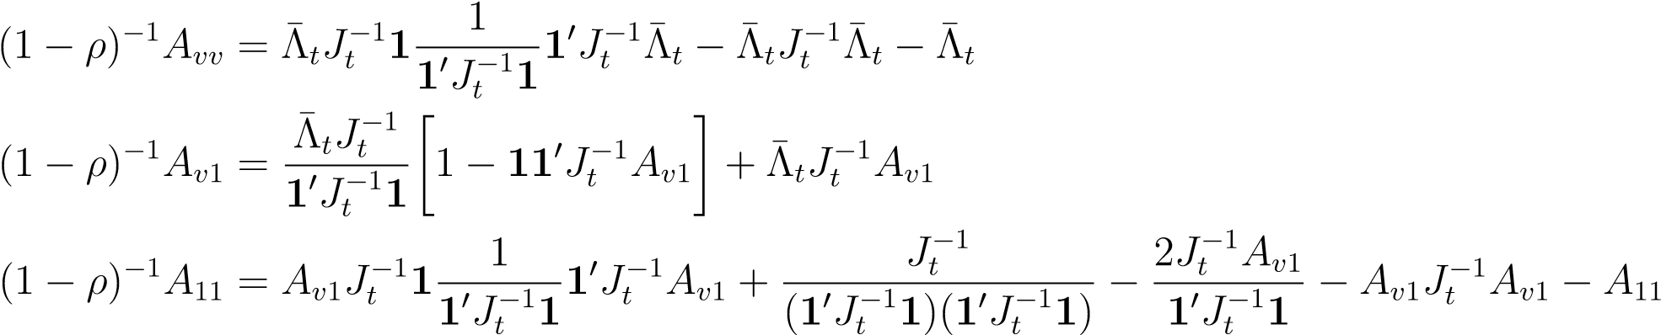

Now, we proceed to solve for the coefficient matrices *Avv*, *Av*1 and *A*11. Lets start with *Avv* and begin with inserting *Jt*

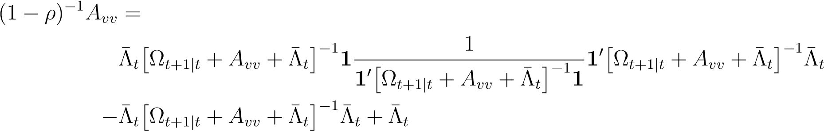

Here, we face a major problem because we are not able to solve for *Avv* analytically as we cannot see a way to to isolate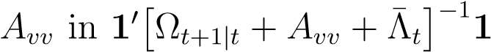. We see only two approaches.

Either one would have to take the inverse of 1 and 10 which is not defined as these are not square matrices. Even more exotic inverses like a left- and right-inverse requires either full column or row rank which a matrix of 1’s does not have. Alternatively, one could take the inverse of the entire scalar 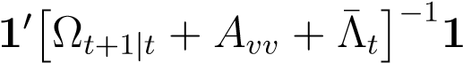 which simply moves the problem to one of the other terms. We therefore see now way to solve this problem analytically.

However, we can numerically solve for *Avv* by using the two sides of the equation (LHS and RHS, respectively). We define the objective function as the sum of squared differences element wise between the matrix LHS*l,j*(*Avv*) and RHS*l,j*(*Avv*). Denote row as *l* and column as *j*

*N N* argminXX LHS*l,j*(*Avv*) − RHS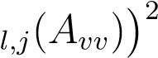 (38)

*Avv l*=1 *j*=1

We implement the minization problem in Python using the Scipy package of [Virtanen et al., 2020], with the SLSQP solver. We constrain *Avv* to be symmetric in order to fulfill the requirements from our derivations. We achieve numerical convergence after about 20 iterations on average.

In contrast to *Avv*, it is possible to analytically solve for *Av*1

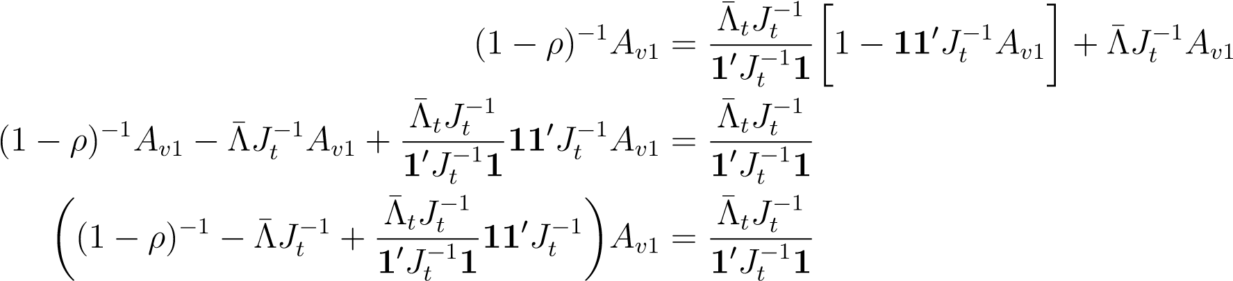

resulting in

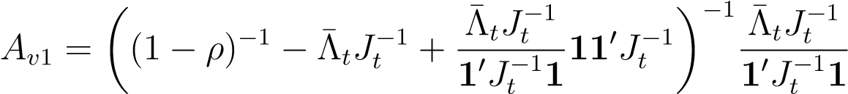

Now insert for *Jt* and 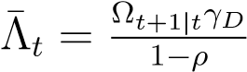

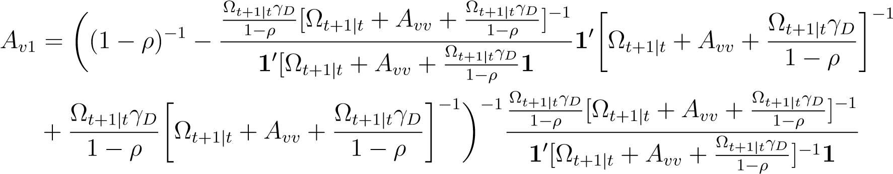 (39) Note that even though we can analytically solve for *Av*1, this solution is not analytical as it uses *Avv*, which we solved for numerically which in turn, causes *Av*1 to be a numerical solution as well.

Lastly, we solve for *A*11 which similar to *Av*1 can be solved for analytically but requires both *Avv* and *Av*1 and is thus not an analytical solution but numerical.

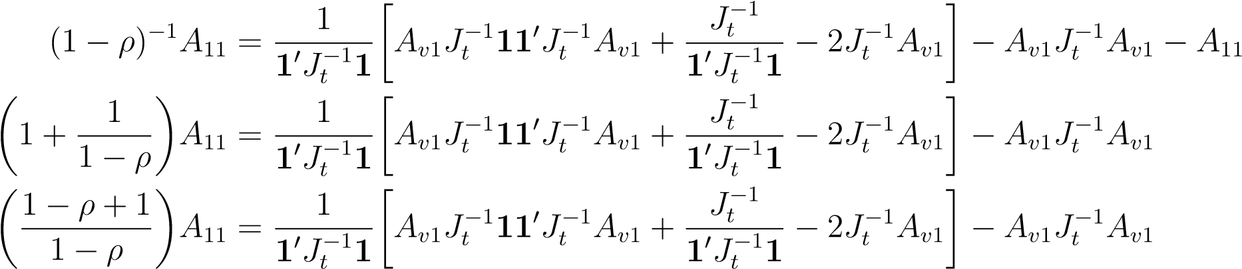

Multiplying the term on *A*11 over yields

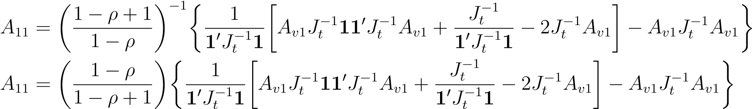

Now insert for *Jt* and 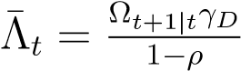

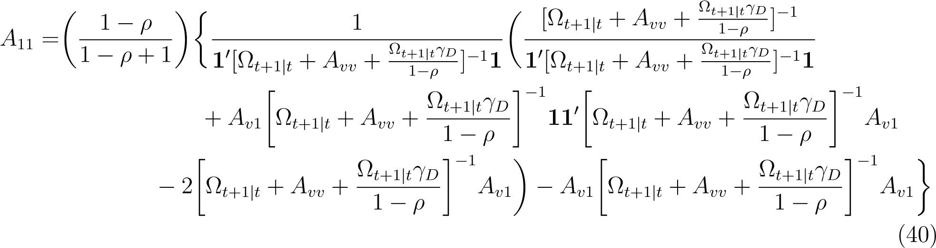

## A.4 Empirical

### A.4.1 MGARCH model estimates

Table 9: Estimates of a DCC MGARCH(1,1) with univariate ARCH(1) - *tν* error terms

|  |  |
| --- | --- |
|  | Univariate GARCH |
|  |  |
|  | Multivariate GARCH |
| *a* Scalar-BEKK(1,1) | *b ν* |

*Note*: Estimated via MLE using data from January 1st 2008 to October 11th 2017. Robust standard errors in (·).

Table 10: Estimates of a DCC MGARCH(1,1) with univariate GJR-GARCH(1,1) - *tν* error terms

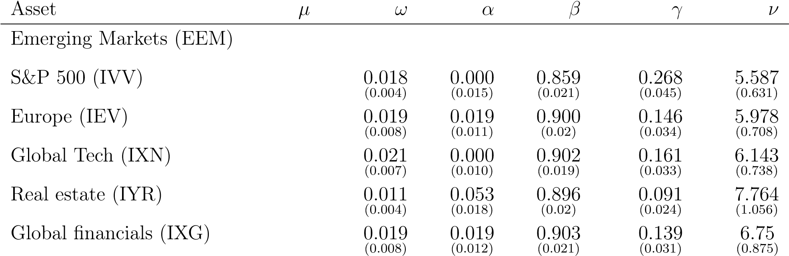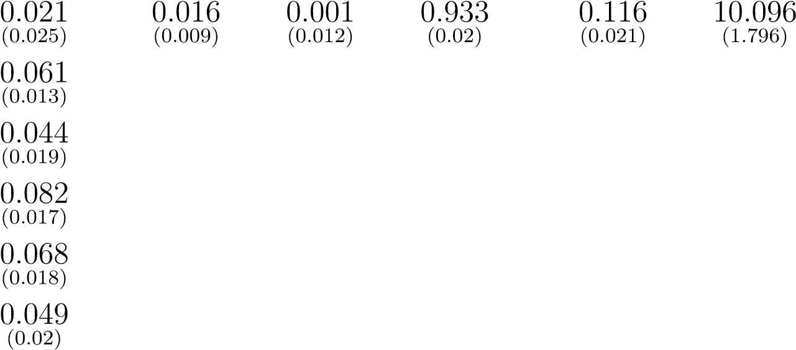Univariate GARCH

Global Industrials (EXI)

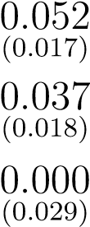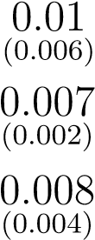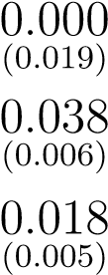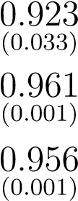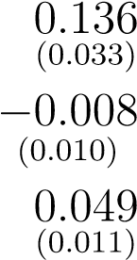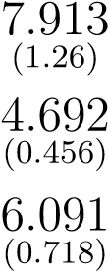

Gold (GC=F)

Brent crude oil (BZ=F)

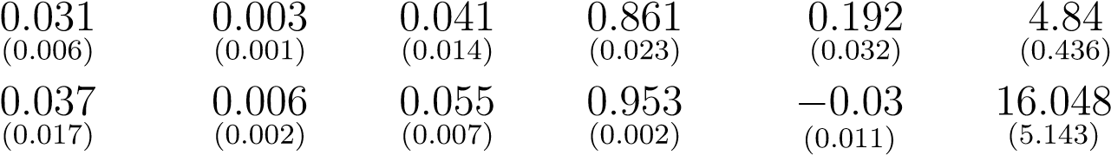High-yield bonds (HYG)

20+ year treasuries (TLT)

Multivariate GARCH

*a b ν*

Scalar-BEKK(1,1) 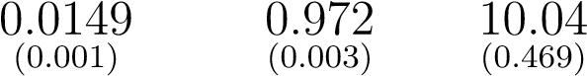

*Note*: Estimated via MLE using data from January 1st 2008 to October 11th 2017. Robust standard errors in (·).

### A.4.2 Excess figures

Figure 23: Impulse response function of *vt*MVP for GJR-GARCH(1,1) with a shock of 2

(a) Weights, *vt*MVP (b) Volatility, *σt*

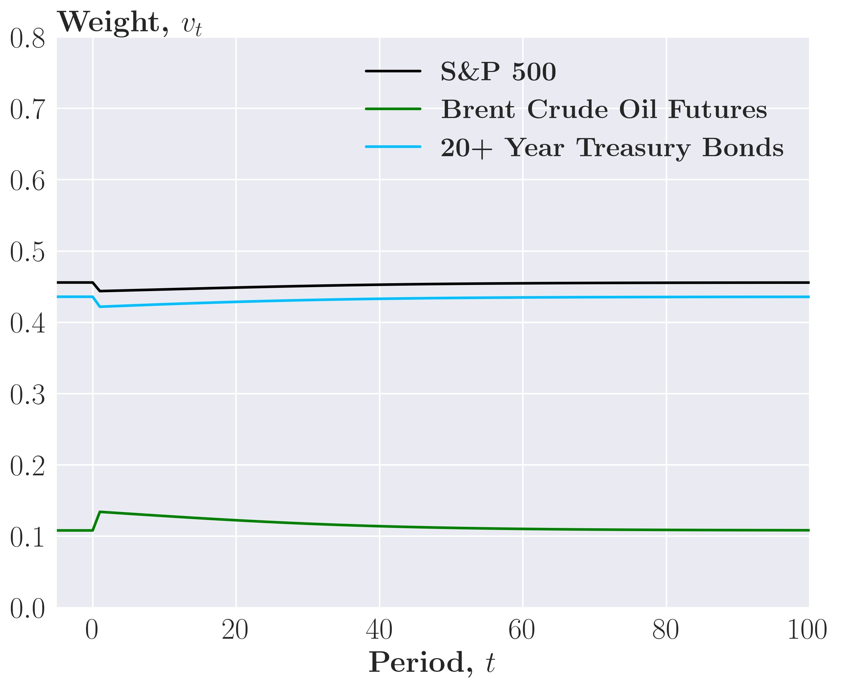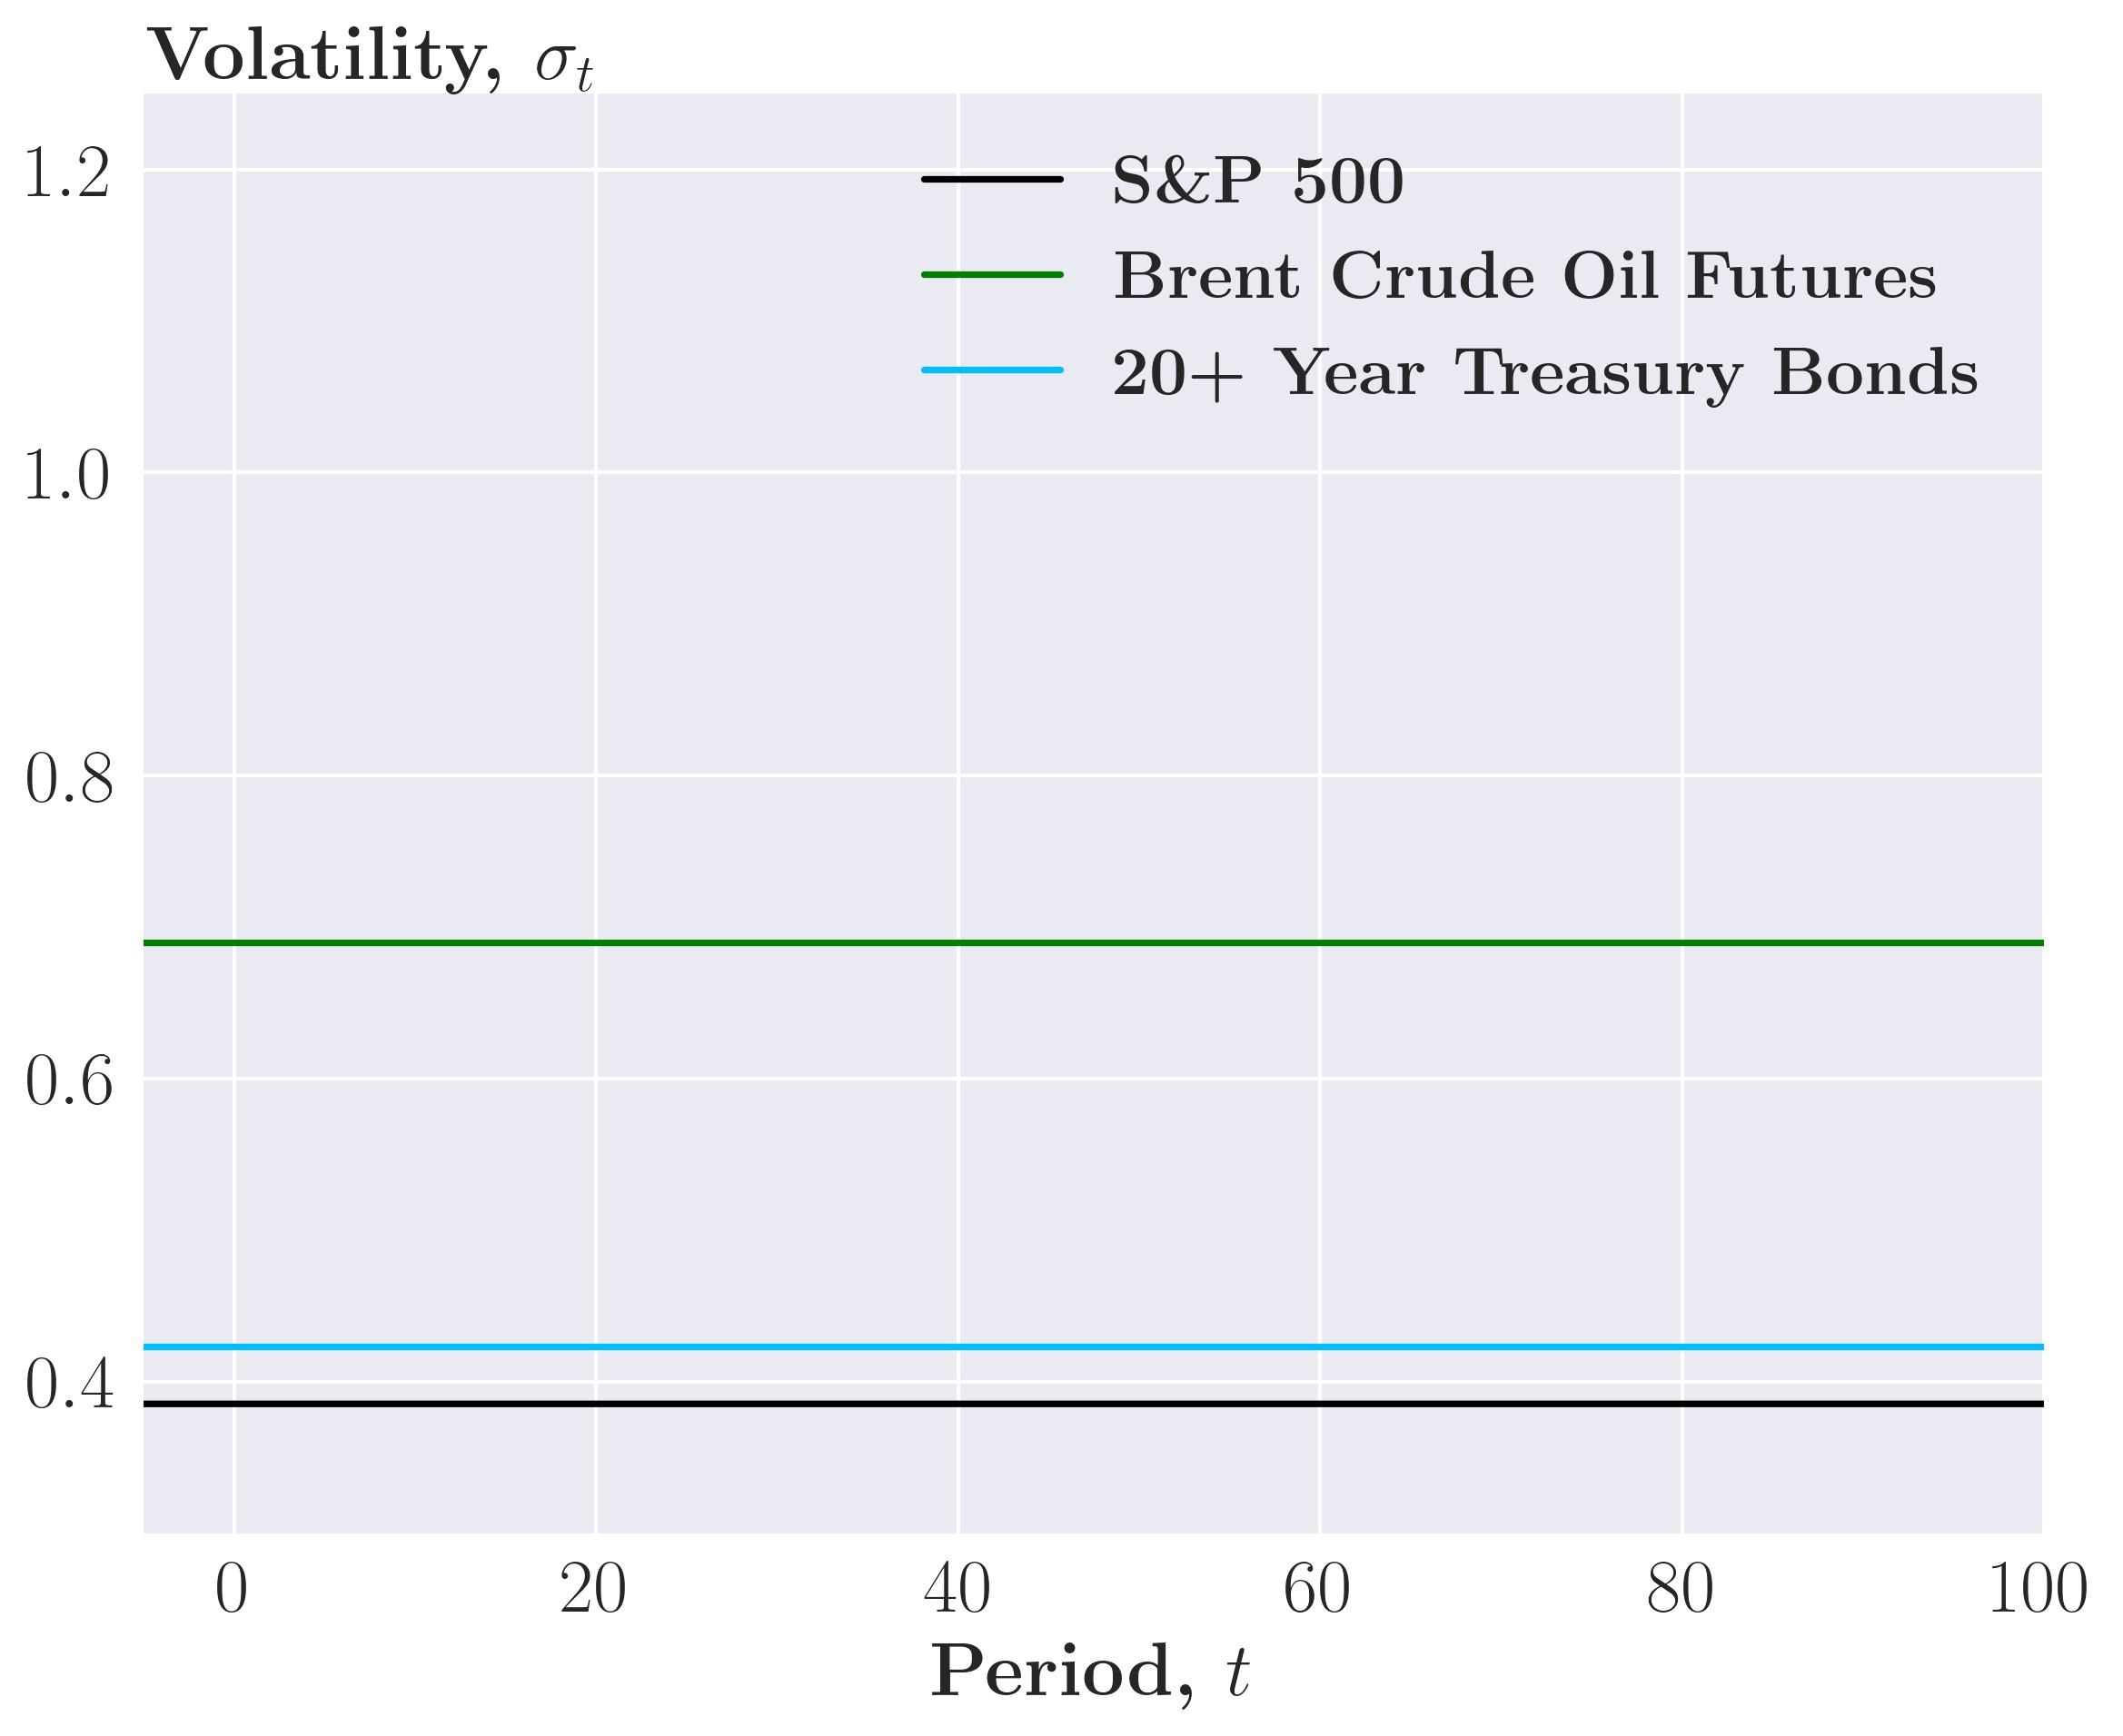

Figure 24: Annualized performance measures across different values of *γ*˜*D*

(a) Standard deviation, Stocks (b) Sharpe Ratio, Stocks

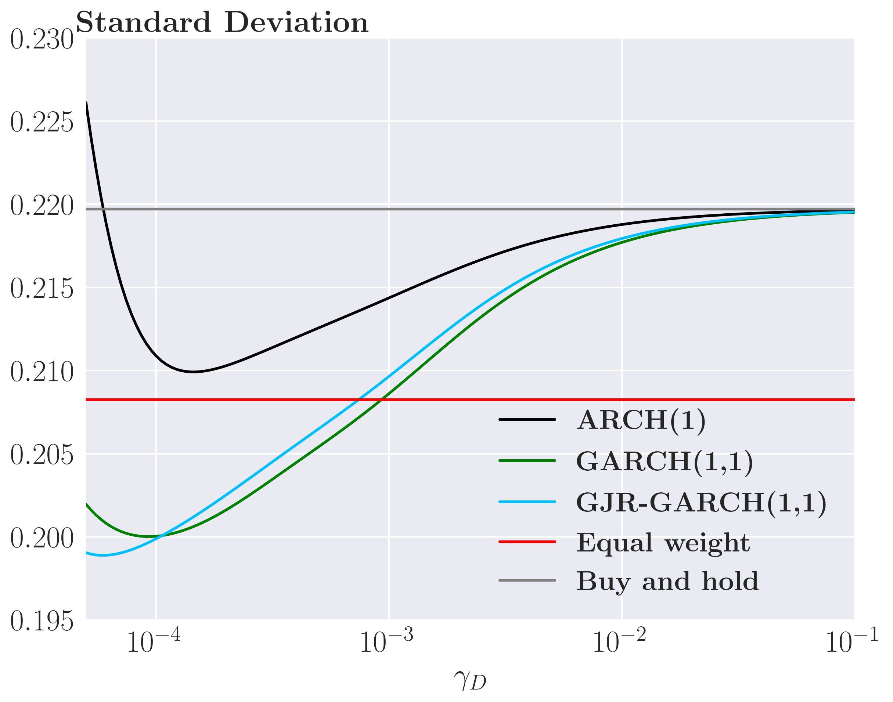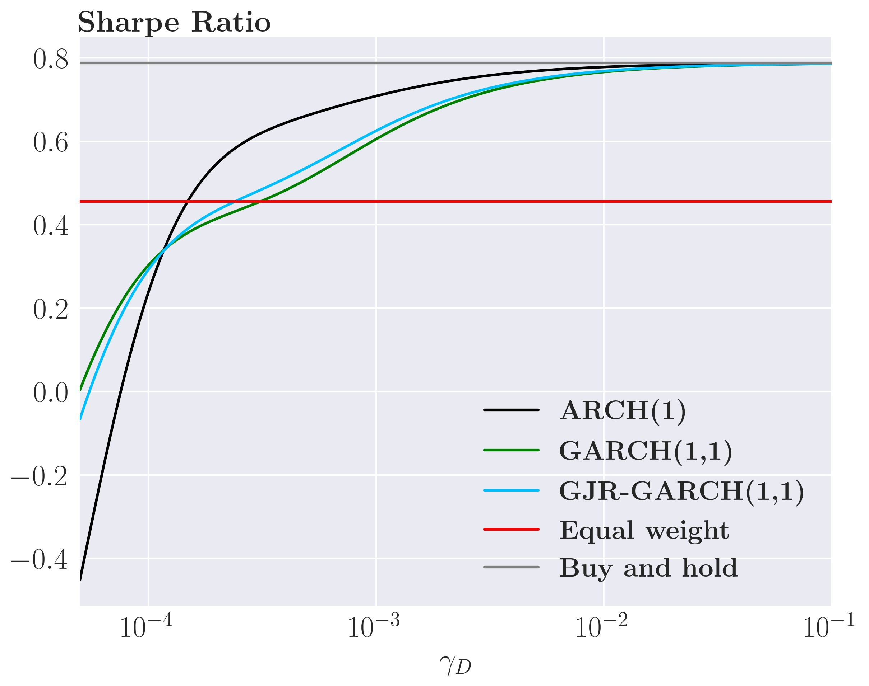

(c) Standard deviation, bonds (d) Sharpe Ratio, bonds

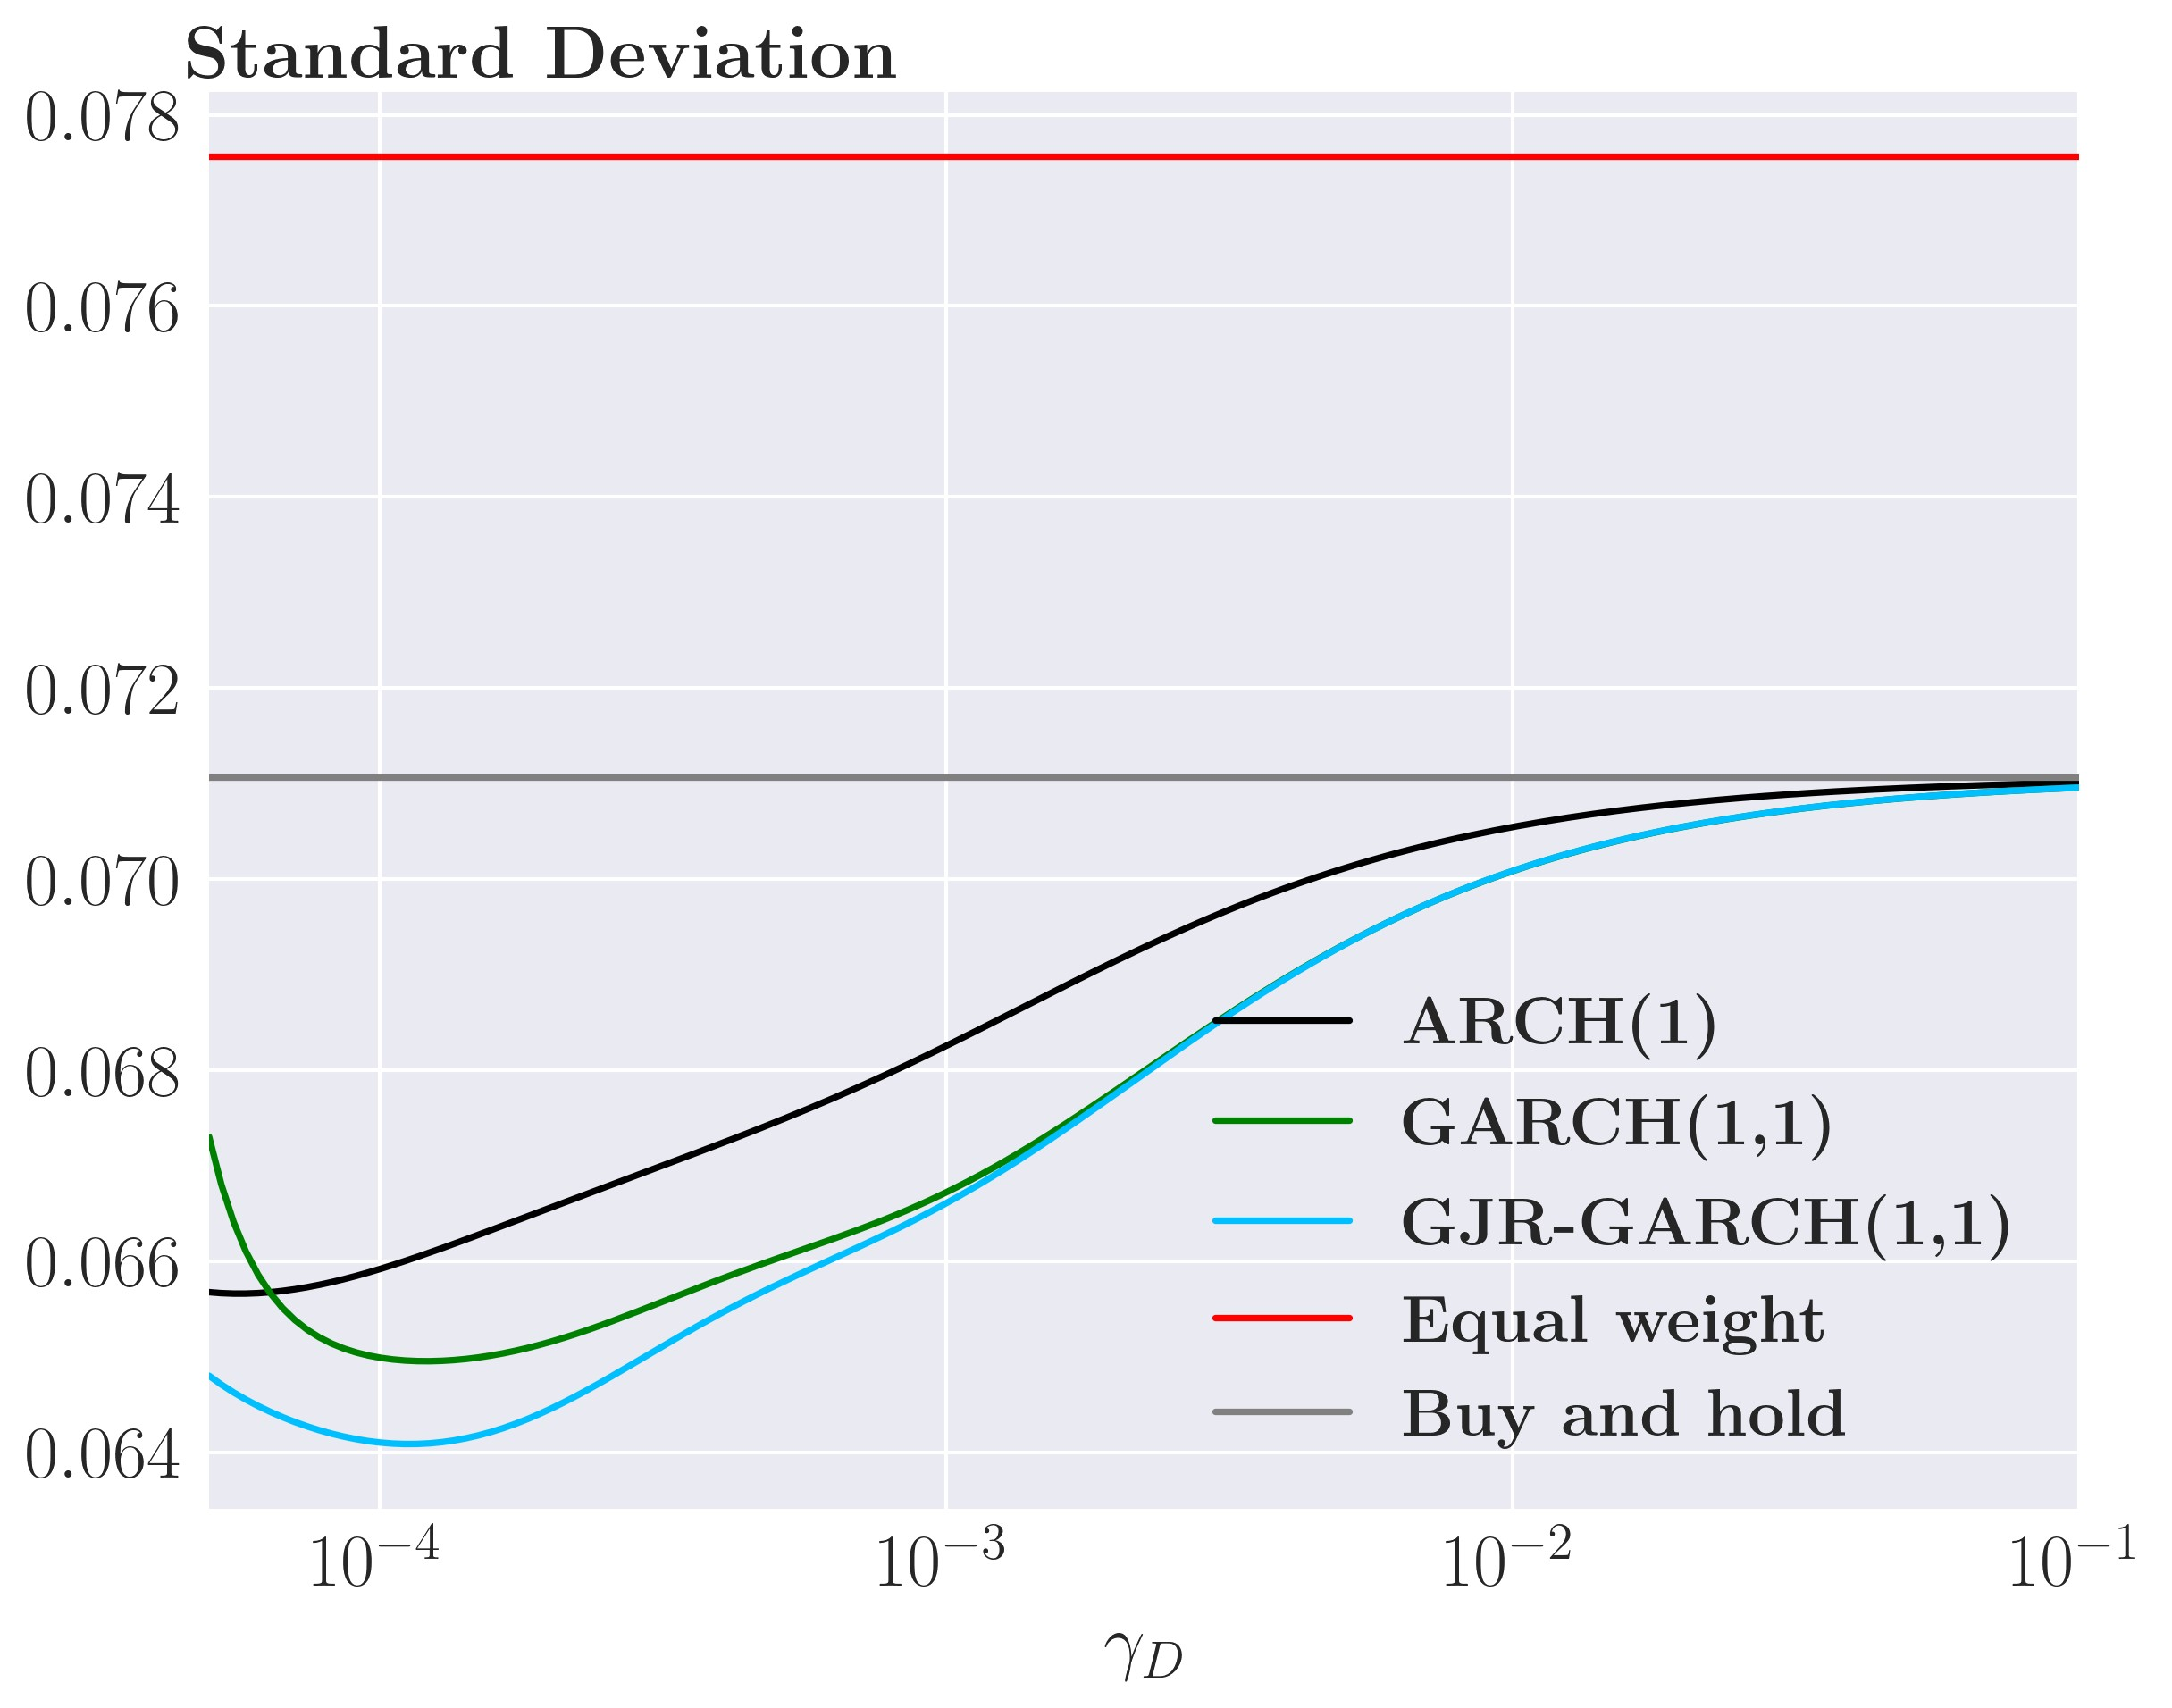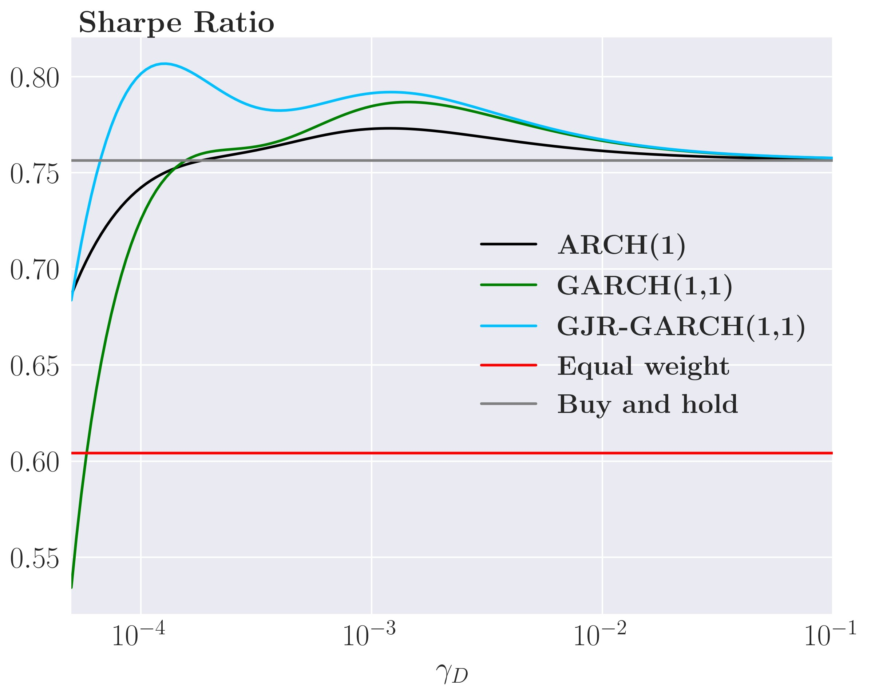

Figure 25: Simple GJR-GARCH(1,1) portfolio weights

* 1. All assets
  2. Stock ETFs

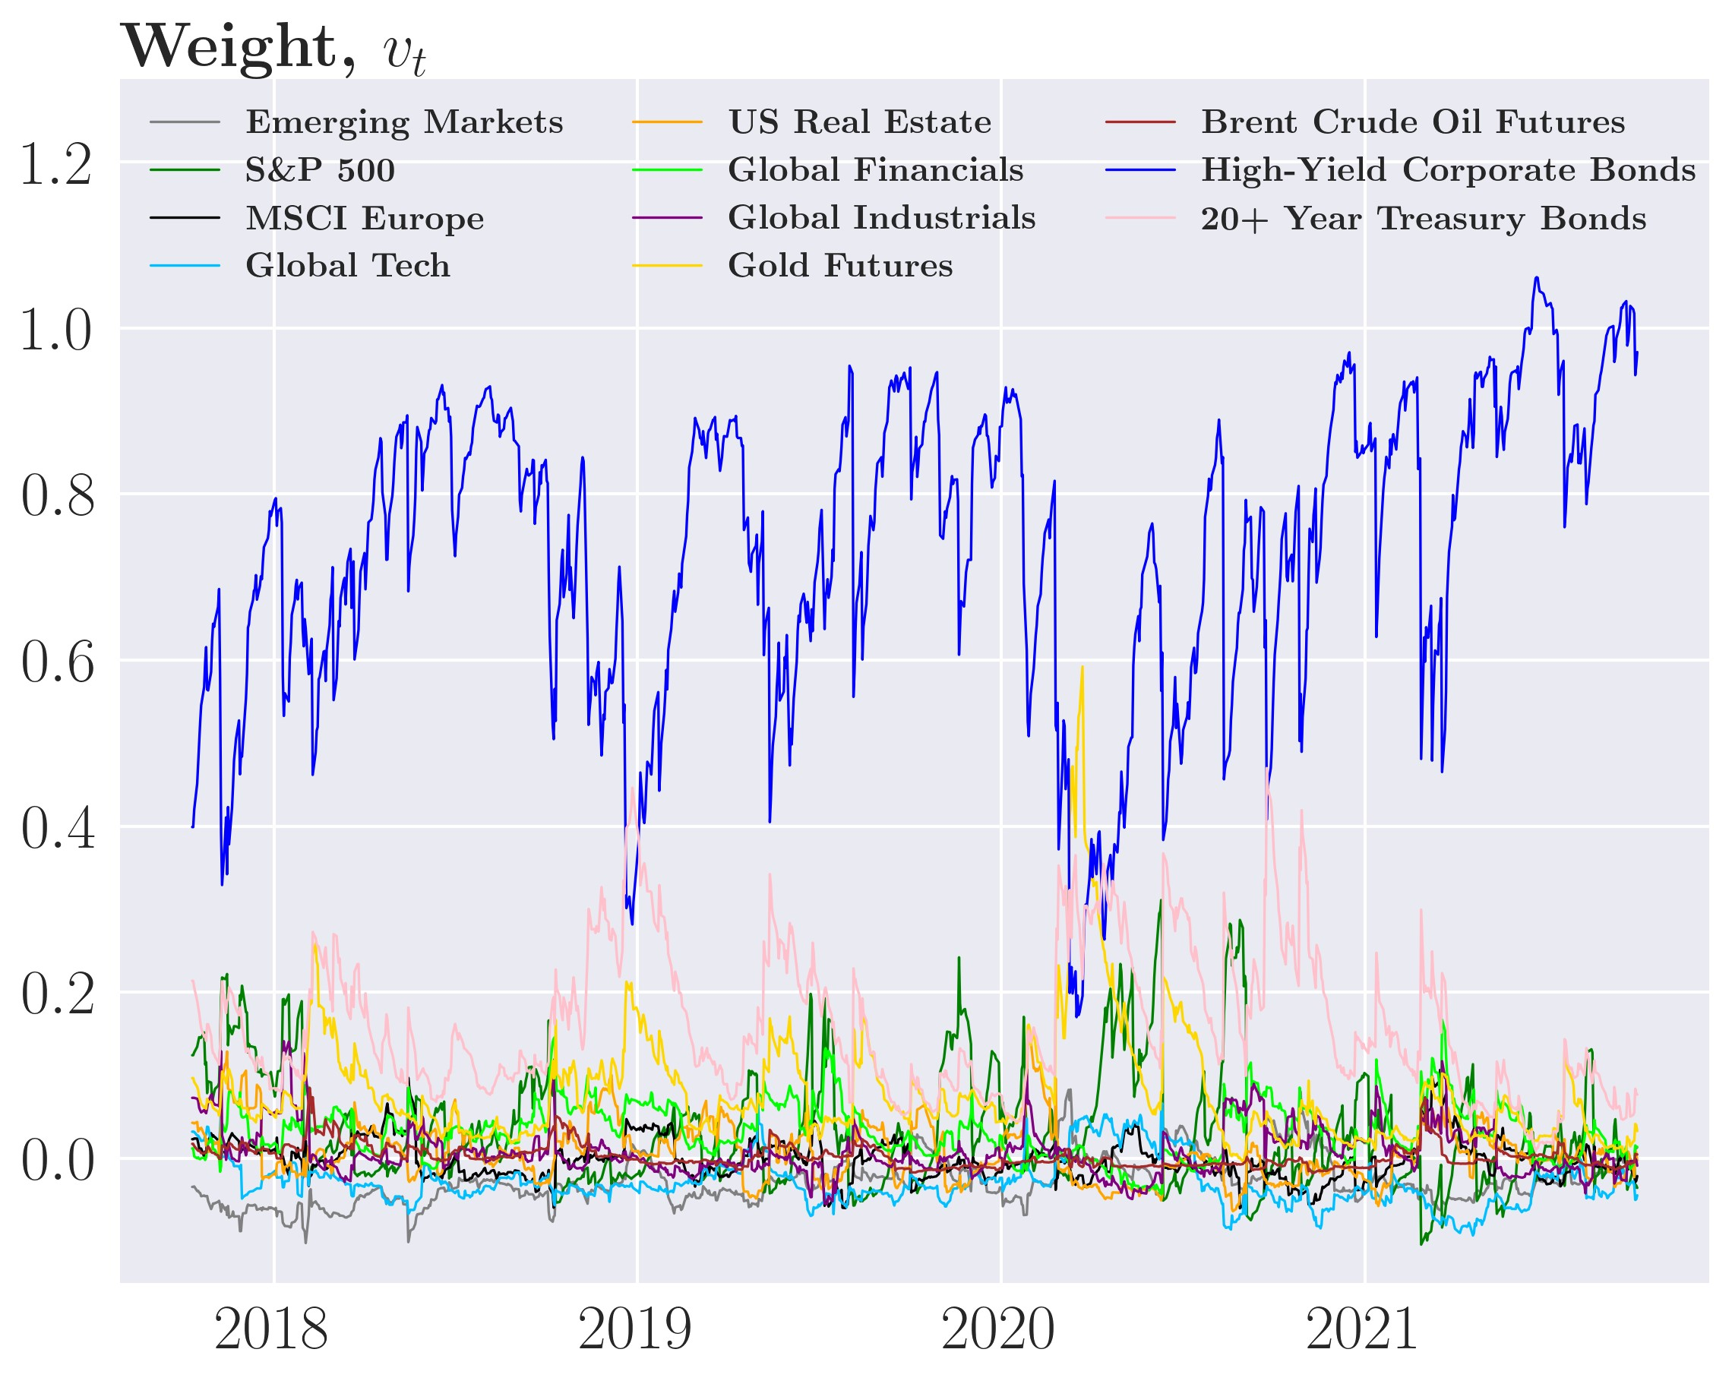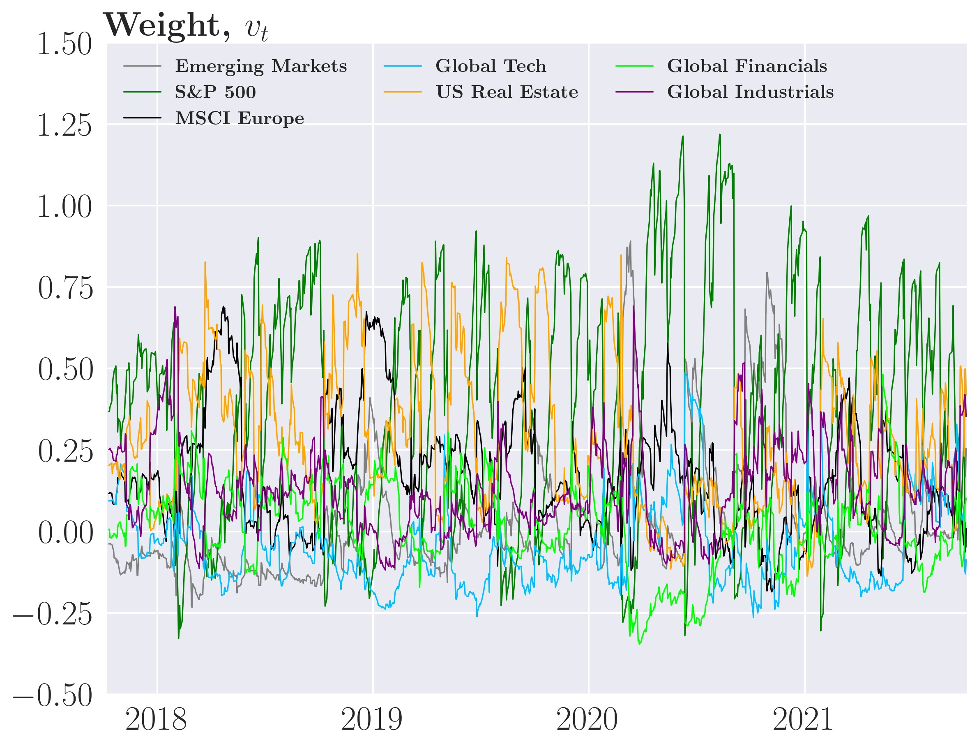

Figure 26: Weights of different sophisticated GARCH type strategies for *γ*˜*D* = 1*.*52e−6

(a) *vt*MVP, ARCH(1) (b) *vt*MVP, GARCH(1,1)

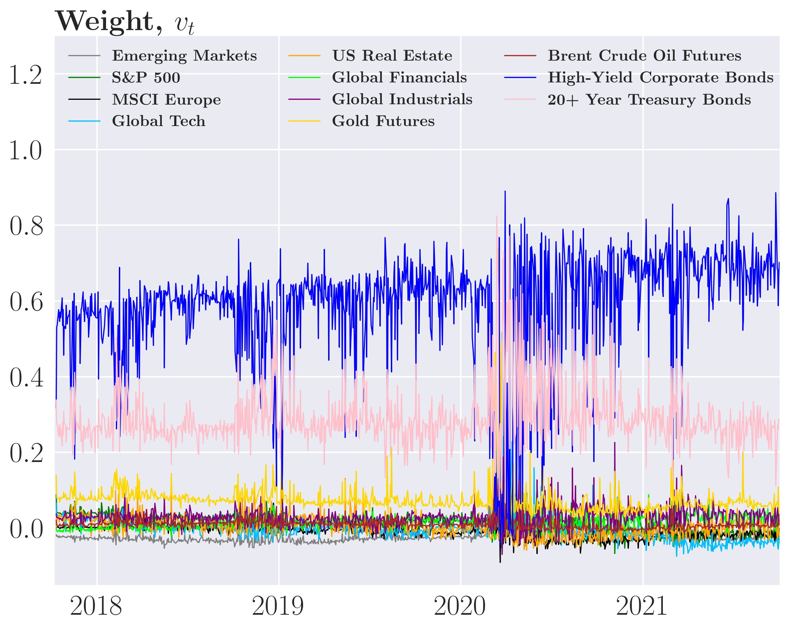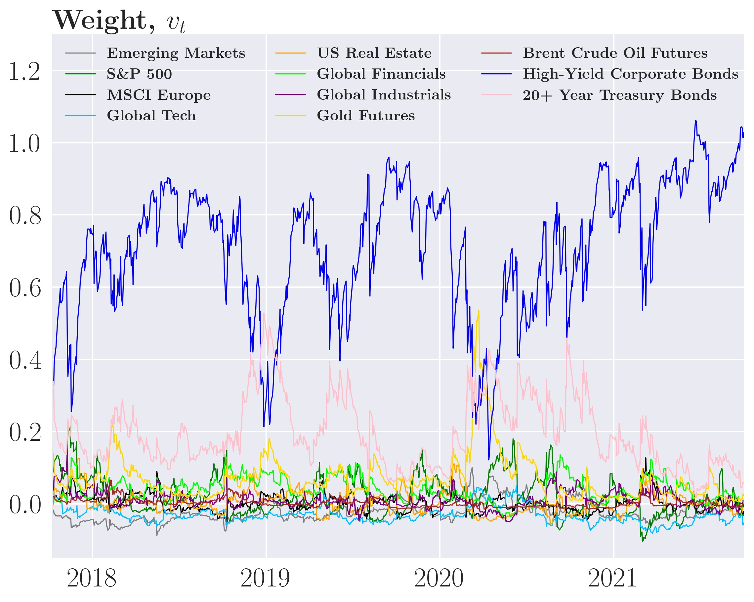

(c) *vt*MVP, GJR-GARCH(1,1)

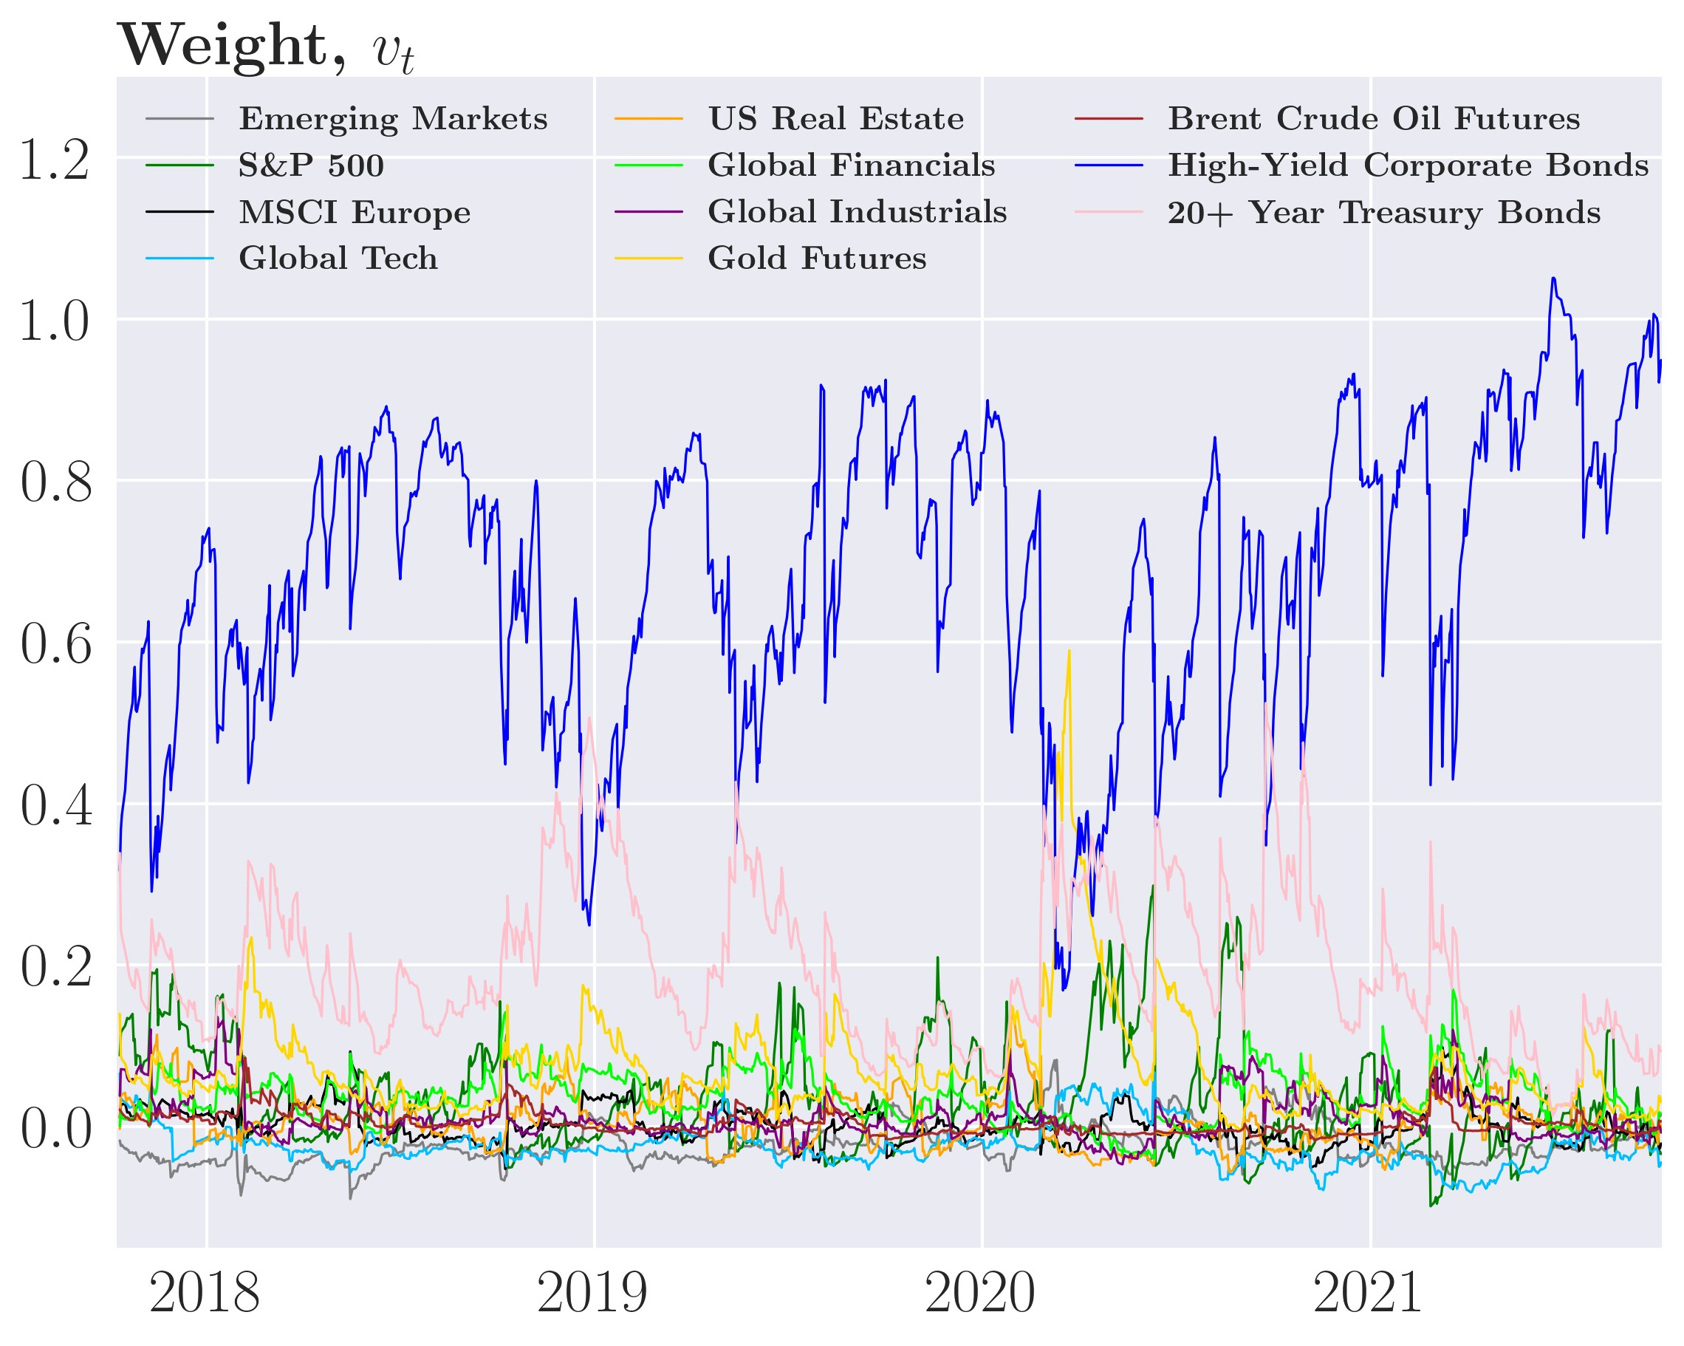

Figure 27: Sophisticated GJR-GARCH(1,1) portfolio weights

(a) *vt*MVP for *γ*˜*D* = 2*.*3e−5 (b) *vt*MVP for *γ*˜*D* = 1e−4

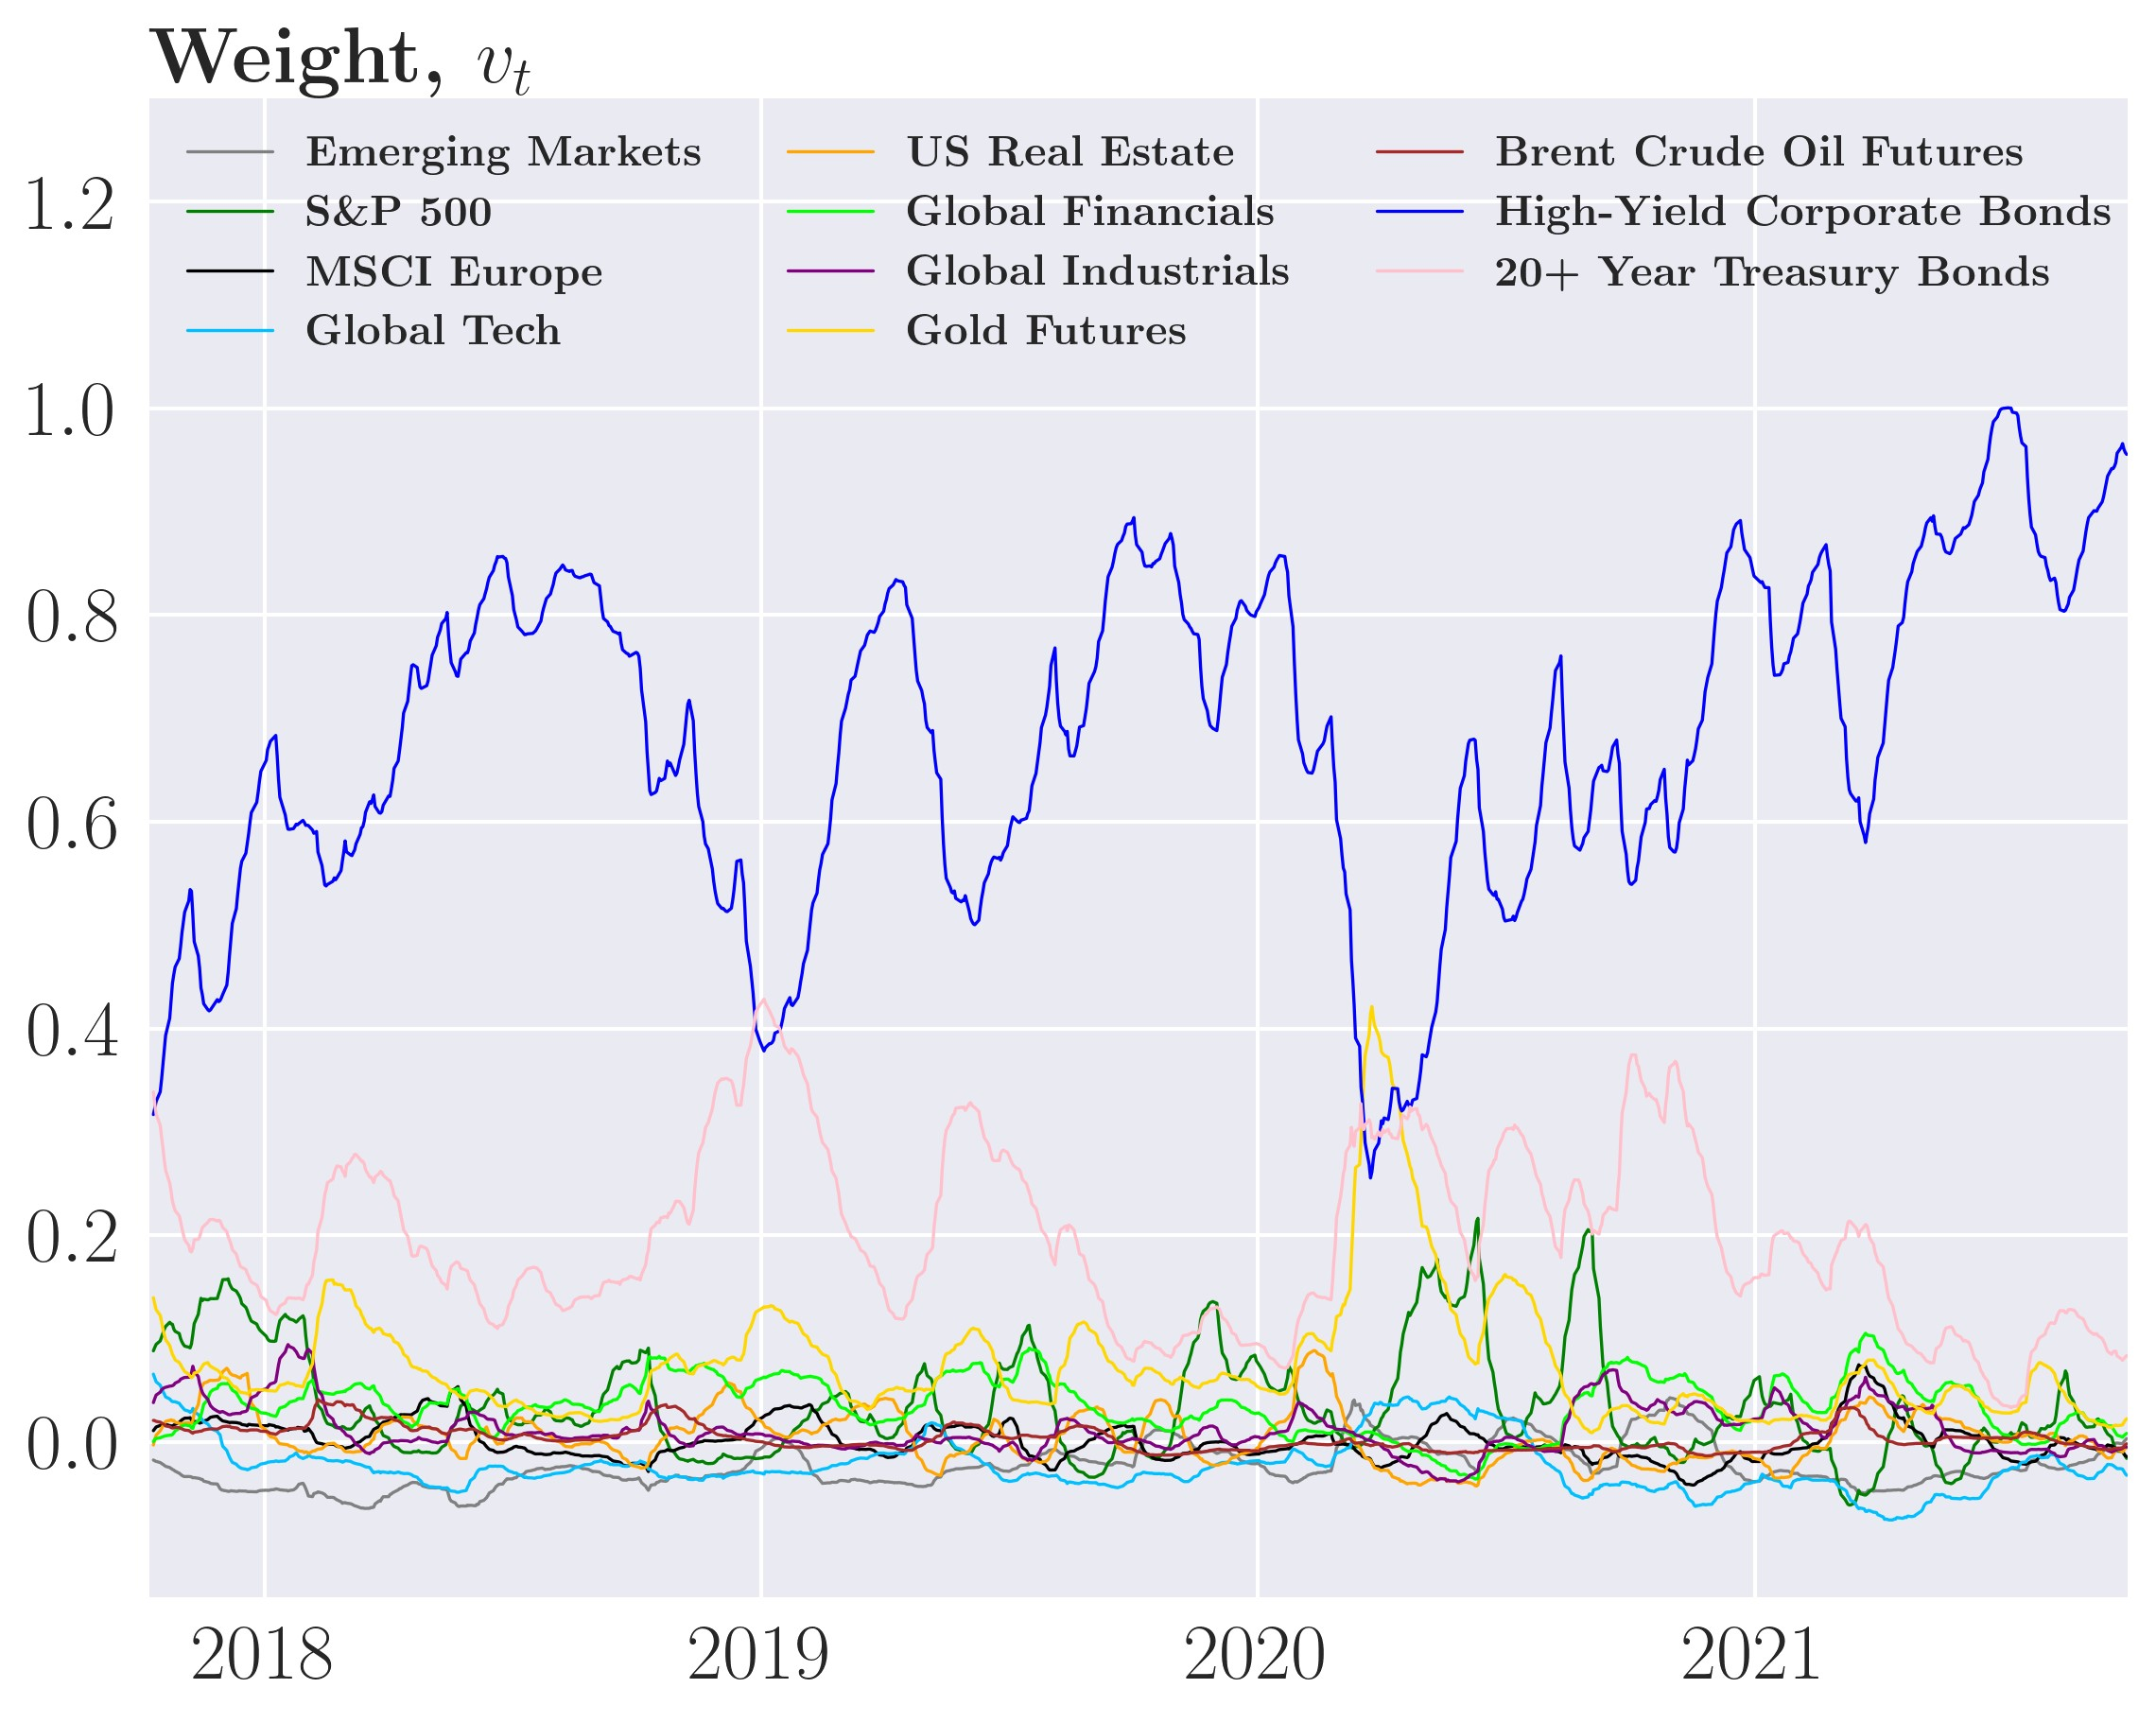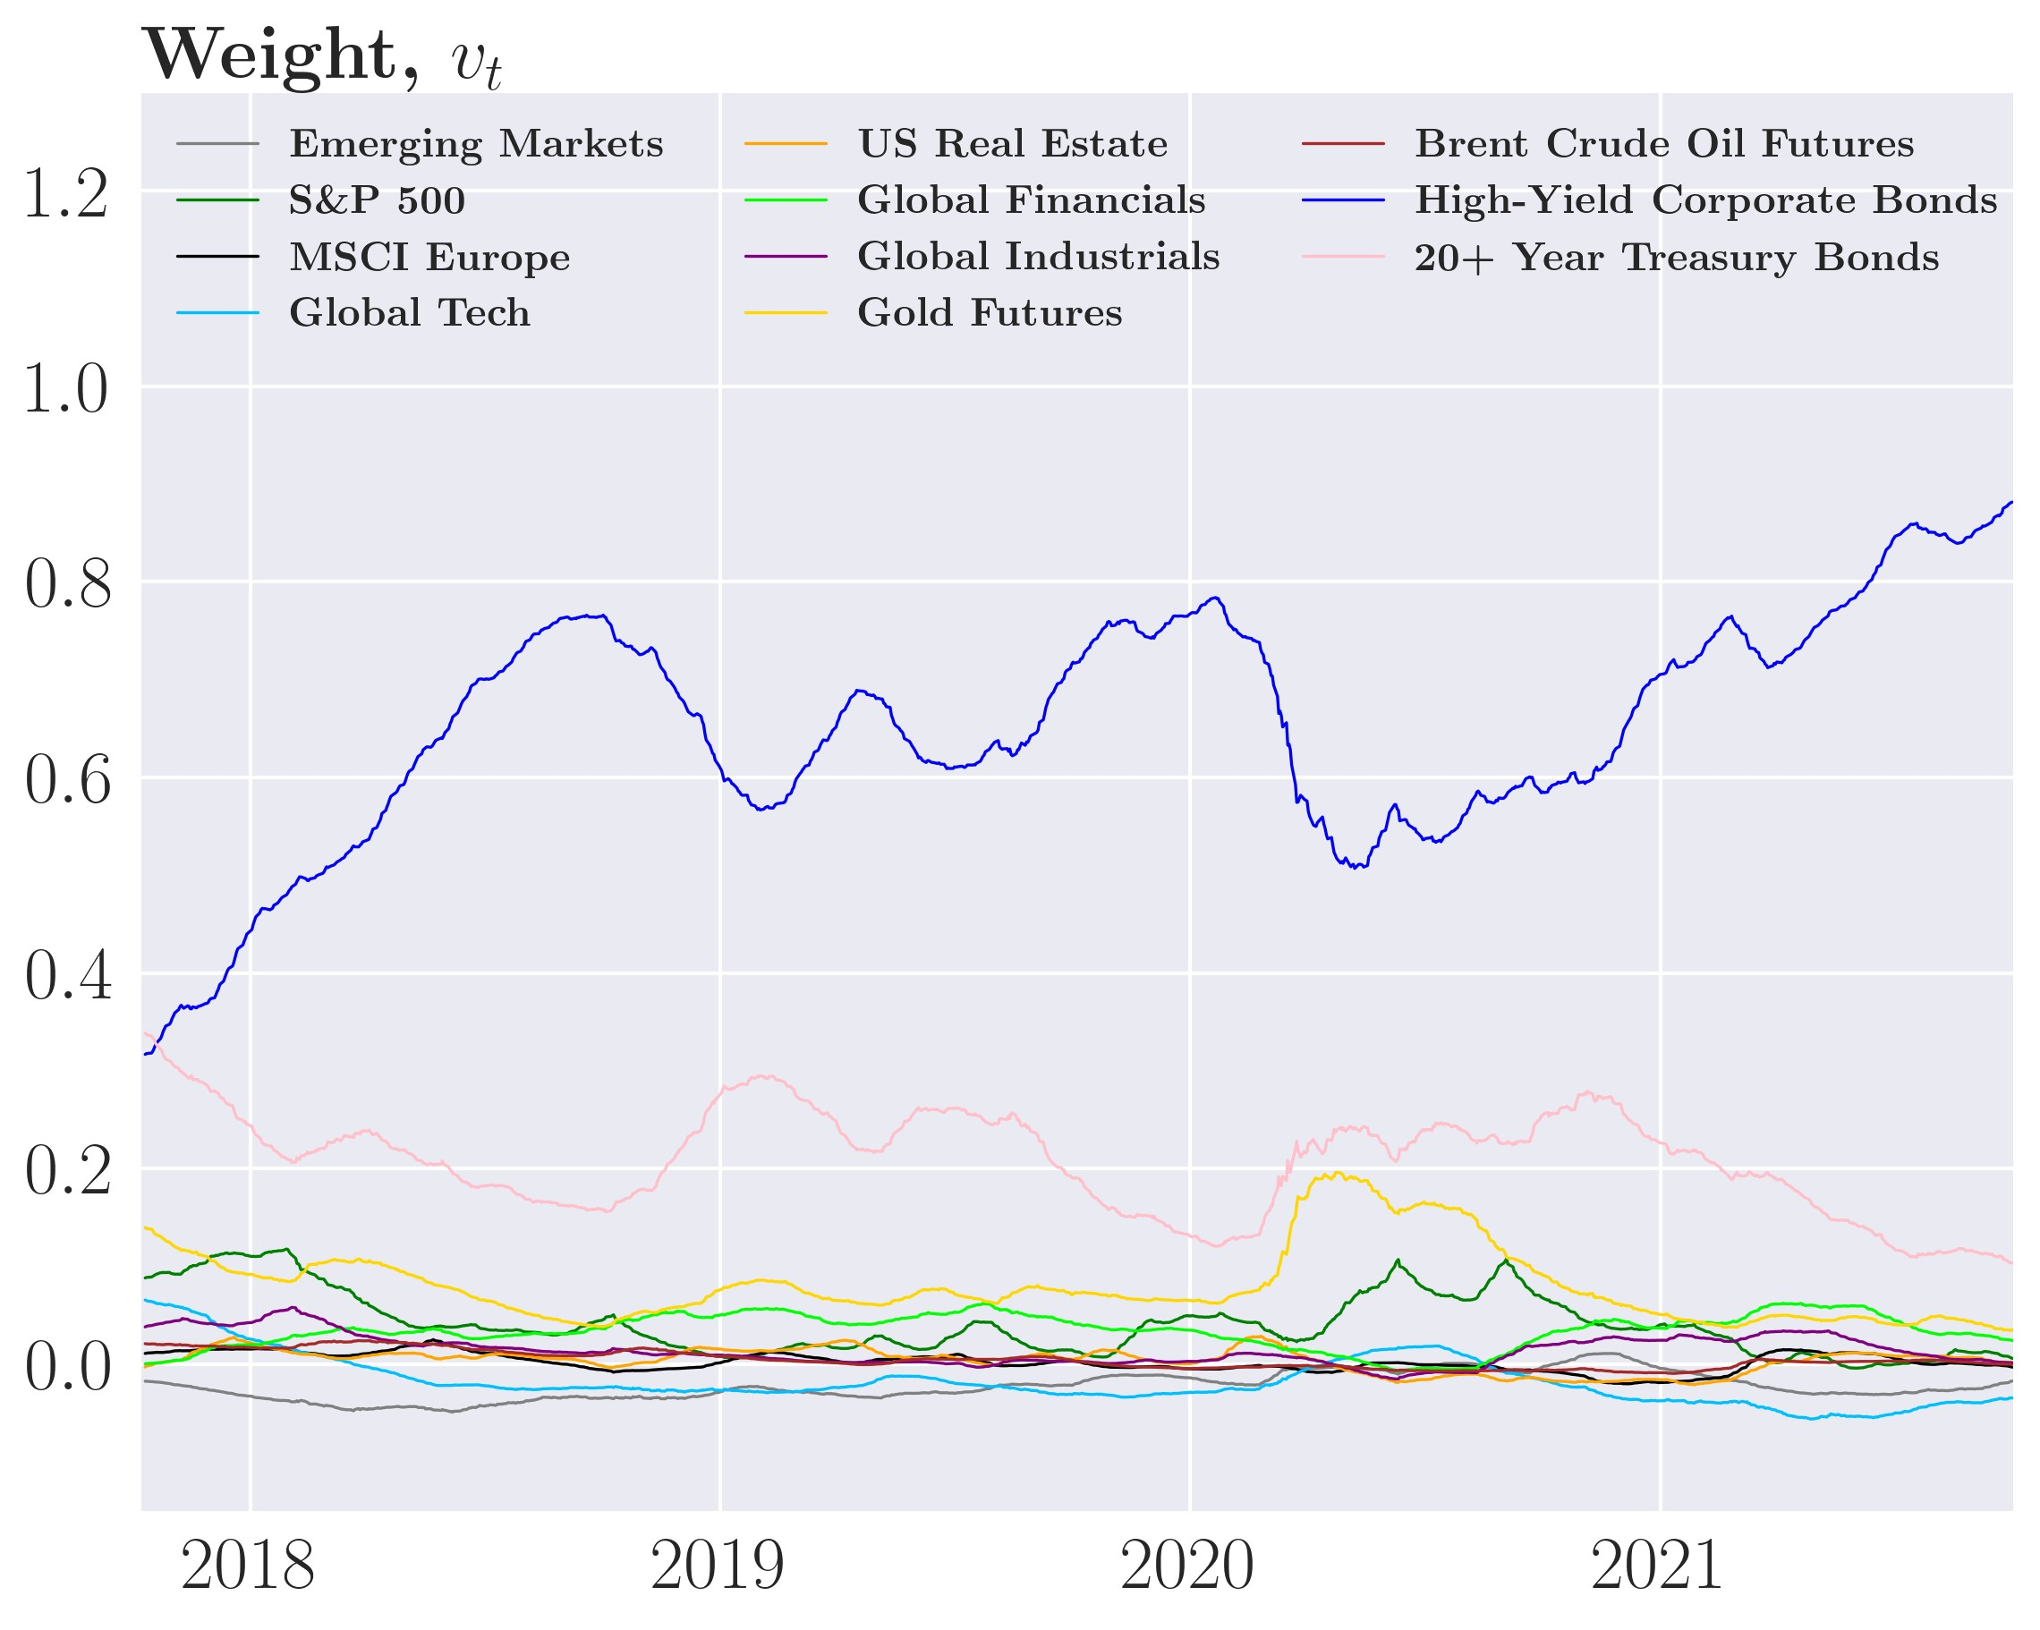

Figure 28: ARCH(1) MVP weights for different *γ*˜*D*

(a) *γ*˜*D* = 1*.*52e−6 (b) *γ*˜*D* = 2*.*3e−5

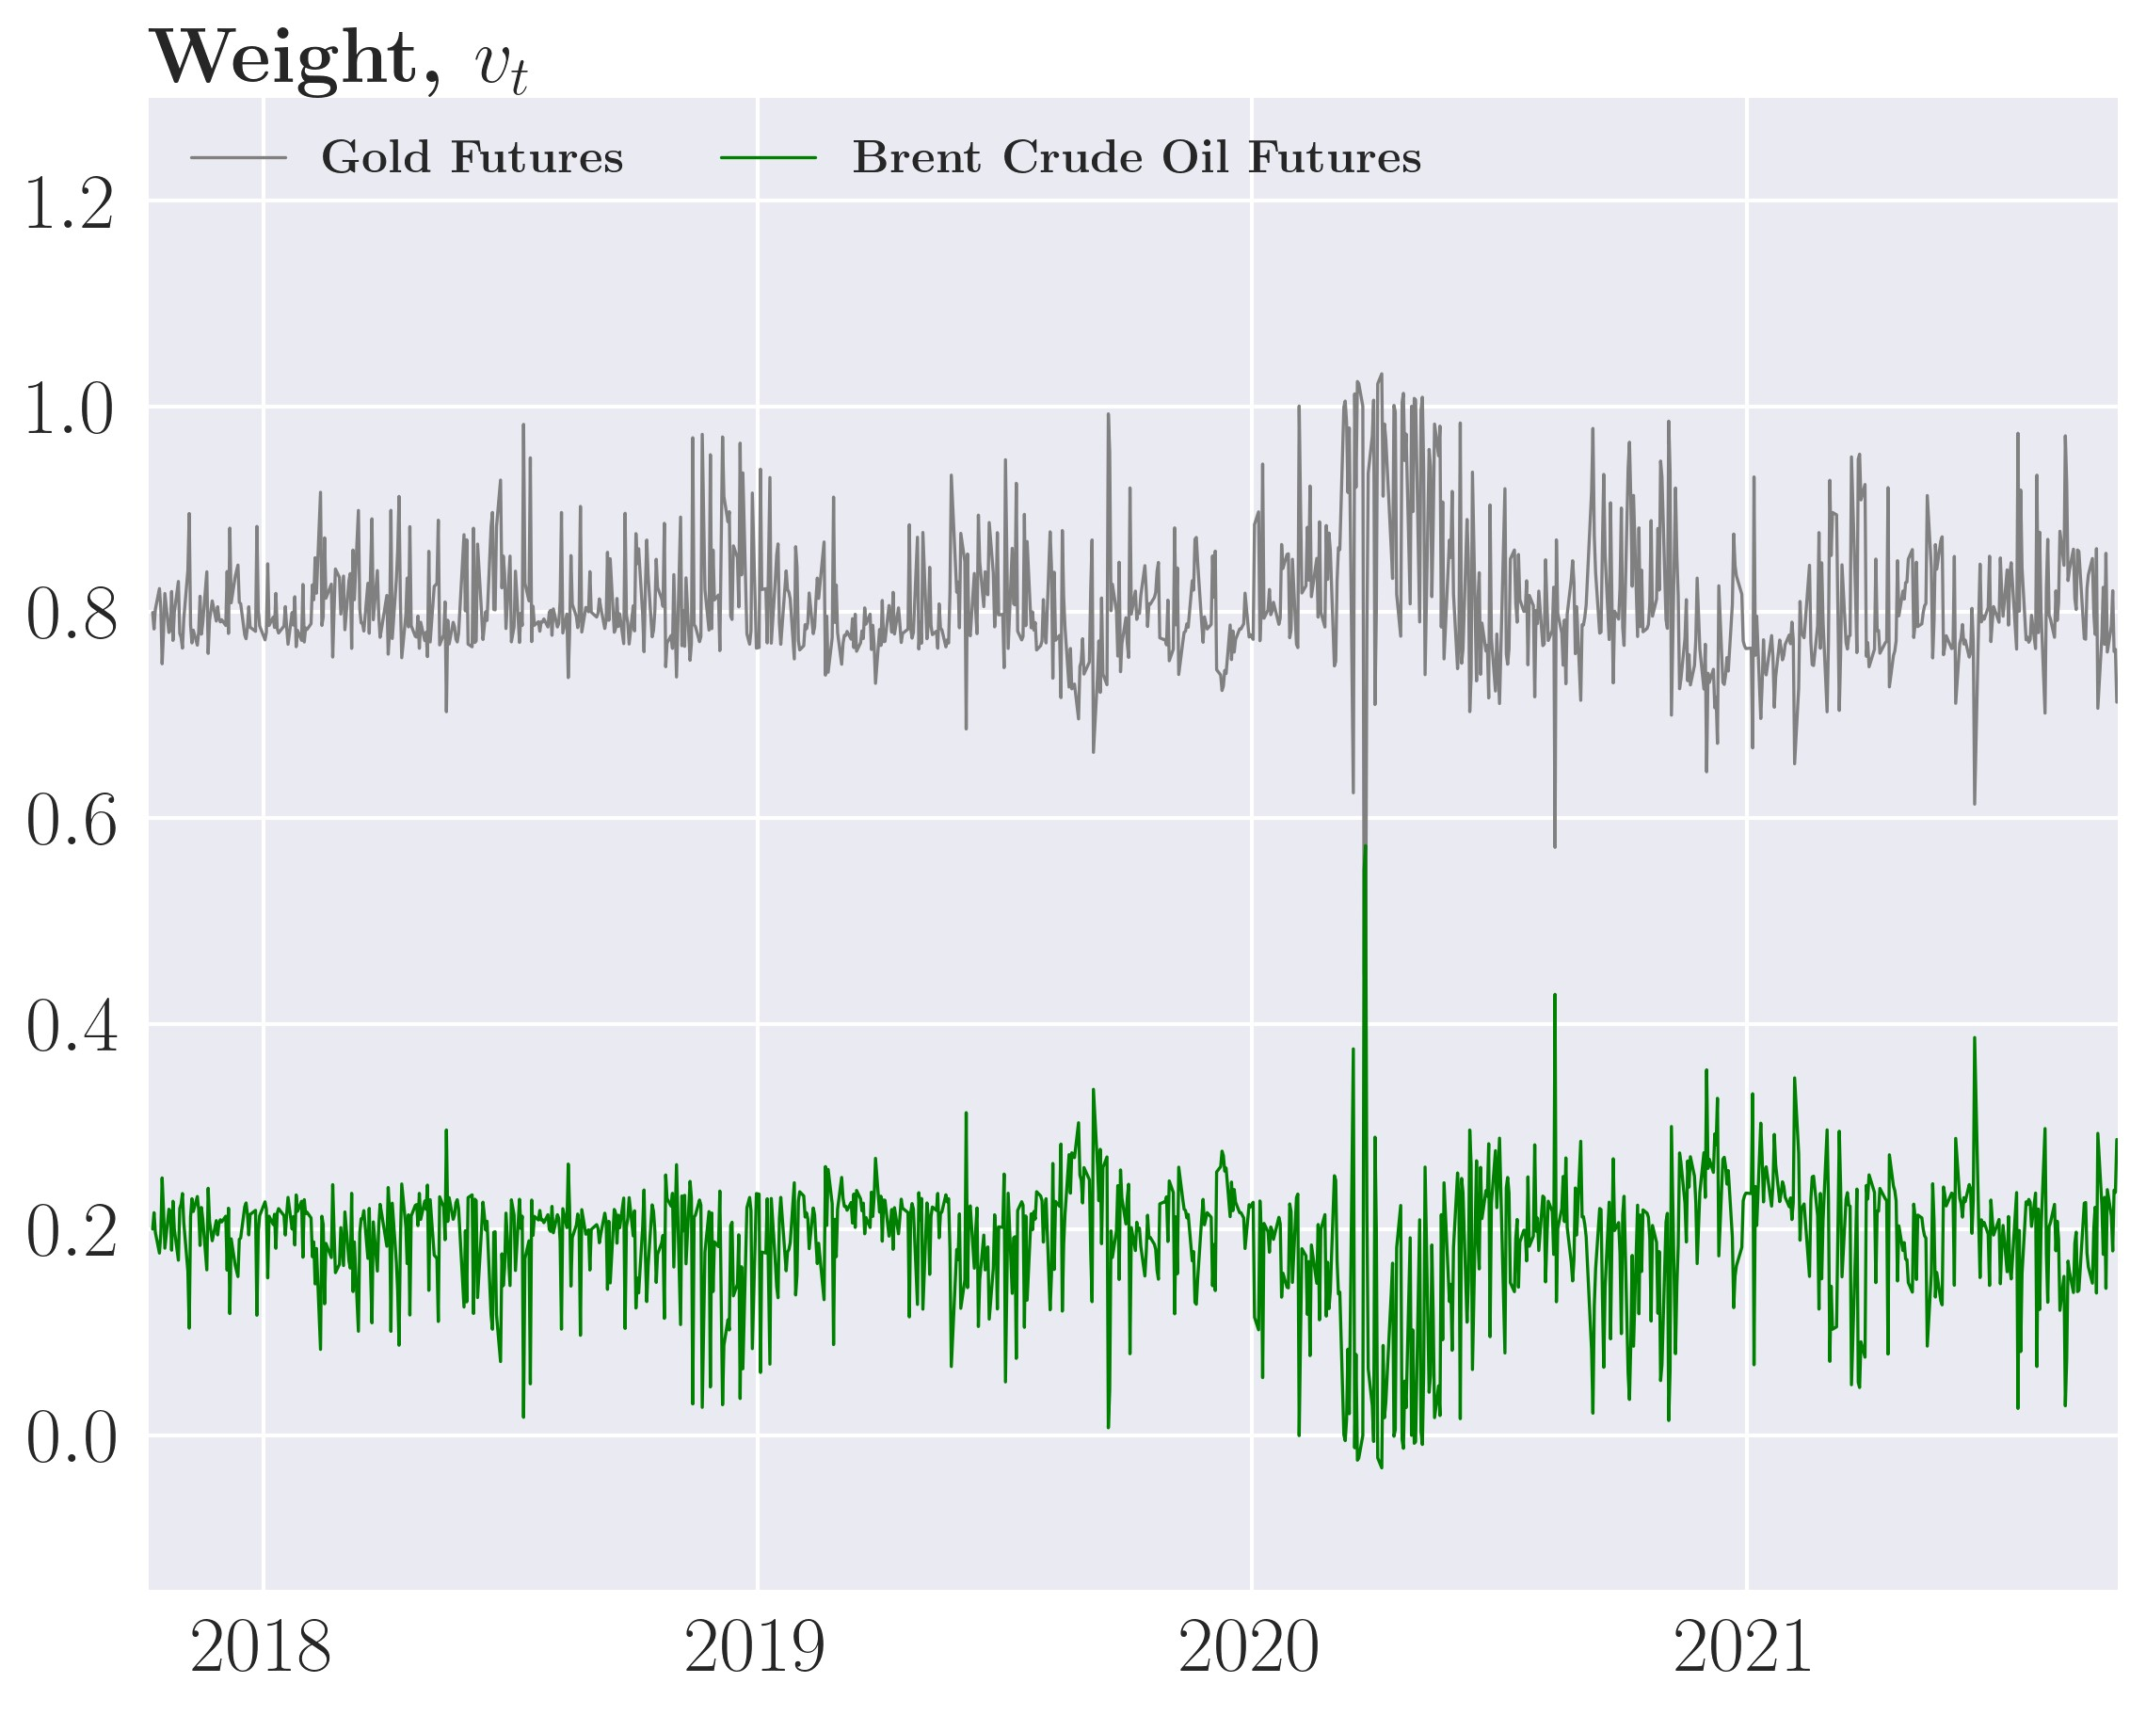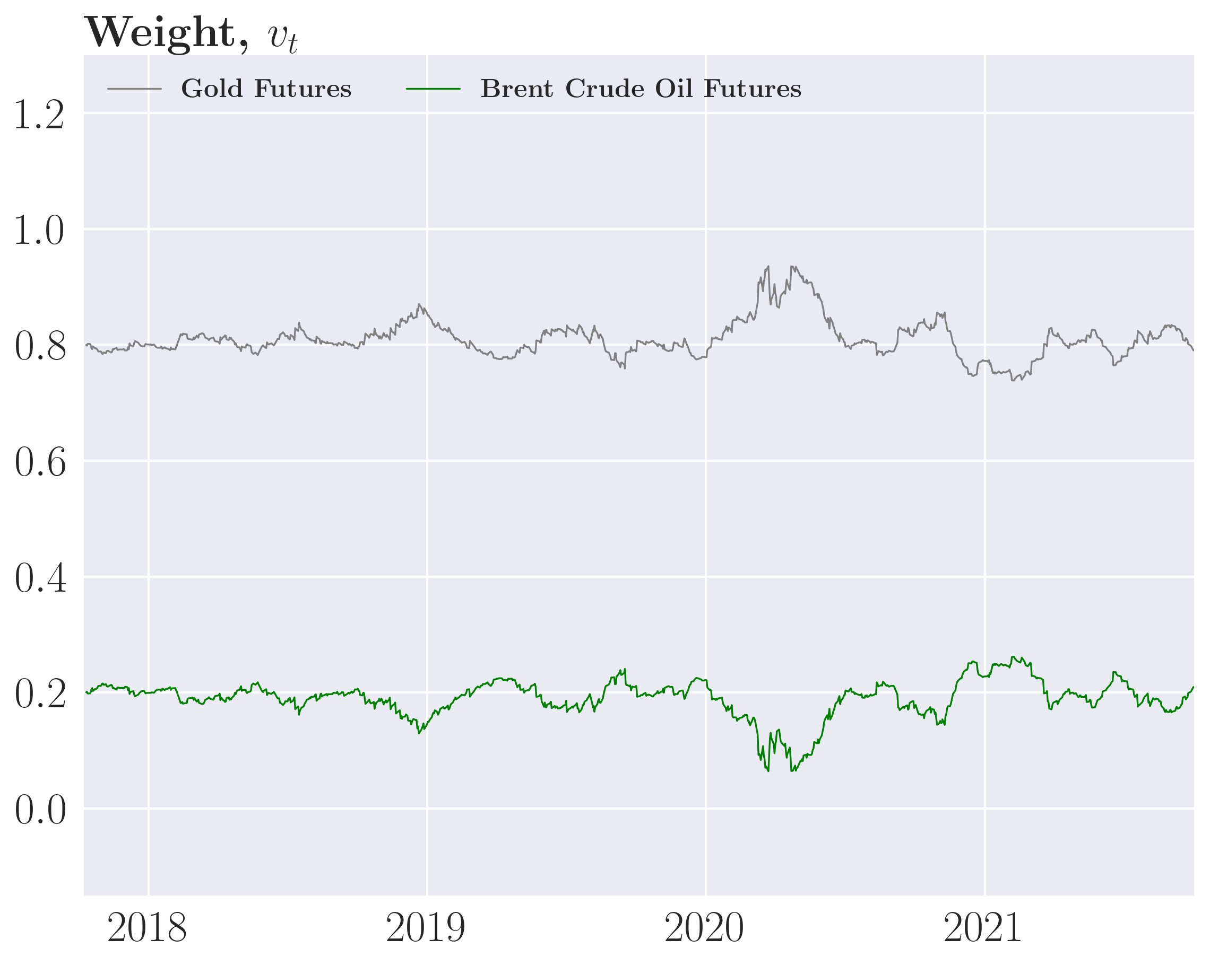

(c) *γ*˜*D* = 1e−4

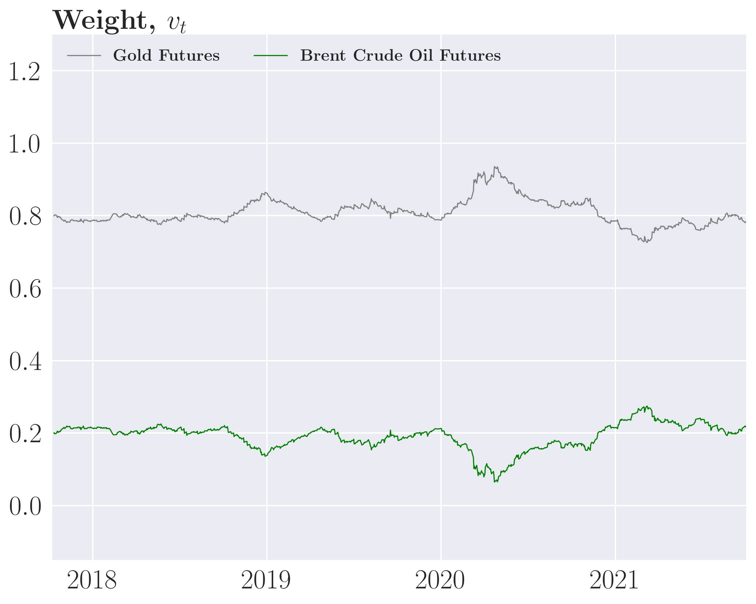

Figure 29: GARCH(1,1) MVP weights for different *γ*˜*D*

(a) *γ*˜*D* = 1*.*52e−6 (b) *γ*˜*D* = 2*.*3e−5

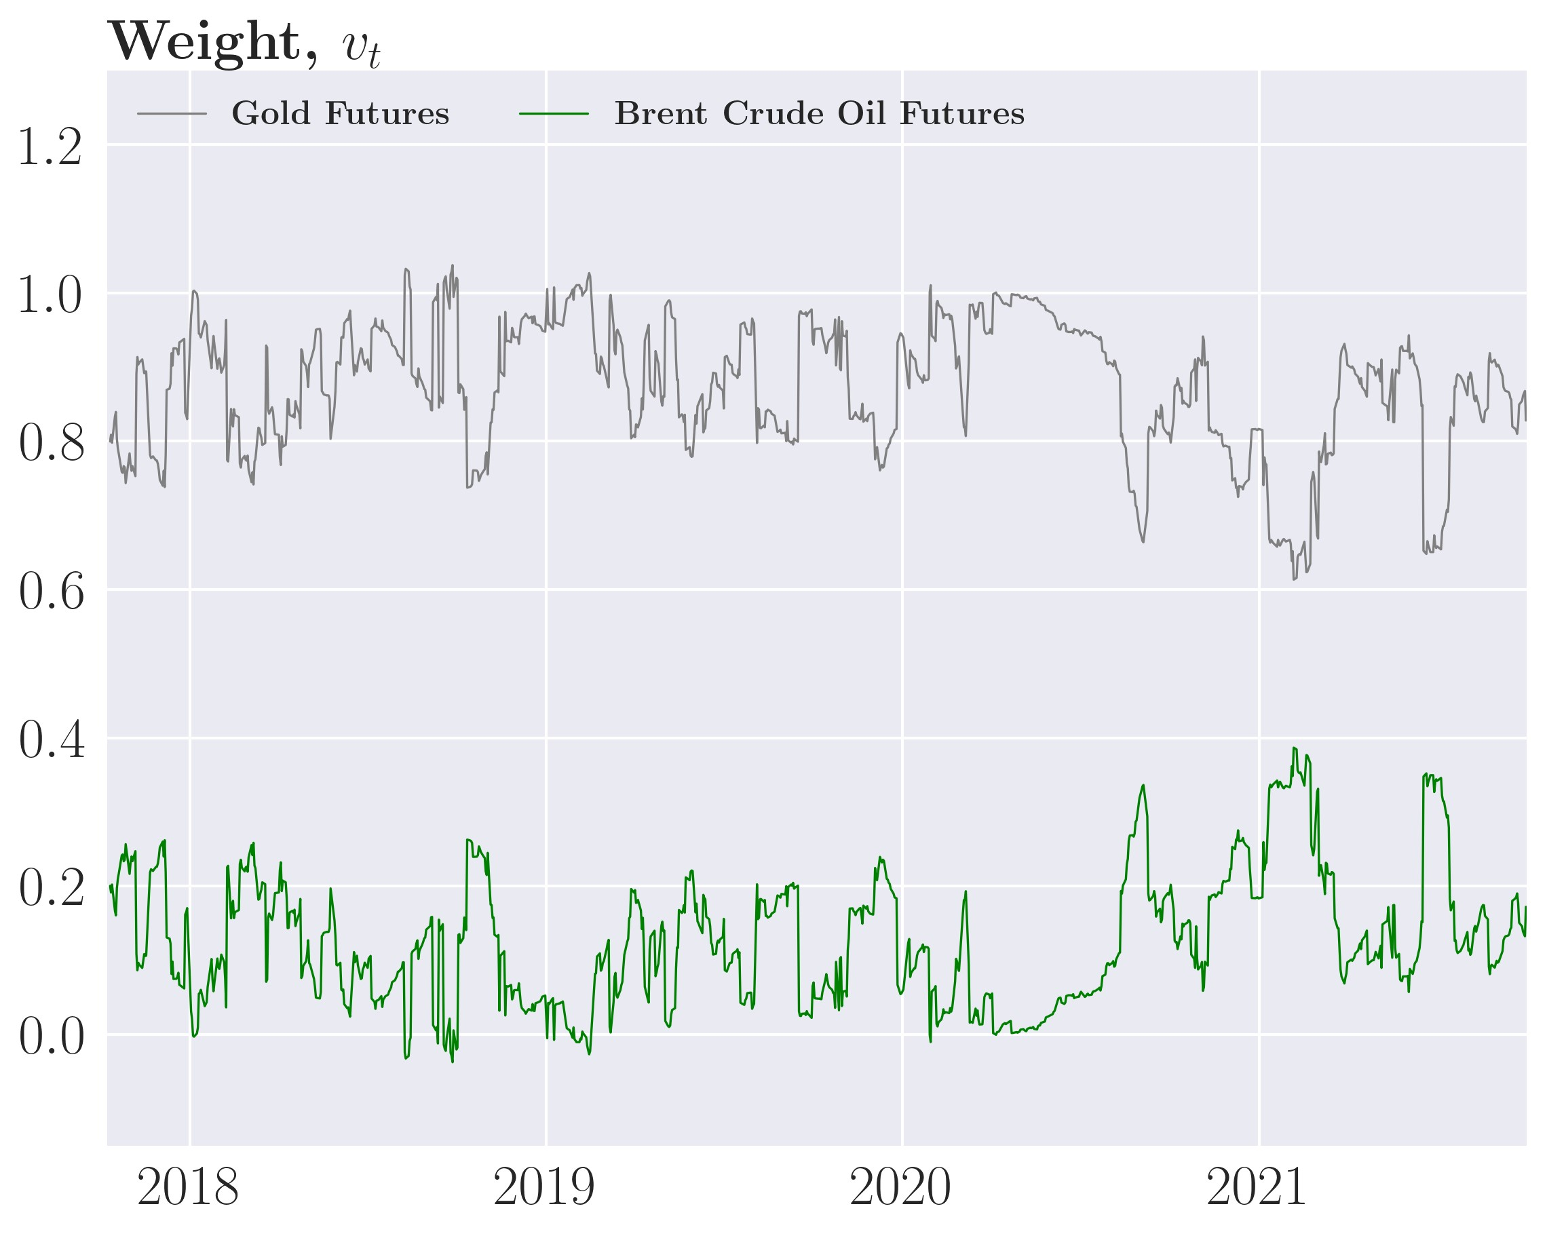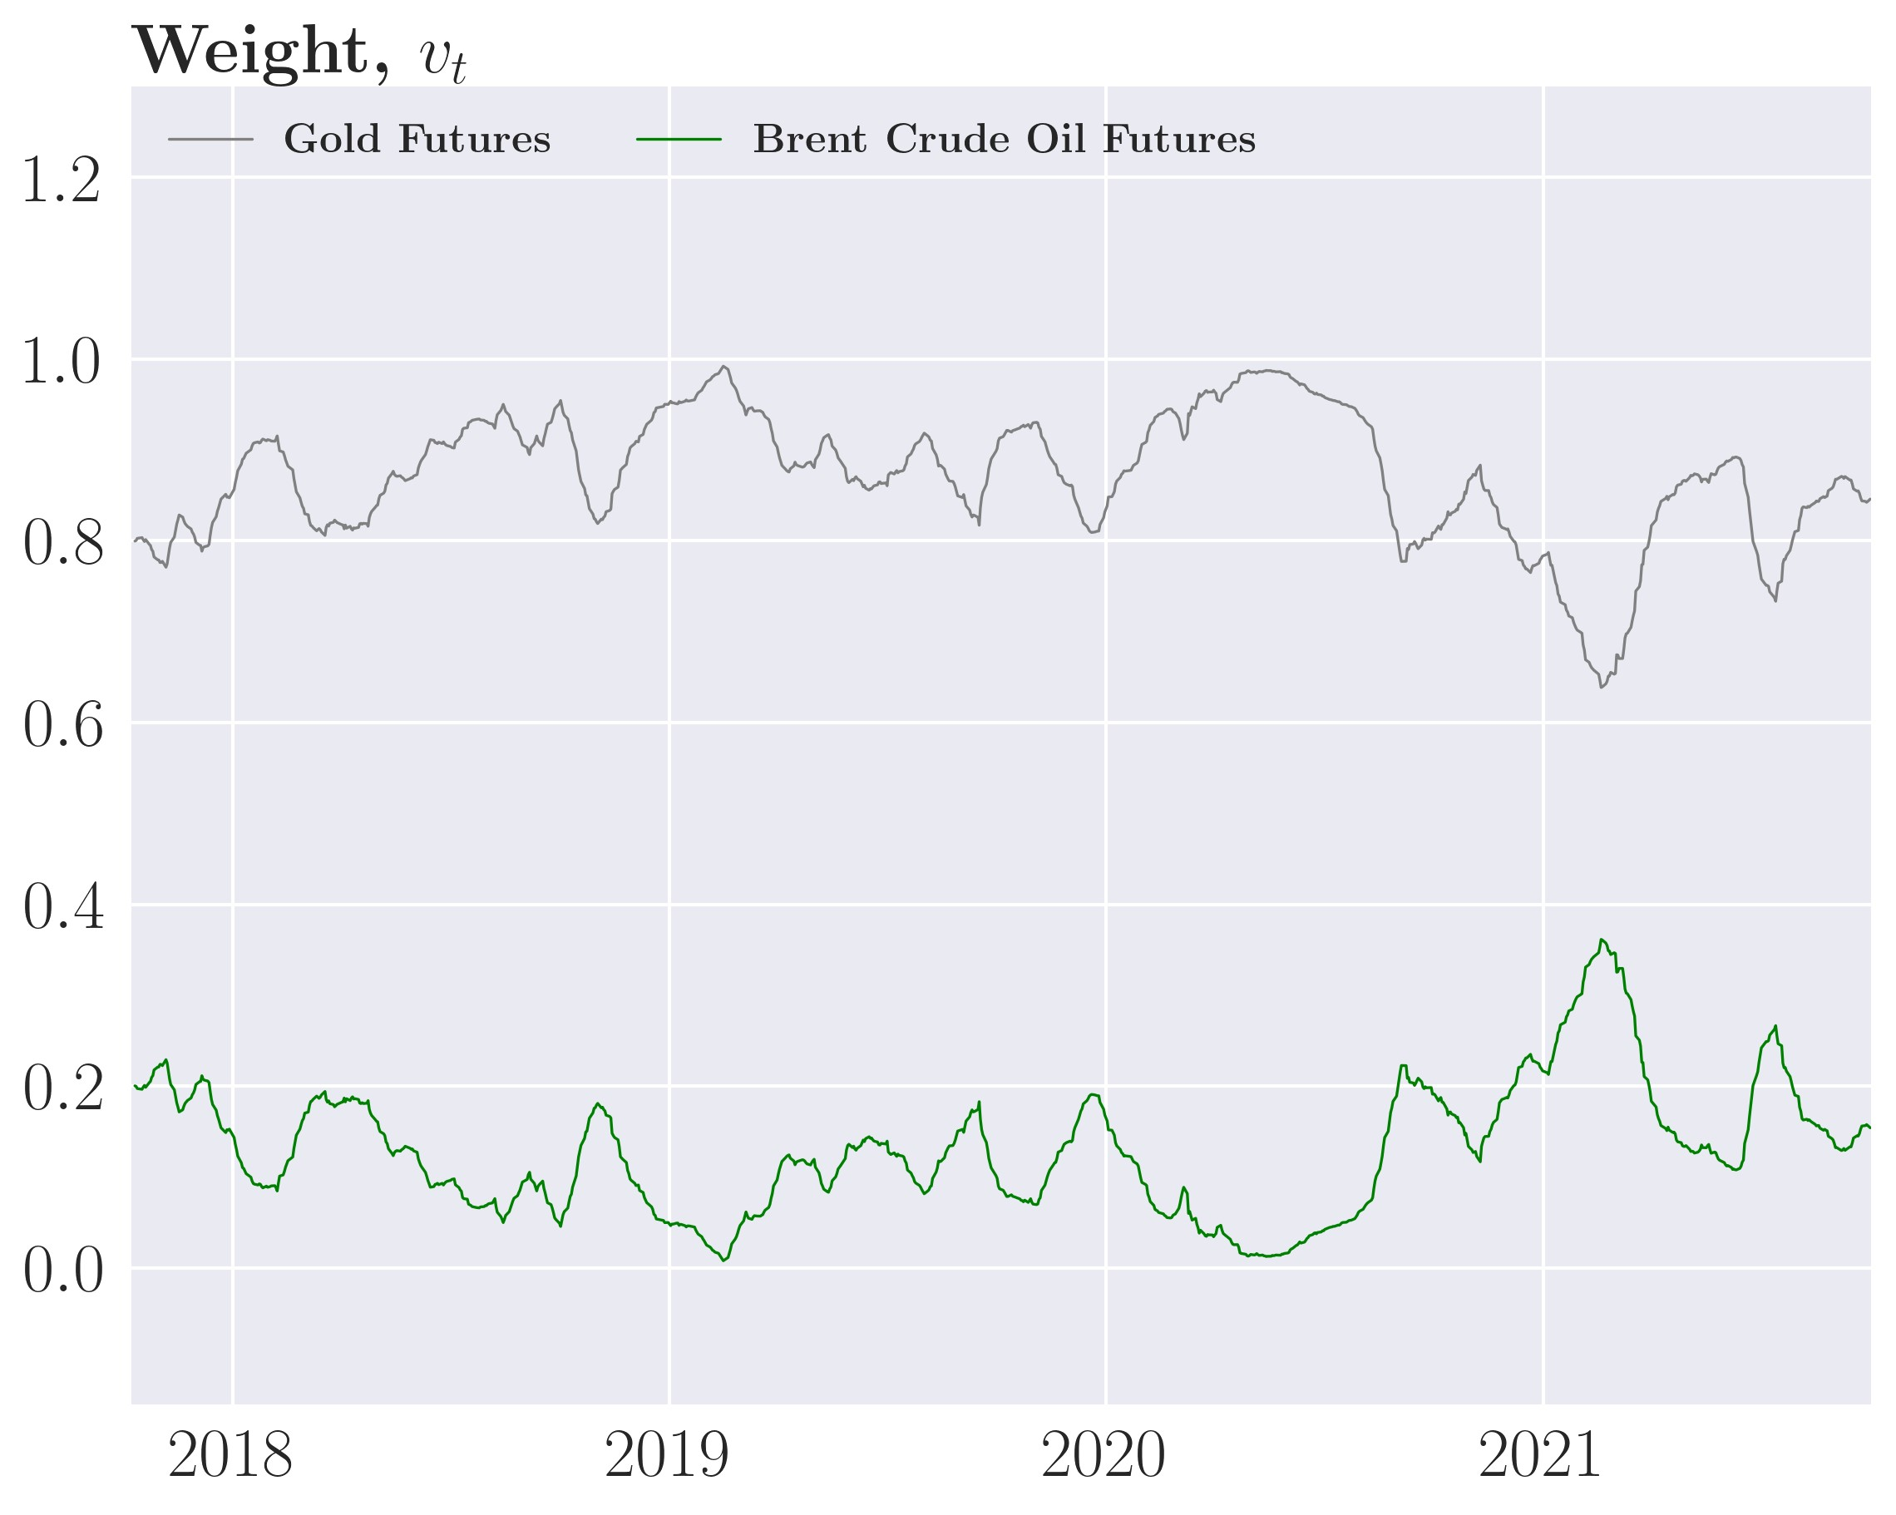

(c) *γ*˜*D* = 1e−4

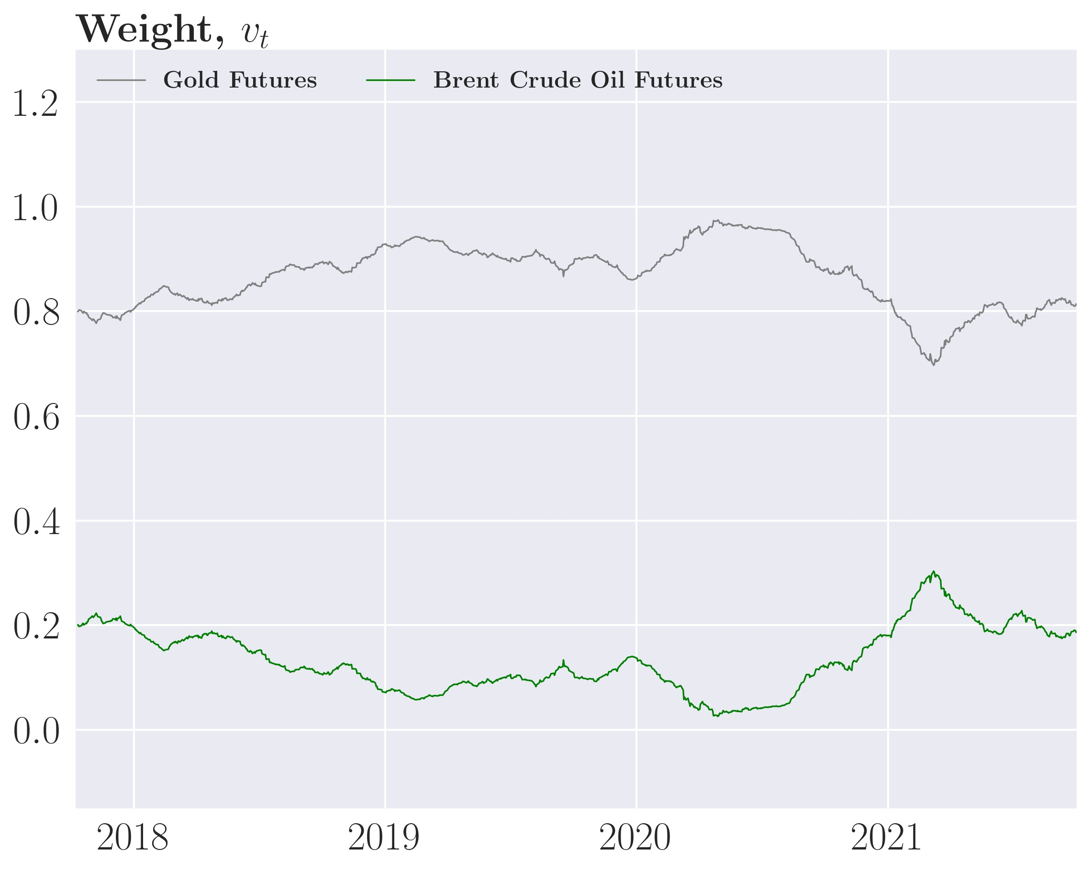

Figure 30: GJR-GARCH(1,1) MVP weights for different *γ*˜*D*

(a) *γ*˜*D* = 1*.*52e−6 (b) *γ*˜*D* = 2*.*3e−5

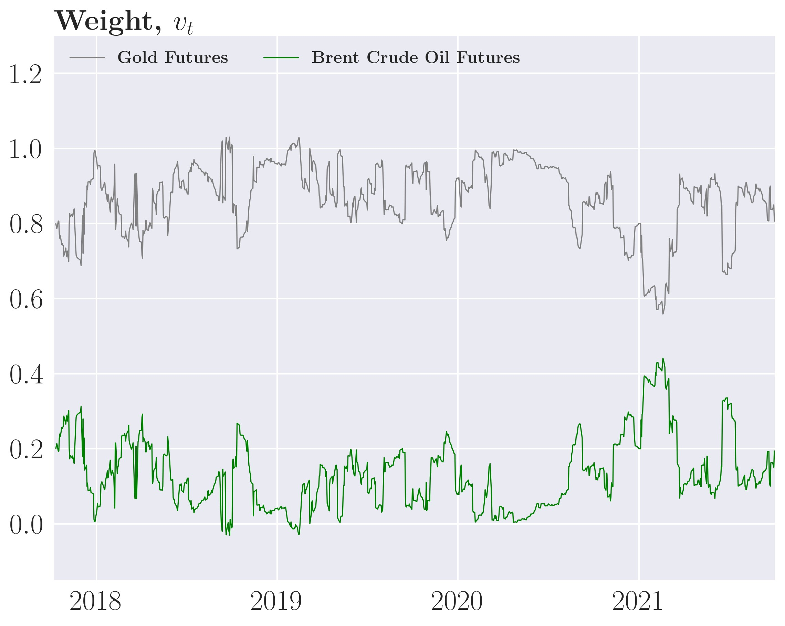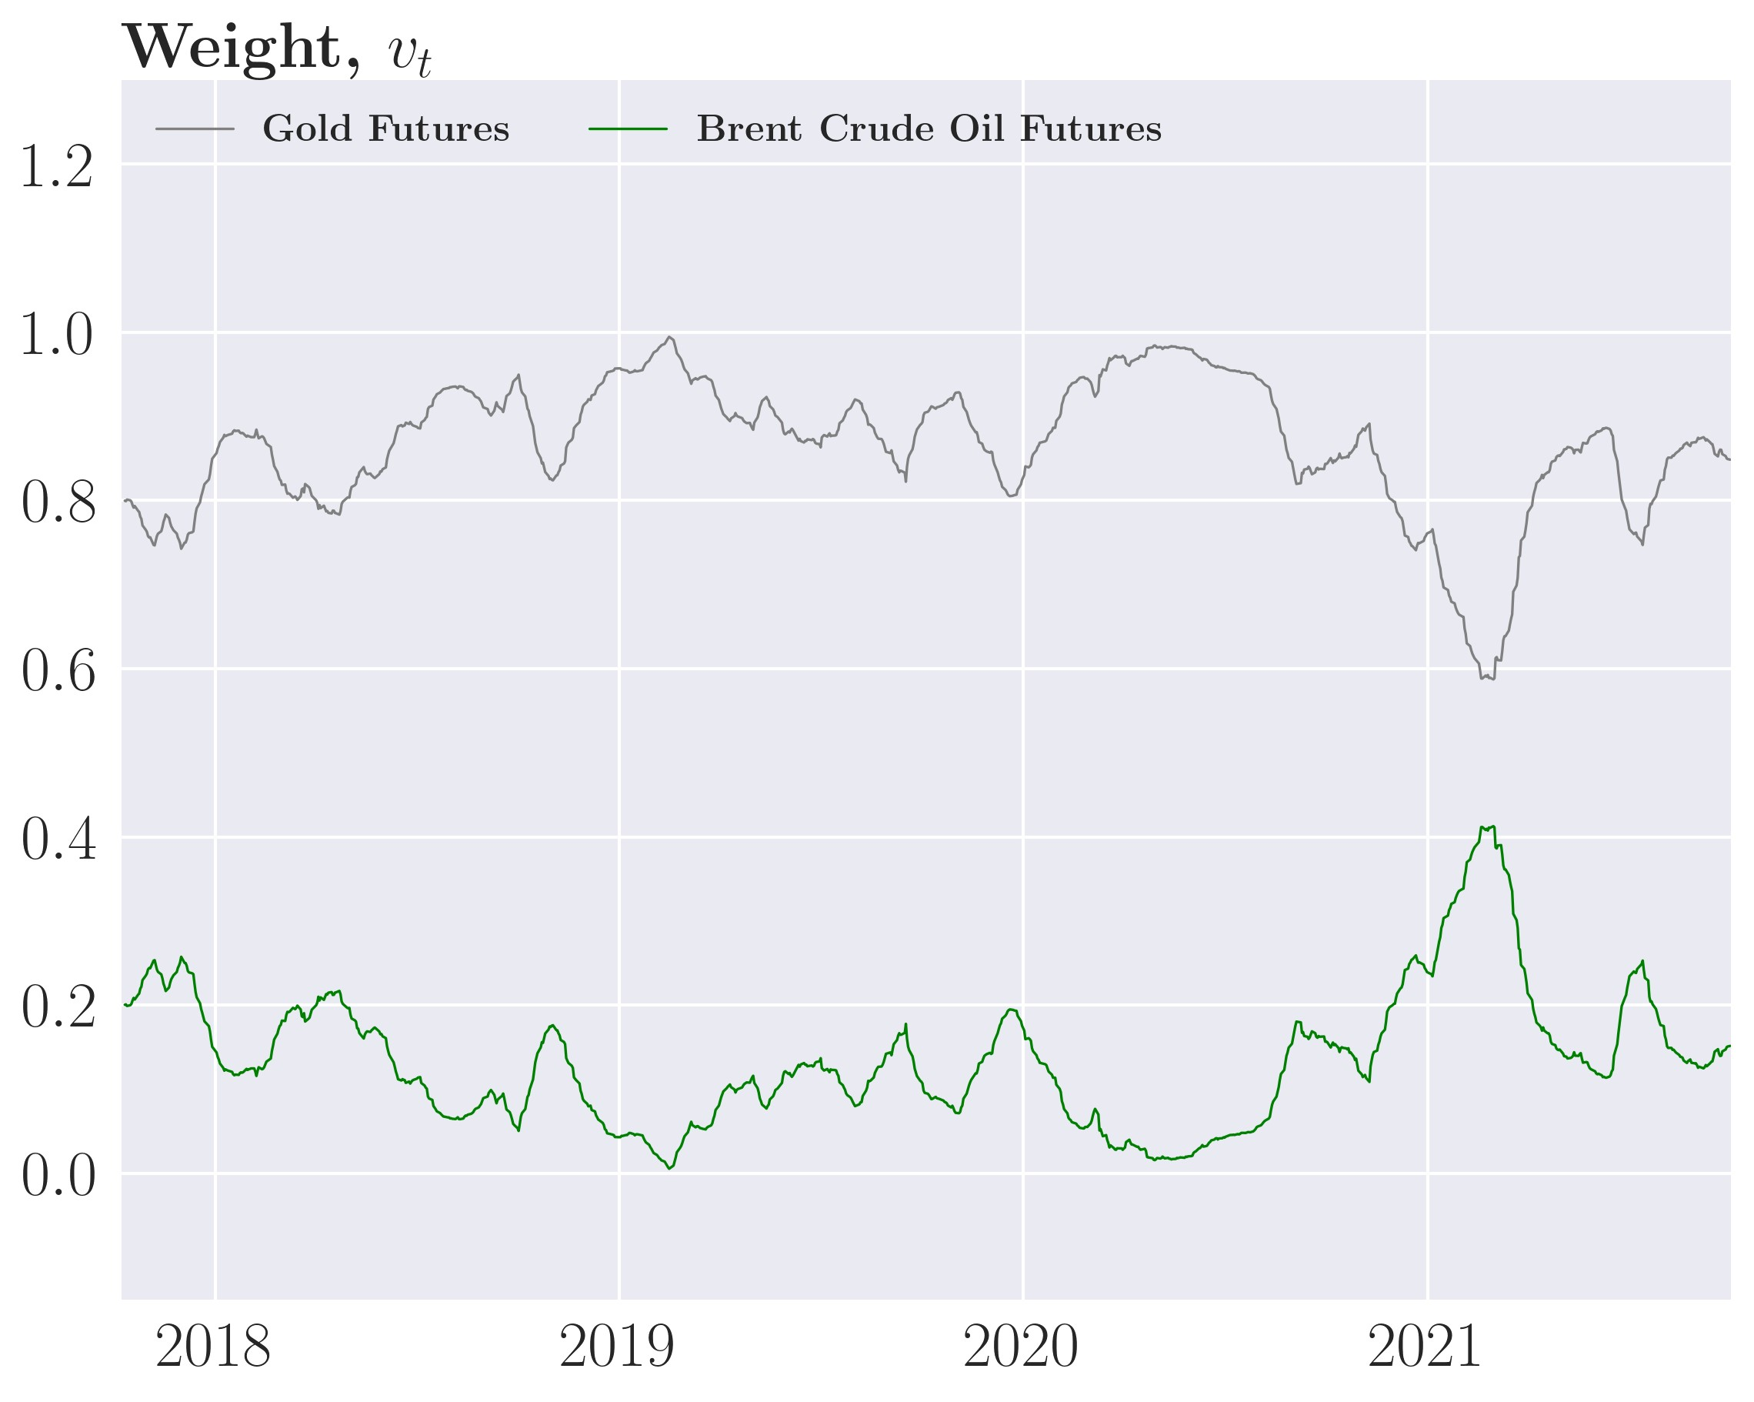

(c) *γ*˜*D* = 1e−4

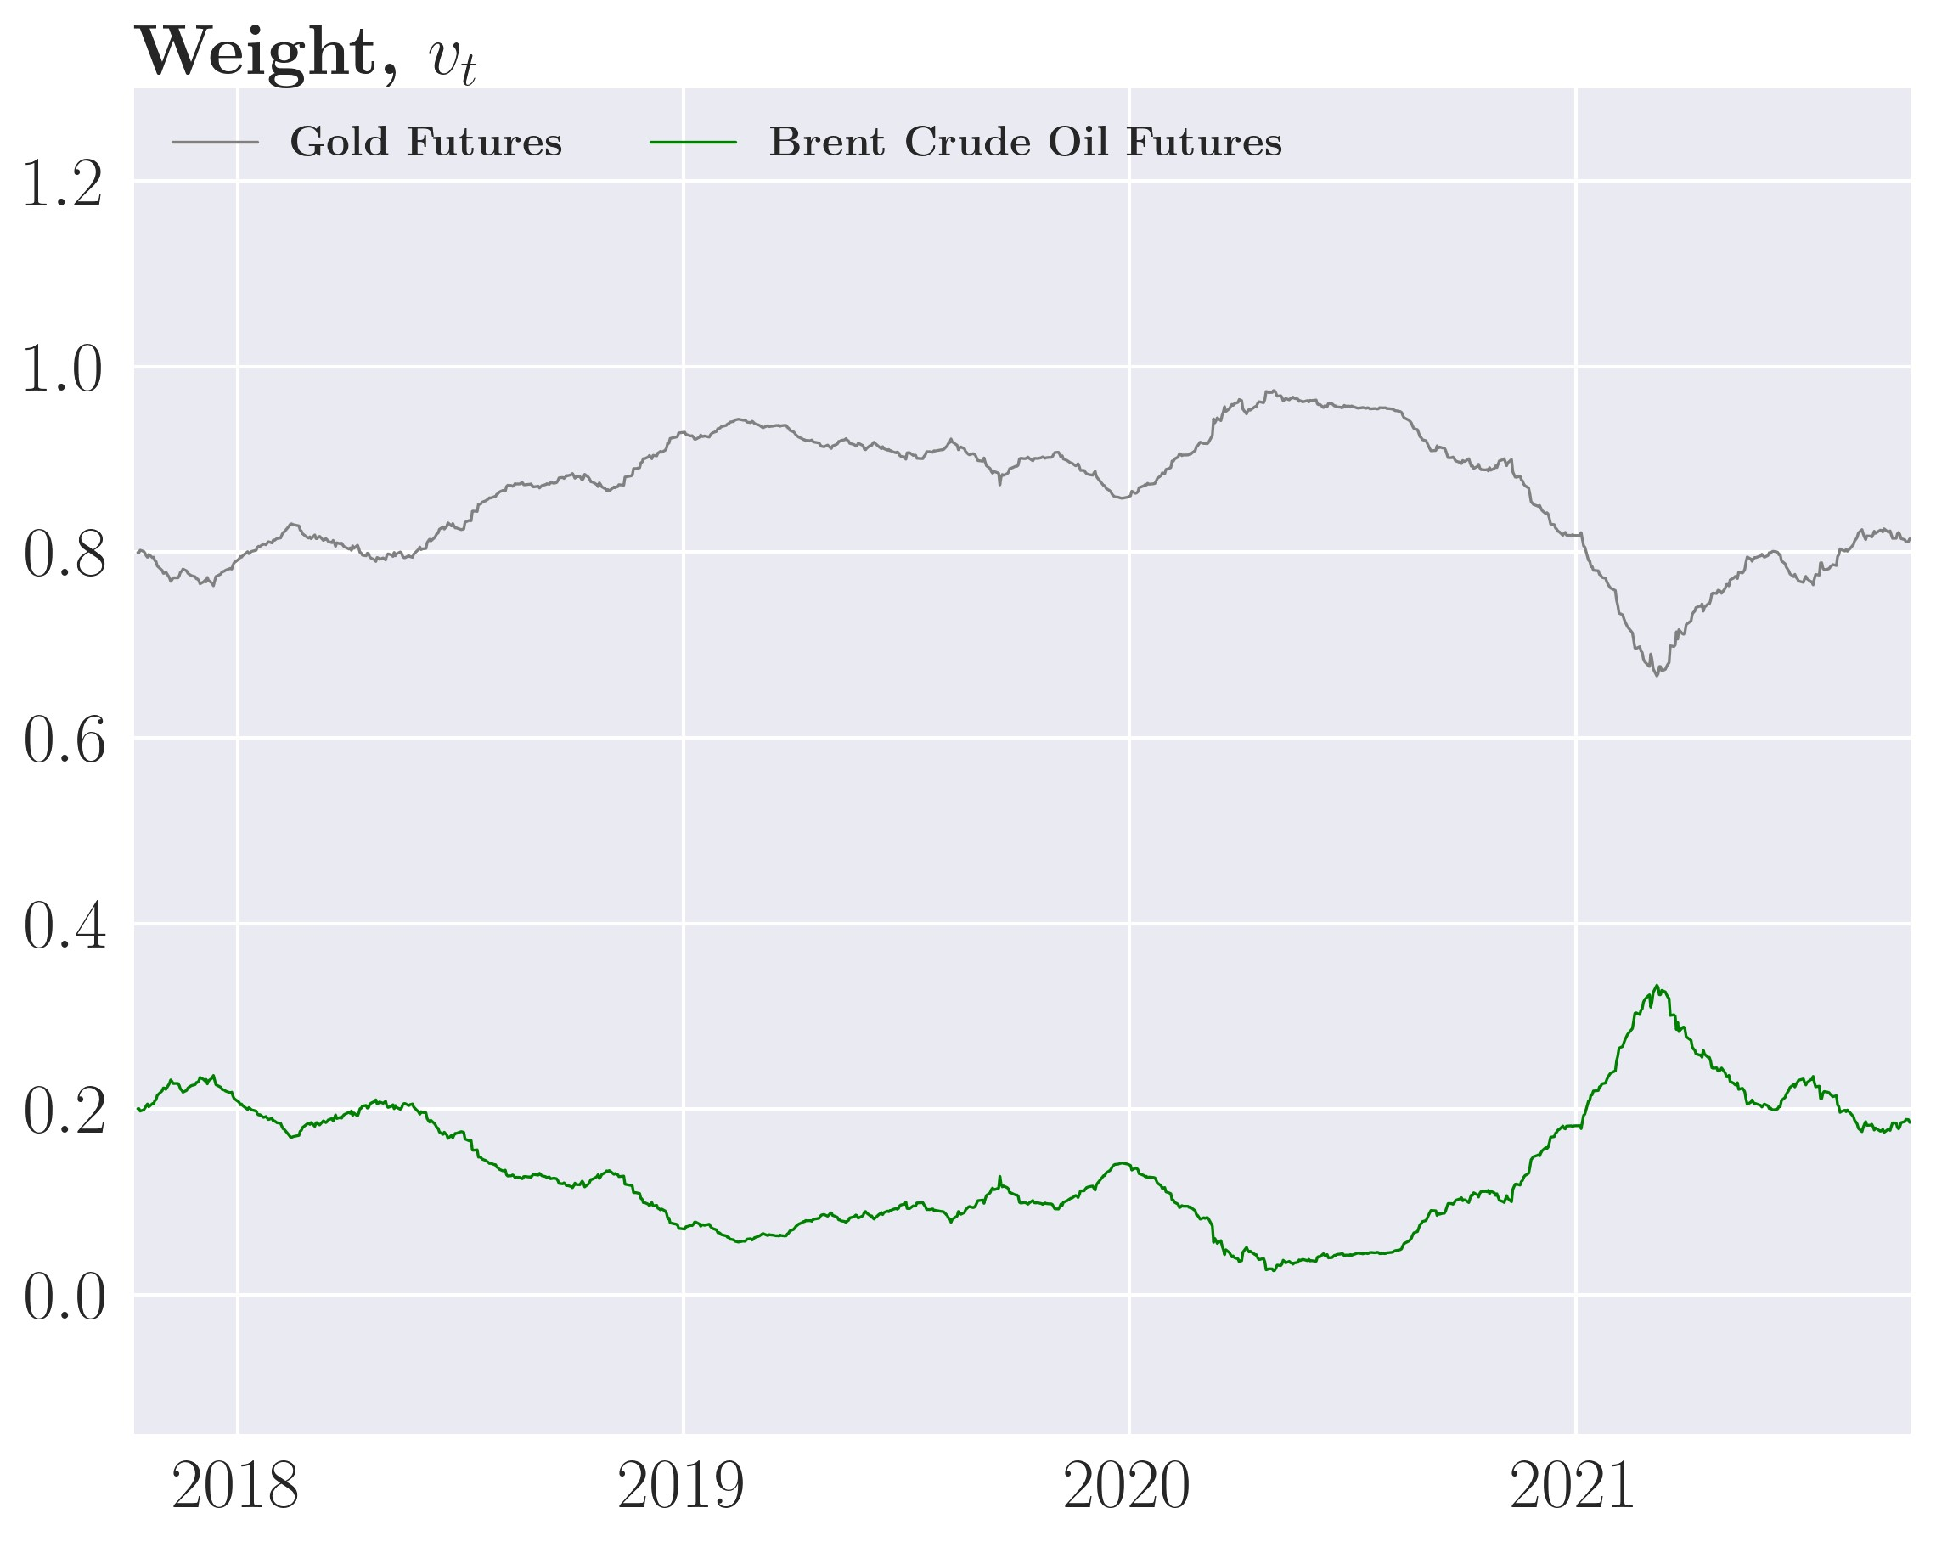

### A.4.3 Algorithms

The algorithms are all formulated as the general GJR-GARCH(1,1) case as the ARCH(1), and GARCH(1,1) are special cases of it.

Algorithm 1 Optimal weights using DCC MGARCH model without transaction costs

|  |  |  |
| --- | --- | --- |
| 1: Data: Asset returns of *N* assets until period *T*. Out of sample period is [*T* + 1*,M*] 2: Result: Array of the weights of *vt* of size (*M* − [*T* + 1]) × *N*  3: Model fit:  4: Use in-sample data from period 0 to *T*  5: Fit a Dynamic Conditional Correlation Multivariate GARCH model based on *R*  6: Univariate part:  7: for Asset *i* ∈ *N* do  8: Estimate a univariate GJR-GARCH(1,1) model  9: Receive the parameters of the model *αi,βi,ωi* ,*κi*  10: Receive variables from the model,  11: end for  12: Multivariate part:  13: Estimate a scalar BEKK GARCH(1,1) model for the pseudo correlation, *Qt* 14: Receive the parameters of the model *a,b*  15: One-period out of sample forecast of Ω*t*  16: while *T* ≤ *M* do  17: Get variables from current period for all *N* assets: | | |
| 18: | Var*t* = diag(*σ*1*,t,σ*2*,t,...,σN,t*) |  |
| 19: | for Asset *i* ∈ *N* do |  |
| 20:  21:  22: | end for |  |
| 23: 24: | Forecast Ω*t*+1 from F*t*-measurable variables, denoted Ω*t*+1|*t* |  |
| 25: | Var*t*+1|*t* = diag(*σ*1*,t*+1|*t,σ*2*,t*+1|*t,...,σN,t*+1|*t*) |  |
| 26: | where | and shrunk |
| 27: | Γ*t*+1|*t* = diag(*Qt*+1|*t*)−1*/*2*Qt*+1|*t*diag(*Qt*+1|*t*)−1*/*2 |  |
| 28: | Ω*t*+1|*t* = Var*t*+1|*t*Γ*t*+1|*t*Var*t*+1|*t* |  |
| 29: end while  30: Portfolio Optimization:  31: Initial weights are the benchmark Buy-and-hold MVP:  32: while *T* ≤ *M* do  33: Use result from section 4.2.1, equation (28) to find the optimal weights  34: end while | | : |

Algorithm 2 Optimal weights using a DCC MGARCH model with transaction costs

1: Data: Asset returns of *N* assets until period *T*. Out of sample period is [*T* + 1*,M*]

2: Result: Array of the weights of *vt* of size (*M* − [*T* + 1]) × *N*

3: Model fit:

4: Use in-sample data from period 0 to *T*

5: Fit a Dynamic Conditional Correlation Multivariate GARCH model based on *R*

6: Univariate part:

7: for Asset *i* ∈ *N* do

8: Estimate a univariate GJR-GARCH(1,1) model

9: Receive the parameters of the model *αi,βi,ωi* ,*κi*

10: Receive variables from the model,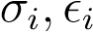

### 11: end for

12: Multivariate part:

13: Estimate a scalar BEKK GARCH(1,1) model for the pseudo correlation, *Qt* 14: Receive the parameters of the model *a,b*

### 15: One-period out of sample forecast of Ω*t* 16: while *T* ≤ *M* do

17: Get variables from current period for all *N* assets: 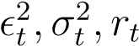

18: Var*t* = diag(*σ*1*,t,σ*2*,t,...,σN,t*)

19: for Asset *i* ∈ *N* do

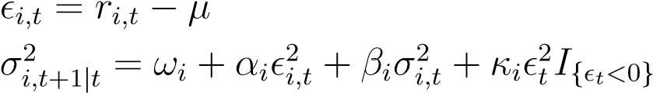20:

21:

### 22: end for

23: 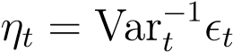

24: Forecast Ω*t*+1 from F*t*-measurable variables, denoted Ω*t*+1|*t*

25: Var*t*+1|*t* = diag(*σ*1*,t*+1|*t,σ*2*,t*+1|*t,...,σN,t*+1|*t*)

26:  where 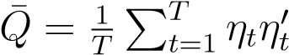 and shrunk

27: Γ*t*+1|*t* = diag(*Qt*+1|*t*)−1*/*2*Qt*+1|*t*diag(*Qt*+1|*t*)−1*/*2

28: Ω*t*+1|*t* = Var*t*+1|*t*Γ*t*+1|*t*Var*t*+1|*t*

29: Calculate *Avv*, *Av*1 and *A*11 using equation (38), (39) and (40)

### 30: end while

31: Portfolio Optimization:

32: Initial weights are the benchmark Buy-and-hold MVP: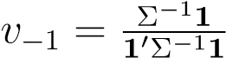

### 33: while *T* ≤ *M* do

34: Find optimal weights using equation (

### 35: end while

Algorithm 3 Calculation of transaction costs

1: Data: Out of sample returns from period [*T* + 1*,M*] of the *N* assets

2: Result: Array of net return size (*M* − [*T* + 1]) × *N*

3: Calculation:

### 4: while *T* ≤ *M* do

5: Calculate turnover (TO) using equation (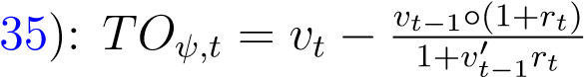

6: Convert relative change in weight into number of stocks traded: ∆*xi* = *TOiψvPi*−1

7: Calculate the dollar transaction cost: *TCψ,t* = ∆*xt*Ω*t*+1|*tγD*∆*xt*

8: Calculate the relative transaction cost: %*TCψ,t* = *TCψ,t/ψv* 9: Calculate net returns: 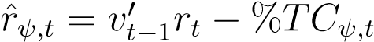

### 10: end while

## A.5 Excess tables

Table 11: Annualized performance, sophisticated strategy, stocks

Strategy Std. deviation Return Sharpe ratio Transaction costs

|  |  |  |  |  |
| --- | --- | --- | --- | --- |
|  |  | Before transaction costs | | |
| ARCH(1) | 0.2085 | 0.1105 | 0.5297 | |
| GARCH(1,1) | 0.1878 | 0.0865 | 0.4609 | |
| GJR-GARCH(1,1) | 0.1899 | 0.0884 | 0.4656 | |
| Equal weight | 0.2082 | 0.1117 | 0.5366 | |
| Buy and hold | 0.2197 | 0.1732 | 0.7882 | |
|  |  | After transaction costs *γ*˜*D* = *γD* = 1*.*52e−6 | | |
| ARCH(1) | 1.4366 | -1.0000 | -0.6961 | 100.00% |
| GARCH(1,1) | 0.9056 | -1.0000 | -1.1042 | 83.362% |
| GJR-GARCH(1,1) | 0.8124 | -1.0000 | -1.2309 | 84.315% |
| Equal weight | 0.2083 | 0.0951 | 0.4565 | 1.4981% |
| Buy and hold | 0.2197 | 0.1732 | 0.7882 | 0.0000% |
|  |  | After transaction costs *γ*˜*D* = 1*.*03e−4 | |  |
| ARCH(1) | 0.2107 | 0.0547 0.2597 | | 5.3285% |
| GARCH(1,1) | 0.1995 | 0.0592 0.2968 | | 2.2943% |
| GJR-GARCH(1,1) | 0.1994 | 0.0577 0.2891 | | 2.7637% |
|  | After transaction costs *γ*˜*D* = 1*.*03e−3 | | |  |
| ARCH(1) | 0.2100 0.1379 0.6565 | | | 2.1754% |
| GARCH(1,1) | 0.2039 0.1050 0.5148 | | | 1.0545% |
| GJR-GARCH(1,1) | 0.2048 0.1114 0.5443 | | | 1.2475% |

*Note*: The actual transaction costs the investor pays is identical for each *γ*˜

Table 12: Annualized performance, sophisticated strategy, bonds

Strategy Std. deviation Return Sharpe ratio Transaction costs

|  |  |  |  |  |
| --- | --- | --- | --- | --- |
|  |  | Before transaction costs | | |
| ARCH(1) | 0.0807 | 0.0649 | 0.8047 | |
| GARCH(1,1) | 0.0703 | 0.0508 | 0.7224 | |
| GJR-GARCH(1,1) | 0.0777 | 0.0324 | 0.4174 | |
| Equal weight | 0.0756 | 0.0590 | 0.7806 | |
| Buy and hold | 0.0711 | 0.0538 | 0.7565 | |
|  |  | After transaction costs *γ*˜*D* = *γD* = 1*.*52e−6 | | |
| ARCH(1) | 0.3829 | -0.5652 | -1.4761 | 59.078% |
| GARCH(1,1) | 0.8087 | -1.0000 | -1.2366 | 100.02% |
| GJR-GARCH(1,1) | 0.8087 | -1.0000 | -1.2366 | 48.585% |
| Equal weight | 0.0776 | 0.0469 | 0.6043 | 1.1341% |
| Buy and hold | 0.0711 | 0.0538 | 0.7565 | 0.0000% |
|  |  | After transaction costs *γ*˜*D* = 1*.*3e−4 | |  |
| ARCH(1) | 0.0661 | 0.0497 0.7506 | | 0.0655% |
| GARCH(1,1) | 0.0650 | 0.0486 0.7483 | | 0.1112% |
| GJR-GARCH(1,1) | 0.0641 | 0.0517 0.8067 | | 0.0927% |
|  | After transaction costs *γ*˜*D* = 2*.*13e−4 | | |  |
| ARCH(1) | 0.0666 0.0505 0.7580 | | | 0.0251% |
| GARCH(1,1) | 0.0652 0.0497 0.7615 | | | 0.0395% |
| GJR-GARCH(1,1) | 0.0645 0.0512 0.7941 | | | 0.0356% |

*Note*: The actual transaction costs the investor pays is identical for each *γ*˜

## A.6 Python Code

All the code used for backtesting and plots is available at [https://github.com/neriksen/ thesis](https://github.com/neriksen/thesis)

1. The portfolio is self financing as.
2. [Taylor, 2011],*Asset price dynamics, volatility, and prediction*,p. 70-76
3. [Taylor, 2011],*Asset price dynamics, volatility, and prediction*,p. 76+77
4. [Taylor, 2011],*Asset price dynamics, volatility, and prediction*,p. 82-86
5. See appendix A.1 for details on the distribution
6. [Bohn Nielsen, 2017]: Introduction to likelihood-based estimation and inference, Page 52-53
7. [Taylor, 2011], *Asset price dynamics, volatility, and prediction*, p. 221
8. [Engle and Kroner, 1995], *Multivariate Simultaneous Generalized Arch*, proposition 2.5
9. [Engle and Kroner, 1995], *Multivariate Simultaneous Generalized Arch*, proposition 2.7
10. [Rossi and Spazzini, 2010], *Model and distribution uncertainty in multivariate GARCH estimation: a*

    *Monte Carlo analysis*, p. 7
11. [Engle and Kroner, 1995], *Multivariate Simultaneous Generalized Arch*, p. 138-139
12. See [Gan and Lu, 2014], *General Setting and solution of Bellman equation in monetary theory*, page 2
13. See appendix A.2 for exact density for non-central Student’s t-distribution
14. S&P 500, 20+ Year Treasury Bonds, Brent Crude Oil Futures, and Gold Futures
15. with the weight of the simple GJR-GARCH(1,1) in the appendix in figure 25 panel (b)
16. The subset using all stocks and all bonds are in the appendix 24
17. See figure 26
18. We acknowledge the absurdity of having a multiyear strategy with annualized transaction costs of 100%. But sometimes the ARCH(1) makes extreme changes to its portfolio such that the transactions costs exceeds the portfolio value. This can cause annual transaction costs of +100%. We cap the cost at 100% though, as we assume the investor cannot lose more than everything.